Materials Engineering Lab Report
LTR Number: 143800

______________________________________________________________________
To: Peter Bauerle Phone: 776-7387
Location: W2003: Chrysler Technical Centre

______________________________________________________________________

Lead Engineer: Peter Bauerle Phone: 776-7387
Location: W2003: Chrysler Technical Centre Completed: 04/11/2013

______________________________________________________________________

Part Name: Fatigue Specimen - Iteration 161/162(D)
Number of Parts: 1
Nature of Work: Process/Materials/DFSS/Decoupled Dev.

History of Part

The sample that has been submitted is a fatigue specimen that has been used for the development of the AISI fatigue database, namely iterations 161 and 162. The test specimen was prepared from an 8615 steel grade with low hardenability in an attempt to produce a composite fatigue specimen with a case and core. The sample has been carburized in the gage section by using the following heat treat cycle: austenitize at 1700F with a 0.9% carbon potential for 4.5 hours, step down to 1550F followed by quenching in 150F oil and then tempering at 350F.

Test Results are on the following pages

Metallography - 143800

General Microstructure Description (Performed By: Kathryne Bacas)

A fatigue specimen from iteration 161/162(D) was received for metallographic analysis. The sample was sectioned longitudinally through the grip section and transversely through the gauge section. The two sections were mounted in Bakelite, ground, and polished in accordance to ASTM E3. The as-polished samples were examined using an Olympus PMG3 metallograph. Both cross-sections contained Intergranular Oxidation (IGO) at the surface to a depth of approximately 13µm (Figure Met-1). An inclusion rating was performed on the longitudinal grip section in accordance to ASTM E45 and the results recorded in Table Met-1. The samples were etched using a 3% Nital solution to reveal the microstructure in accordance to ASTM E407. Photographs were taken of the surface and core microstructure of the longitudinal grip section and mid-radius of the transverse gauge section. Microstructural details and corresponding figures were recorded in Table Met-2.

Table Met-1. Inclusion rating for the longitudinal grip section of fatigue specimen 161/162(D).
 | A |  | B |  | C |  | D
 | Thin | Heavy | Thin | Heavy | Thin | Heavy | Thin | Heavy
Rating (1-5) | 4 | 0 | 0 | 0 | 0 | 0 | 2 | 1

Table Met-2. Microstructural descriptions and corresponding figures for the specified locations in fatigue specimen 161/162(D).
Section | Location | Microstructure | Figure
161/162(D) | Gauge section mid radius | Tempered martensite, some acicular ferrite, manganese sulfide inclusions, and some carbides | Met-2
 | Grip end case | Tempered martensite and manganese sulfide stringers | Met-3
 | Grip end core | Tempered martensite, acicular ferrite, manganese sulfide stringers, and some carbides | Met-4

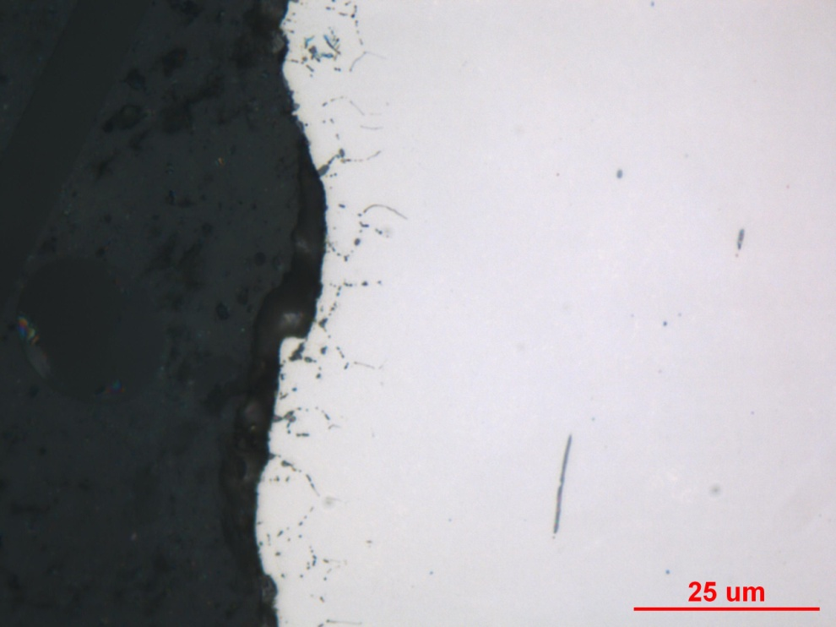
Figure Met-1. Representative photograph of IGO found along the surface of both sections of fatigue specimen 161/162(D), as-polished.

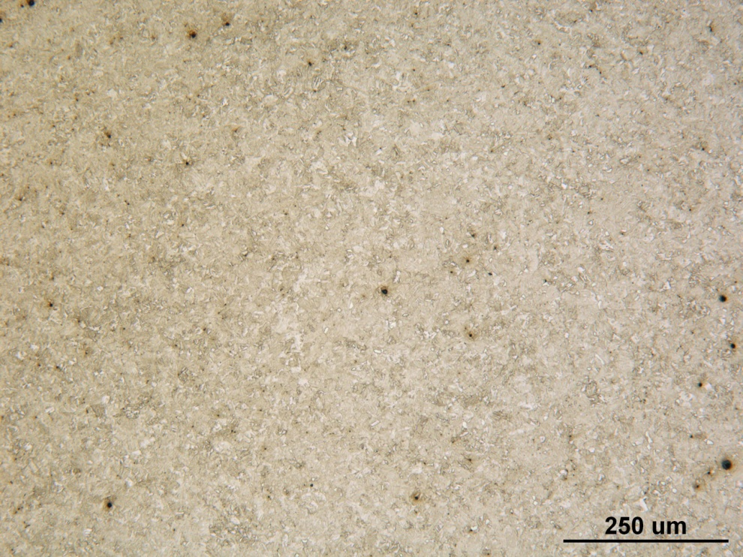

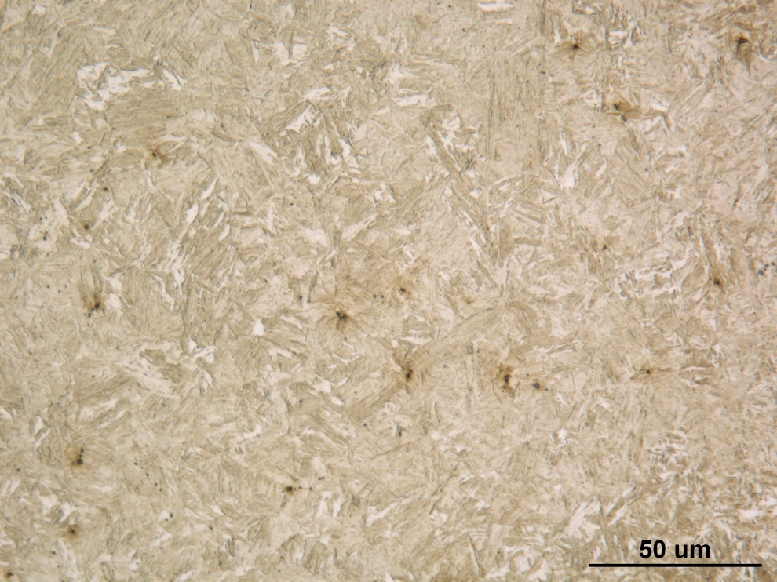
Figure Met-2. Photographs of the mid-radius microstructure of the transverse gauge of fatigue specimen 161/162(D) taken at medium (top) and high (bottom) magnifications, Nital etch.

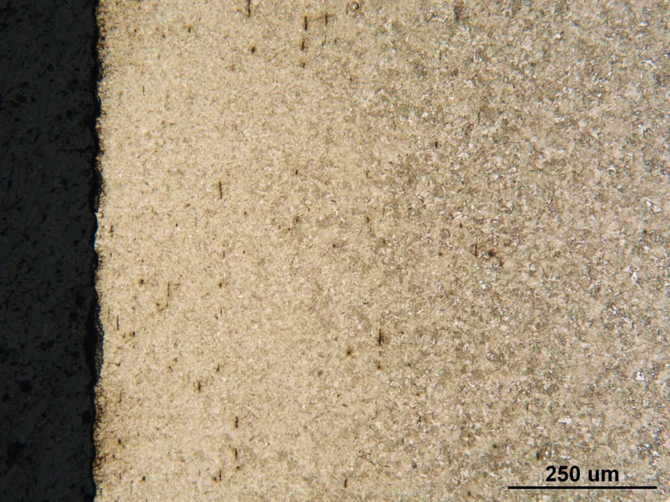

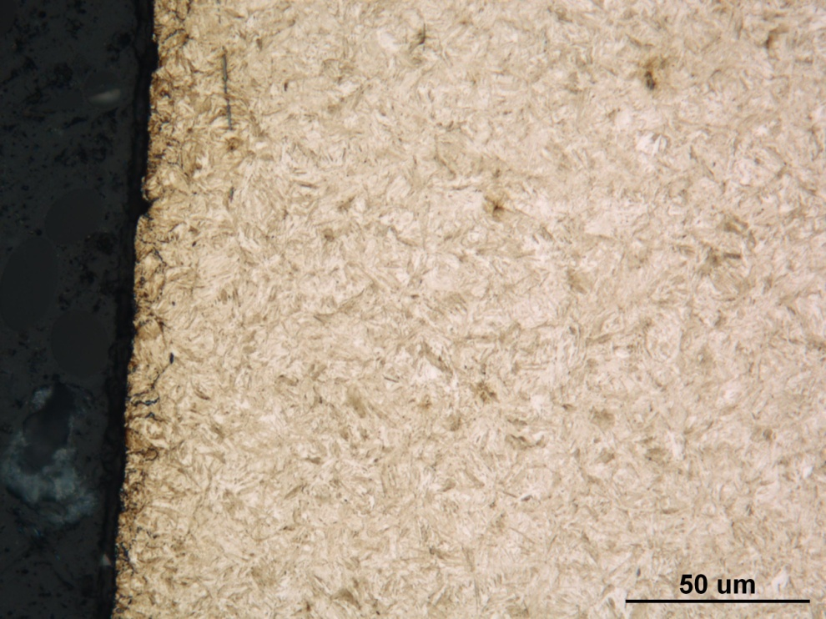
Figure Met-3. Photographs of the surface microstructure in the longitudinal grip section of fatigue specimen 161/162(D) taken at medium (top) and high (bottom) magnifications, Nital etch.

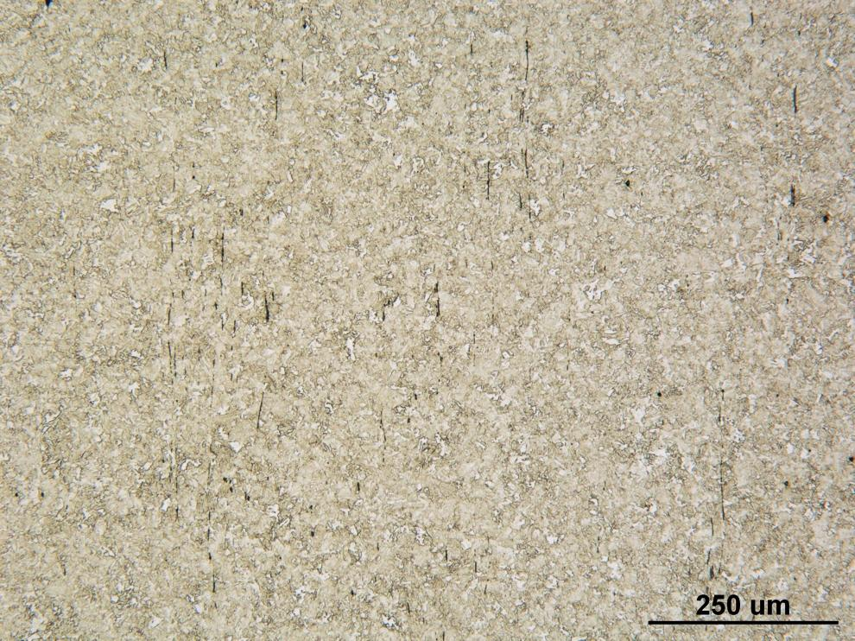

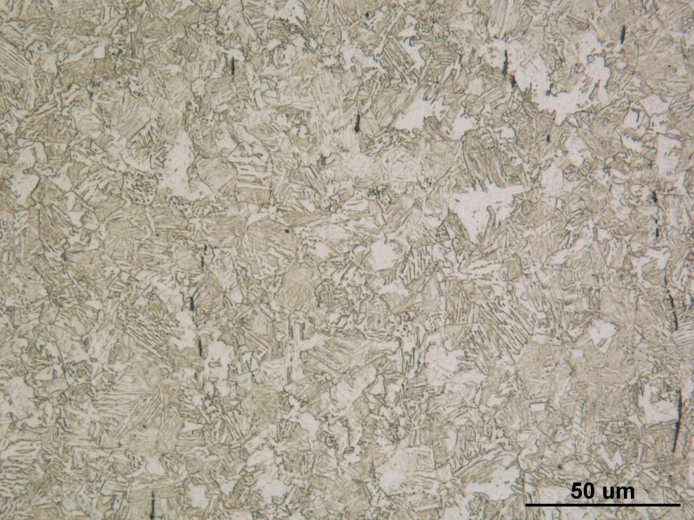
Figure Met-4. Photographs of the core microstructure in the longitudinal grip section of fatigue specimen 161/162(D) taken at medium (top) and high (bottom) magnifications, Nital etch.
Mechanical Properties - 143800

Hardness - Rockwell (Performed By: Dean Martin)

Rockwell Surface Hardness testing was conducted on one sample provided. Data includes correction factor for roundness, diameter of 0.5 inches. Machine verified with calibrated block prior to testing. Data as follows:

Surface Hardness – HRC:
59.8, 59.2 HRC

Hardness - Micro (Performed By: Dean Martin)

Micro Hardness testing was conducted on one sample provided (small diameter) using the Wilson Micro Hardness Tester. Impressions were taken from the surface towards the core to determine and estimated case depth. Machine was verified with calibrated block prior to testing. Data as follows:

Depth from Surface (inches) | Hardness - HRC
.005” | 59.5 HRC
.010” | 58.5
.015”* | 55.5
.020”* | 49.5
.025” | 46
.030” | 43
.035” | 41.5
.040” | 38

*Estimated Case Depth = 50 HRC @ .0175”

