Materials Engineering Summary Report
LTR Number: 146094

______________________________________________________________________

To: Peter Bauerle Phone: 776-7387

Location: W2003: Chrysler Technical Centre

______________________________________________________________________

From: Peter Bauerle Phone: 776-7387

Location: W2003: Chrysler Technical Centre

Date Completed: DateCompleted
______________________________________________________________________

Part Name: Fatigue Specimen-8615-Iteration 155-Met
Number of Parts: 1
Nature of Work: Process/Materials/DFSS/Decoupled Dev.

Summary/Conclusion/Recommendations

Based on this analysis, the following observations can be made:
- The parent microstructure is comprised primarily of termpered martensite with the presence of some ferrite and carbides. The intergranular oxidation (IGO) was measured at a depth of 15 – 20 microns and partial decarburization was evident at the surface from 100 – 150 microns.
- The cleanliness of the steel met ratings that would meet those for application to gears, shafts or pinions.
- The hardness in the cross section of the gage location ranged from 26 – 30 HRC with the exception of the surface which was measured at 22 – 23 HRC.

History of the Part

The sample that has been submitted is an axial fatigue specimen that has been used for Iteration 155. The test specimen was prepared from a 8615 steel grade. The sample has been quench and tempered to simulate the core of a case hardened component. The heat treat cycle was as follows: austenitize at 1650F for one hour at temperature in salt bath followed by quenching in oil at room temperature and then tempering at 325F.

Metallography - 146094

General Microstructure Description (Performed By: Varun Ramasagara Nagarajan)

A fatigue specimen labeled Iteration 155 was submitted for metallographic and hardness analysis. The sample was sectioned longitudinally through the grip portion and transversely through the gage portion. The two sections were mounted in Bakelite, ground, and polished in accordance with ASTM E3. The as-polished samples were examined with an Olympus PMG3 metallograph using light microscopy. Both cross-sections contained Intergranular Oxidation (IGO) at the surface to a depth of approximately 20 µm on the transverse gauge section (Figure 1), and approximately 15 -20 µm on the grip end section (Figure 2).

An inclusion rating was performed on the longitudinal grip section in accordance to ASTM E45 and the results were recorded in Table 1. The sections were etched using a 3% Nital solution to reveal the microstructure in accordance with ASTM E407. Photographs were taken of the mid-radius microstructure in the transverse gauge section and of the surface and core microstructure in the longitudinal grip section (Figures 3-5). Microstructural details and corresponding figures were recorded in Table 2.

Table 1: Inclusion rating for the longitudinal grip section of fatigue specimen 155.
 | A |  | B |  | C |  | D
 | Thin | Heavy | Thin | Heavy | Thin | Heavy | Thin | Heavy
Rating (1-5) | 3 | 2 | 0 | 0 | 0 | 0 | 2 | 1

Table 2: Microstructural descriptions for the specified locations in fatigue specimen 155.
Section | Location | Microstructure | Figure
155 | Gage section mid-radius | Tempered martensite with ferrite and some carbides. | 3
 | Grip end surface | Partial decarburization on the surface is observed up to a depth of approximately 150 microns. Acicular ferrite with some tempered martensite and carbides in a banded structure. | 4
 | Grip end core | Tempered martensite with acicular ferrite, carbides, and Manganese Sulfide stringers in a banded structure. | 5

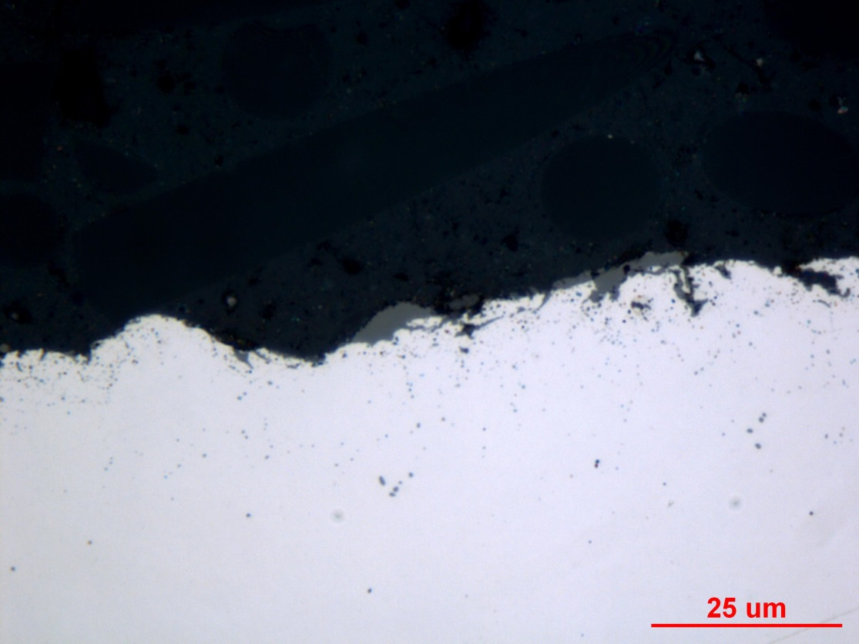
Figure 1: Photograph documenting IGO found at the surface of the transverse gauge section of fatigue specimen 155. Original magnification was 1000X.

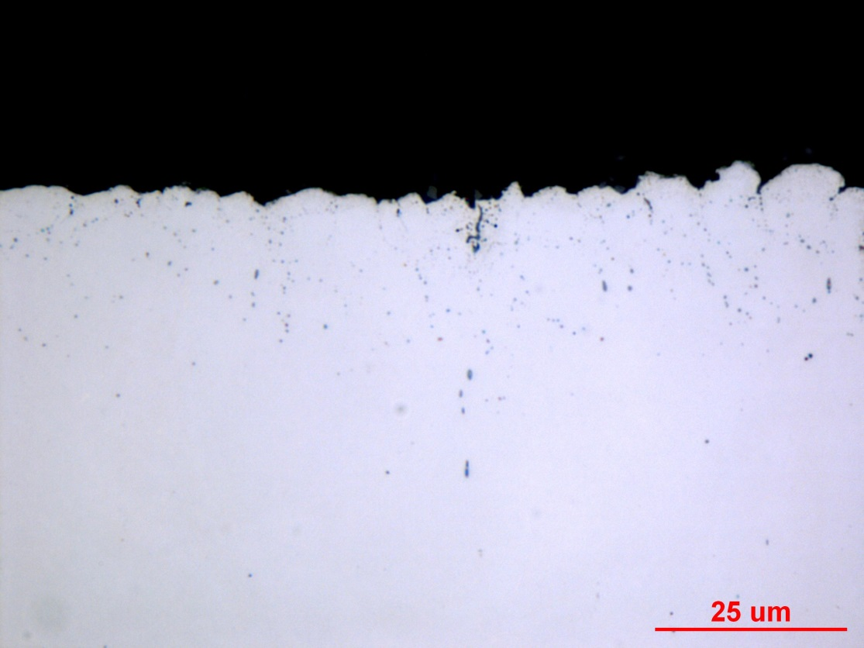
Figure 2: Photograph documenting IGO found at the surface of the longitudinal grip section of fatigue specimen 155. Original magnification was 1000X.
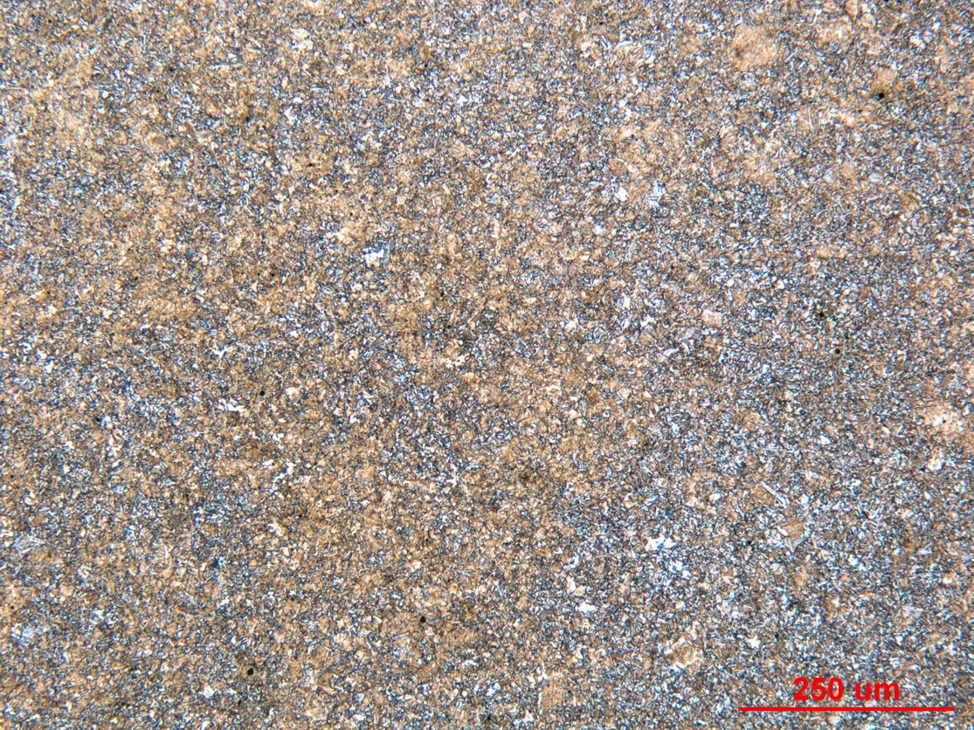

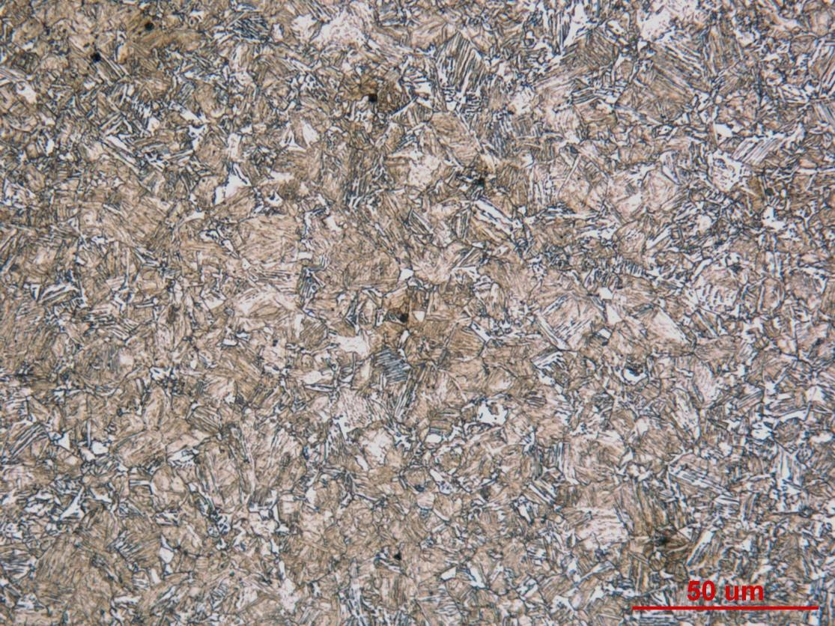

Figure 3: Photographs of the mid-radius microstructure in the transverse gauge section of fatigue specimen 155. Original magnifications were 100X (top) and 500X (bottom).
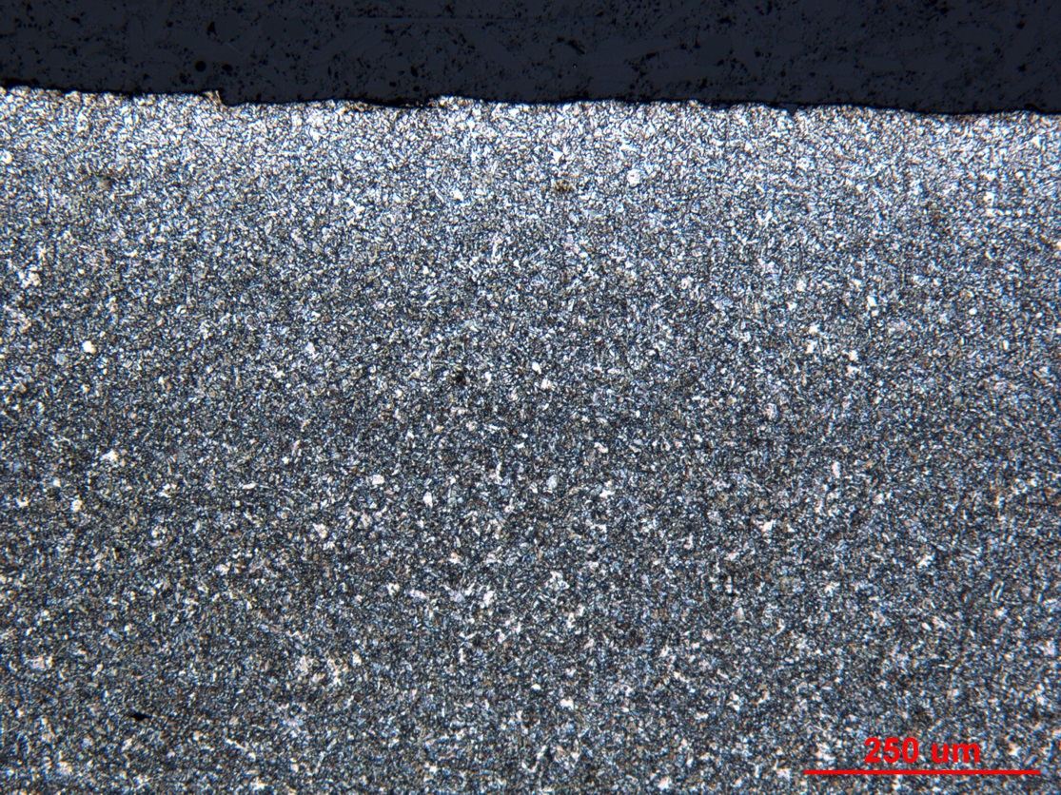

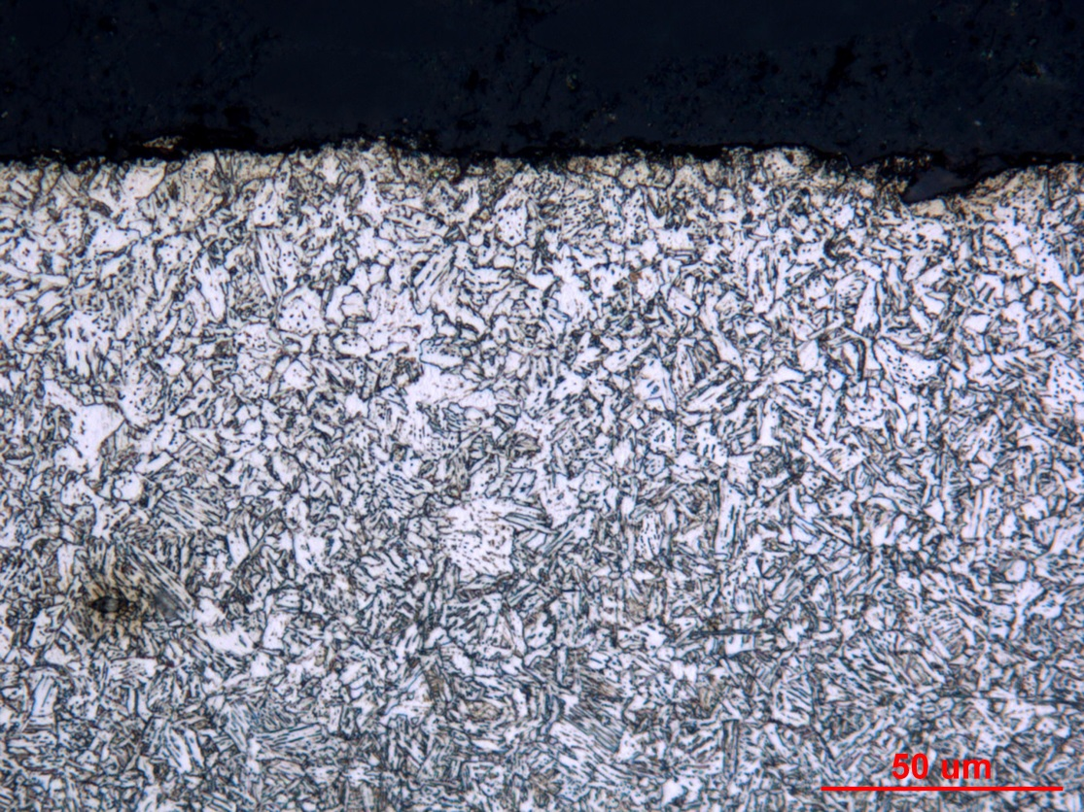

Figure 4: Photographs of the surface microstructure in the longitudinal grip section of fatigue specimen 155. Original magnifications were 100X (top) and 500X (bottom).
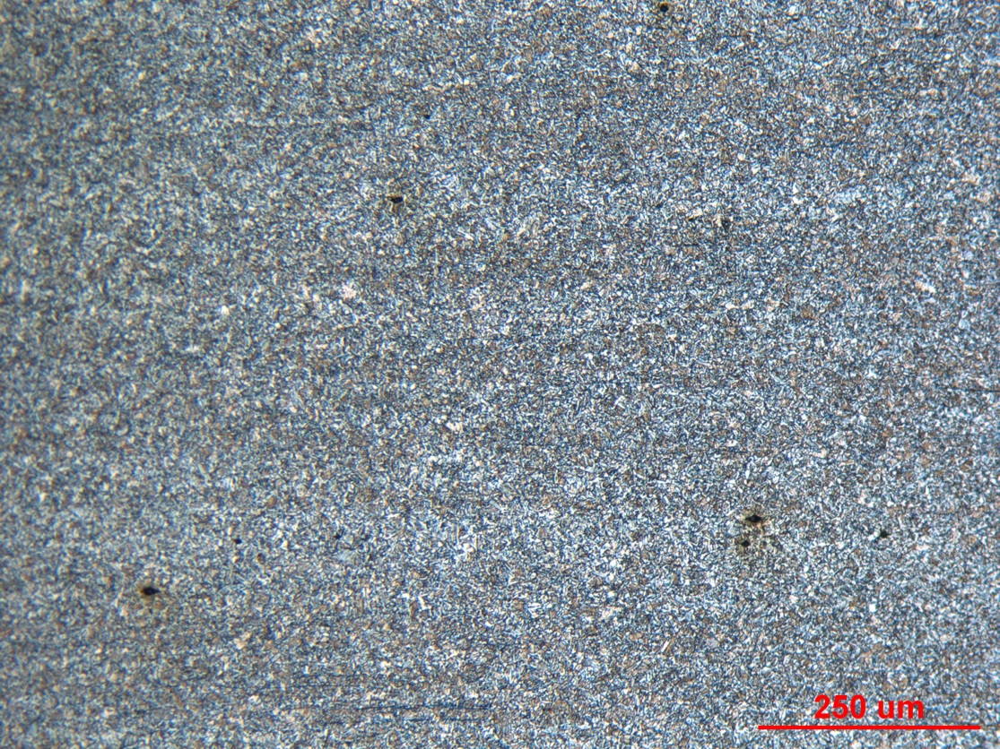

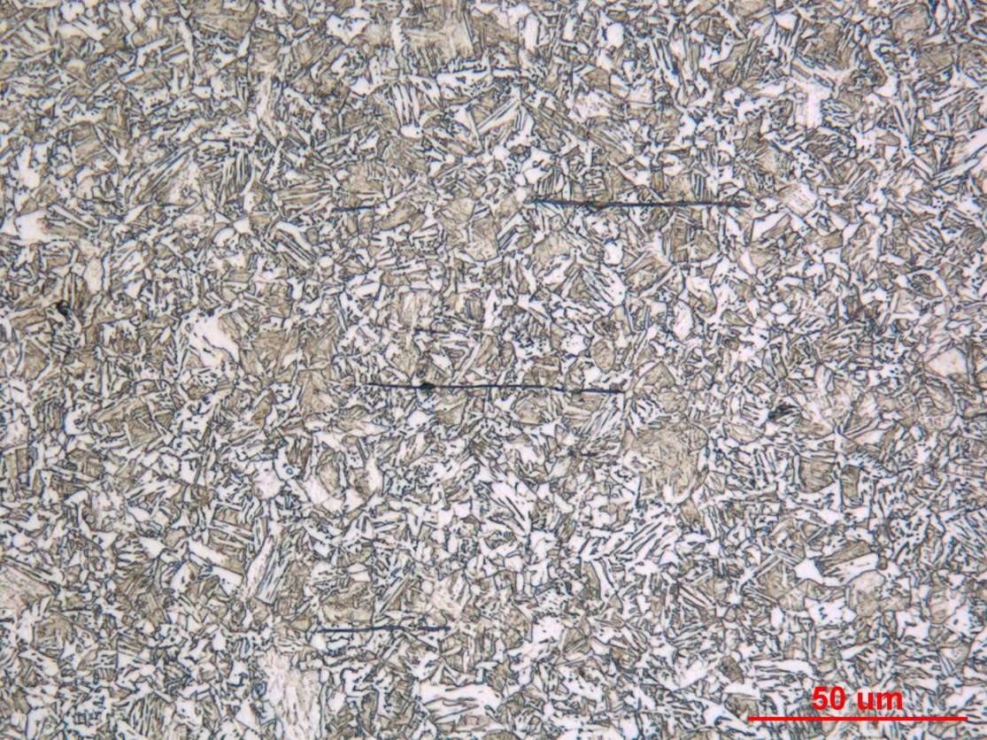

Figure 5: Photographs of the core microstructure in the longitudinal grip section of fatigue specimen 155. Original magnifications were 100X (top) and 500X (bottom)

