Materials Engineering Lab Report
LTR Number: 148346

____________________________________________________________________________
To: Peter Bauerle Phone: 776-7387
Location: Chrysler Technology Center

____________________________________________________________________________
Lead Engineer: Michael Shaw Phone: 722-5868
Location: W2003: Chrysler Technical Center Completed: 10/29/2014

____________________________________________________________________________

Part Name: Fatigue Specimen-Iteration 141/142
Number of Parts: 1
Nature of Work: Pilot, Mule, Program Development Issue

Purpose: Characterize microstructure of heat treated sample.

History of Part:
The sample represents a fatigue specimens that will be tested by AISI. The specimens have been prepared from a 20MoCr4 steel. The sample has been vacuum carburized and is through hardened in the gage section to an aim hardness of 58-60 HRC.

Part Submitted: One fatigue test bar.

Results:
- The microstructure at the narrow point of the gage section is high-carbon martensite from surface to core. About 15% retained austenite is visible near the surface. A hardness traverse from surface to center of the gage section confirms that the sample is through-carburized. Hardness ranges from 61.3 to 63.6Rc.
- The surface of the grip section is fully martensitic, but some NMTP are noted in the core. Surface hardness in the grip section is 61.8 to 62.2Rc.
- No IGO was seen.

Equipment Used:
Mounting Press Left [Buehler 1000 Mounting Press]
Image Pro Plus [Image Pro Plus Image Analysis Software]
Grinding Table [Leco Grinding Table]
Polishing Table [Leco Polishing Tables]
NewAge MT91 [NewAge MT91]
Olympus PMG3 Door [Olympus PMG3 Metallograph]
Accutom [Struers Accutom Wet Cut Off Saw]
Discotom [Struers Discotom-5 Wet Cut Off Saw]
Rockwell Hardness 12

Metallography - 148346

General Microstructure Description (Performed By: Varun Ramasagara Nagarajan)

A fatigue specimen – Iteration 141/142 was submitted for metallographic. The sample was sectioned longitudinally through the grip portion and transversely through the gage portion. The two sections were mounted in Bakelite, ground, and polished in accordance with ASTM E3. The as-polished samples were examined with an Olympus PMG3 metallograph using light microscopy. No surface Inter Granular Oxidation (IGO) was seen in both sections (figures MET1-2). MnS stringers and Alumina type inclusions were observed on the longitudinal grip section (figure MET3).
The sections were etched using a 3% Nital solution to reveal the microstructure in accordance with ASTM E407. Photographs were taken of the core and surface microstructure in the transverse gage section and in the longitudinal grip section. Some minor banding was observed near the surface of the longitudinal grip section (figure MET4). Microstructural details and corresponding figures were recorded in Table 1.

Table 1: Microstructural descriptions for the specified locations in the fatigue specimen – Iteration 141/142.

Location | Microstructure | Figure
Transverse gage section core | Tempered martensite with little retained austenite and some MnS inclusions. | MET5
Transverse gage section surface | Tempered martensite, retained austenite and some MnS inclusions. | MET6
Longitudinal grip section core | Tempered martensite with some ferrite and transformation products and some Alumina type inclusions. | MET7
Longitudinal grip section surface | Tempered martensite with some retained austenite and some MnS stringers. | MET8

No other significant microstructural differences were observed in the transverse gage and the longitudinal grip sections.

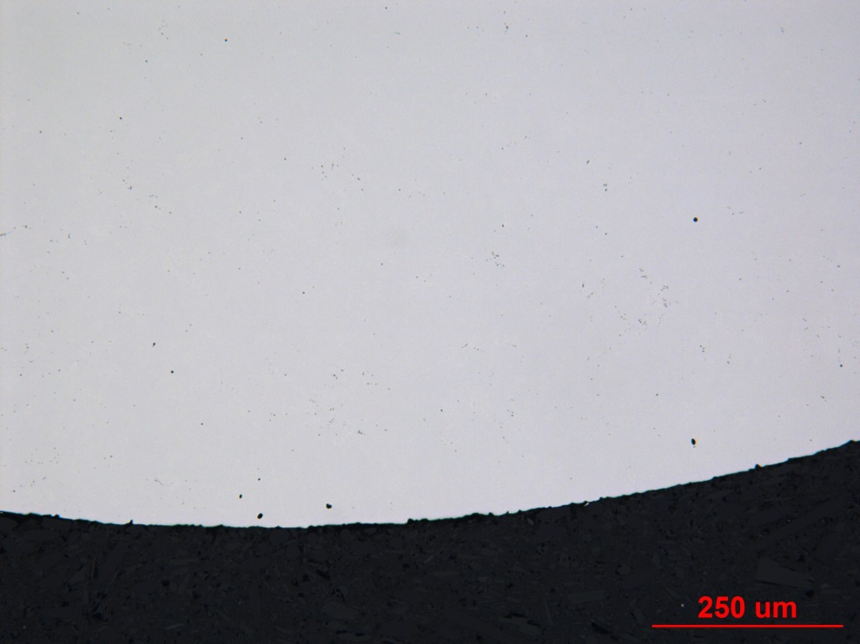

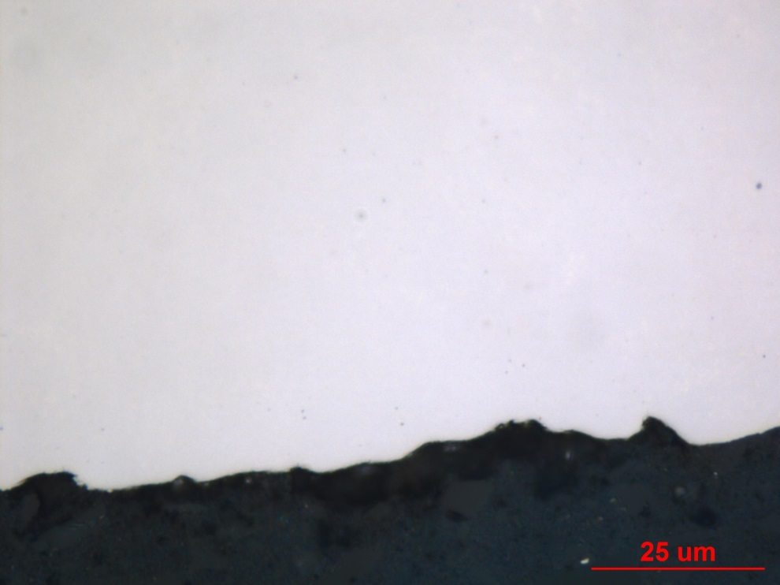

Figure MET1: Photographs documenting as-polished surface of the transverse gage section of fatigue specimen – Iteration 141/142. Original magnifications were 100X (top) and 1000X (bottom).

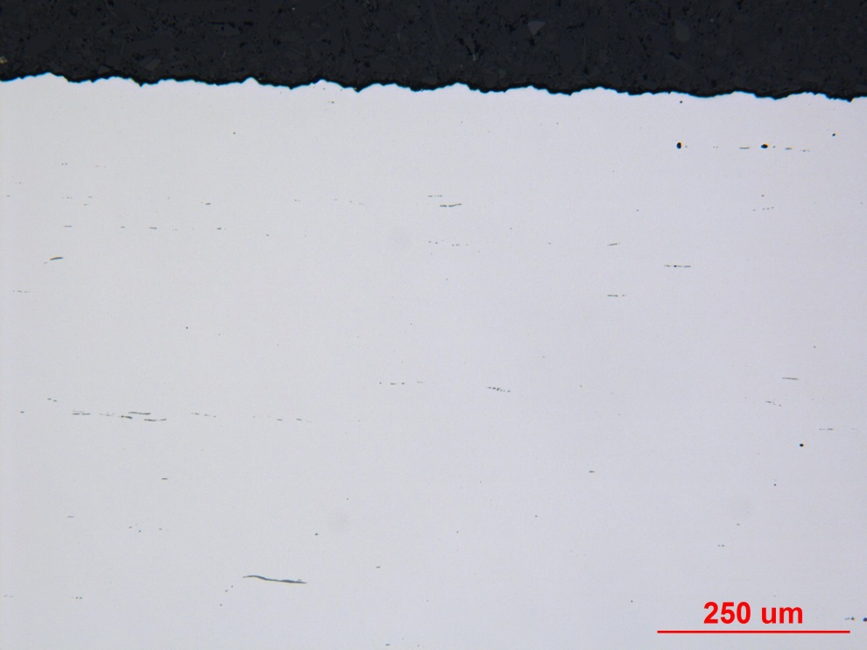

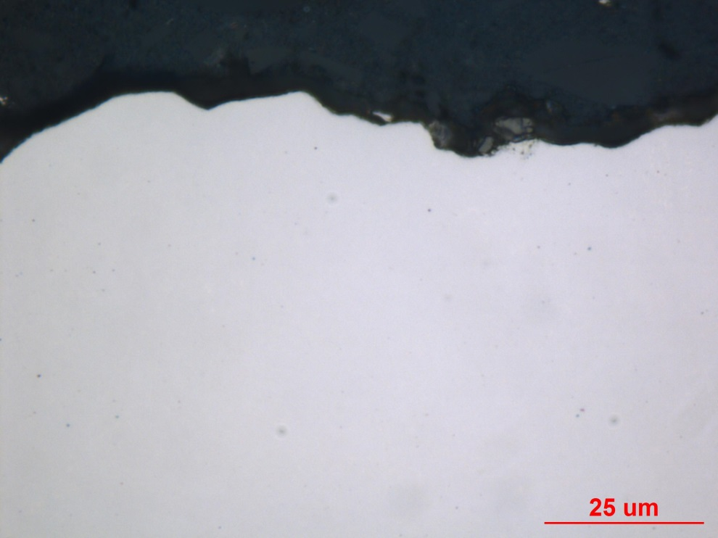

Figure MET2: Photographs documenting as-polished surface of the longitudinal grip section of fatigue specimen –Iteration 141/142. Original magnifications were 100X (top) and 1000X (bottom).

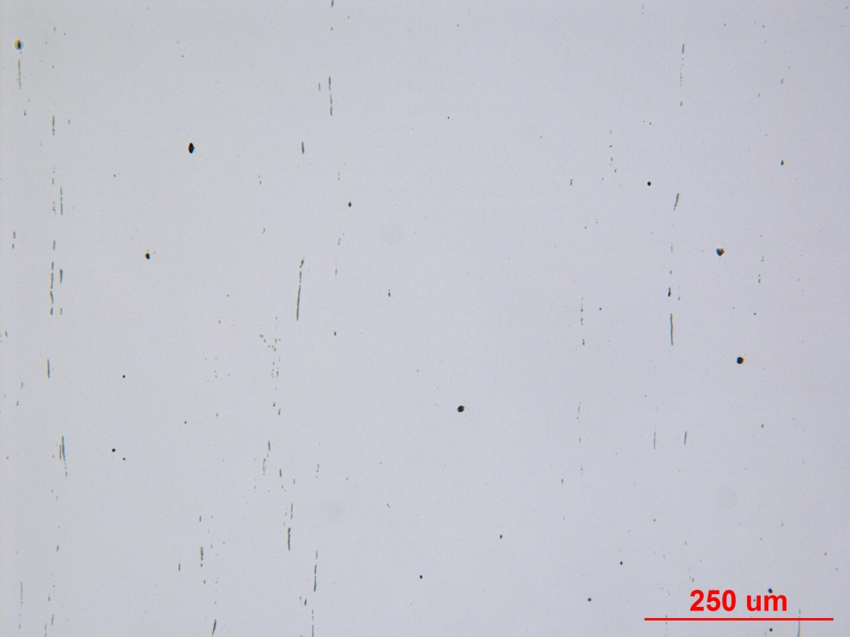

Figure MET3: Photograph documenting inclusions at the core of the longitudinal grip section of fatigue specimen – Iteration 141/142. Original magnification was 100X.

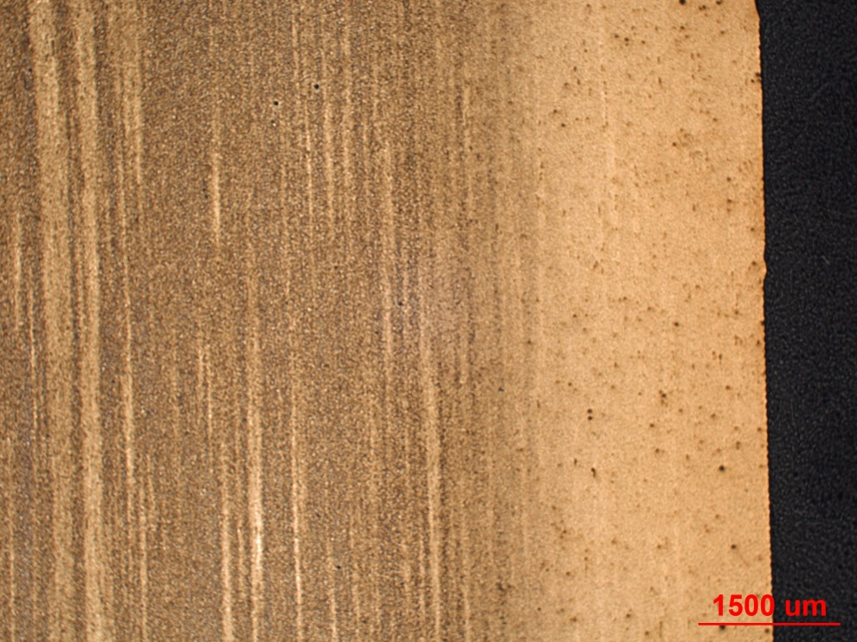

Figure MET4: Photograph documenting some banding found near the surface of the longitudinal grip section of fatigue specimen – Iteration 141/142. Original magnification was 12.5X.

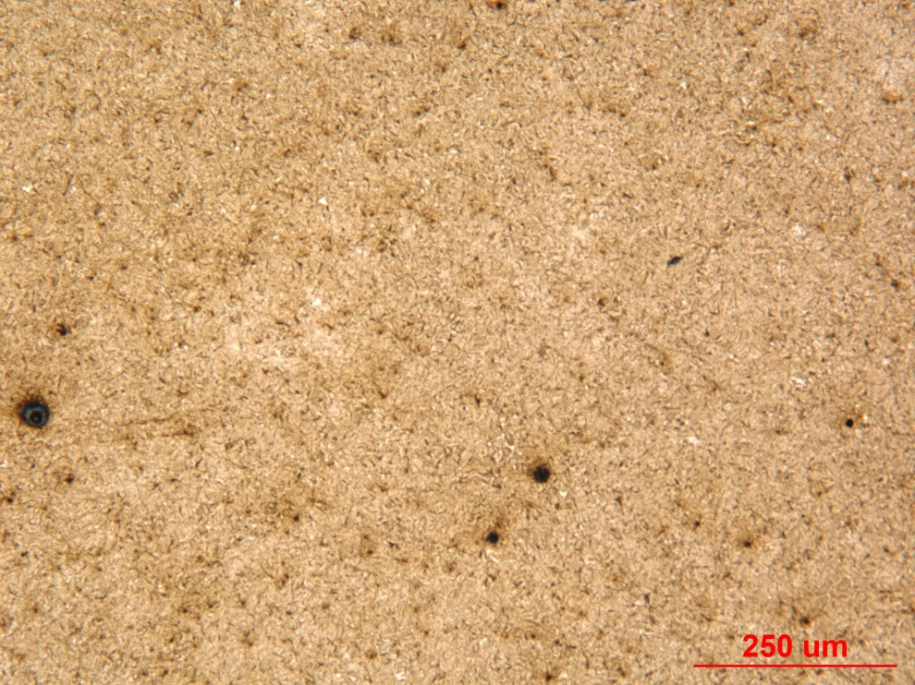

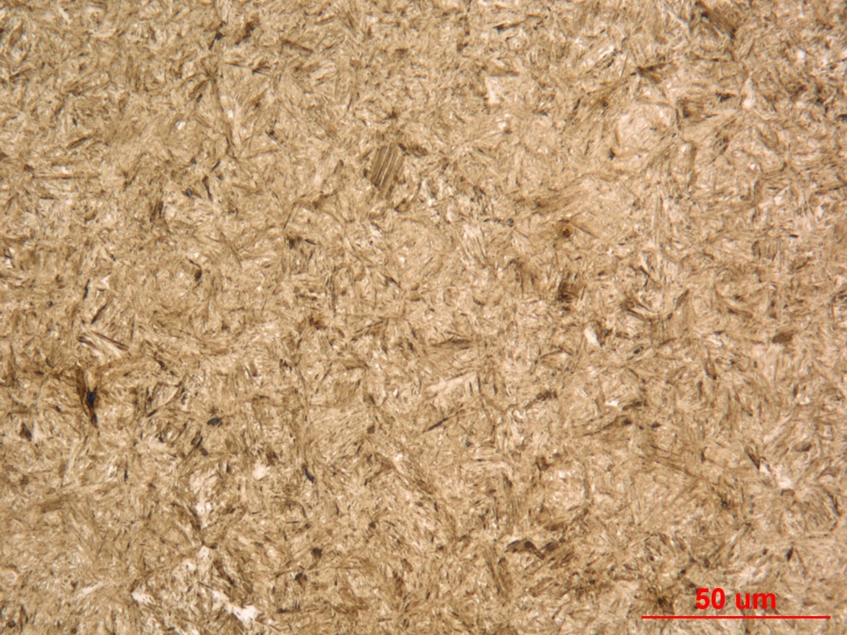

Figure MET5: Photographs of the core microstructure in the transverse gage section of fatigue specimen – Iteration 141/142. Original magnifications were 100X (top) and 500X (bottom).

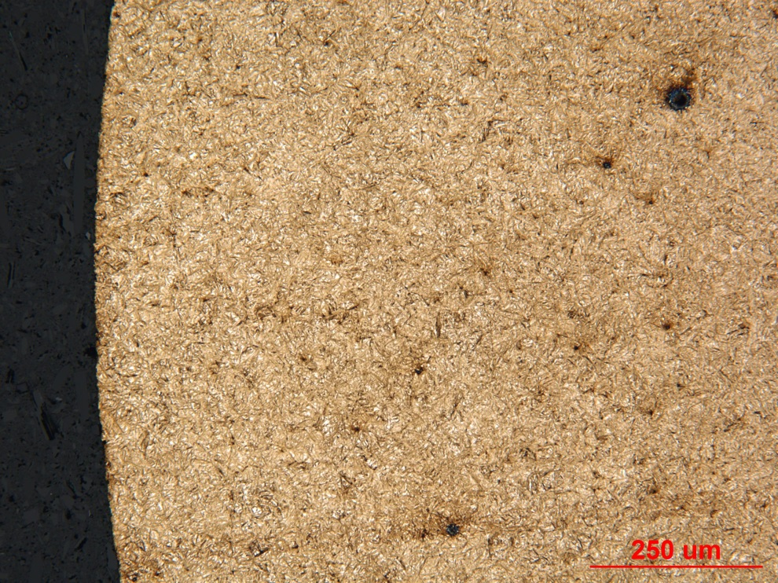

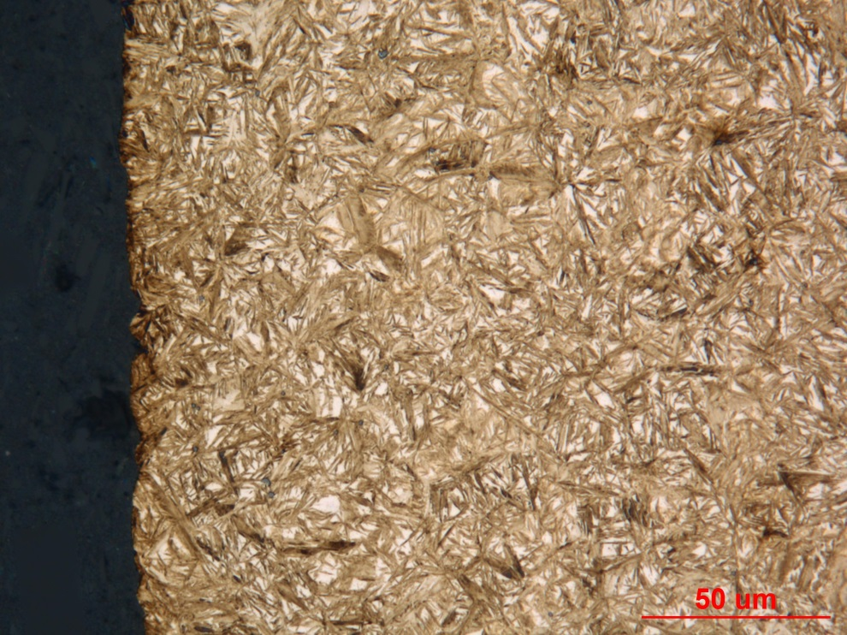

Figure MET6: Photographs of the surface microstructure in the transverse gage section of fatigue specimen – Iteration 141/142. Original magnifications were 100X (top) and 500X (bottom).
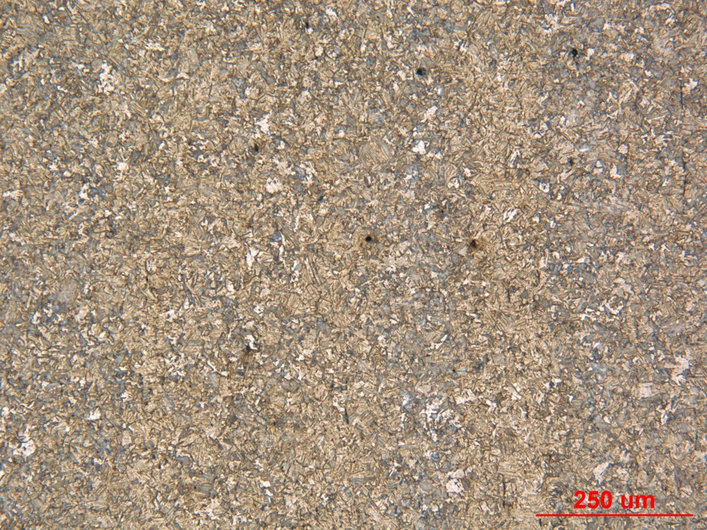

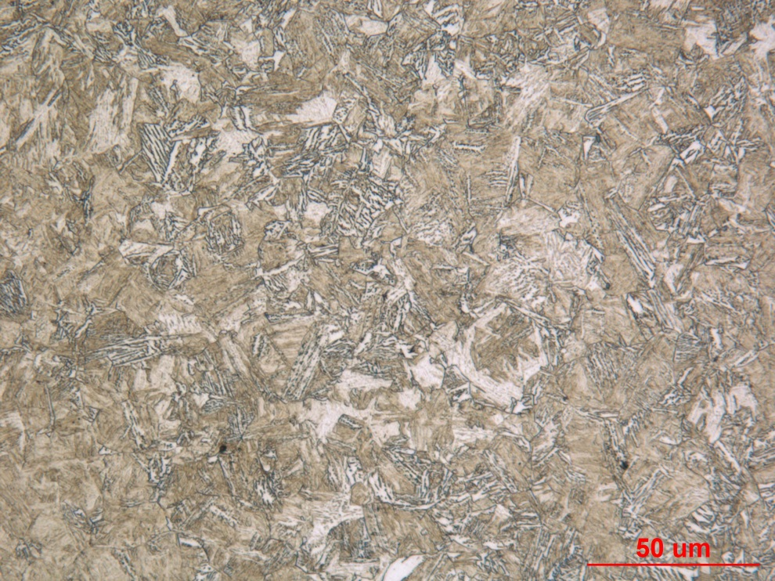

Figure MET7: Photographs of the core microstructure in the longitudinal grip section of fatigue specimen – Iteration 141/142. Original magnifications were 100X (top) and 500X (bottom).
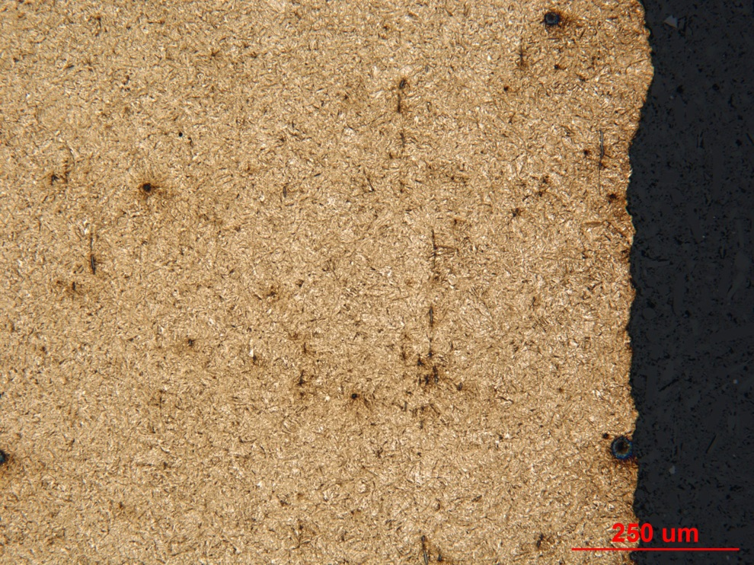

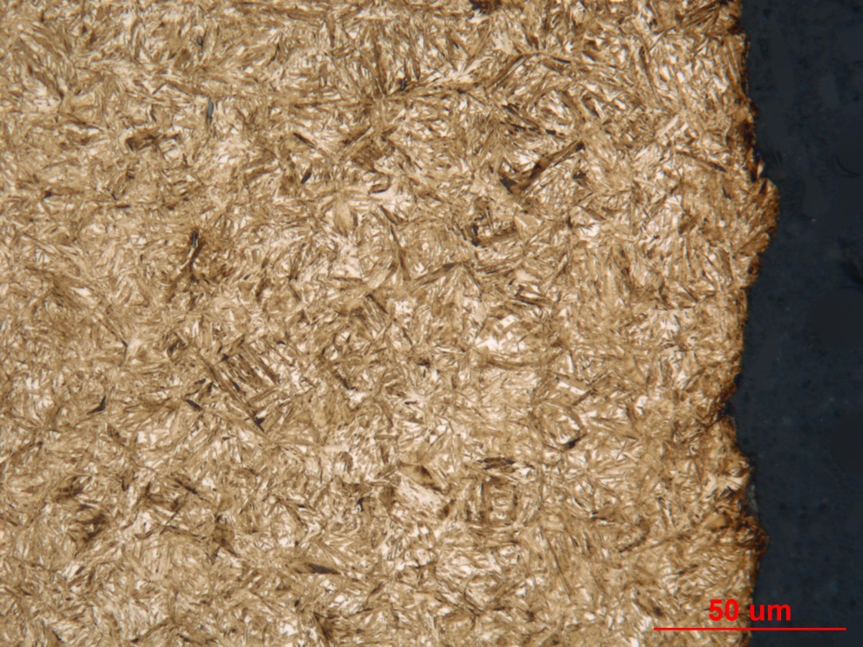
Figure MET8: Photographs of the surface microstructure in the longitudinal grip section of fatigue specimen – Iteration 141/142. Original magnifications were 100X (top) and 500X (bottom)

Mechanical Properties - 148346

Hardness - Micro (Performed By: Varun Ramasagara Nagarajan)
Micro hardness test was performed on one metallographic mount with the transverse section using the MT-91 Micro Hardness Tester. The machine was checked by calibration block prior to the test. Indentations were taken at 0.127 mm increments until a depth of 0.762 mm and then at 0.254mm intervals starting from the surface to the core on the transverse (small dia) gage section. Transverse section - Surface to core:

Hardness - Rockwell (Performed By: Varun Ramasagara Nagarajan)

Rockwell hardness test was performed with the Wilson Rockwell Series B2000 hardness tester on the surface of the larger diameter grip end of the fatigue specimen. Measurements were taken in HRC for the surface after accounting for the surface curvature (outer dia = 12.70 mm). Machine was verified with the calibration block before testing.

Data obtained are as follows:

Corrected Surface Hardness (HRC): 62.2, 62.1, 61.8.

