Materials Engineering Lab Report
LTR Number: 148347

____________________________________________________________________________
To: Peter Bauerle Phone: 776-7387
Location: Chrysler Technical Center

____________________________________________________________________________
Lead Engineer: Michael Shaw Phone: 722-5868
Location: W2003: Chrysler Technical Center Completed: 1/08/2014

____________________________________________________________________________
Part Name: Fatigue Specimen - Iteration 139/140
Number of Parts: 1
Nature of Work: Process/Materials/DFSS/Decoupled Dev.

Purpose: Characterize microstructure of heat treated test specimen.

History of Part:
The sample that has been submitted is a fatigue specimen that has been used for the development of the AISI fatigue database, namely iterations 139 and 140. The test speciman was prepared from a 20MoCr4 steel grade. The sample has been quenched and tempered in the gage section to simulate the core of a case hardened component.

Part Submitted: One fatigue test bar.

Results:
- The microstructure at the narrow point in the gage section of the test bar is low-carbon martensite from surface to core. Hardness ranges from 30.6 to 37.2Rc in a traverse from the surface to the center of the gage section.
- In the grip section some NMTP was seen at the surface and core. Surface hardness in the grip section is 25.7 to 26.4Rc.
- Some IGO was noted in the gage section, in the range of 5microns or less.

Equipment Used:
Mounting Press Rght [Buehler 1000 Mounting Press]
Image Pro Plus [Image Pro Plus Image Analysis Software]
Grinding Table [Leco Grinding Table]
Polishing Table [Leco Polishing Tables]
NewAge MT91 [NewAge MT91]
Olympus PMG3 Door [Olympus PMG3 Metallograph]
Olympus PMG3 Wall [Olympus PMG3 Metallograph]
Accutom [Struers Accutom Wet Cut Off Saw]
Labotom-15 [Struers Labotom-15 Wet Cut Off Saw]
Rockwell Hardness 12

Metallography - 148347

General Microstructure Description (Performed By: Varun Ramasagara Nagarajan)
A fatigue specimen – Iteration 139/140 was submitted for metallographic analysis. The sample was sectioned longitudinally through the grip portion and transversely through the gage portion. The two sections were mounted in Bakelite, ground, and polished in accordance with ASTM E3. The as-polished samples were examined with an Olympus PMG3 metallograph using light microscopy. No surface Inter Granular Oxidation (IGO) was seen (figure MET1). MnS stringers were observed on the longitudinal grip section (figure MET1).
The sections were etched using a 3% Nital solution to reveal the microstructure in accordance with ASTM E407. Photographs were taken of the mid radius microstructure in the transverse gage section, and of the core and surface in the longitudinal grip section. Microstructural details and corresponding figures were recorded in Table 1.

Table 1: Microstructural descriptions for the specified locations in the fatigue specimen – Iteration 139/140.
Location | Microstructure | Figure
Transverse gage section mid radius | Tempered martensite with transformation products and some MnS inclusions. | MET2
Longitudinal grip section core | Tempered martensite with Widmanstatten ferrite and some transformation products in a banded structure | MET3
Longitudinal grip section surface | Widmanstatten ferrite with some transformation products. | MET4

No other significant microstructural differences were observed in the transverse gage and the longitudinal grip sections.

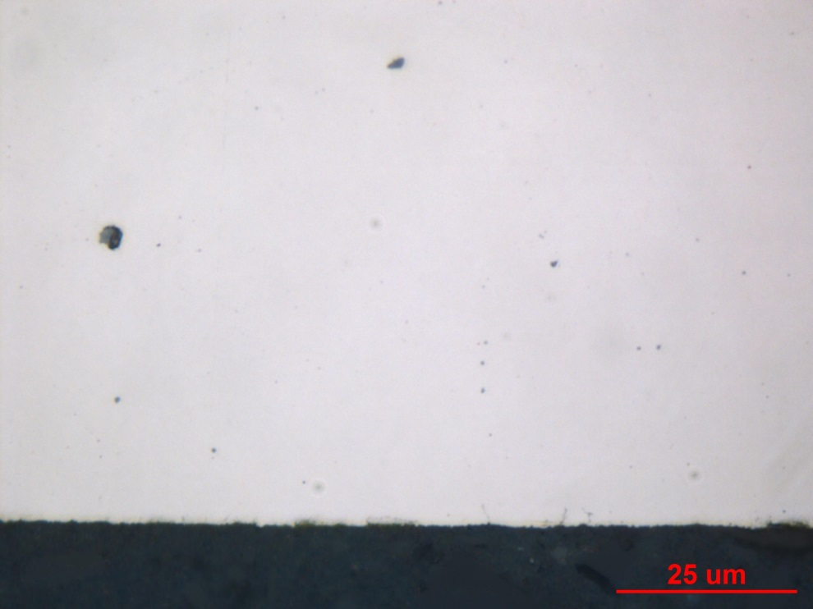

Figure MET1: Photographs documenting as-polished - transverse gage section surface (top) and longitudinal grip section core (bottom) of fatigue specimen – Iteration 139/140. Original magnifications were 1000X (top) and 100X (bottom).

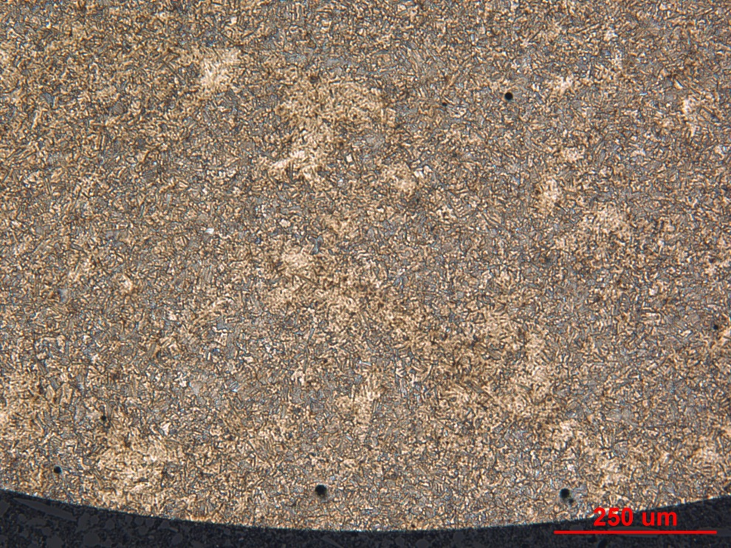

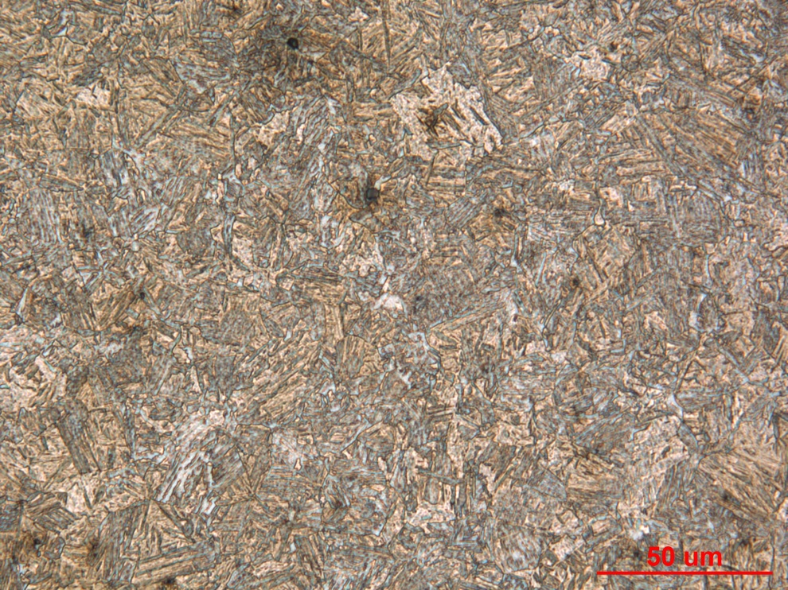

Figure MET2: Photographs of the mid radius microstructure in the transverse gage section of fatigue specimen – Iteration 139/140. Original magnifications were 100X (top) and 500X (bottom).

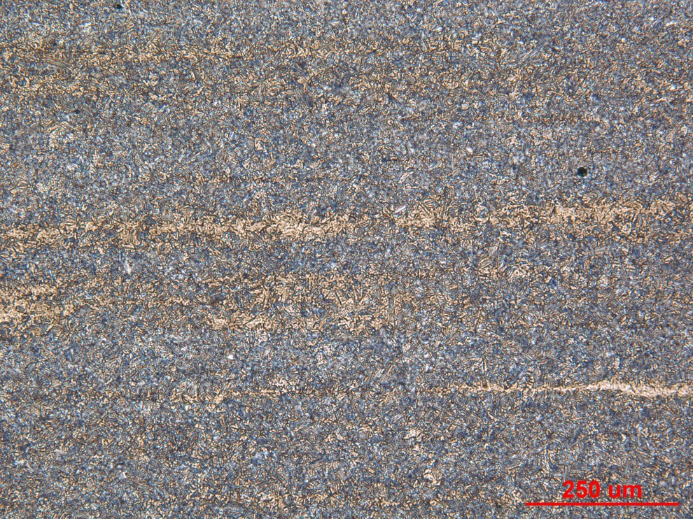

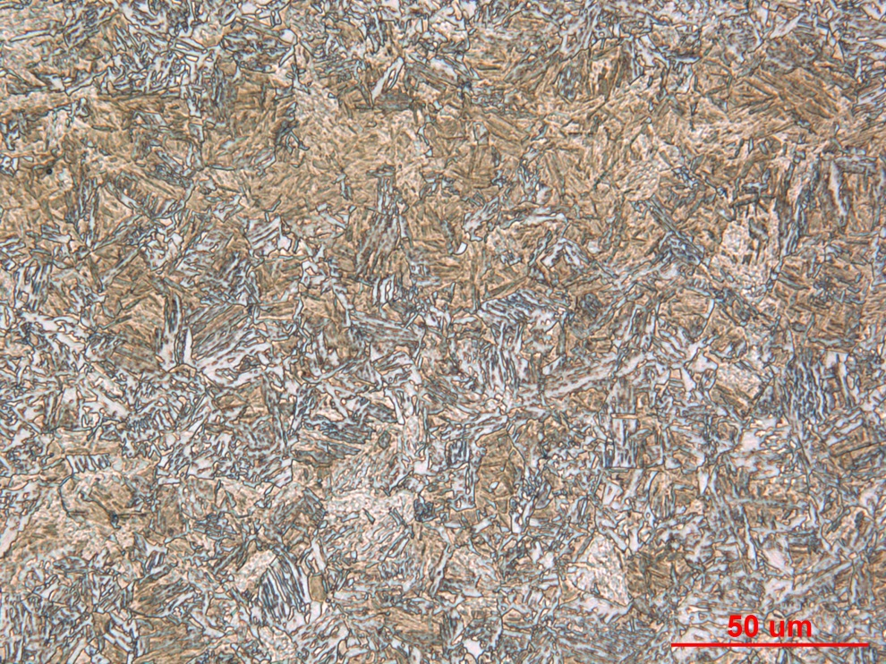

Figure MET3: Photographs of the core microstructure in the longitudinal grip section of fatigue specimen – Iteration 139/140. Original magnifications were 100X (top) and 500X (bottom).
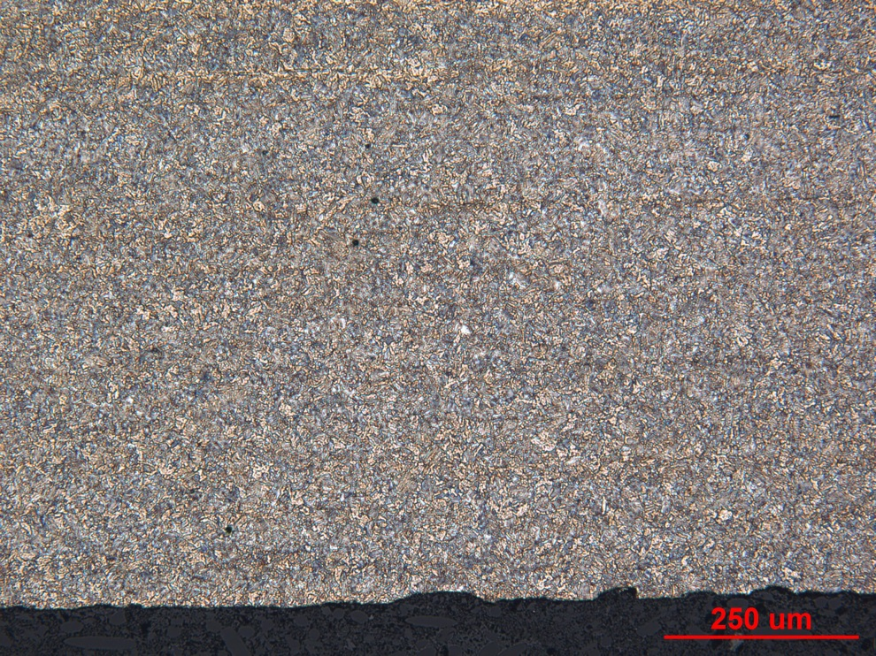

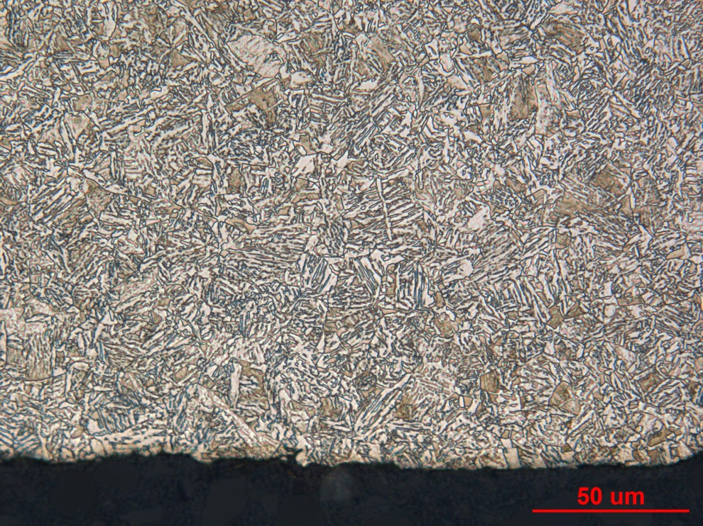
Figure MET4: Photographs of the surface microstructure in the longitudinal grip section of fatigue specimen – Iteration 139/140. Original magnifications were 100X (top) and 500X (bottom)

Mechanical Properties - 148347

Hardness - Micro (Performed By: Varun Ramasagara Nagarajan)
Micro hardness test was performed on one metallographic mount with the transverse section using the MT-91 Micro Hardness Tester. The machine was checked by calibration block prior to the test. Indentations were taken at 0.254 mm increments starting from the surface to the core on the transverse (small diameter) gage section.

Transverse section - Surface to core:

Hardness - Rockwell (Performed By: Varun Ramasagara Nagarajan)

Rockwell hardness test was performed with the Wilson Rockwell Series B2000 hardness tester on the surface of the larger diameter grip end of the fatigue specimen. Measurements were taken in HRC for the surface after accounting for the surface curvature (outer diameter = 12.70 mm). Machine was verified with the calibration block before testing.

Data obtained are as follows:

Corrected Surface Hardness (HRC): 25.7, 26.4, 26.0.

