Materials Engineering Summary Report
LTR Number: 142689

______________________________________________________________________

To: Peter Bauerle Phone: 776-7387

Location: W2003: Chrysler Technical Centre

______________________________________________________________________

From: Peter Bauerle Phone: 776-7387

Location: W2003: Chrysler Technical Centre

Date Completed: DateCompleted
______________________________________________________________________

Part Name: Fatigue Specimen - Iteration 135/136 - R
Number of Parts: 1
Nature of Work: Process/Materials Development

History of the Part

The sample that has been submitted is a fatigue specimen that has been used for the development of the AISI fatigue database, namely iterations 135 and 136. The test specimen was prepared from a 20MoCr4 steel grade. The sample has been quench and tempered in the gage section to simulate the core of a case hardened component.The heat treat cycle was as follows: austenitize at 1700F followed by quenching in 150F oil and then tempering at 1050F.Additional tempering was not pursued due to a minimal change in hardness over increments of 75F - 100F (one point of HRC hardness).

Metallography - 142689

General Microstructure Description (Performed By: Myron Rudnitsky)

One fatigue specimen was submitted for microstructural examination. The fatigue specimen was sectioned transversely through the gage section and longitudinally through the grip end, mounted, ground, polished in accordance with ASTM E3, and etched in 3% Nital to reveal the microstructure in accordance with ASTM E407. Photographs were taken at low and high magnification for each sample and reported in Table 1.

Table 1: Microstructural results per sample and location.

Sample | Location | Microstructure | Figure
135/136-R | Gauge section mid radius | Tempered martensite and some ferrite | 1
 | Grip end case | Tempered martensite with some evidence of a banded structure | 2
 | Grip end core | Tempered martensite, ferrite with some evidence of a banded structure | 3

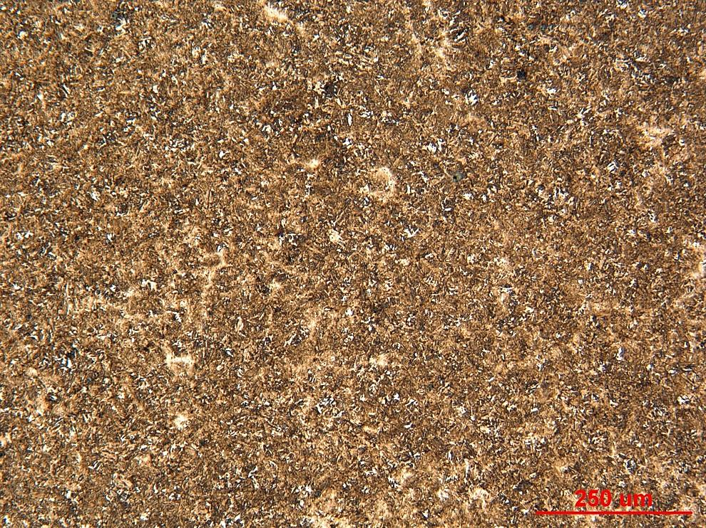

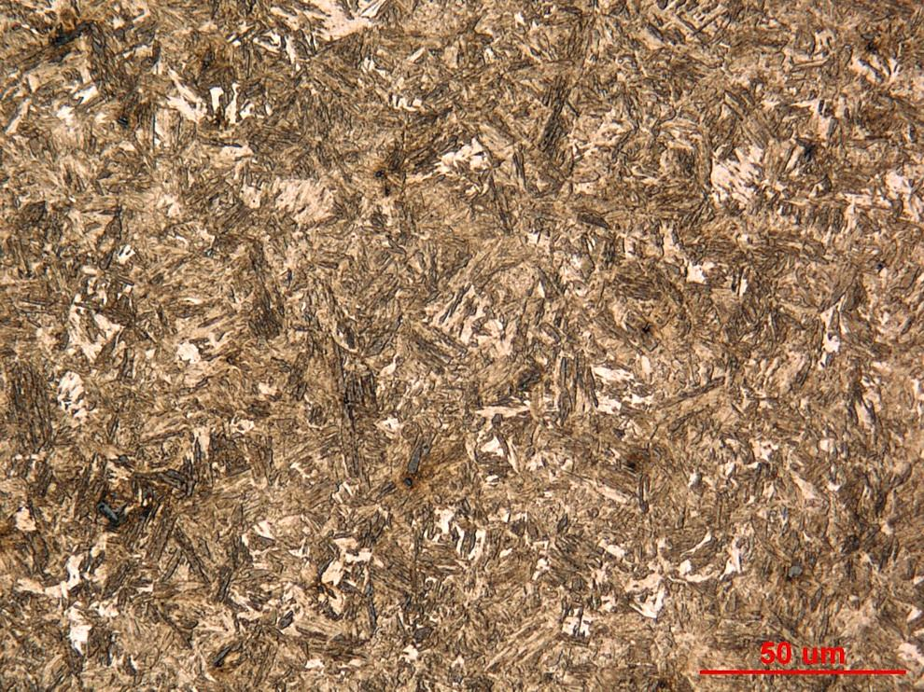

Figure 1. Photograph of sample 135/136-R cross section mid radius at low and high magnification.

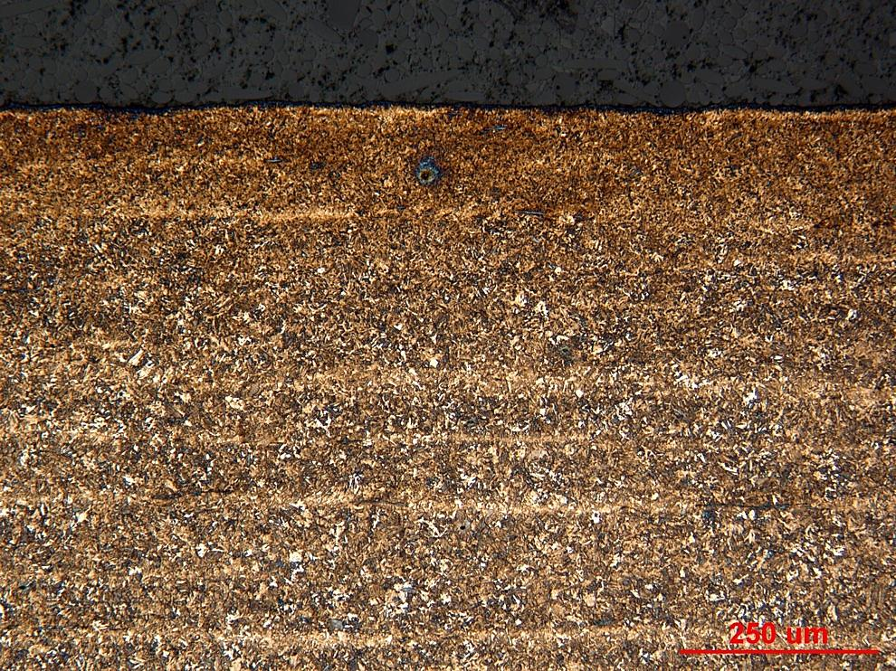

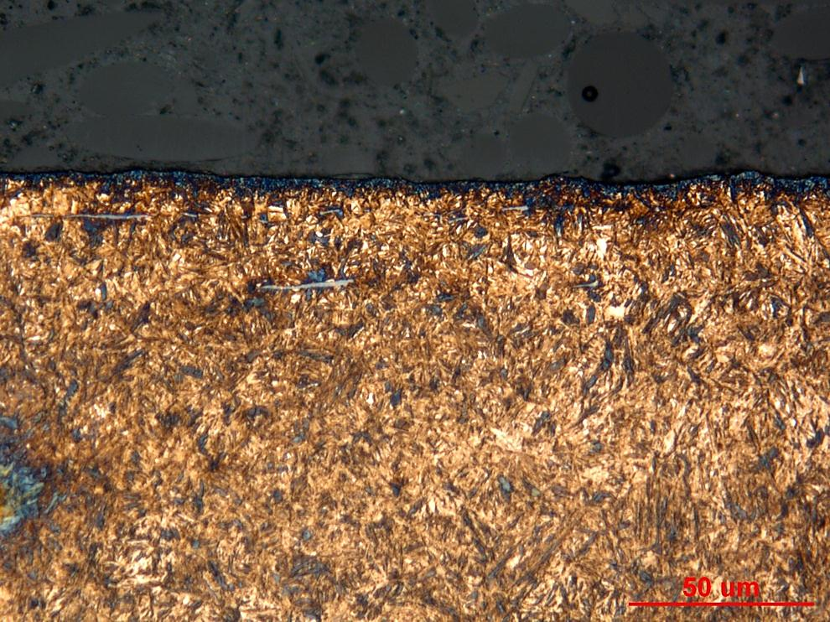

Figure 2. Photograph of sample 135/136-R grip end case at low and high magnification.

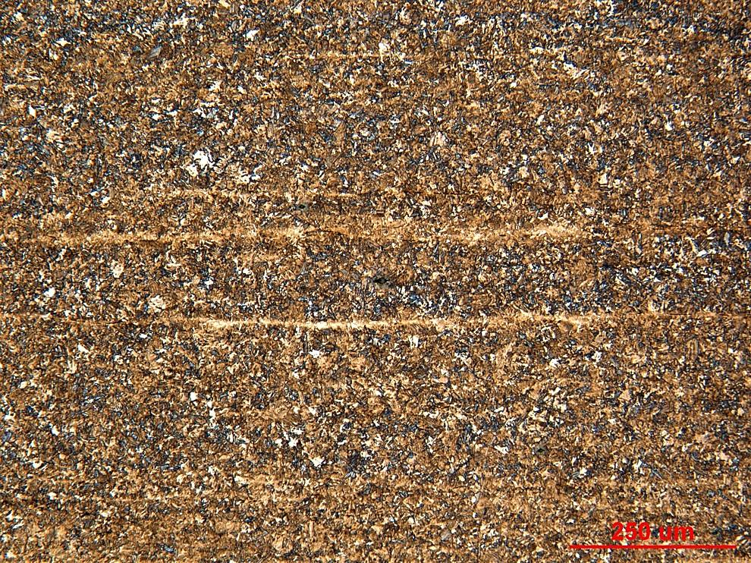

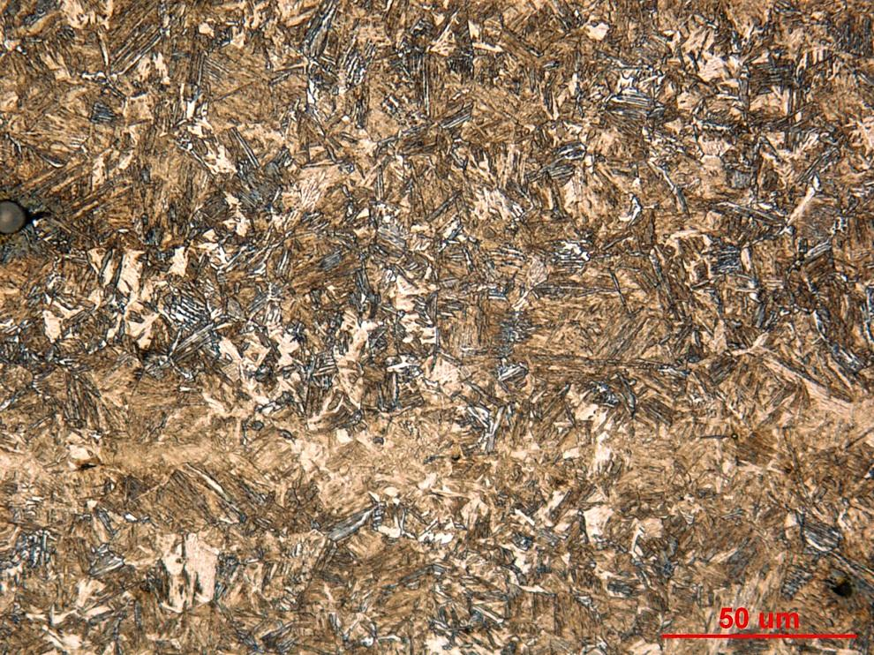

Figure 3. Photograph of sample 135/136-R grip end core at low and high magnification.

Mechanical Properties - 142689

Hardness - Rockwell (Performed By: Dean Martin)

Rockwell surface hardness testing was conducted on one sample provided. Three impressions were taken in HRC. Machine was verified with calibrated block prior to testing. Data as follows:

Surface Hardness - HRC:
- 47.2 HRC
- 47.7 HRC
- 48.7 HRC

Hardness - Micro (Performed By: Dean Martin)
Micro Hardness testing was conducted on one sample provided. A traverse was taken from the surface to the core, in the gage cross section as requested, using the MT-90 Micro Hardness tester. Machine was verified with calibrated block prior to testing. Data as follows:

