

Materials Engineering Lab Report
LTR Number: 133860

To: Peter Bauerle Phone: 776-7387

Location: CTC

From: Metallography Completed: 12/10/2008

Mechanical Properties

Subject/Part Name: Fatigue Specimen-Iteration 109/113

Report Status: Complete

Originator: Peter Bauerle

Originator Phone: 248-576-7387

Number of Parts: 1
Nature of Work: Pilot, Mule, Program Development Issue
Vendor:
Plant:
P/N:
MS:
PS:

History of Part

The samples represent fatigue specimens that will be tested by AISI. The specimens have been prepared from an 8822 steel with high side hardenability. The sample has been through carburized in the gage section by austenitizing at 1700F with a 0.9% carbon potential prior to quenching in 150F oil and then tempering at 425F to an aim hardness of 58-60 HRC.

Test Results

Metallography - 133860

General Microstructure Description (Performed By: Gerry Shulke)

The mounted sample was polished and examined using light microscopy. The surface contained some intergranular oxidation in both the grip end and the gage section that extended roughly 25 microns. The sample was then etched with 3% nital and was reexamined. The surface at both the grip end and the gage contained a microstructure of tempered martensite with retained austenite. The retained austenite was measured via image analysis, and the sample contained 13.3% white area. The core microstructure was tempered martensite. Some ghost banding from slight chemical segregation was observed associated with some non-metallic inclusions.

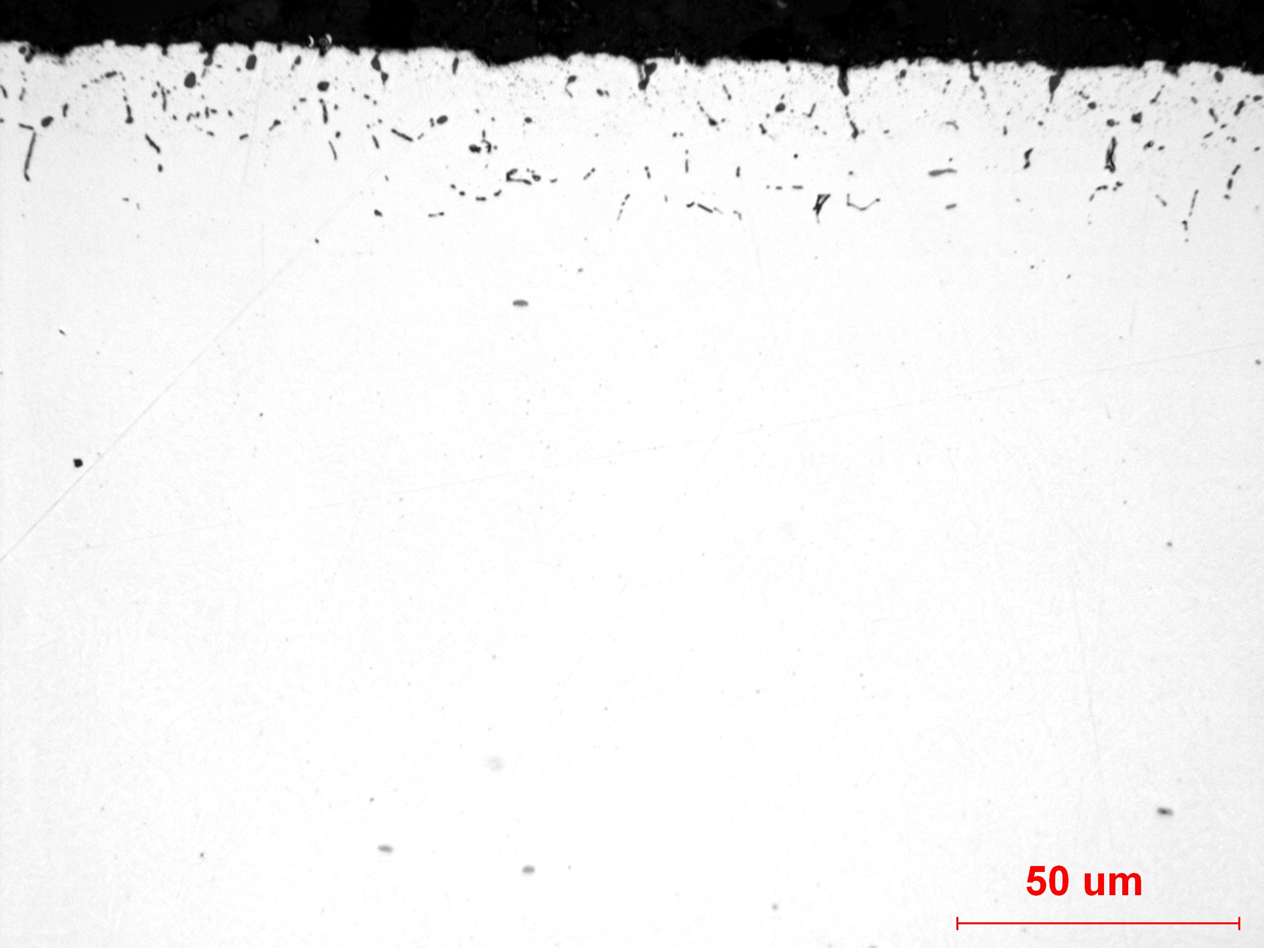
Figure 1. Image of the intergranular oxidation along the surface of the grip end.

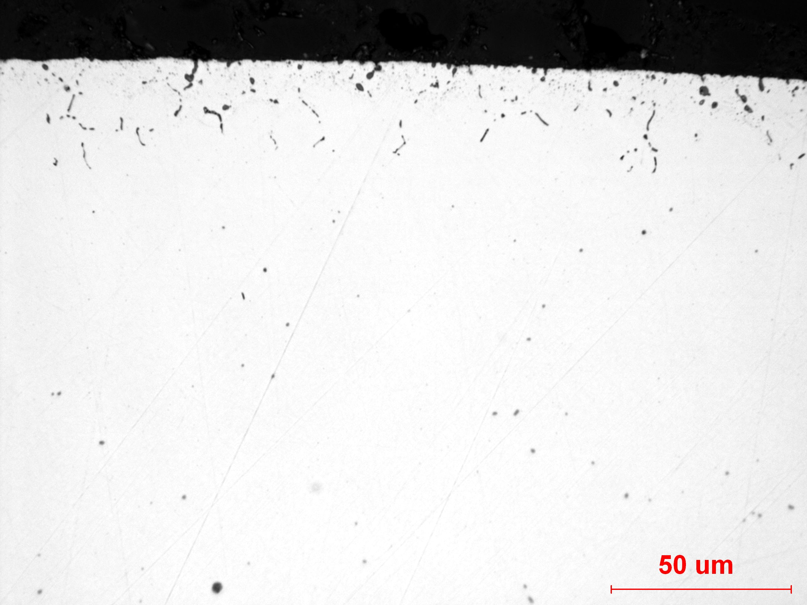
Figure 2. Image of the intergranular oxidation present in the gage section.


Figure 3. Medium magnification image of the grip surface.

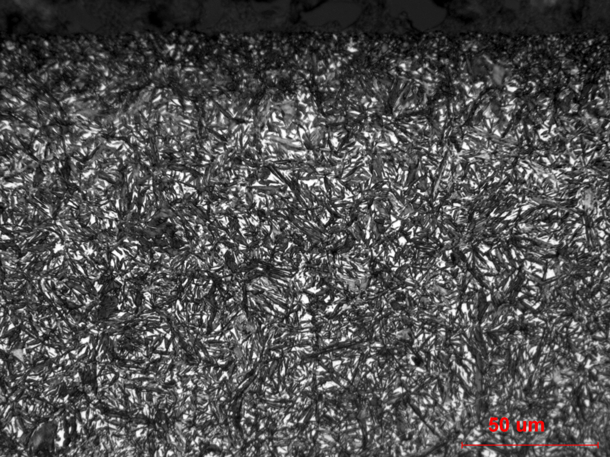
Figure 4. Higher magnification image of the microstructure near the surface, which contained tempered martensite and retained austenite.

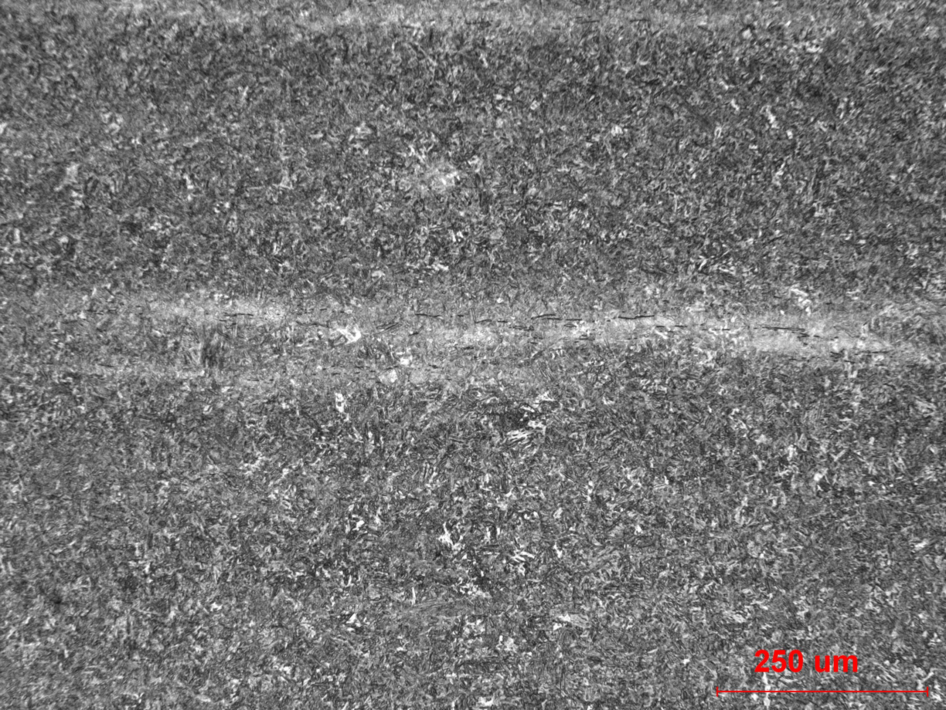
Figure 5. Medium magnification image of the core of the grip end. The microstructure contains some ghost banding from slight chemical segregation.

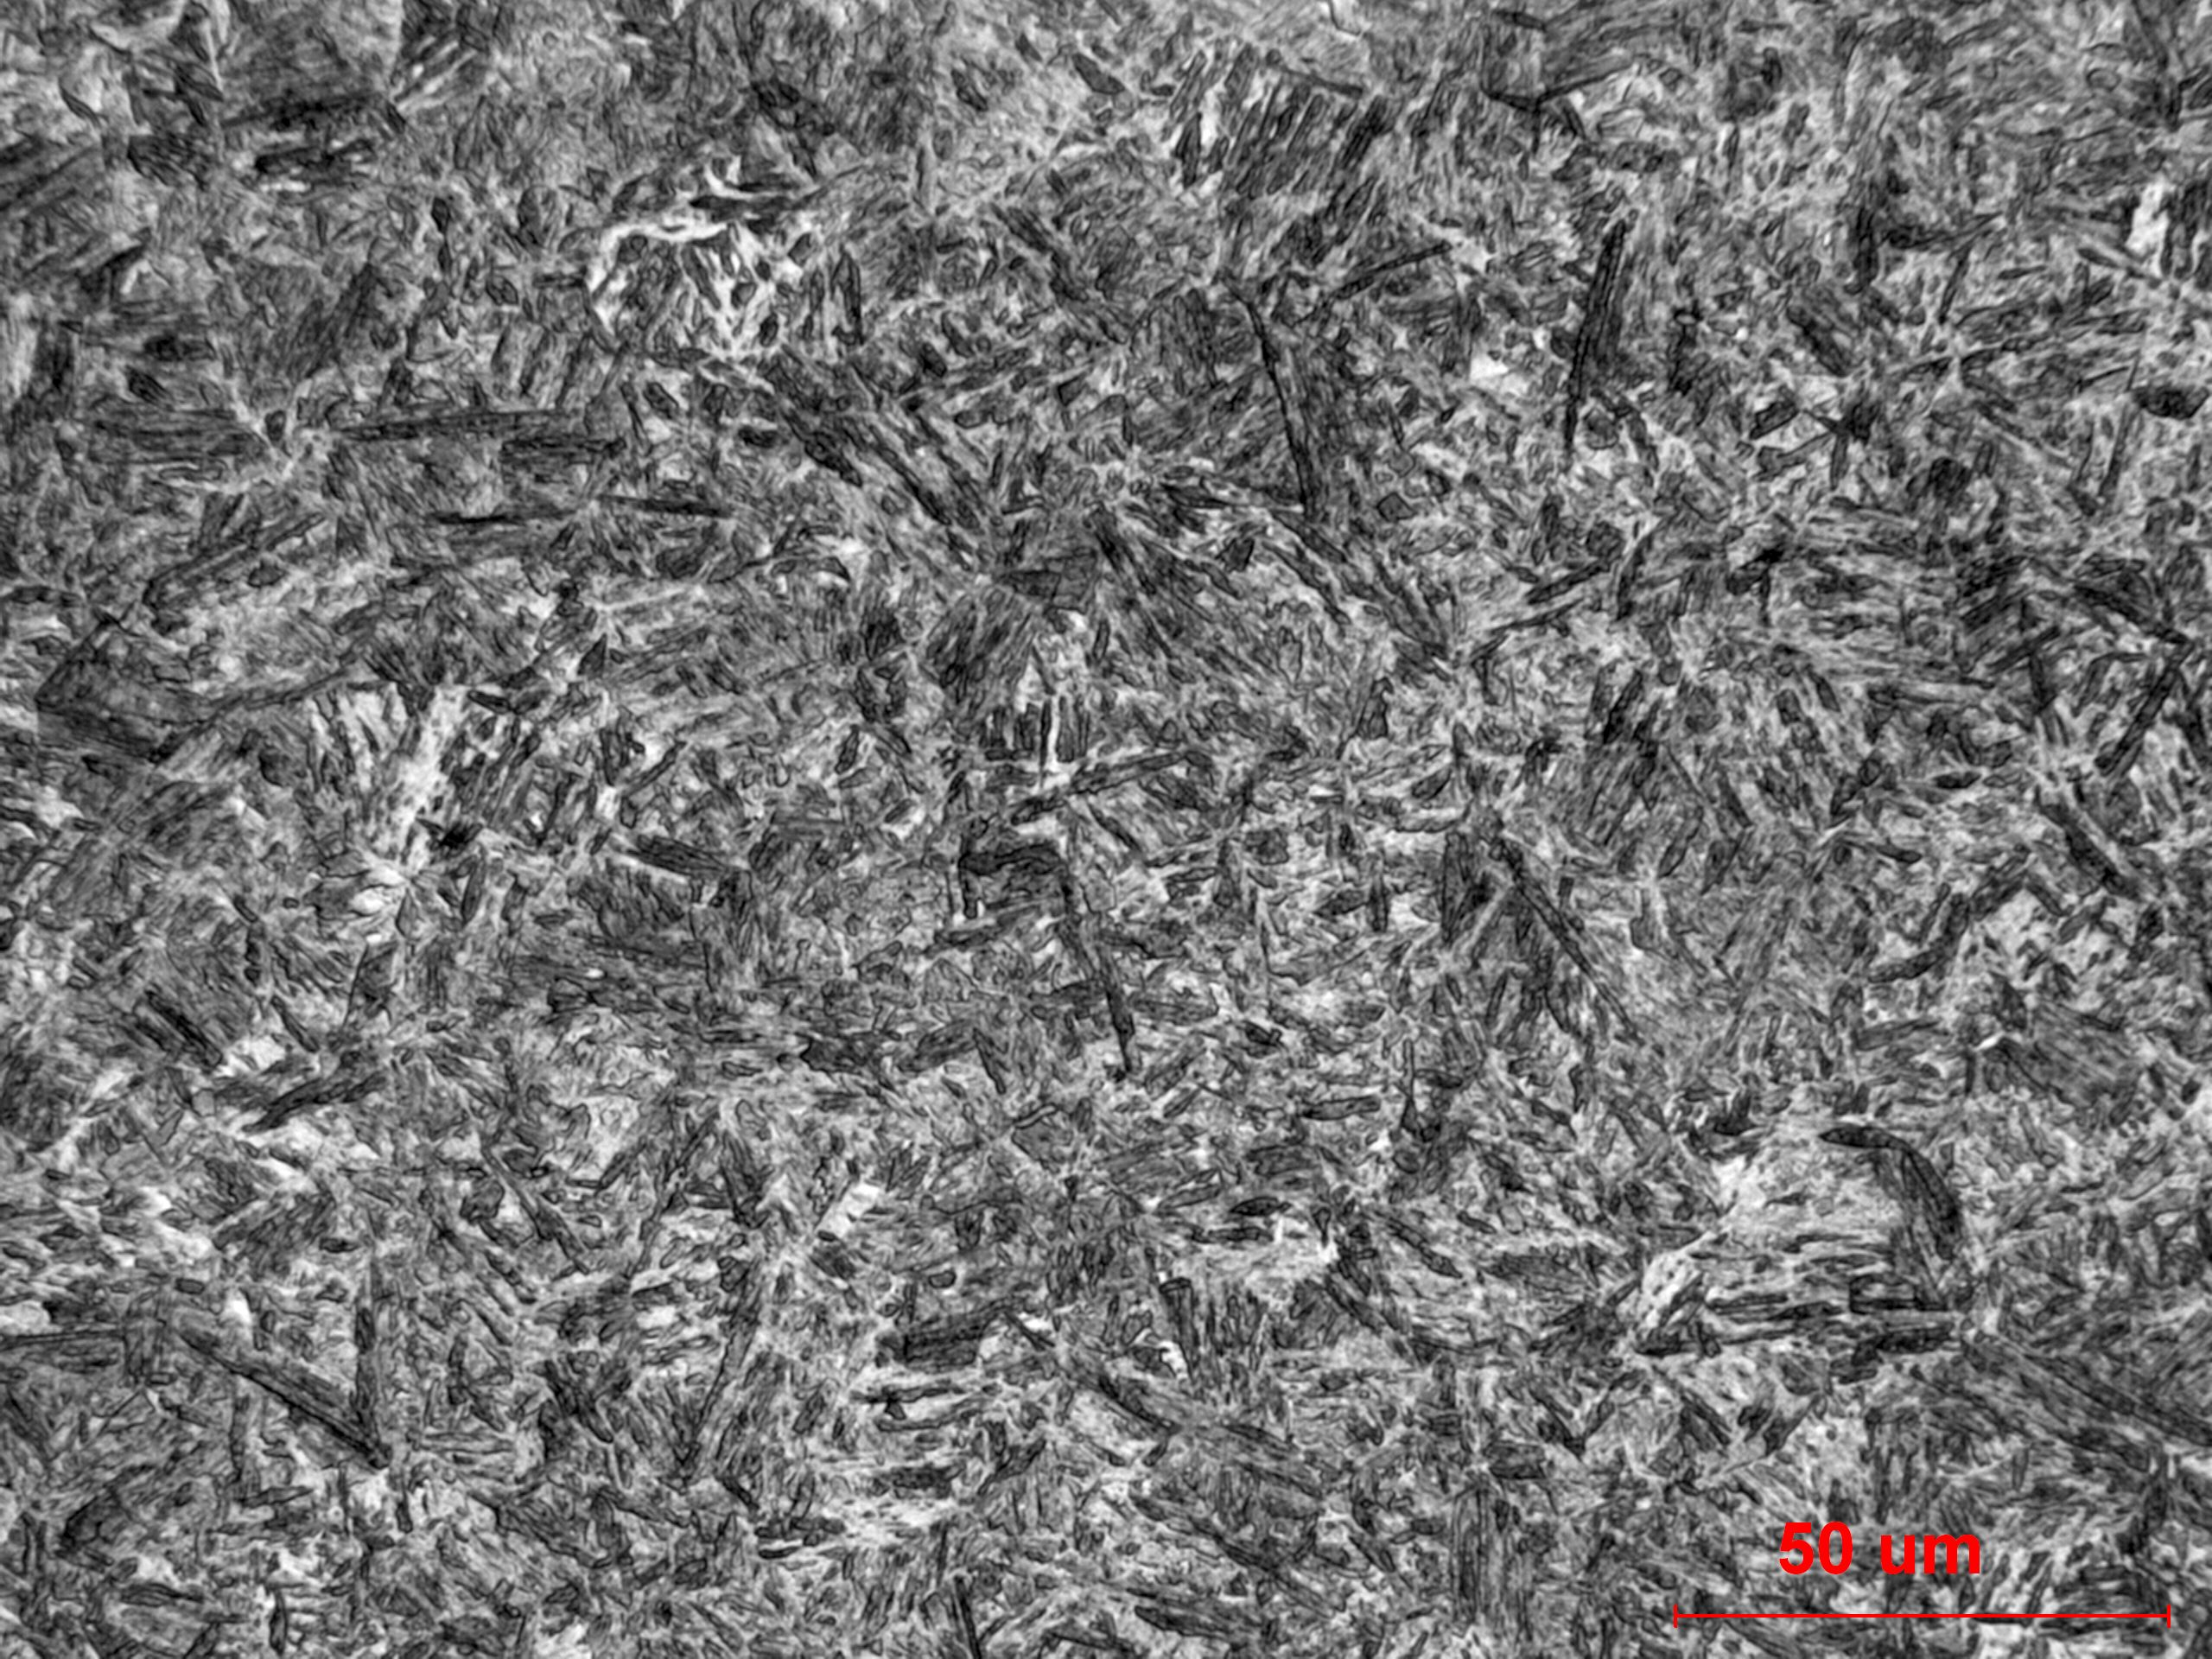
Figure 6. Higher magnification image of the tempered martensite in the core.

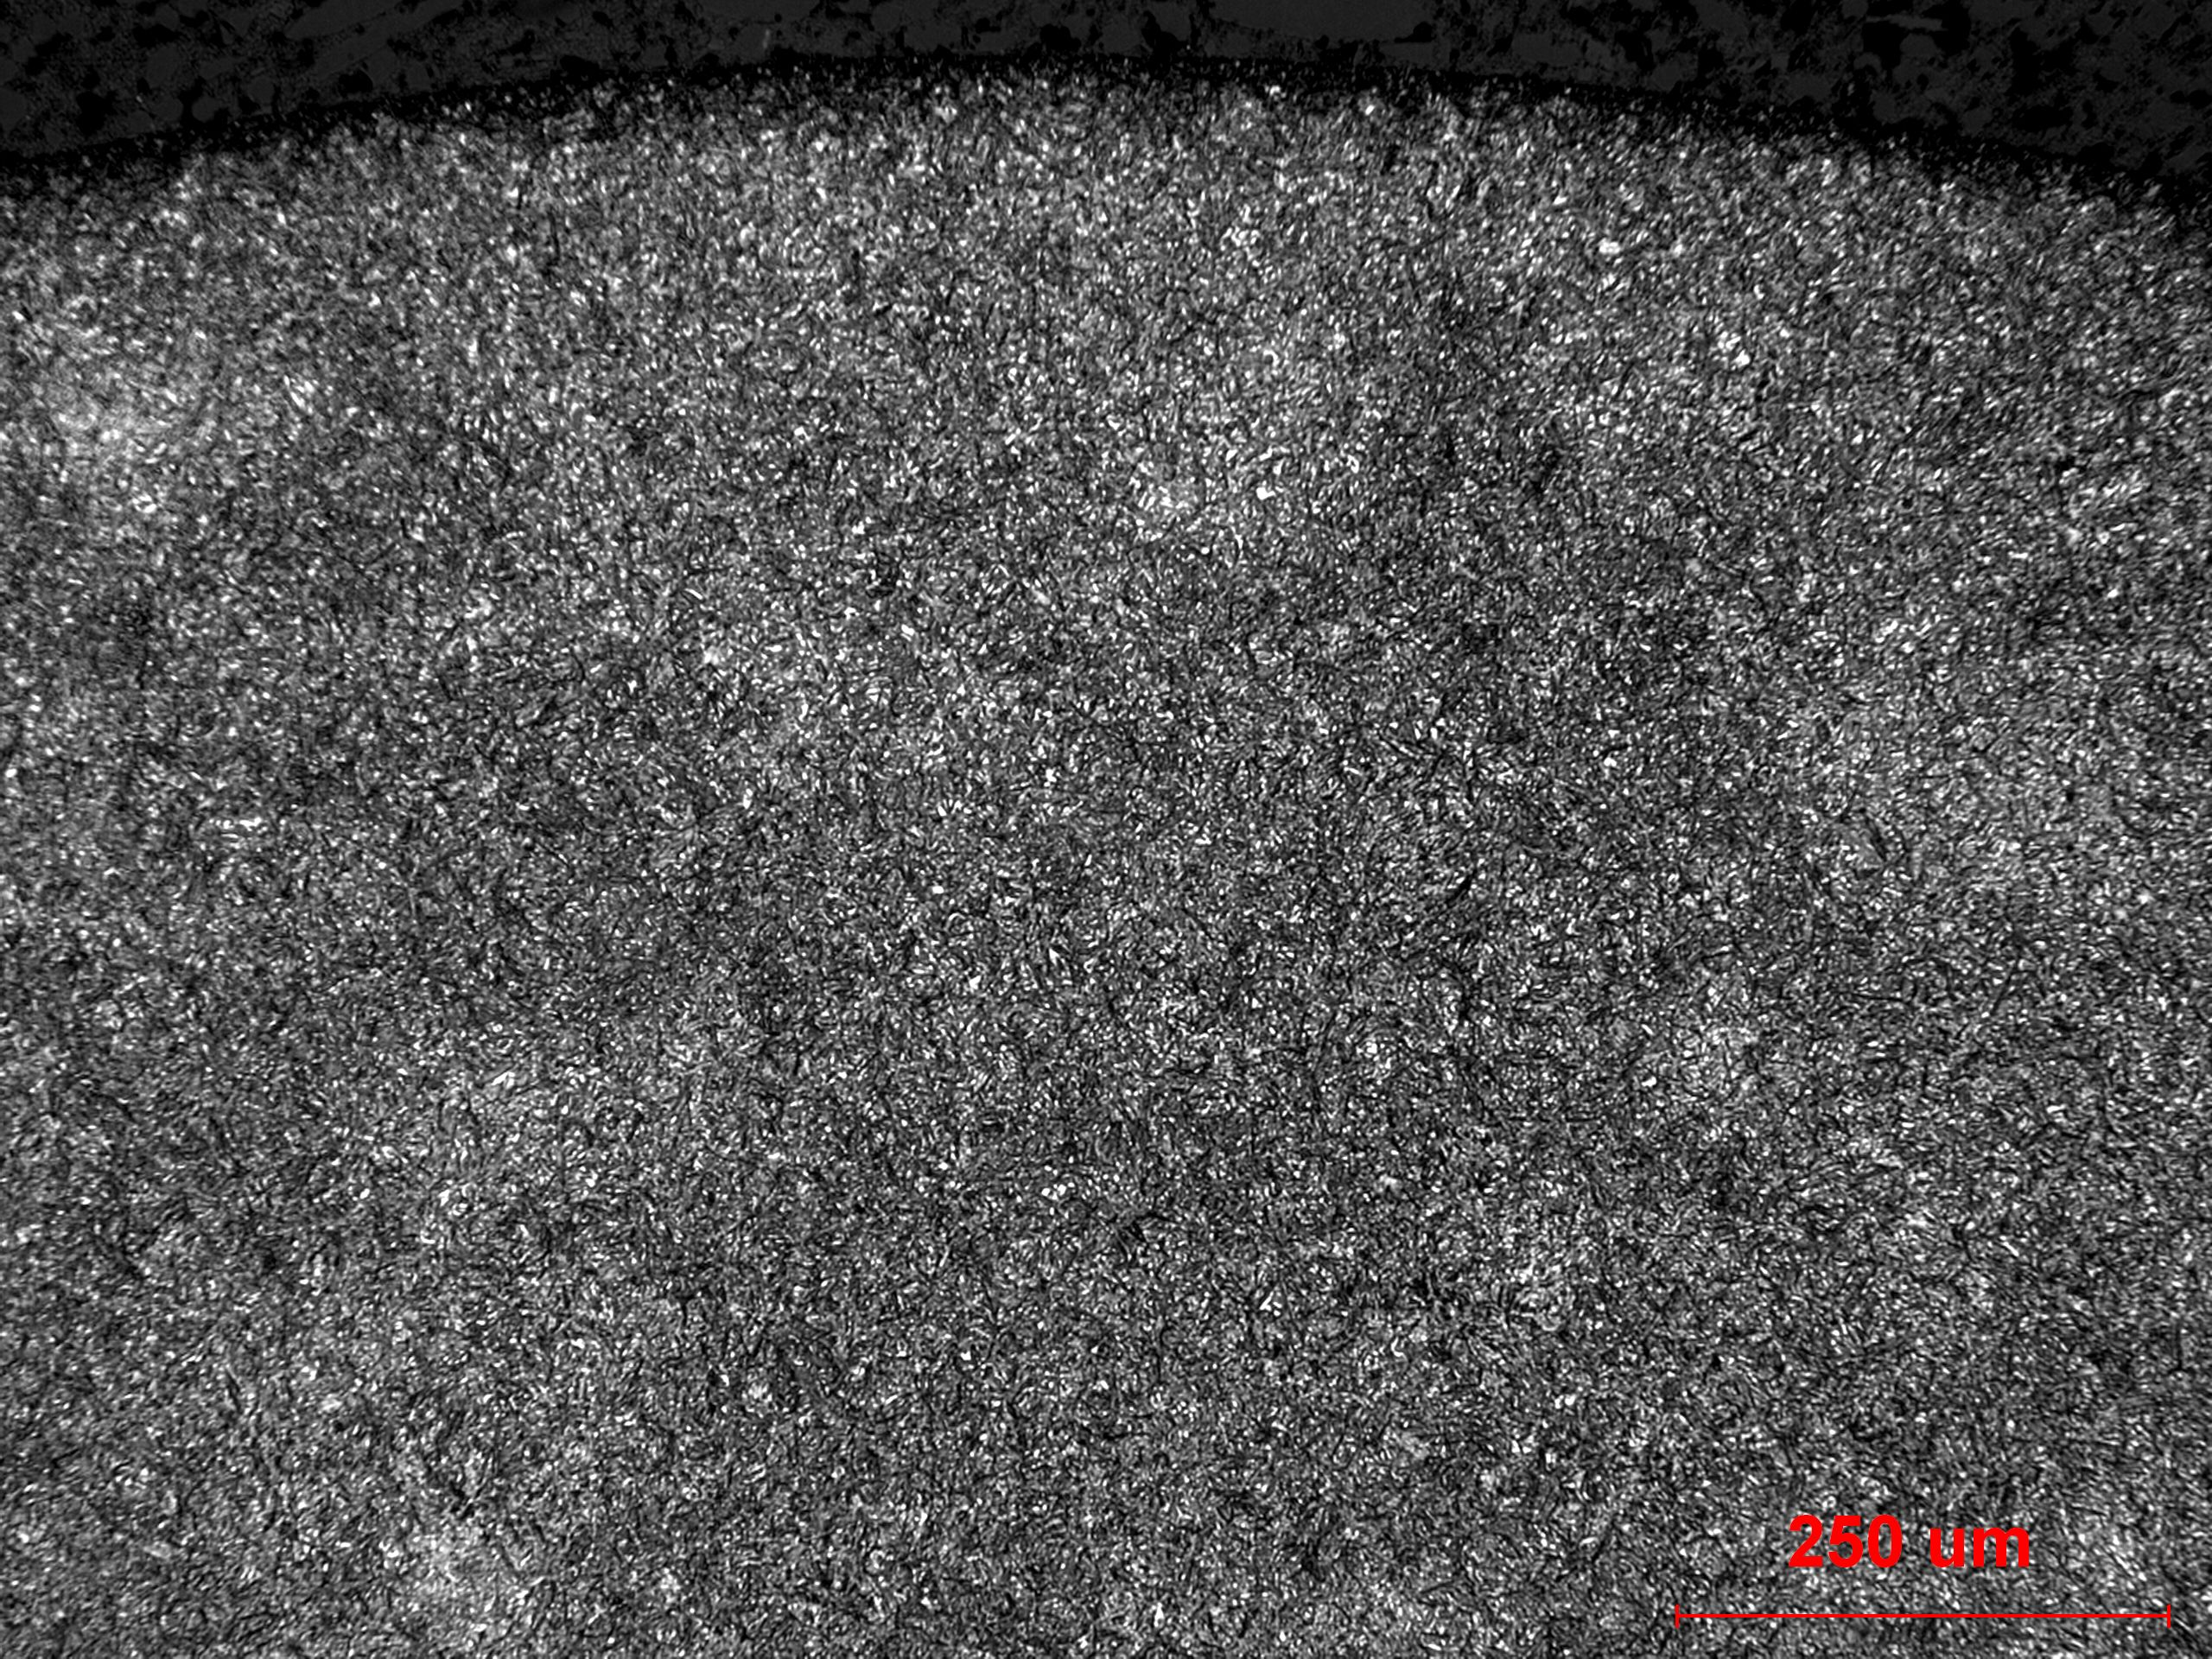
Figure 7. Medium magnification image of the microstructure of the surface of the gage section.

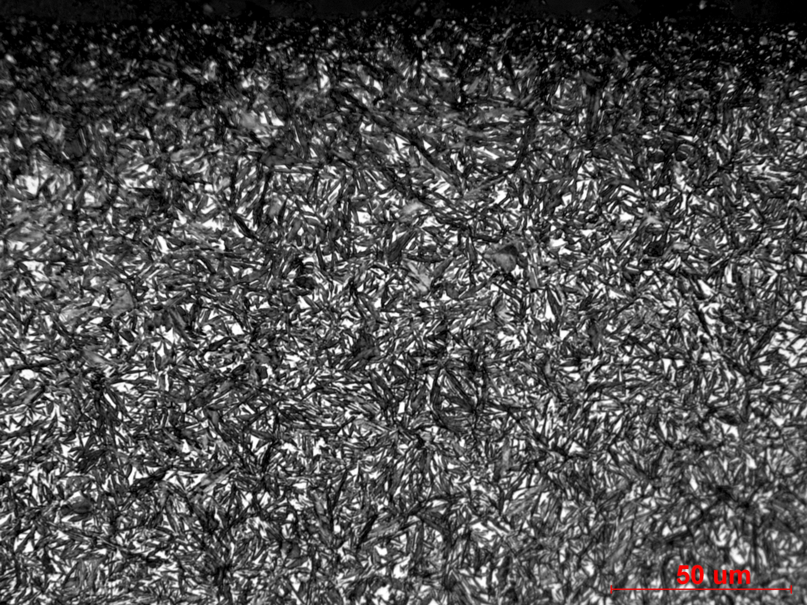
Figure 8. Higher magnification image of the microstructure of the surface, containing tempered martensite and retained austenite.

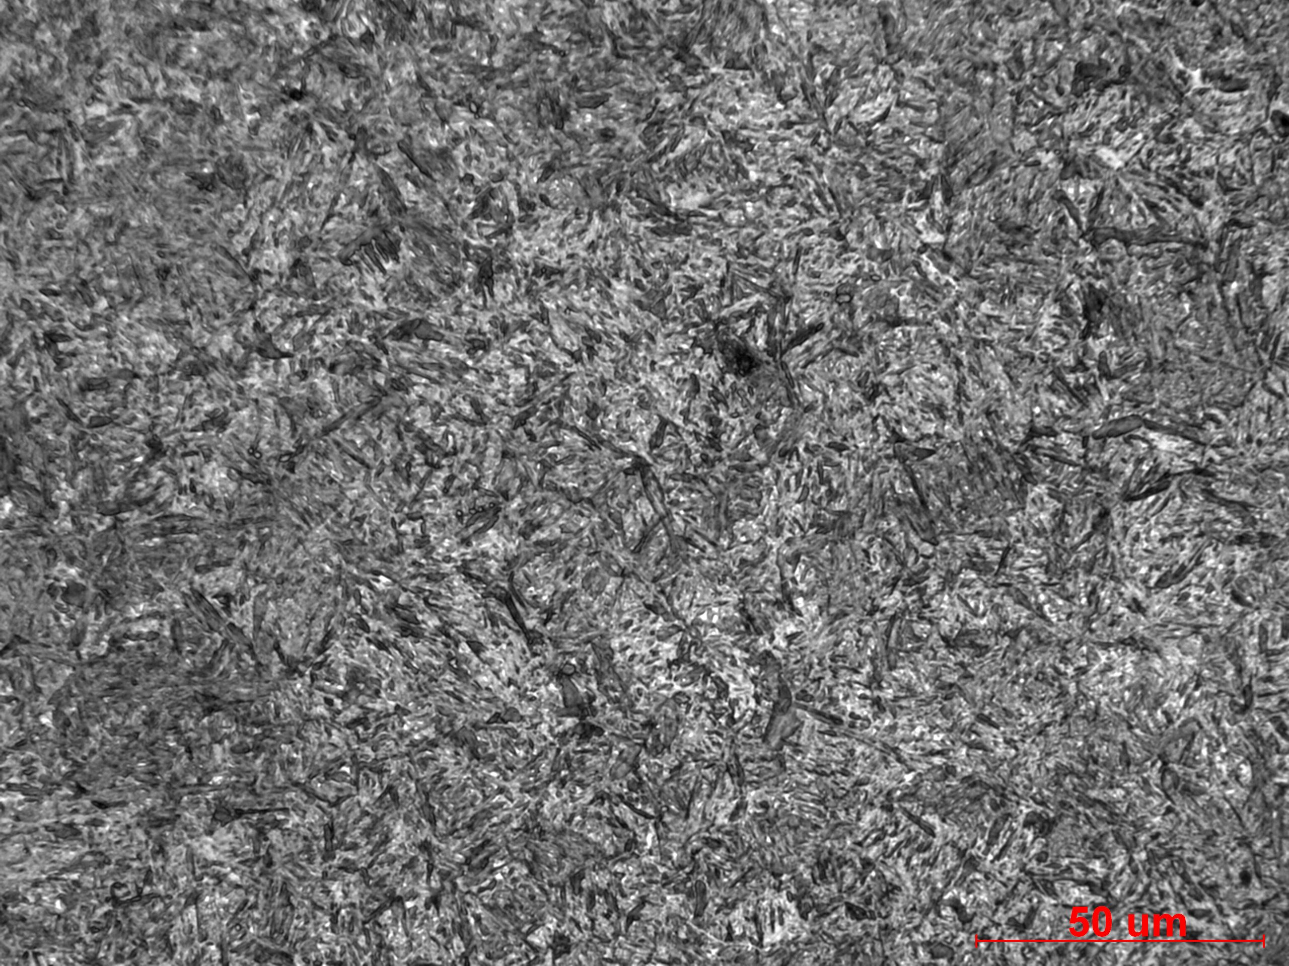
Figure 9. Image of the core microstructure of the gage section, containing tempered martensite.

Mechanical Properties - 133860

Hardness - Rockwell

Test was taken at the surface of the grip end with a HRC scale

59.7 HRC
60.7 HRC
60.1 HRC
61.2 HRC

Hardness - Micro

Depth Hardness (HRC converted)
0.005 61.2
0.010 61.5
0.015 61.4
0.020 61.0
0.025 61.5
0.030 61.4
0.040 61.7
0.050 61.0
0.060 60.2
0.070 58.6
0.080 60.0
0.090 58.6
0.100 59.1

