

Materials Engineering Summary Report
LTR Number: 130899

From: Peter Bauerle Phone: 776-7387

Location: CTC

Lab(s): Mechanical Properties Completed: 11/20/2007

Metallography

Subject/Part Name: Fatigue Specimen-Iteration 100/104

Approver: Dale Wetzel

Originator: Peter Bauerle

Originator Phone: 248-576-7387

Number of Parts: 1
Nature of Work: Process/Materials Development
Vendor:
Plant:
P/N:
MS:
PS:

History of Part

The sample that has been submitted is a fatigue specimen that will be used for the development of the AISI fatigue database, iterations 100 & 104. The test speciman was prepared from an 8822 steel grade with low side chemistry. The sample has been quench and tempered by austenitizing at 1700F prior to quenching in 150F oil and then tempering at 1050F to an aim hardness of 25-30 HRC.

Purpose

The purpose of this LTR is to evaluate the microstructure and hardness of the sample.
Mechanical Properties - 130899

Hardness - Rockwell (Performed By: Greg Cornelissen)

Grip end (surface hardness) - 32.0 HRC 32.0 HRC 31.5 HRC

Hardness - Micro (Performed By: Greg Cornelissen)

Newage Microhardness Tester - 1000gf

Micrhardness traverse across the gage section starting from the edge staggered in increments of .005” up to a depth of .030” followed by .010” increments beyond this point to the core.

.005” 33.8 HRC
.010” 32.8 HRC
.015” 32.0 HRC
.020” 32.5 HRC
.025” 33.3 HRC
.030” 32.0 HRC
.040” 31.6 HRC
.050” 30.1 HRC
.060” 30.2 HRC
.070” 29.6 HRC
.080” 30.4 HRC
.090” 30.4 HRC
.100” 29.6 HRC

Metallography - 130899

General Microstructure Description (Performed By: Jin Dong)

A fatigue Specimen-Iteration 100/104 was sectioned longitudinally from the grip end and transversely from the gage section to conduct a general microstructure description.

The sample was prepared with standard test procedures for sectioning, mounting, polishing, and etched with 3% nital. The sample was reviewed and microphotographs were taken using an Olympus PMG3 Microscope.

The microphotographs revealed that the microstructure consisted of martensite with some evidence of some minor banding.

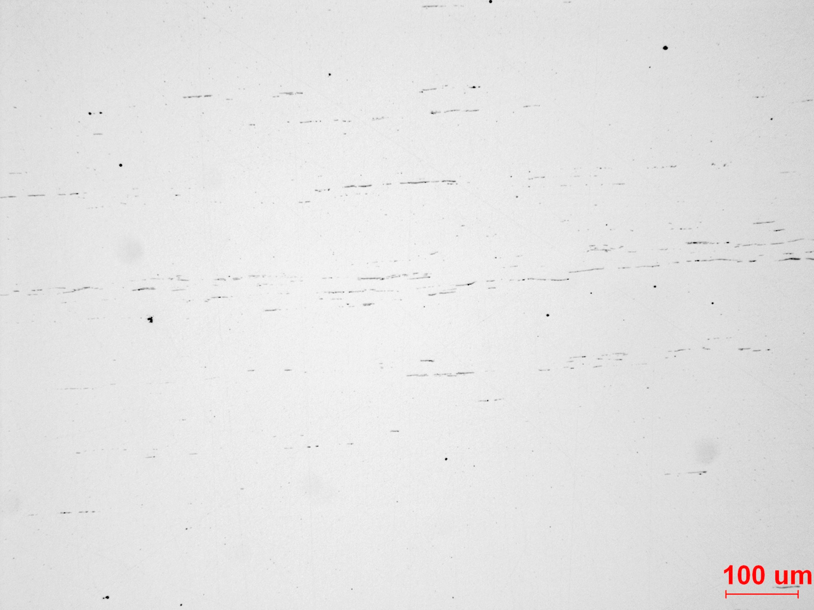
Fig. 1 Showing the inclusion rate of the steel.

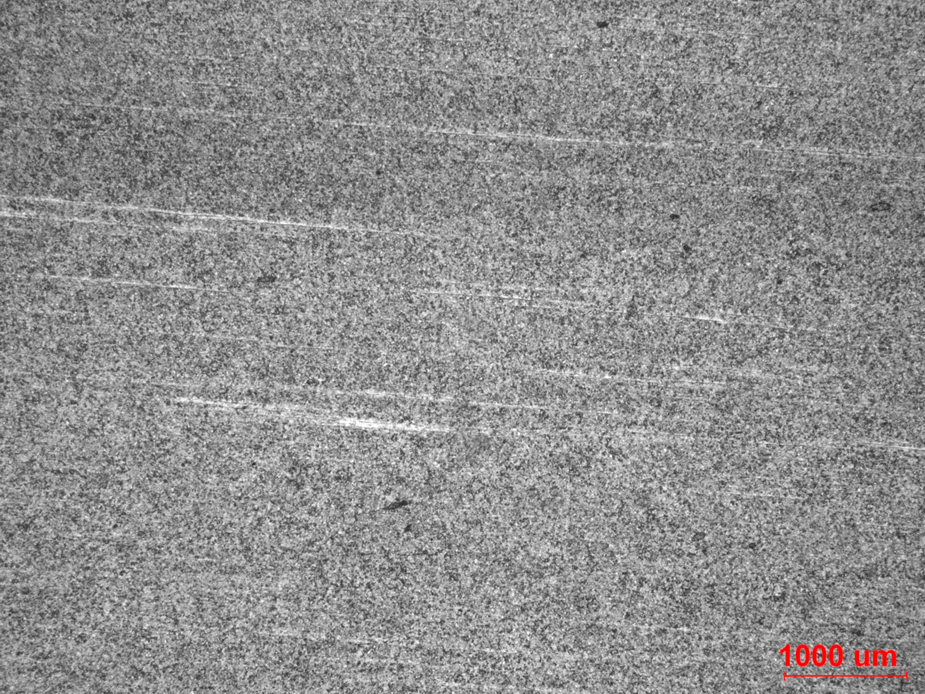
Fig. 2 Overall view of the longitudinal section from the grip end.

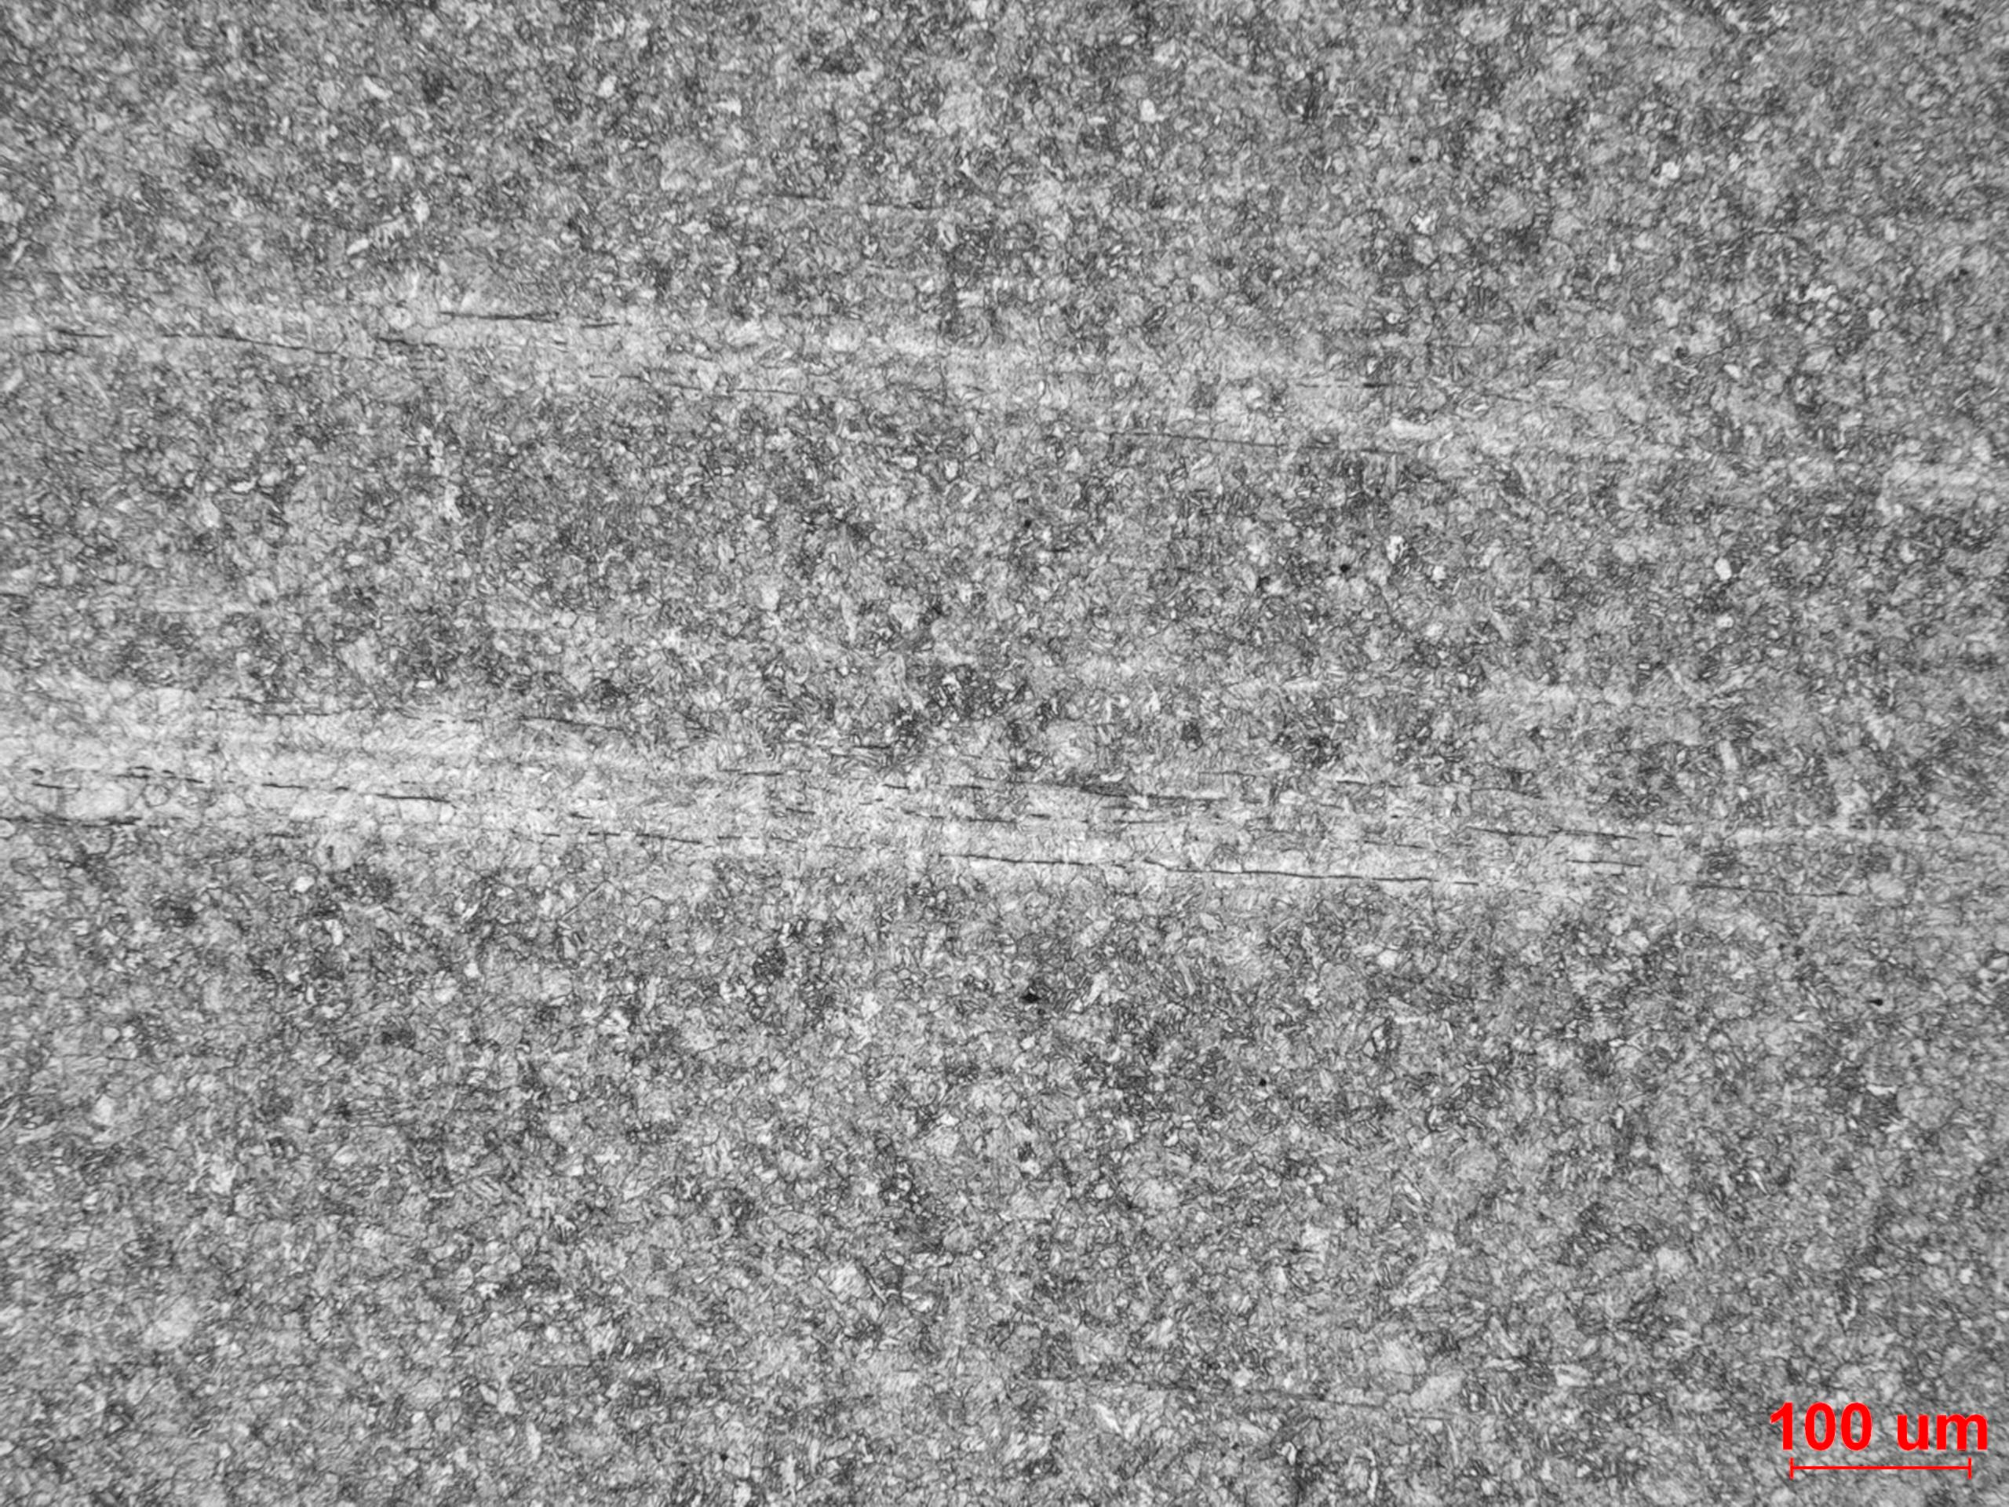
Fig. 3 Low magnification showing the microstructure at the longitudinal section from the grip end.

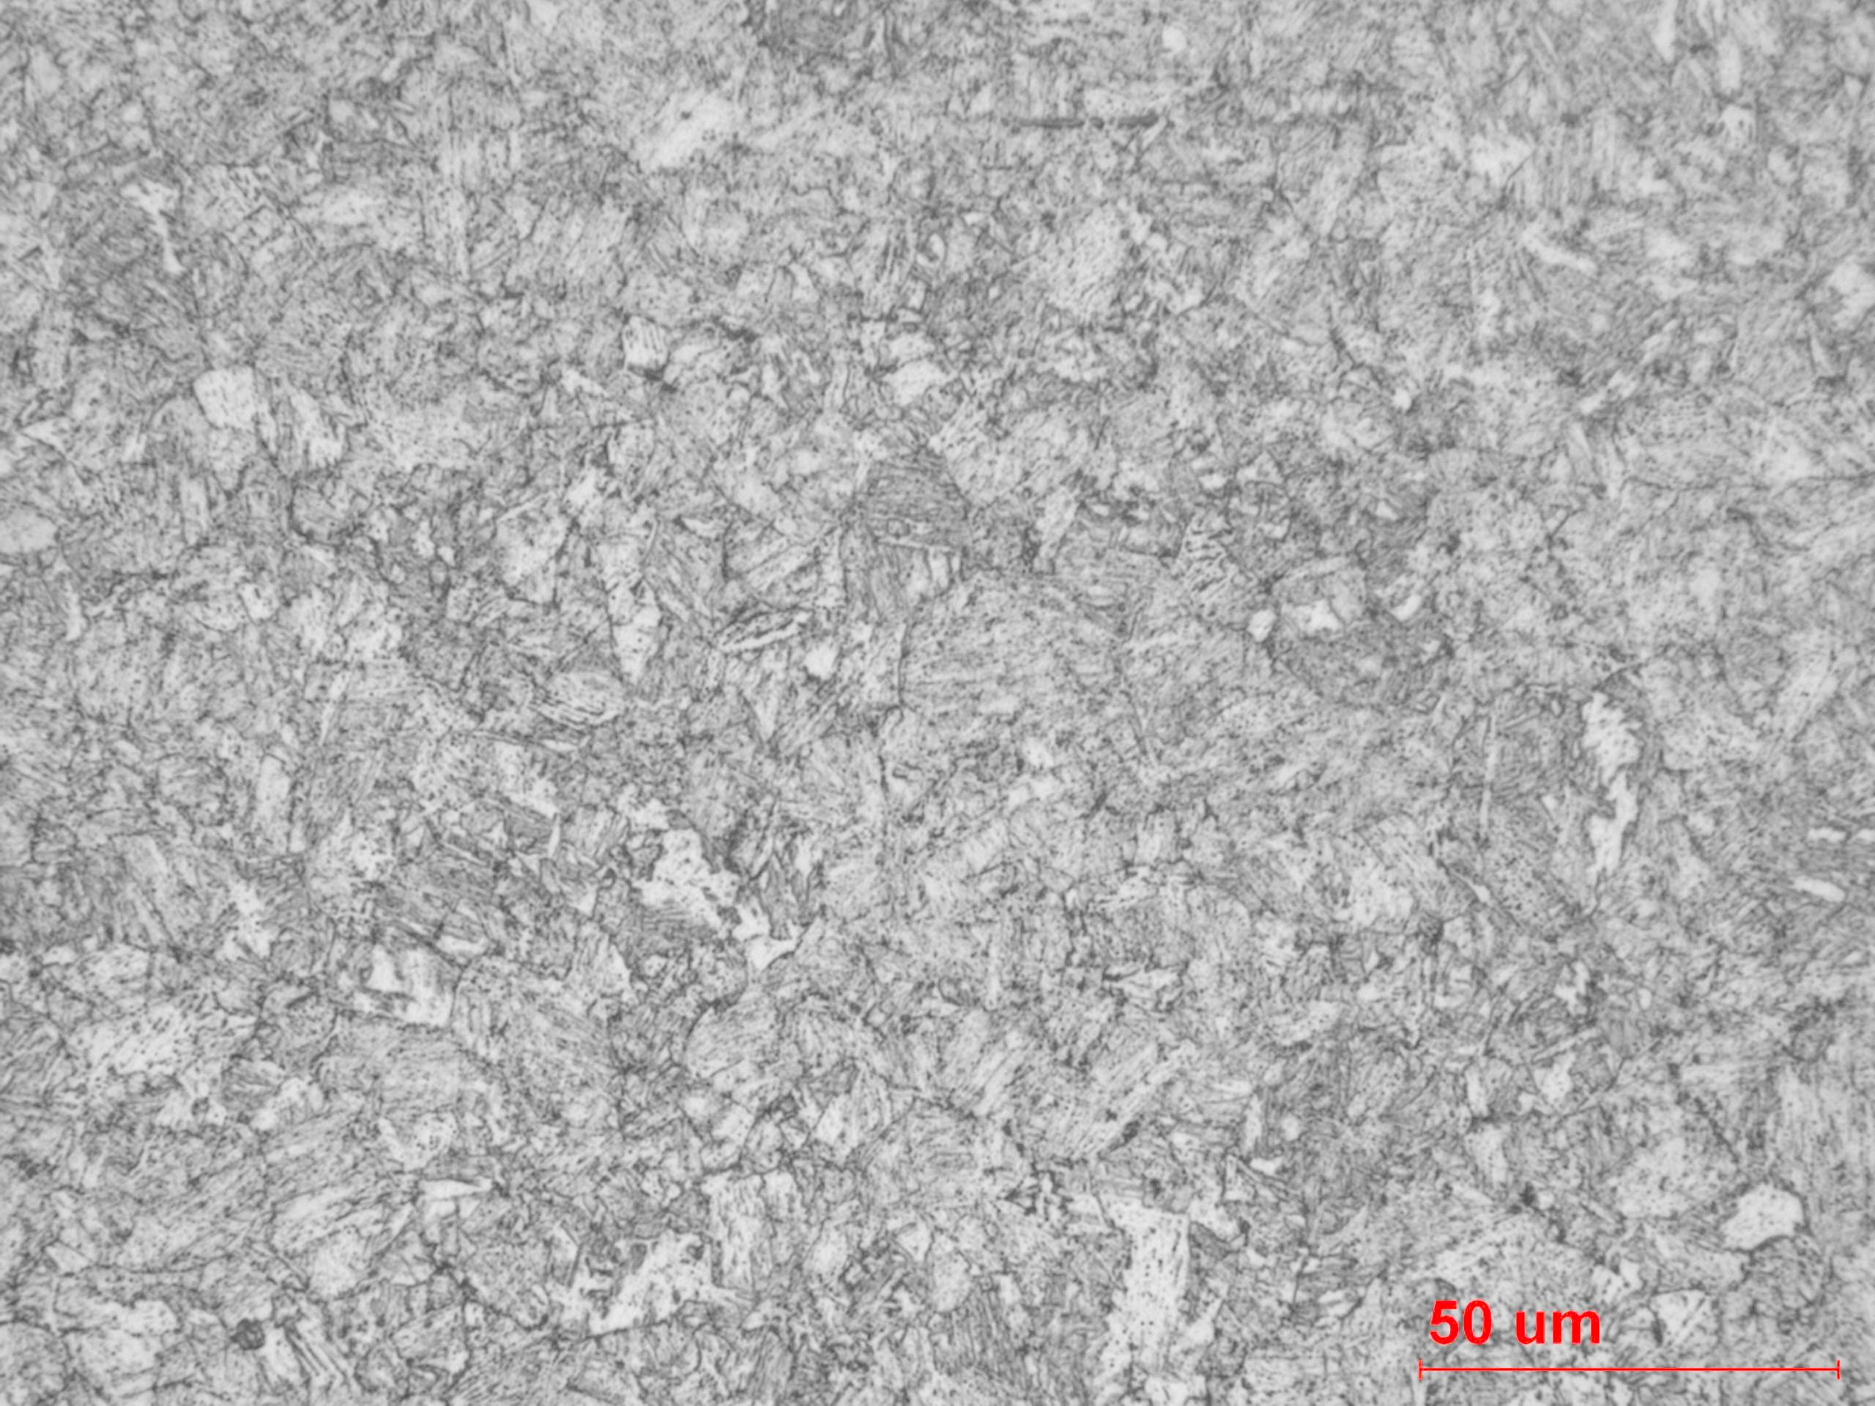
Fig. 4 High magnification showing the microstructure at the longitudinal section from the grip end.

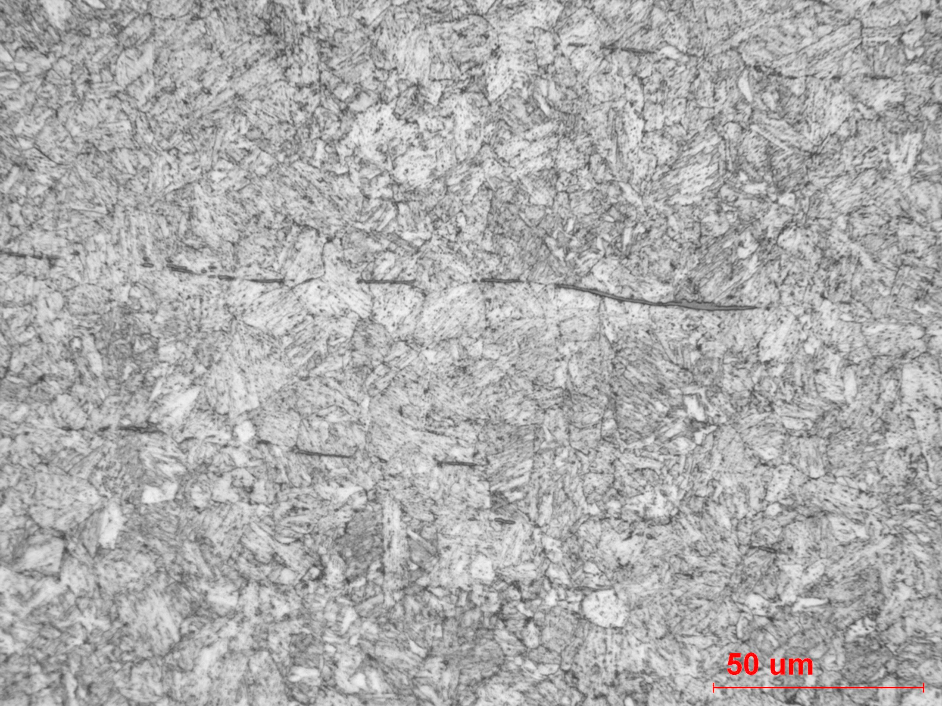
Fig. 5 High magnification showing the microstructure at the longitudinal section from the grip end (another area showing the banding).

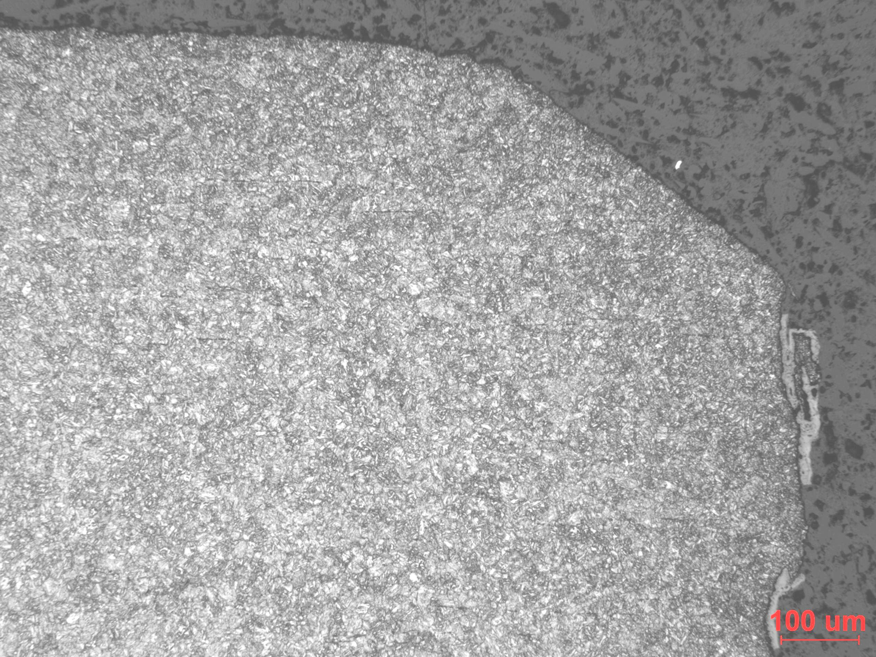
Fig. 6 Low magnification showing the microstructure at the longitudinal section (surface area) from the grip end.

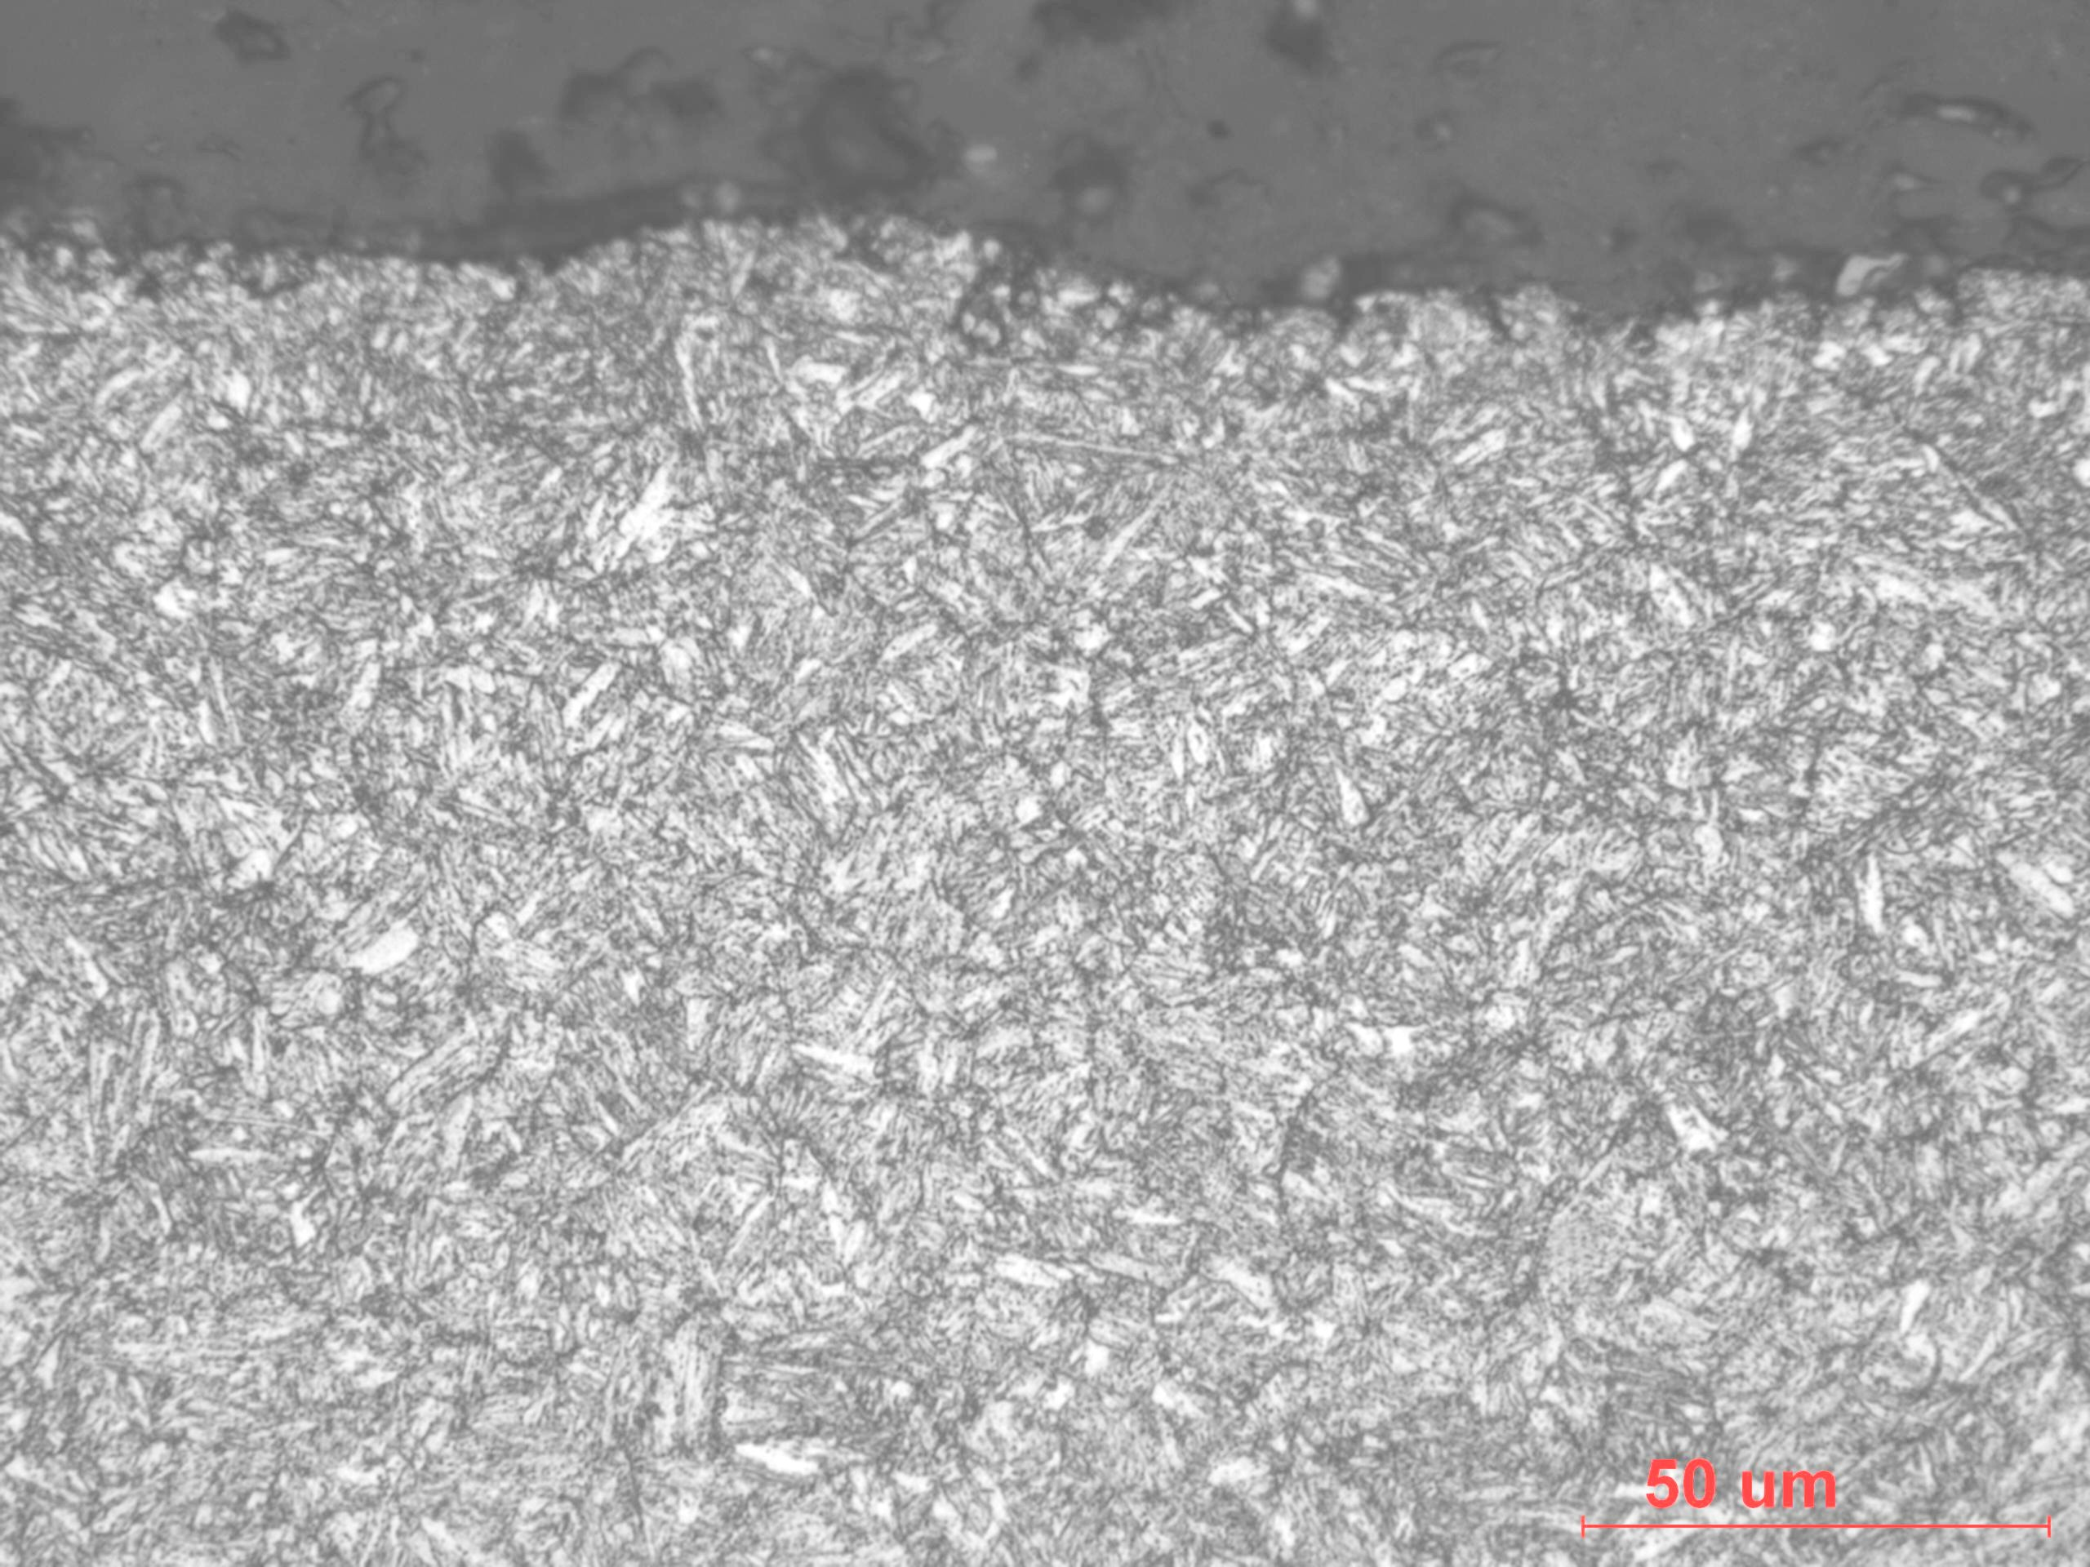
Fig. 7 High magnification showing the microstructure at the longitudinal section (surface area) from the grip end.


Fig. 8 Low magnification showing the microstructure at the transverse section from the gage area.

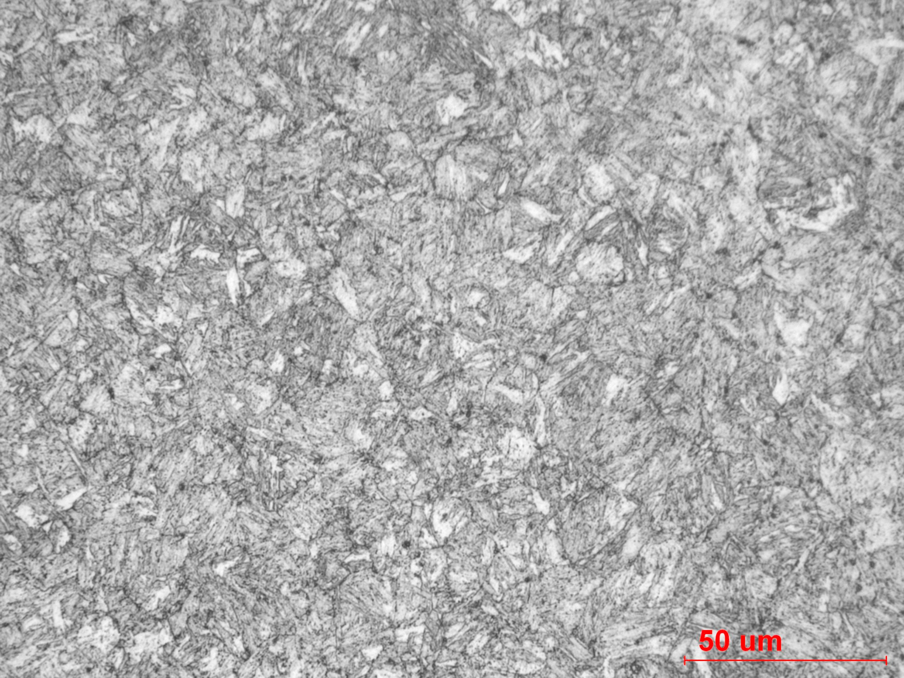
Fig. 9 High magnification showing the microstructure at the transverse section from the gage area.

Summary/Conclusion/Recommendations

Based on this analysis, the fatigue specimens will be forwarded to AISI for test and evaluation. It should be noted that the hardness range is at or above the desired range of 25-30 HRC.

