


Materials Engineering Lab Report
LTR Number: 126816

To: Peter Bauerle Phone: 776-7387

Location: CTC

From: Mechanical Properties Completed: 8/9/2006

Metallography

Subject/Part Name: Fatigue Test Specimen-Iteration 98 (Reported in Database as 99)

Report Status: Complete

Originator: Peter Bauerle

Originator Phone: 248-576-7387

Number of Parts: 1
Nature of Work: Process/Materials Development
Vendor:
Plant:
P/N:
MS:
PS:

History of Part

The sample that has been submitted is a fatigue specimen that will be used for the development of the AISI fatigue database, iteration 98 (Reported in Database as 99). The sample is an ultra low sulfur version of a 4140 steel that has been forged to size. The sample has been quench and tempered by austenitizing at 1550-1575F in a salt bath for 15 minutes prior to quenching in 150F oil. The samples were then washed and immediately tempered at 900F with a resulting hardness of 41 HRC.

Test Results

Mechanical Properties - 126816

Hardness - Rockwell (Performed By: Mike Terrell)

Rockwell hardness to measure the surface hardness on the grip end.

HRC
35.2
35.4
36.5

Hardness - Micro (Performed By: Mike Terrell)

Micro hardness to the gage section of the part.

Distance HRC
.005 39.1
.01 42.2
.015 42.3
.02 41.6
.025 44.3
.03 42.6
.04 42.5
.05 41.4
.06 42.4
.07 41.8
.08 42.9
.09 41.6
.1 41.6

Metallography - 126816

General Microstructure Description (Performed By: Jin Dong)

A fatigue test specimen-Iteration 98 (Reported in Database as 99) was sectioned longitudinally from the grip end to conduct a general microstructure description. A transverse section from the gage section is also mounted for microhardness test.

The sample was prepared with standard test procedures for sectioning, mounting, polishing, and etched with 3% nital. The sample was reviewed and microphotographs were taken using an Olympus PMG3 Microscope.

The microphotographs revealed that the specimen consisted of tempered martensite throughout the entire cross section. There is an oxidization layer at the gage surface (Fig. 7).

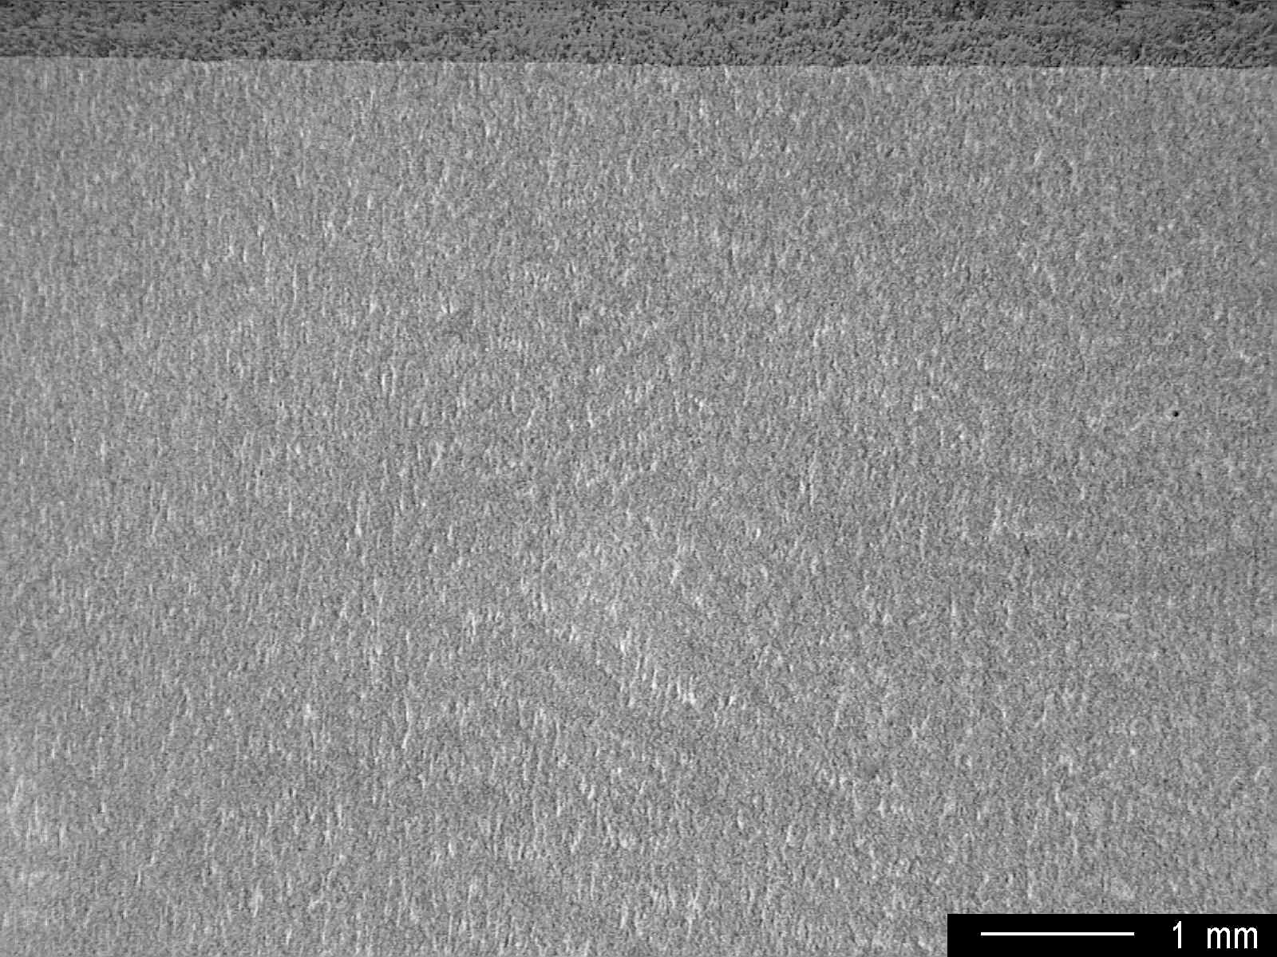
Fig. 1 Overall view of the cross section.

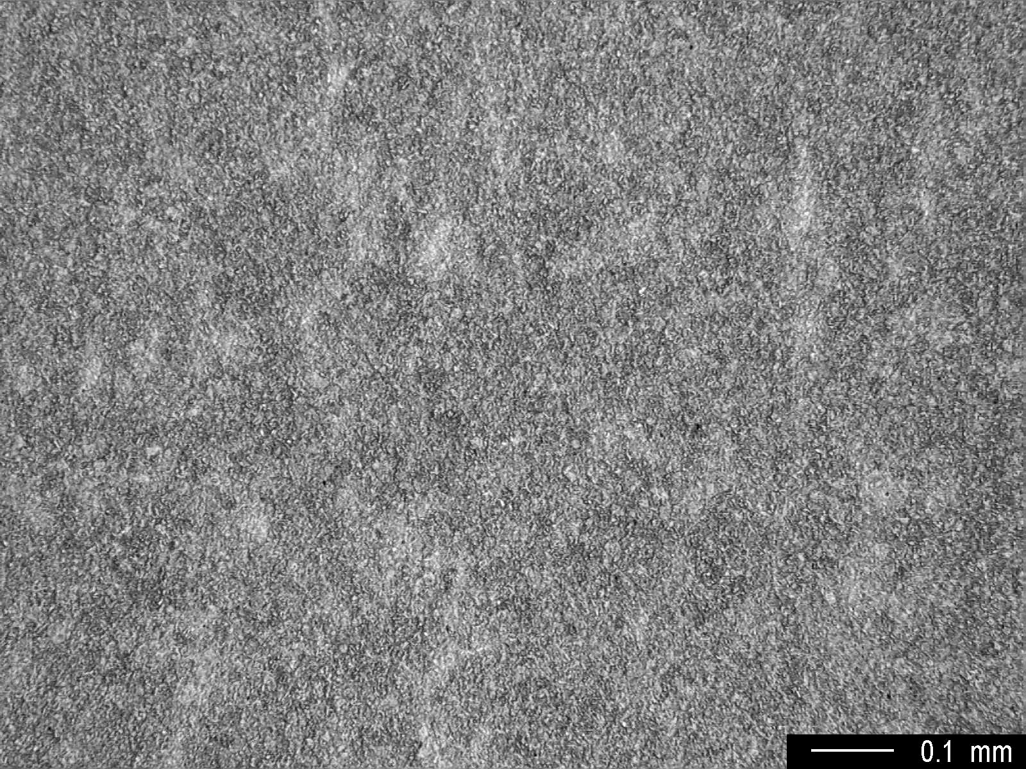
Fig. 2 Low magnification showing microstructure at the core area.

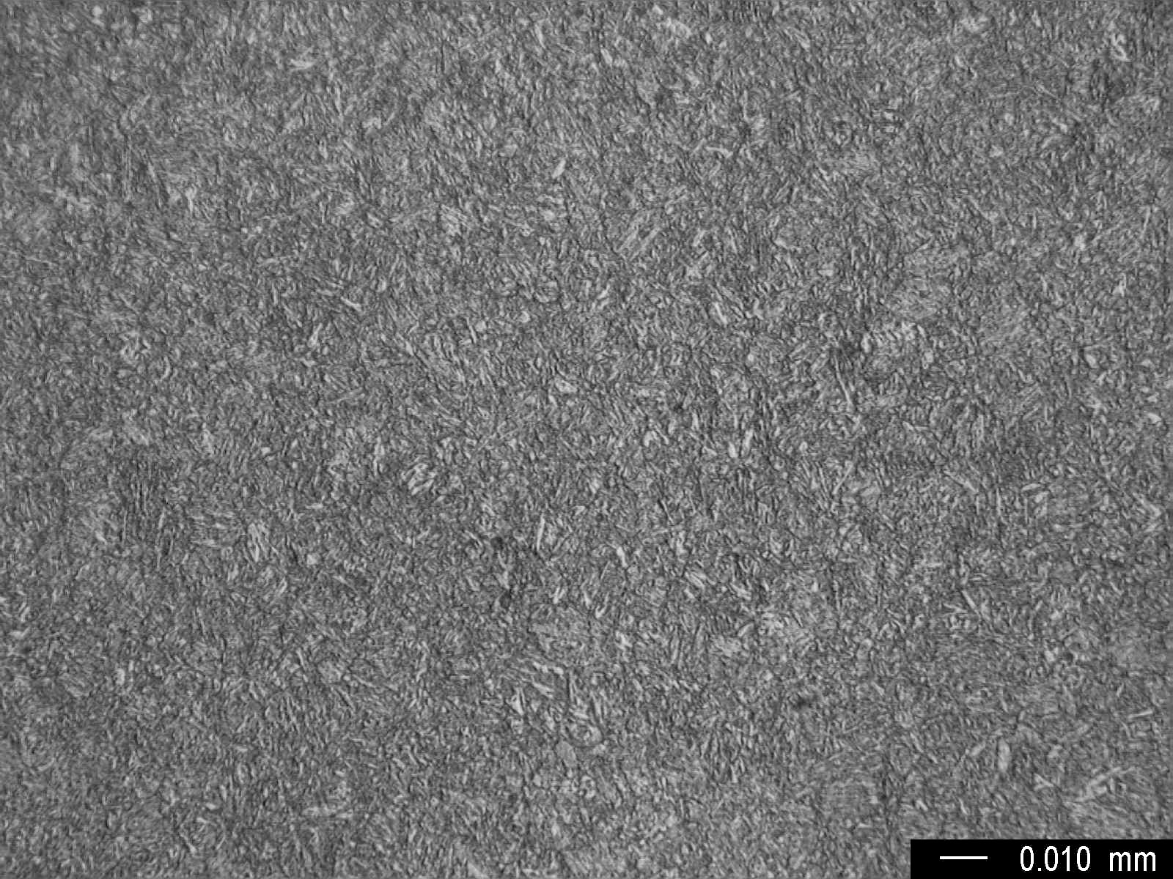
Fig. 3 High magnification showing microstructure at the core area.

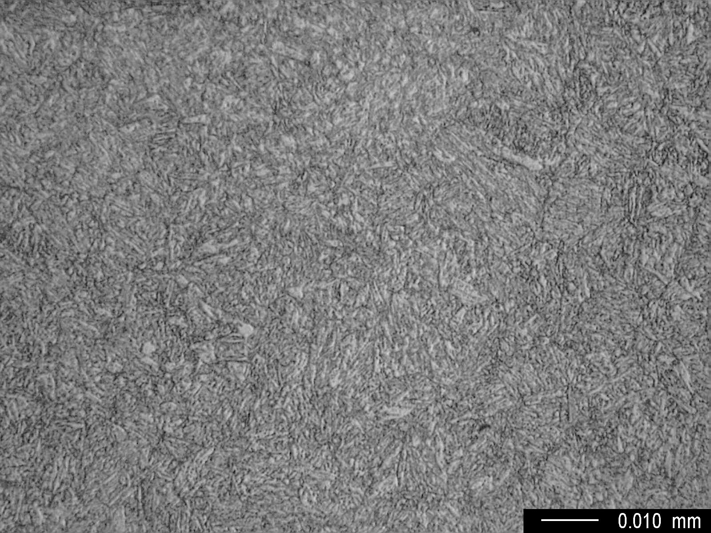
Fig. 4 Very high magnification showing microstructure at the core area.

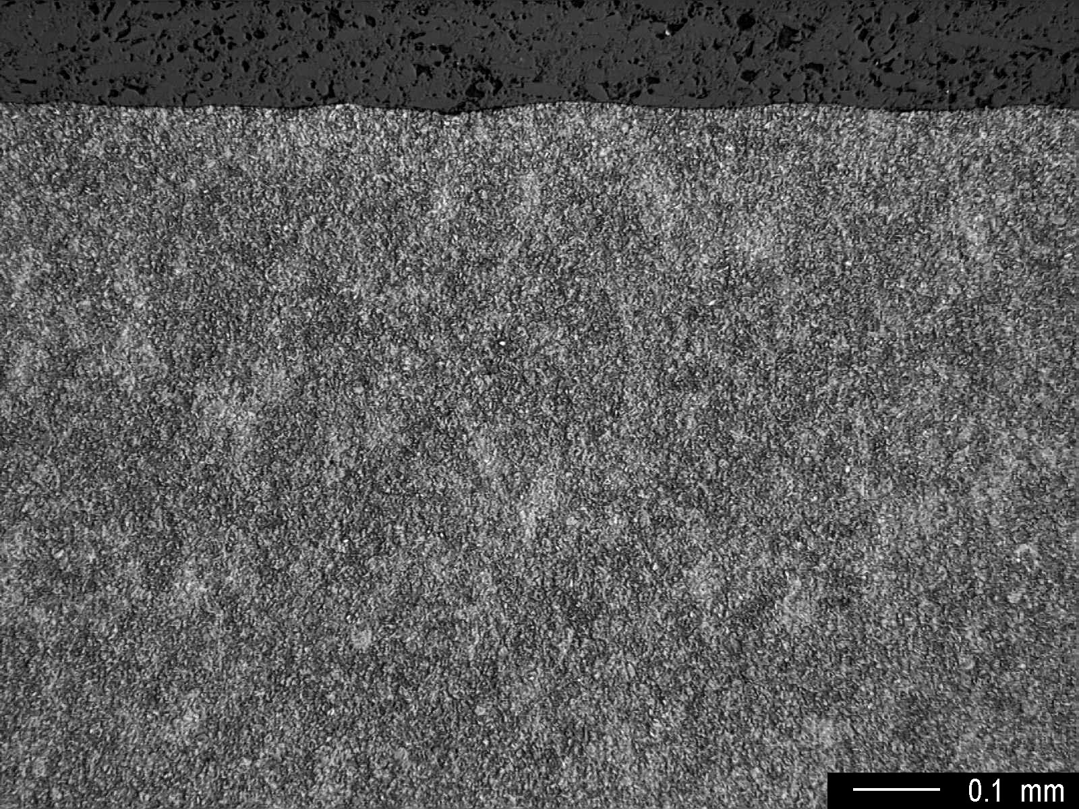
Fig. 5 Low magnification showing microstructure at surface.

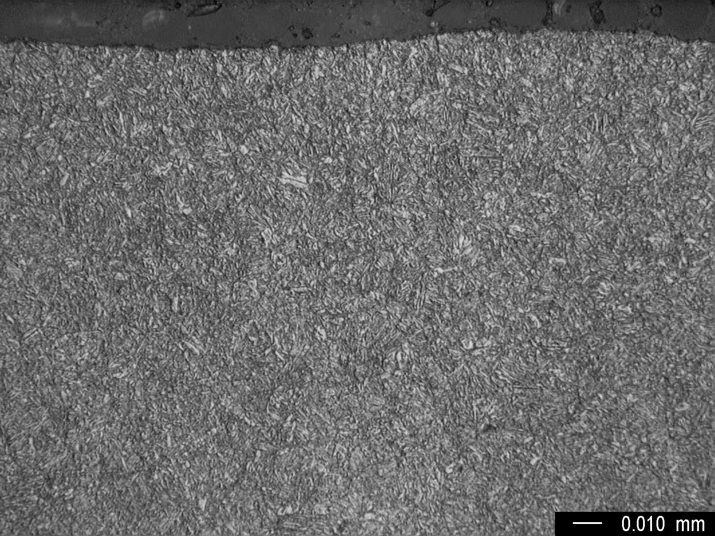
Fig. 6 High magnification showing microstructure at surface.

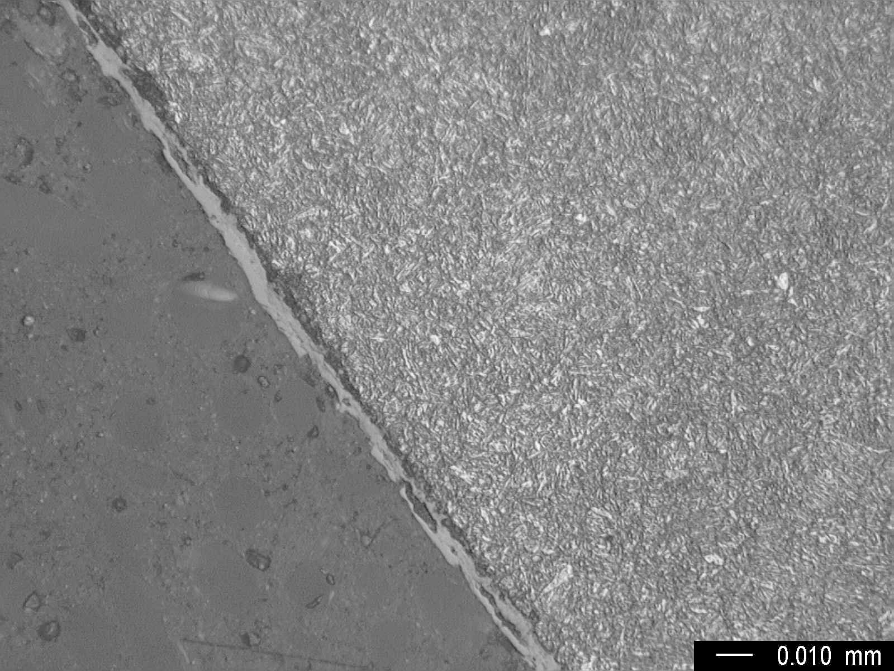
Fig. 7 High magnification showing microstructure at the transversely sectioned gage surface area.

