


Materials Engineering Summary Report
LTR Number: 120955

From: Peter Bauerle Phone: 776-7387

Location: CTC

Lab(s): Mechanical Properties Completed: 12/2/2004

Metallography

Subject/Part Name: Fatigue Specimen

Approver: Peter Bauerle

Originator: Peter Bauerle

Originator Phone: 248-576-7387

Number of Parts: 1
Nature of Work: Process/Materials Development
Vendor:
Plant:
P/N:
MS:
PS:

History of Part

The sample that has been submitted is a fatigue specimen that is used for the development of the AISI database. This sample has been identified as iteration 89 and is a grade 8620. The sample has first been through carburized in the gage section and then reaustenitized at 1575F for 30 minutes followed by isothermal transformation at 450F for 50 minutes. The isothermal treatment was used to generate a microstructure with 50% bainite.

Purpose

The purpose of this LTR is to evaluate hardness and microstructure of the gage section of the test specimen.
Mechanical Properties - 120955

Hardness - Rockwell (Performed By: Jim Bolton)

Direct hardness readings were taken on grip area of sample and found to be
57.3/56.9/59.4*
* note a value of 1 has been added for roundness correction

Hardness - Micro (Performed By: Jim Bolton)

120955
DEPTH | HARDNESS FROM O.D.
.005 | 62.3
.010 | 62.9
.015 | 63.1
.020 | 62.9
.025 | 62.2
.030 | 63.7
.040 | 62.3
.050 | 61.2
.060 | 61.2
.070 | 57.1
.080 | 55.9
.090 | 55.5
.100 | 55.6
.110 | 55.1
.120 | 56.1
.130 | 55.6
.140 | 57.1
.150 | 57.6
.160 | 59.1
.170 | 62.3
.180 | 62.5
.190 | 63.5
.200. | 62.8

Metallography - 120955

General Microstructure Description (Performed By: James Shi)

The submitted fatigue specimen was sectioned longitudinally at the grip end and prepared according to the normal procedures for microstructural evaluation. Using optical microscope Olympus PMG3, the microstructures were examined and microphotographs were taken. The results of the evaluation revealed that the part was case carburized. The typical case pattern is shown in Fig.1. The microstructure of the part consisted of some transformation product at the surface followed by bainite region, martensite region, second bainite region, and tempered martensite with a small amount of ferrite to the core. In addition, some inclusions were observed. The details of the microstructures are shown in Figs.2-5. The bainite at the subsurface (below transformation product and decarburization) was estimated to be about 40% of the volume.

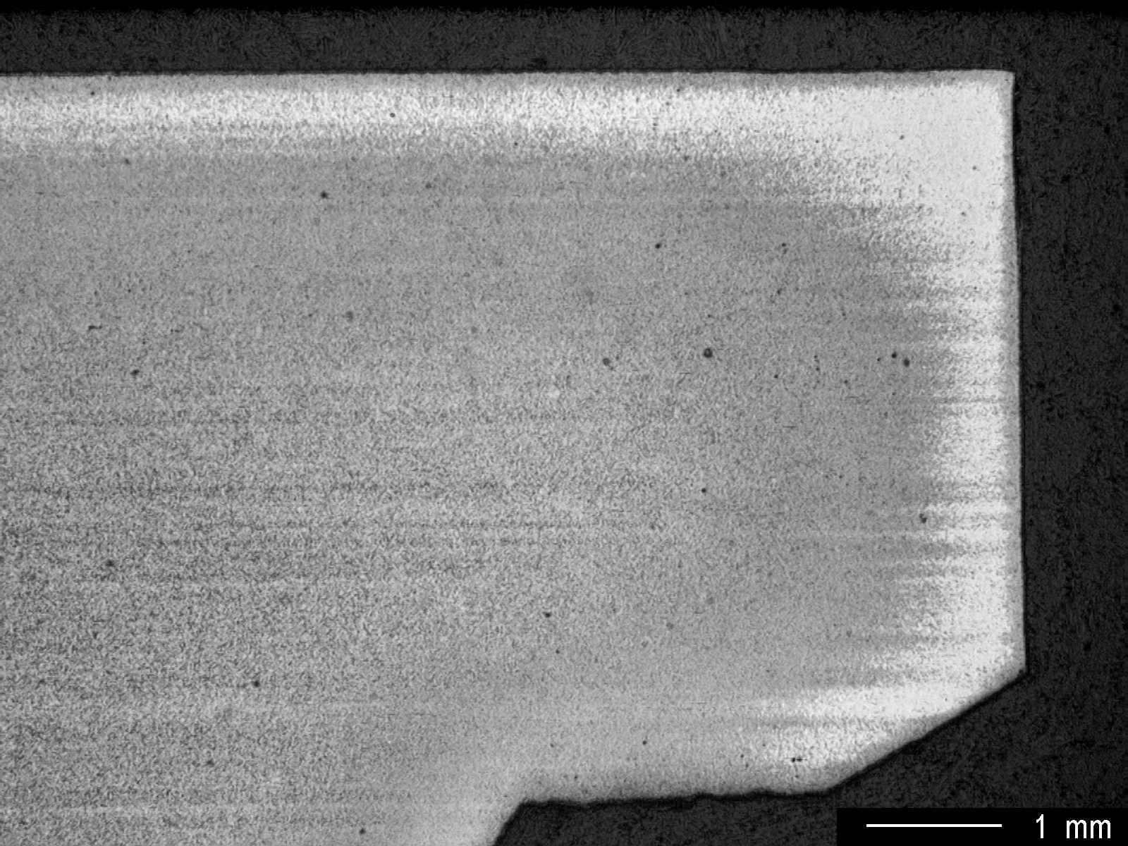

Fig.1 Case pattern inclusions at the grip end, low magnification.

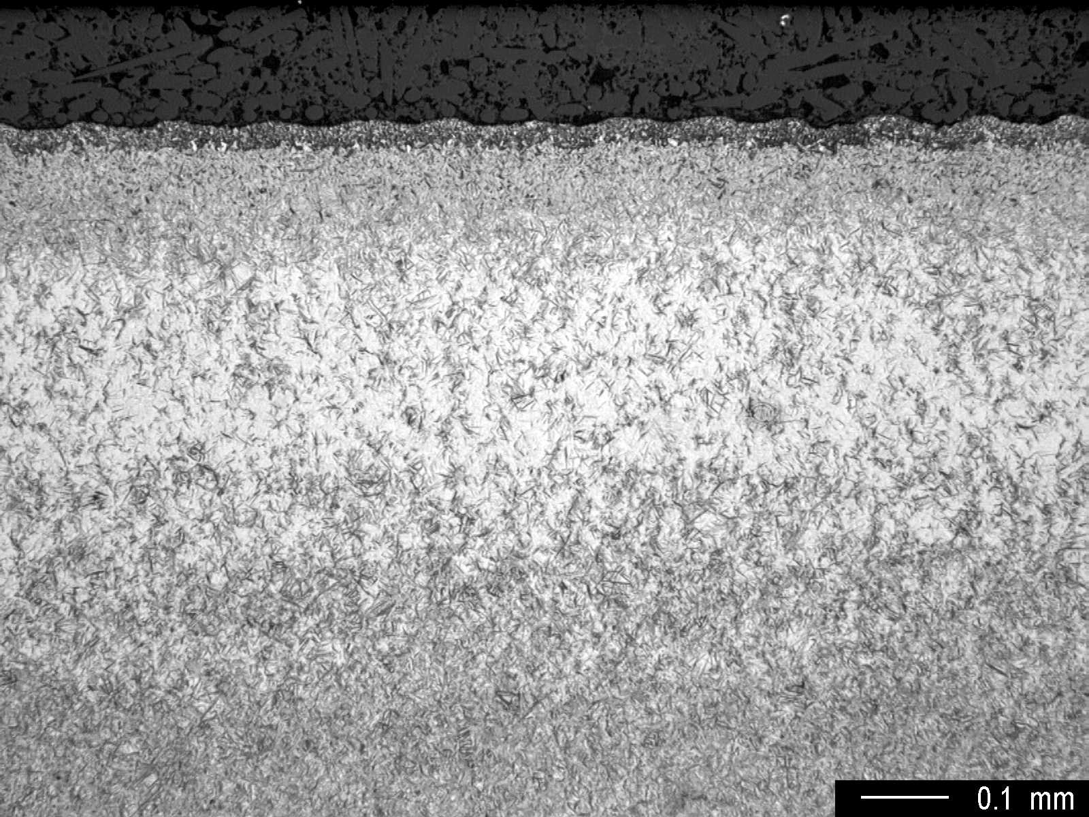

Fig.2 Microstructure at the surface showing bainite regions (darker and lighter phases
at the subsurface), 40% bainite estimated, medium magnification.

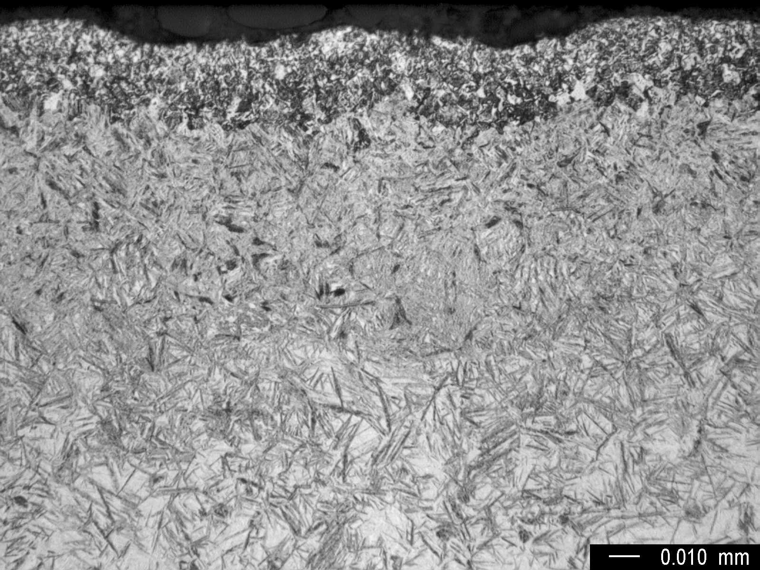

Fig.3 Microstructure at the surface showing transformation product,
bainite and martensite, high magnification.

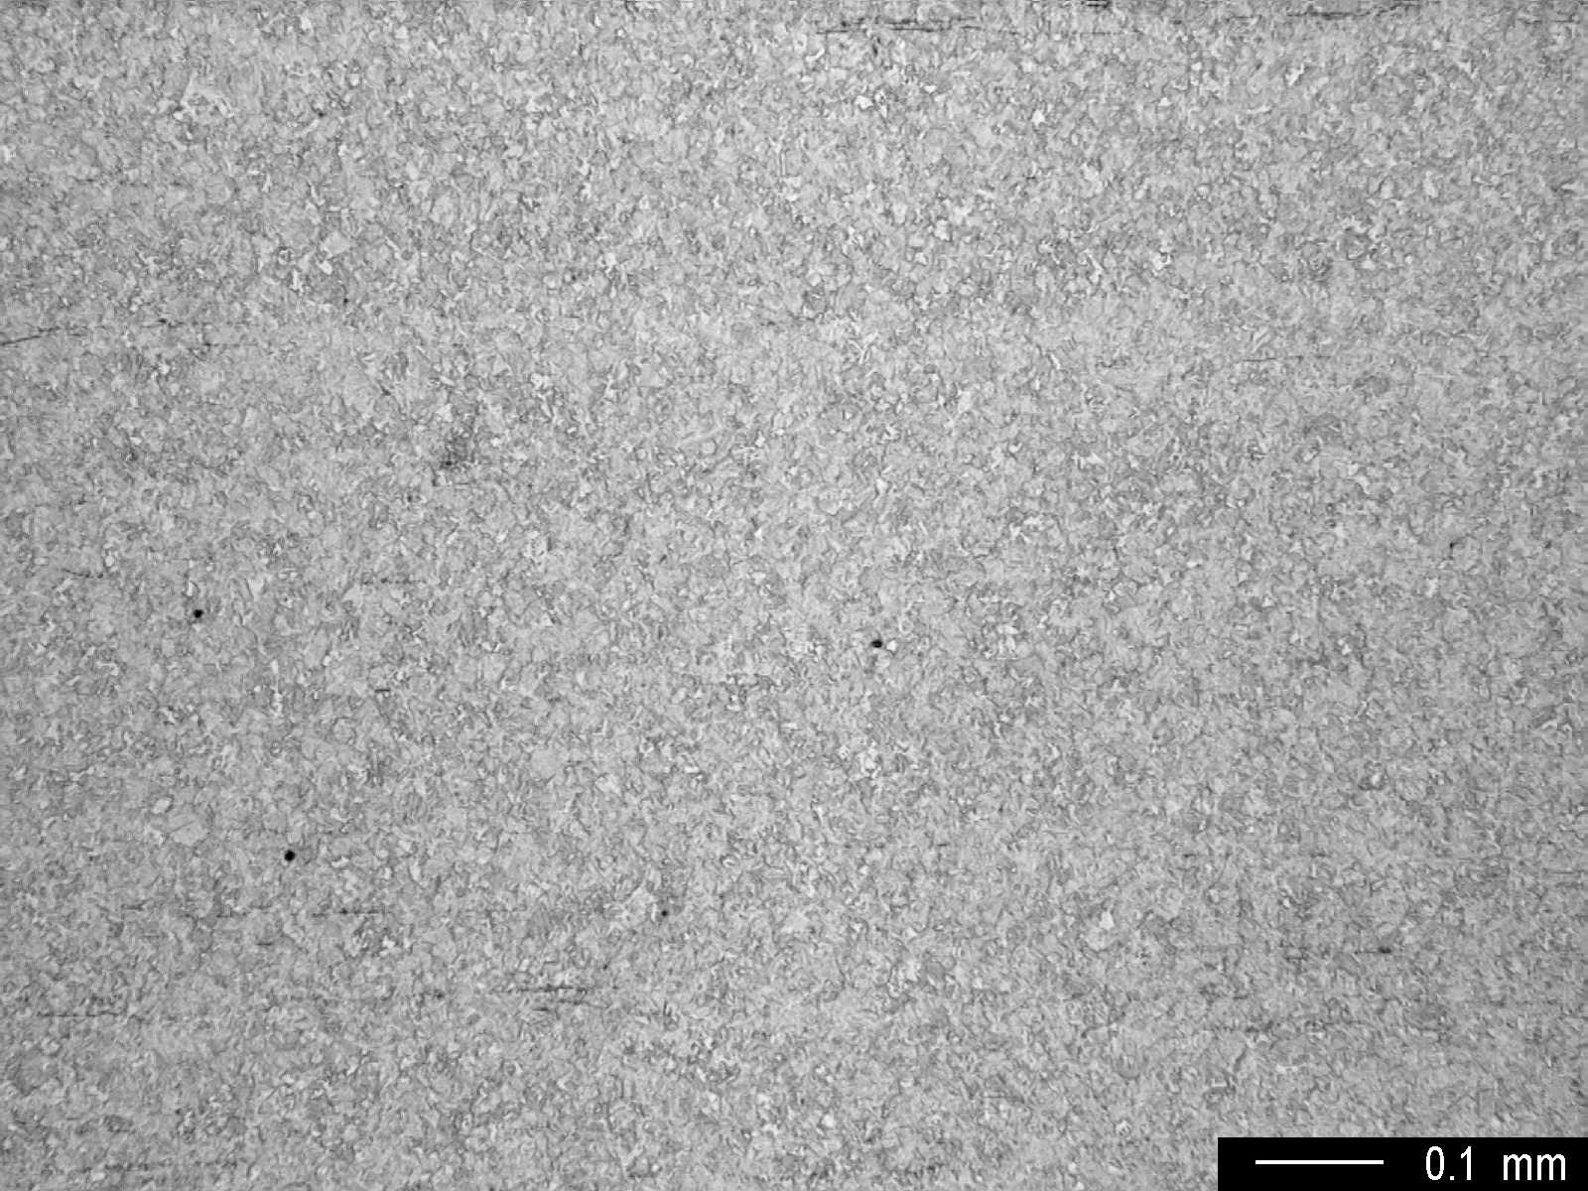

Fig.4 Core microstructure, medium magnification.

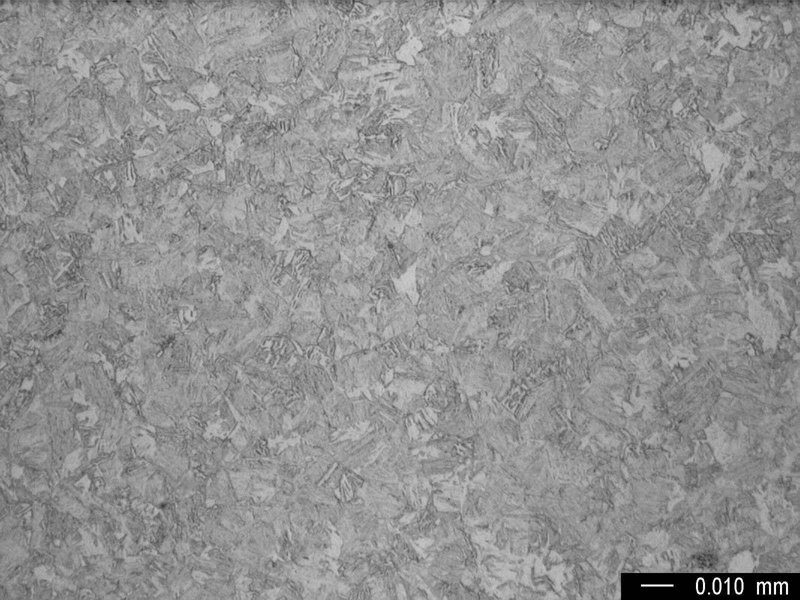

Fig.5 Core microstructure, tempered martensite with a small amount of ferrite,
high magnification.

Summary/Conclusion/Recommendations

This sample represents a series of test specimens prepared for iteration 89 of the AISI fatigue properties database. The objective for this iteration was to achieve a microstructure of approximately 50% martensite and 50% bainite. The metallographic examination reveals that a 40-50% bainite content has been achieved and the objective met. The results shall be forwarded to AISI and DCX for use in the materials database.

