THIS REPORT SHALL NOT BE REPRODUCED EXCEPT IN FULL WITHOUT THE CONSENT OF THE MATERIALS ENGINEERING DEPARTMENT.

LAB NO. | : | 2015-0134 | PART NO. | : | N/A
PART NAME | : | aISI TENSILE bARS | PRINT REV. | : | N/A
REP. TITLE | : | TENSILE BARS – aisi | MODEL | : | N/A
MARKINGS | : | 20MnCr5, 4320, 8620, 8620 DANA, 9310 | HEAT CODE | : | 136
MATERIAL | : | 20MnCr5, 4320, 8620, 9310 | MFG. DATE | : | n/a
VENDOR | : | N/A | SAMP. REQ. | : | n/a
CUSTOMER | : | N/A | VIN | : | n/a
TAR NO. | : | N/A | MAR NO. | : | sr-15105
TEST ENG. | : | N/A | REC’D DATE | : | 2/13/15
REQ. BY | : | MIKE FOLLIS | REP. DATE | : | 2/18/15
REP. BY | : | kyle buente | NO. OF PAGES | : | 16
ADD. COMMENTS | : | Recipe #136 related to carbon bar 2250

COPIES | : | GREG FETT, DANA COMBS, mike follis

REQUEST | : | On AISi and Dana through carburized bars check surface and core hardness on grip diameter. run traverse across grip and necked down area along with microstructure analysis.

REASON | : | hardness was reportedly low when checked at the university of waterloo on the grip ends.

RESULTS | :

vISUAL INSPECTION

a total of five test bars were received. each samples marked respectively with their material composition. all bars are the same size, shape, and surface finish.

SURFACE HARDNESS ASTM E18-14

SURFACE HARDNESS TAKEN AS DIRECT ROCKWELL INDENTATION ON THE SAMPLES IN HRC AND HR15N ON THE TENSILE BAR GRIPS.

SAMPLE | HARDNESS |  |  |  | specification
20MnCr5 | HRC | 59 | 57 | 58 | 57 min
 | HR15N | 89 | 91 | 90 | 89 min
4320 | HRC | 59 | 59 | 58 | 57 min
 | HR15N | 89 | 90 | 91 | 89 min
8620 | HRC | 59 | 60 | 60 | 57 min
 | HR15N | 91 | 88* | 91 | 89 min
8620 DANA | HRC | 58 | 61 | 60 | 57 min
 | HR15N | 89 | 88* | 89 | 89 min
9310 | HRC | 55* | 56 | 56 | 56 min
 | HR15N | 89 | 88 | 89 | 88 min
* below specification

micro-hardness astm e384-11

hardness readings were done using a 500g load reported in vickers and then converted to hrc

DISTANCE BELOW  SURFACE  (inches) | LARGE DIAMETER
 | 20MnCr5 | 4320 | 8620 | DANA 8620 | 9310
0.002 | 60.3 | 59.8 | 61.4 | 61.8 | 58.3
0.004 | 60.9 | 60.7 | 61.8 | 61.2 | 57.2
0.006 | 62.0 | 60.9 | 61.4 | 62.0 | 57.9
0.008 | 61.4 | 61.2 | 62.0 | 61.4 | 58.5
0.010 | 61.6 | 60.7 | 61.8 | 62.0 | 58.3
0.015 | 61.5 | 61.4 | 62.0 | 61.8 | 59.6
0.020 | 61.0 | 60.0 | 62.2 | 61.8 | 58.5
0.025 | 60.9 | 60.5 | 62.2 | 61.6 | 59.6
0.030 | 60.5 | 60.7 | 61.5 | 62.0 | 58.8
0.035 | 60.0 | 60.5 | 61.6 | 61.4 | 58.1
0.040 | 59.8 | 60.5 | 61.6 | 61.4 | 58.8
0.045 | 59.4 | 59.8 | 61.4 | 60.7 | 57.9
0.050 | 59.0 | 60.3 | 61.4 | 60.5 | 58.1
0.060 | 58.3 | 59.2 | 61.2 | 60.3 | 56.6
0.070 | 57.2 | 58.5 | 59.6 | 59.6 | 55.4
0.080 | 56.3 | 57.4 | 59.0 | 58.8 | 53.7
0.090 | 54.3 | 56.6 | 57.9 | 57.9 | 51.8
0.100 | 53.7 | 55.0 | 56.8 | 55.9 | 50.2
0.120 | 50.5 | 51.8 | 52.6 | 52.6 | 46.9
0.140 | 47.2 | 48.4 | 50.5 | 50.7 | 43.2
0.160 | 46.6 | 46.6 | 48.4 | 47.2 | 41.7
0.180 | 46.6 | 44.3 | 47.7 | 47.7 | 40.8
0.200 | 46.6 | 44.7 | 46.6 | 46.0 | 40.8
0.220 | 45.3 | 44.1 | 46.4 | 46.9 | 39.9
0.240 | 46.2 | 43.8 | 45.8 | 45.5 | 39.9
0.260 | 47.5 | 44.5 | 46.4 | 44.9 | 39.9

DISTANCE BELOW  SURFACE  (inches) | SMALL DIAMETER
 | 20MnCr5 | 4320 | 8620 | DANA 8620 | 9310
0.002 | 60.9 | 60.0 | 62.0 | 61.4 | 58.3
0.004 | 61.5 | 61.2 | 62.0 | 62.0 | 58.5
0.006 | 62.2 | 61.8 | 62.2 | 62.0 | 59.2
0.008 | 61.4 | 60.5 | 62.4 | 62.2 | 58.8
0.010 | 61.6 | 60.5 | 62.4 | 62.0 | 58.8
0.015 | 61.5 | 61.2 | 62.0 | 61.6 | 58.5
0.020 | 62.4 | 61.2 | 61.8 | 62.2 | 60.3
0.025 | 61.4 | 61.4 | 62.7 | 62.0 | 60.0
0.030 | 62.0 | 60.9 | 62.2 | 61.8 | 58.3
0.035 | 61.4 | 60.9 | 62.2 | 61.2 | 59.6
0.040 | 62.2 | 61.8 | 62.0 | 62.0 | 59.2
0.045 | 61.2 | 61.8 | 62.2 | 62.0 | 59.2
0.050 | 61.8 | 61.4 | 62.4 | 62.0 | 58.5
0.060 | 61.8 | 61.2 | 61.6 | 62.4 | 59.0
0.070 | 61.6 | 61.4 | 63.1 | 62.4 | 58.1
0.080 | 61.8 | 60.5 | 62.2 | 63.1 | 58.5
0.090 | 61.5 | 60.5 | 62.0 | 62.2 | 58.3
0.100 | 62.4 | 60.5 | 62.0 | 61.8 | 59.0

Core Hardness astm e18-14

CORE HARDNESS TAKEN AS direct hrc on mounted TRAVERSE cross sections OF THE TENSILE BAR GRIPS.

SAMPLE | HARDNESS (hrc)
20MnCr5 | 46 | 46
4320 | 43 | 43
8620 | 45 | 46
8620 DANA | 45 | 45
9310 | 40 | 40

mICROSTRUCTURE

for each sample the grip case MICROSTRUCTURE consists of tempered martensite. the core
consists of tempered martensite and transformation products. the surface of each sample has
pitting from the vacuum gas carburizing process.

the small diameter section is through hardened consisting of tempered martensite and traces of
retained austenite.

other characteristics specific to each material can be found below
20mncr5 | : | the small diameter also has a subsurface crack along the grain boundaries and a crack in the large diameter area along grain boundaries from stress due to the cutting process. grain growth was also noted.
9310/8620 | : | grain growth is evident in both the large and small diameter.
8620 Dana | : | a subsurface crack was found in the large diameter and grain growth can be seen in both small and large diameters

cONCLUSION

The aisi Test bars are consistently hard throughout the testing diameter with tempered martensite throughout the MICROSTRUCTURE. the 9310 bars are 58-60 hrc while the other steels are 60-63 hrc. the grip area or large diameter has an effective case depth of 0.100” – 0.140” depending on the steel grade. abnormal grain growth or duplex grain growth was noted on all grades except the 4320. pitting OCCURRED at the surface of the bars from the vacuum gas CARBURIZING PROCESS.

it appears there are some questionable readings when the hardness is measured on the surface at the grip ends. this is most likely a result of the small bAR SIZE AND PROPER SEATING OF THE SAMPLE.

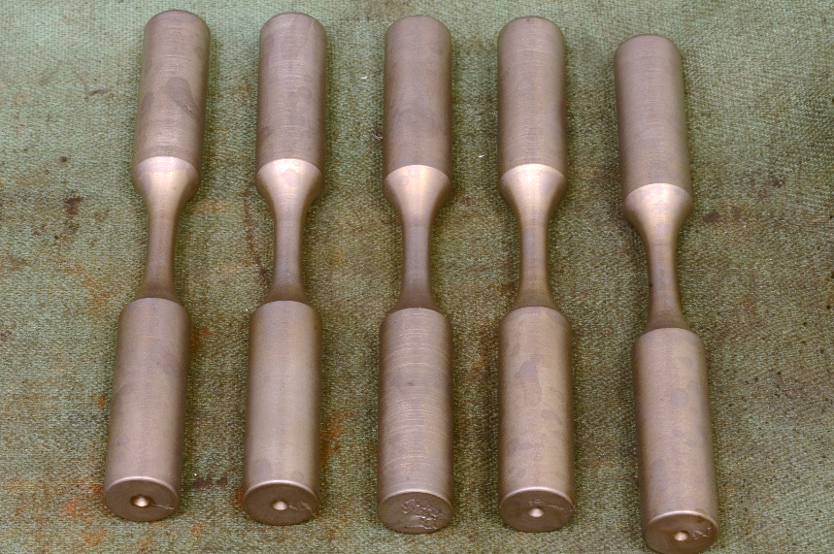 | 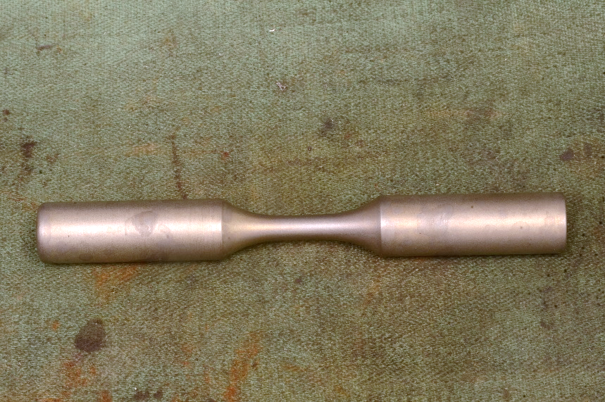  SMALL DIAMETER  (TEST)  LARGE DIAMETER  (GRIP)
FIGURE 1: 5 AISI TEST BARS AS RECEIVED | FIGURE 2: TEST BAR GEOMETRY AND SECTIONS MADE
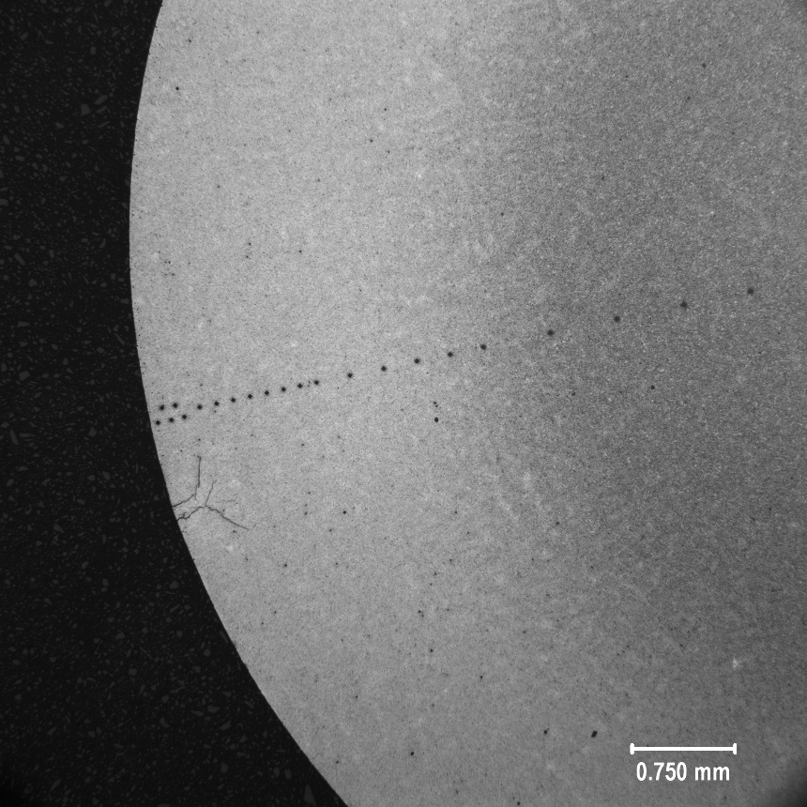 | 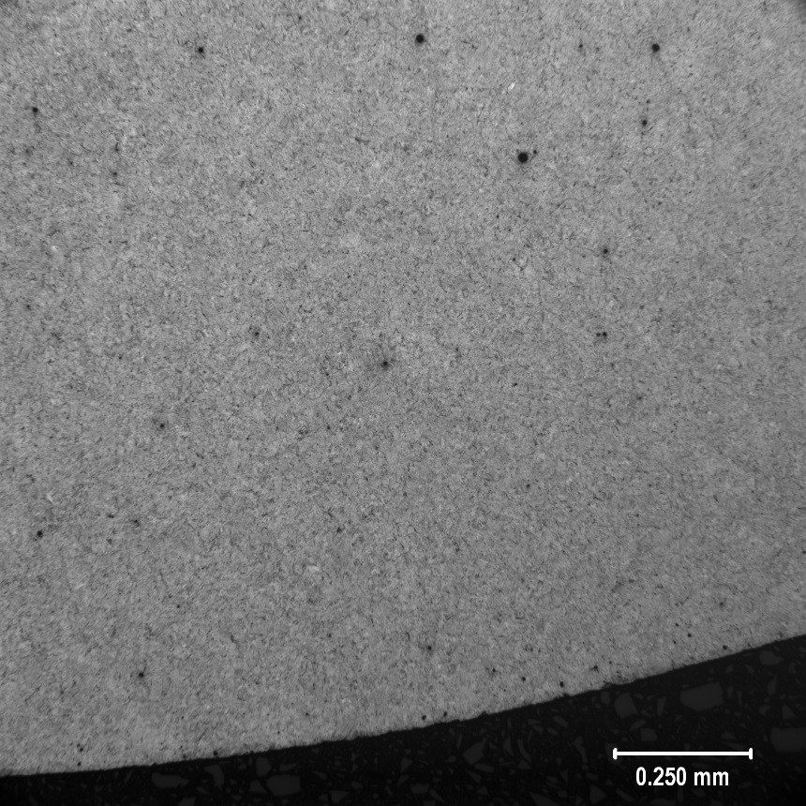
FIGURE 3: 20MnCr5 GRIP CASE MICROSTRUCTURE 25X | FIGURE 4: 20MnCr5 GRIP CASE MICROSTRUCTURE 100X
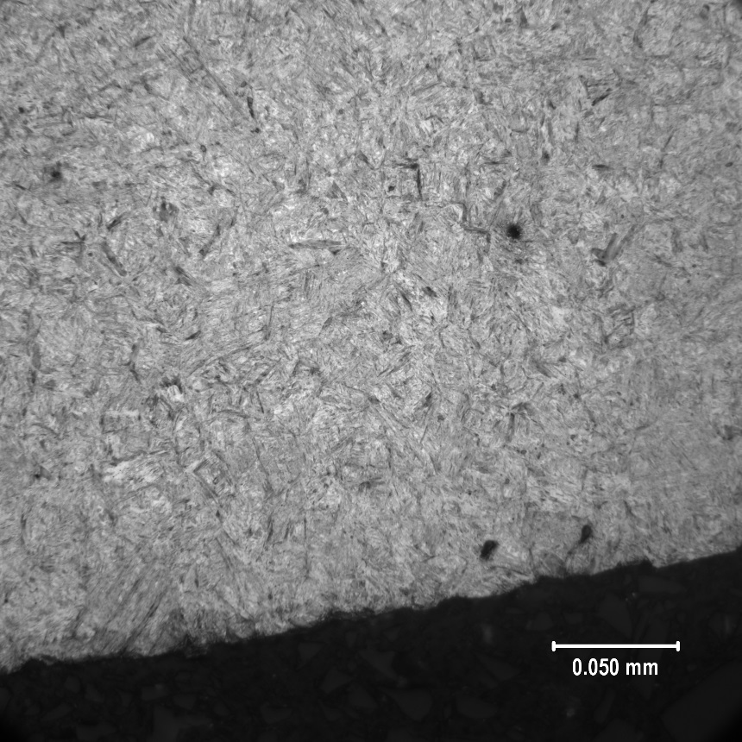 | 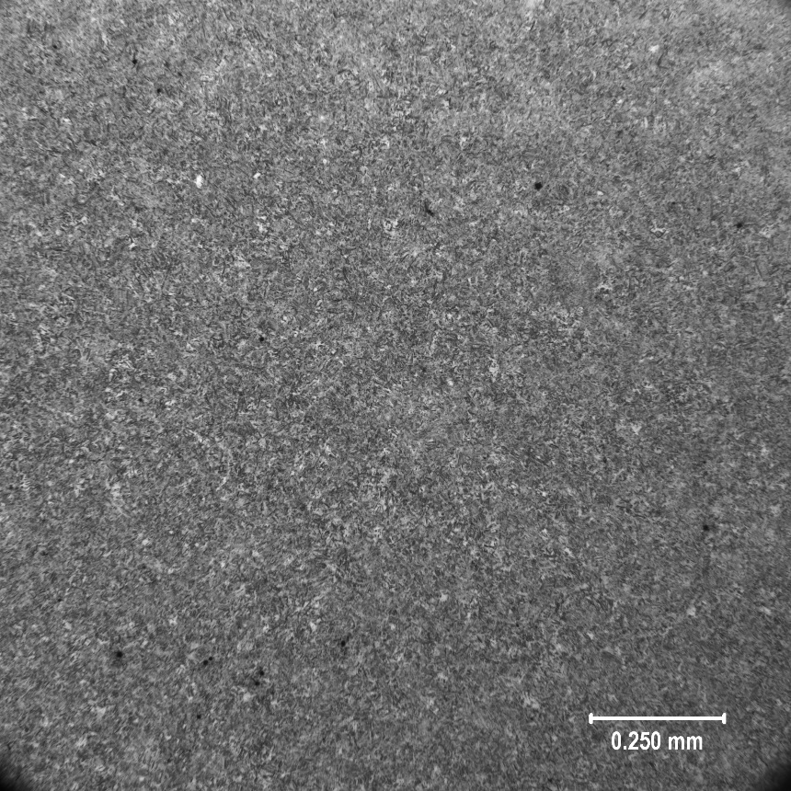
FIGURE 5: 20MnCr5 GRIP CASE MICROSTRUCTURE 500X | FIGURE 6: 20MnCr5 GRIP CORE MICROSTRUCTURE 100X
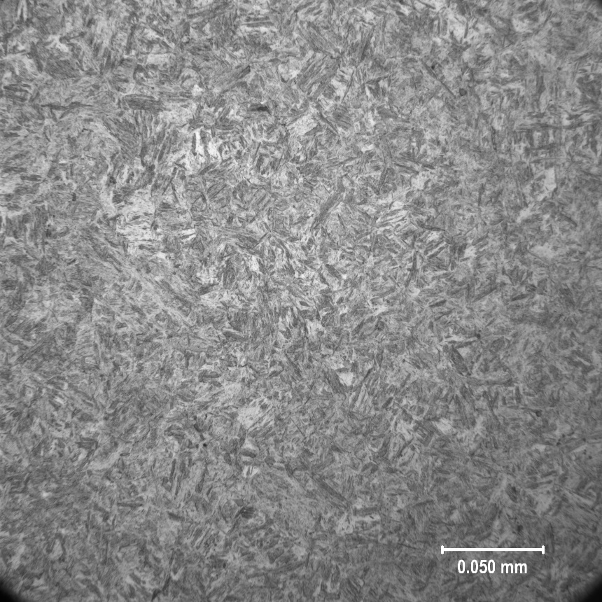 | 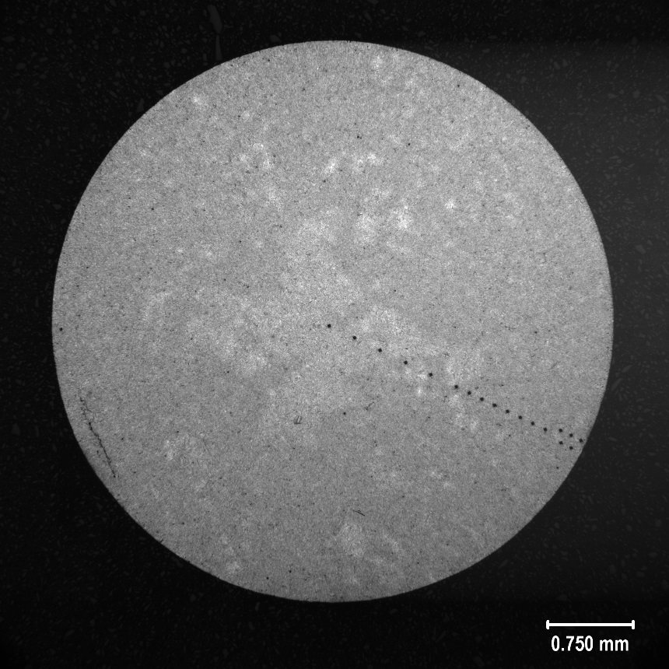
FIGURE 7: 20MnCr5 GRIP CORE MICROSTRUCTURE 500X | FIGURE 8: 20MnCr5 CASE MICROSTRUCTURE 25X
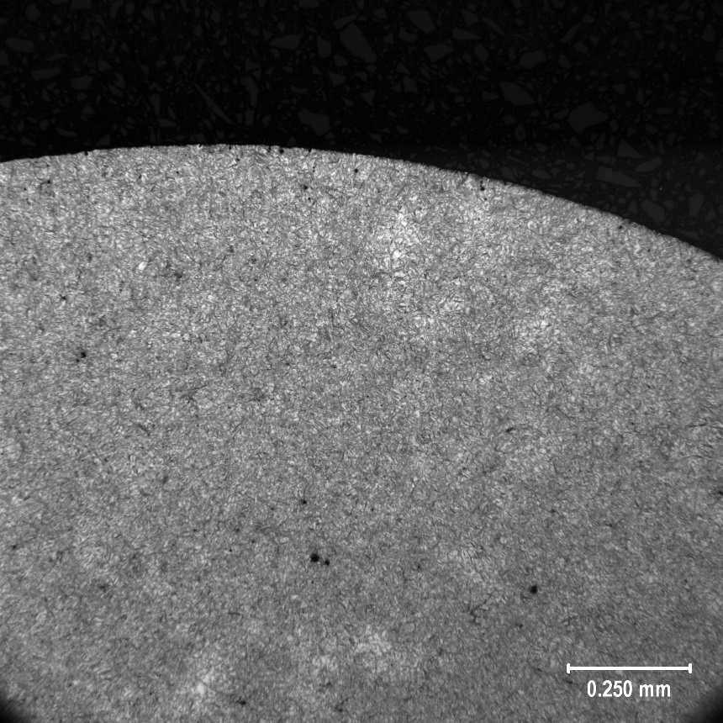 | 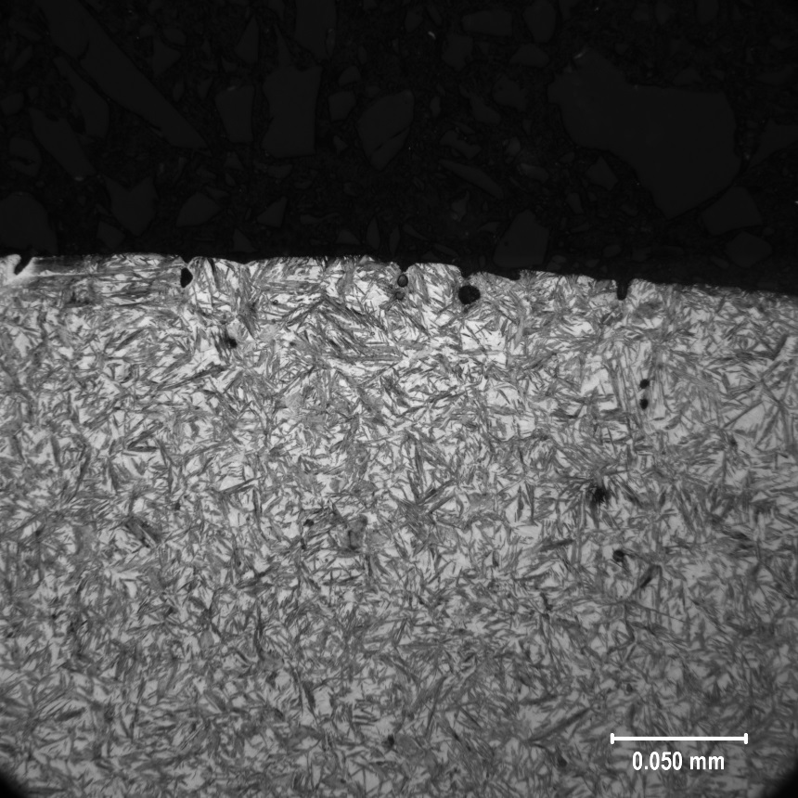
FIGURE 9: 20MnCr5 CASE MICROSTRUCTURE 100X | FIGURE 10: 20MnCr5 CASE MICROSTRUCTURE 500X
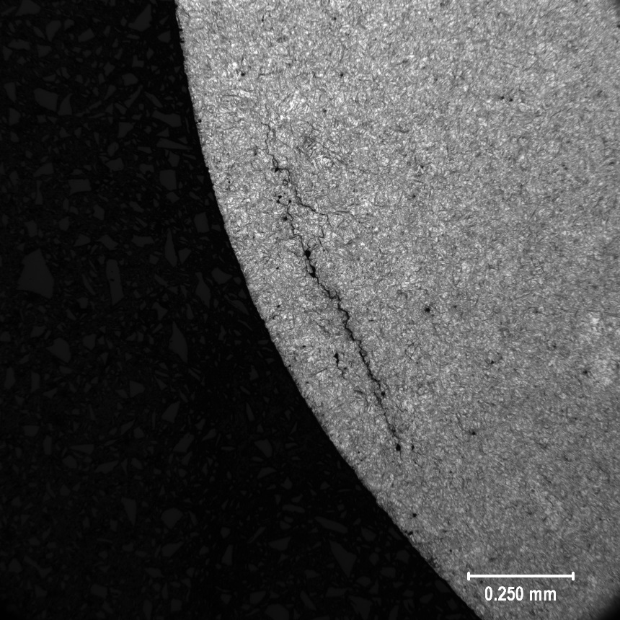
FIGURE 11: 20MnCr5 SUBSURFACE CRACK 100X
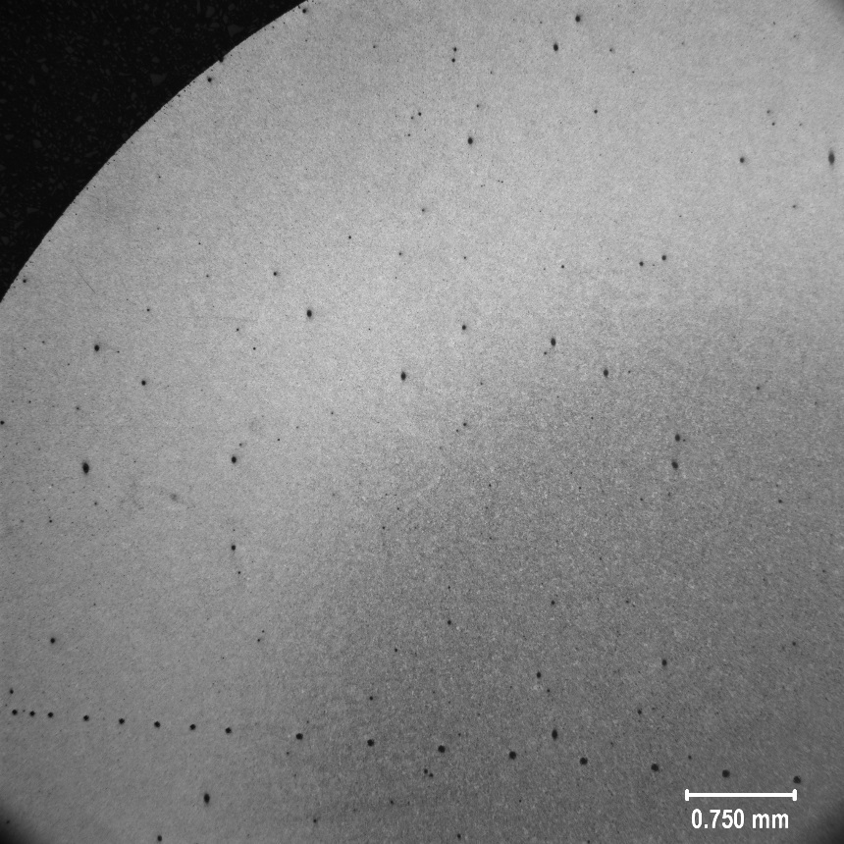 | 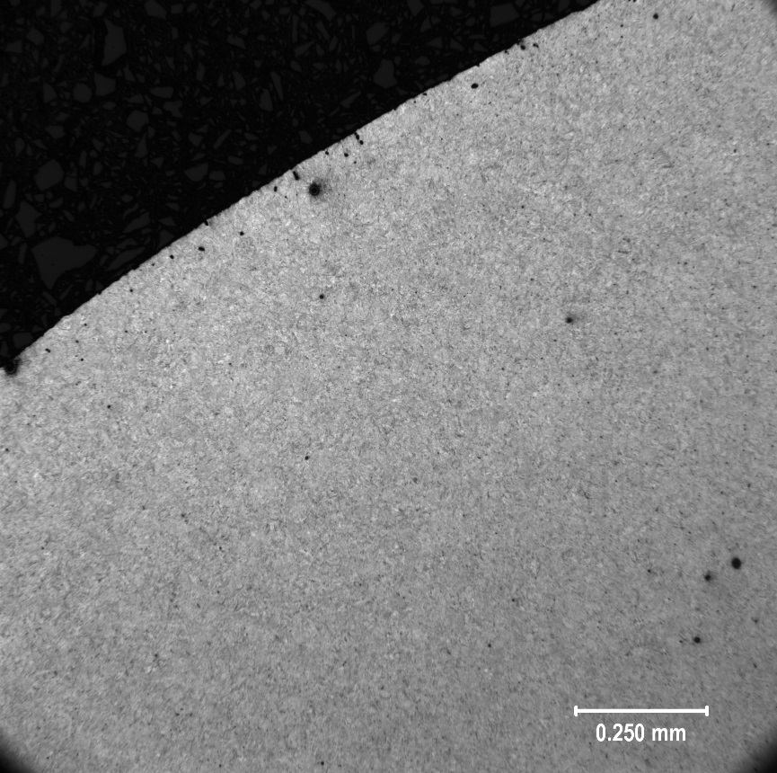
FIGURE 12: 4320 GRIP CASE MICROSTRUCTURE 25X | FIGURE 13: 4320 GRIP CASE MICROSTRUCTURE 100X
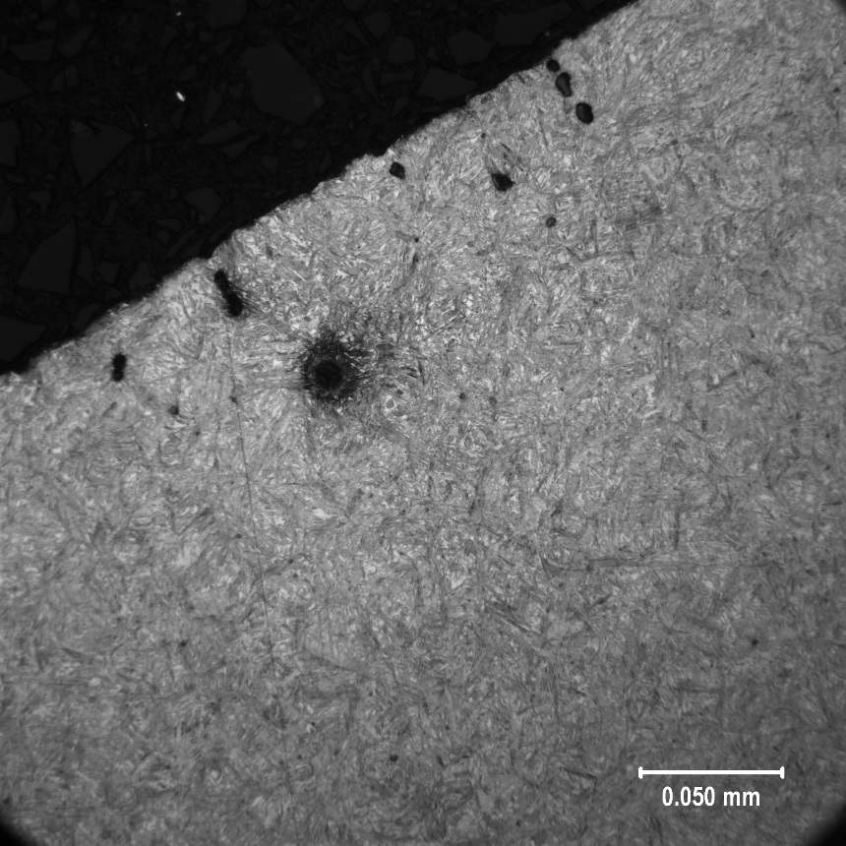 | 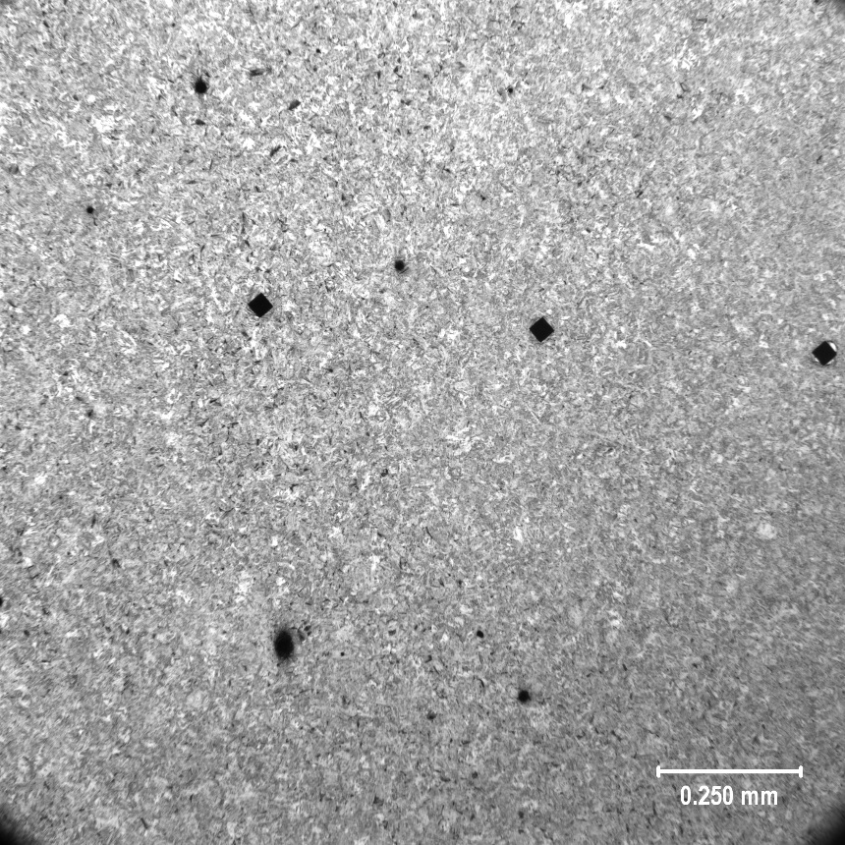
FIGURE 14: 4320 GRIP CASE MICROSTRUCTURE 500X | FIGURE 15: 4320 GRIP CORE MICROSTRUCTURE 100X
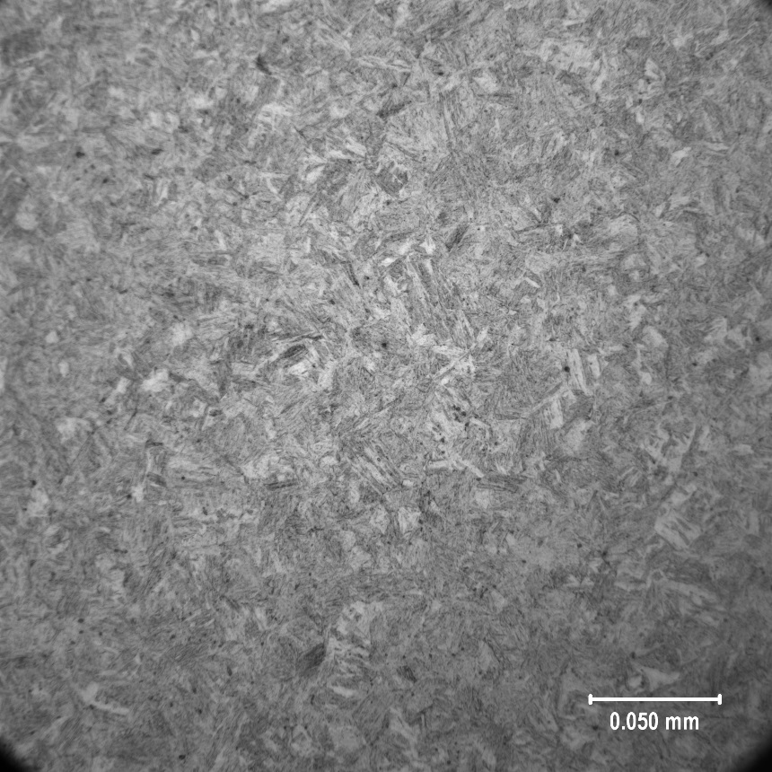 | 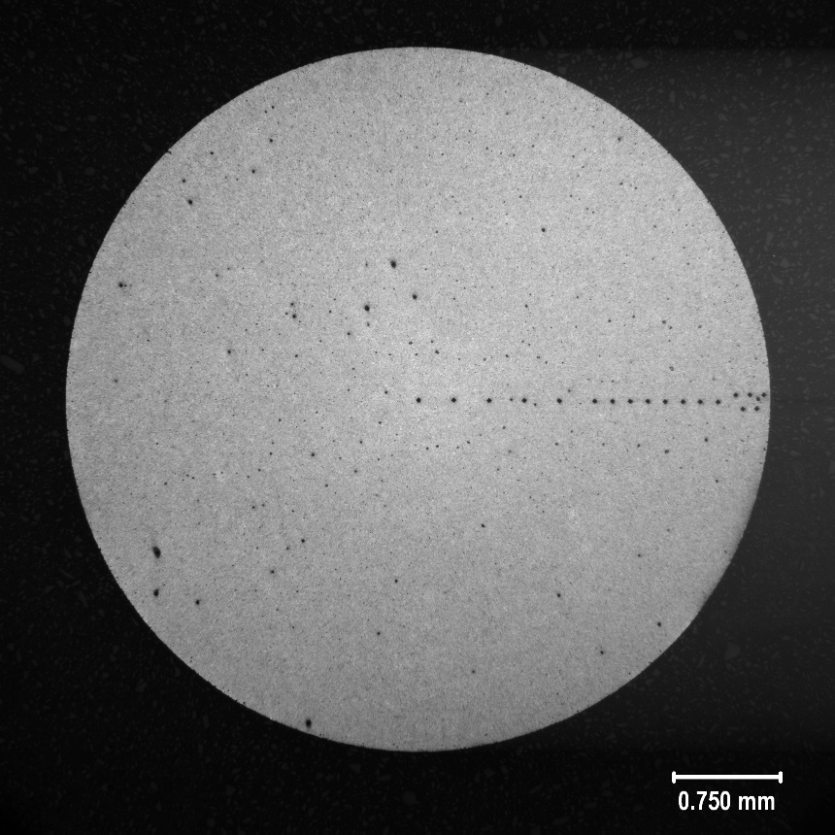
FIGURE 16: 4320 GRIP CORE MICROSTRUCTURE 500X | FIGURE 17: 4320 CASE MICROSTRUCTURE 25X
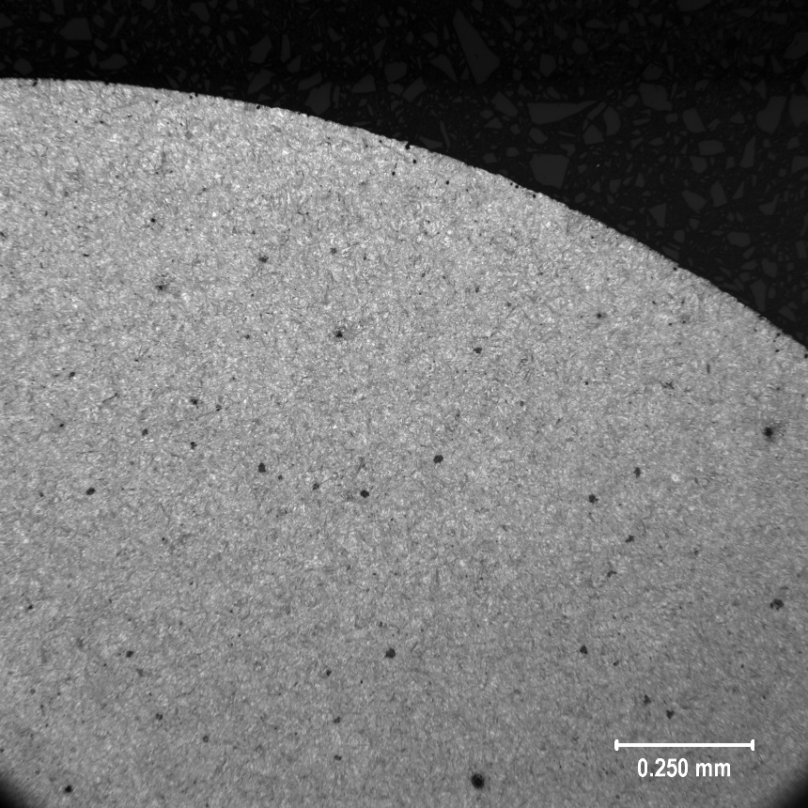 | 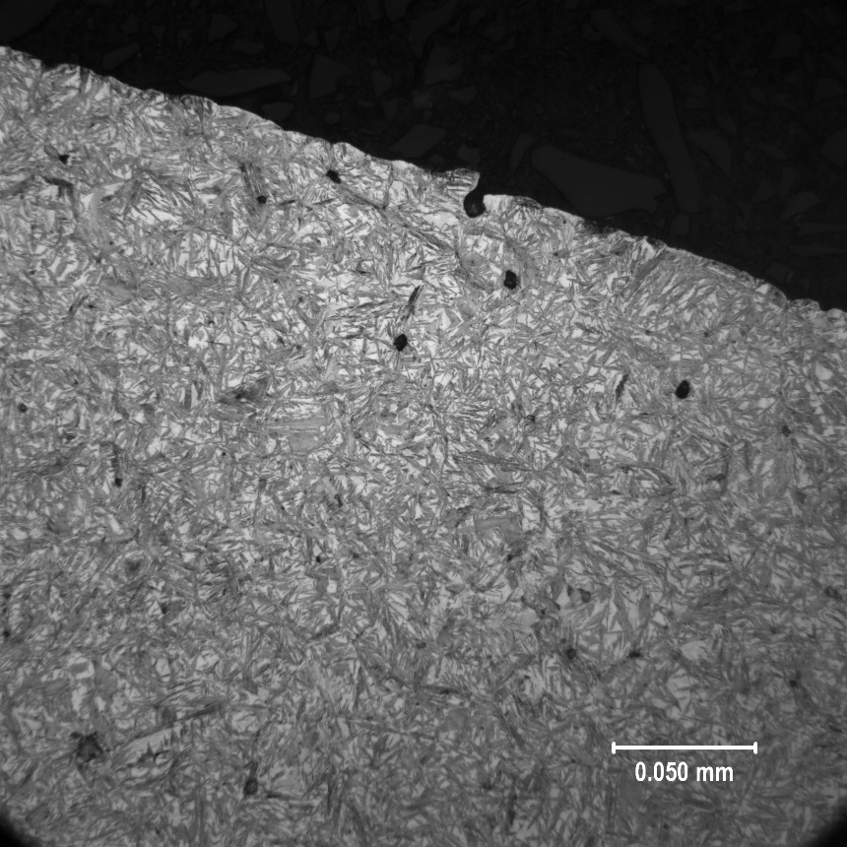
FIGURE 18: 4320 CASE MICROSTRUCTURE 100X | FIGURE 19: 4320 CASE MICROSTRUCTURE 500X
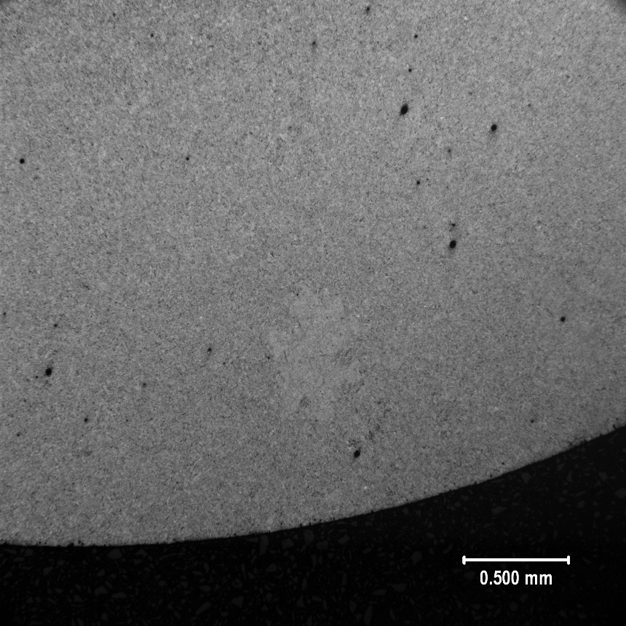 | 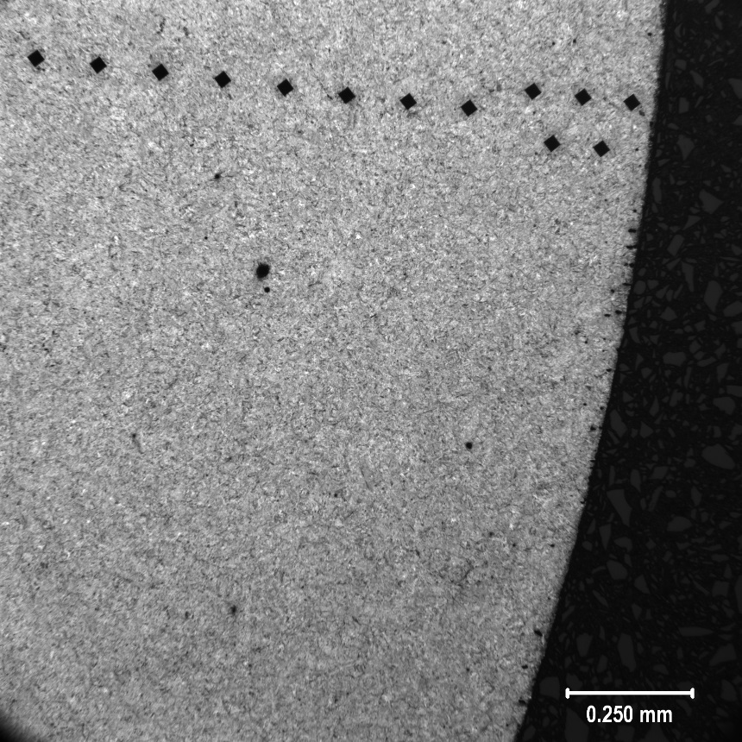
FIGURE 20: 8620 GRIP CASE MICROSTRUCTURE 25X | FIGURE 21: 8620 GRIP CASE MICROSTRUCTURE 100X
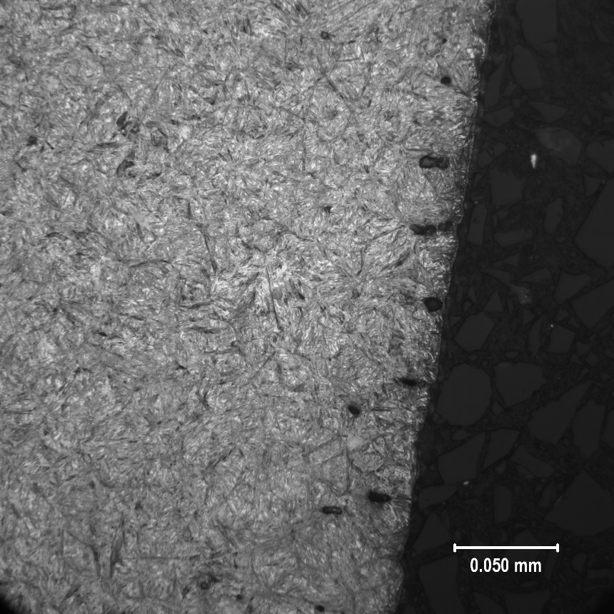 | 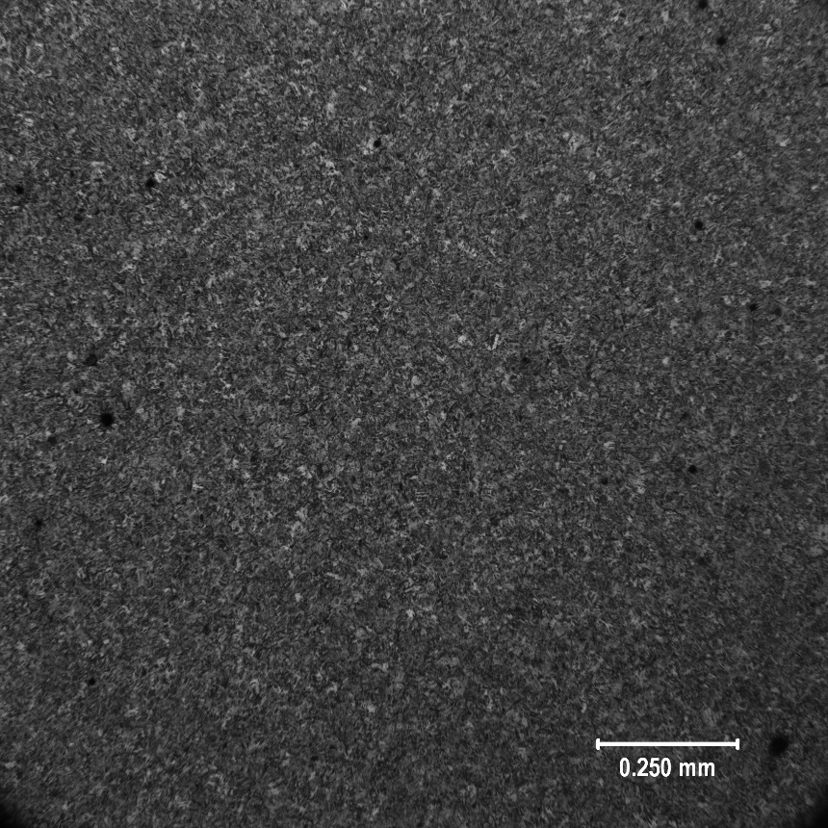
FIGURE 22: 8620 GRIP CASE MICROSTRUCTURE 500X | FIGURE 23: 8620 GRIP CORE MICROSTRUCTURE 100X
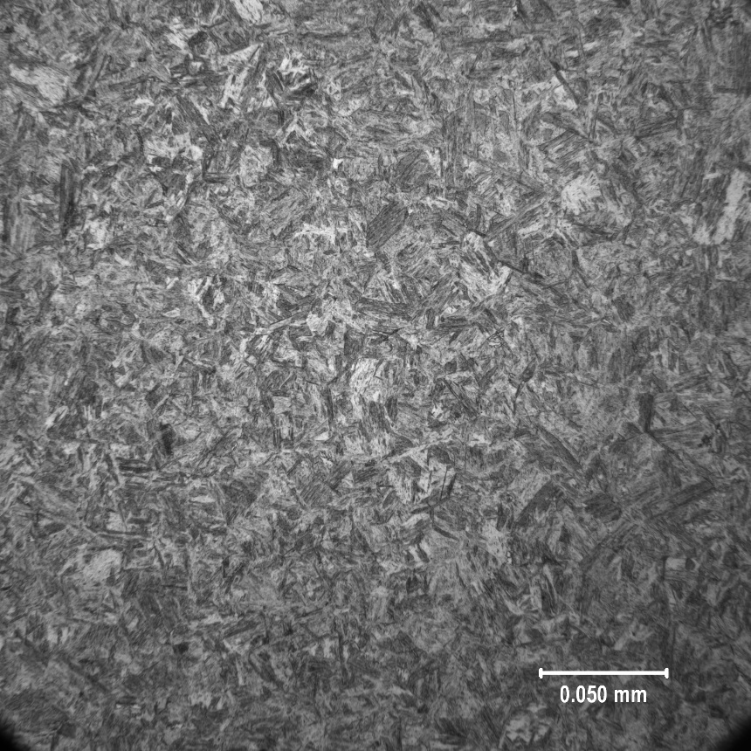 | 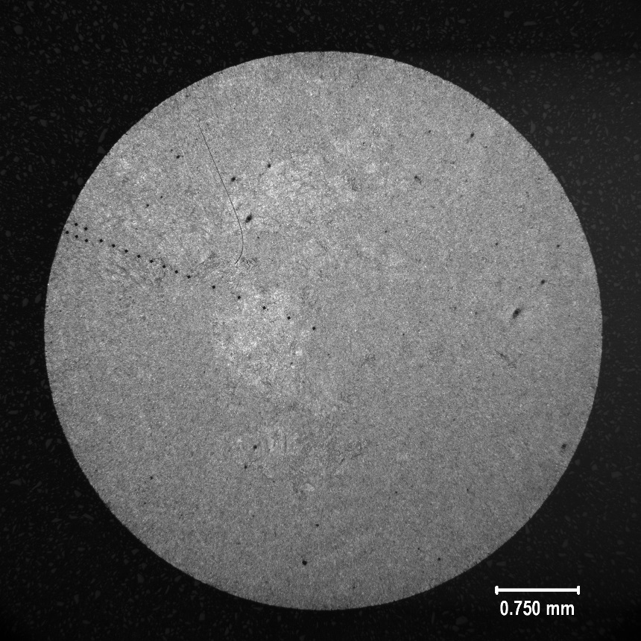
FIGURE 24: 8620 GRIP CORE MICROSTRUCTURE 500X | FIGURE 25: 8620 CASE MICROSTRUCTURE 25X
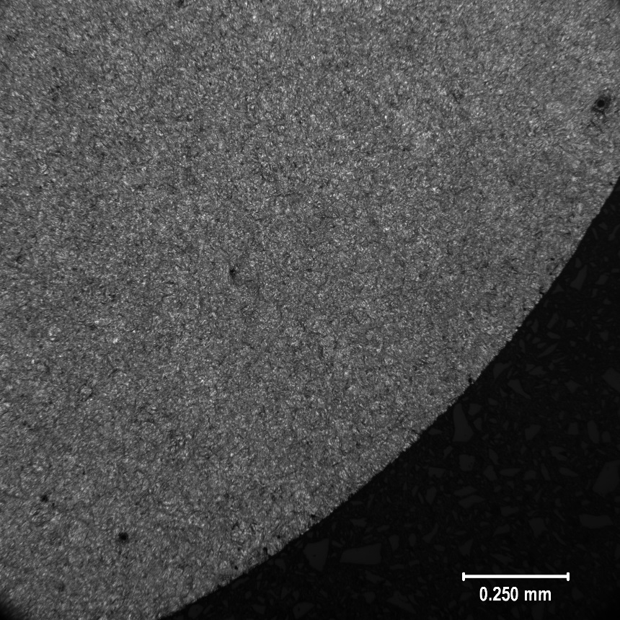 | 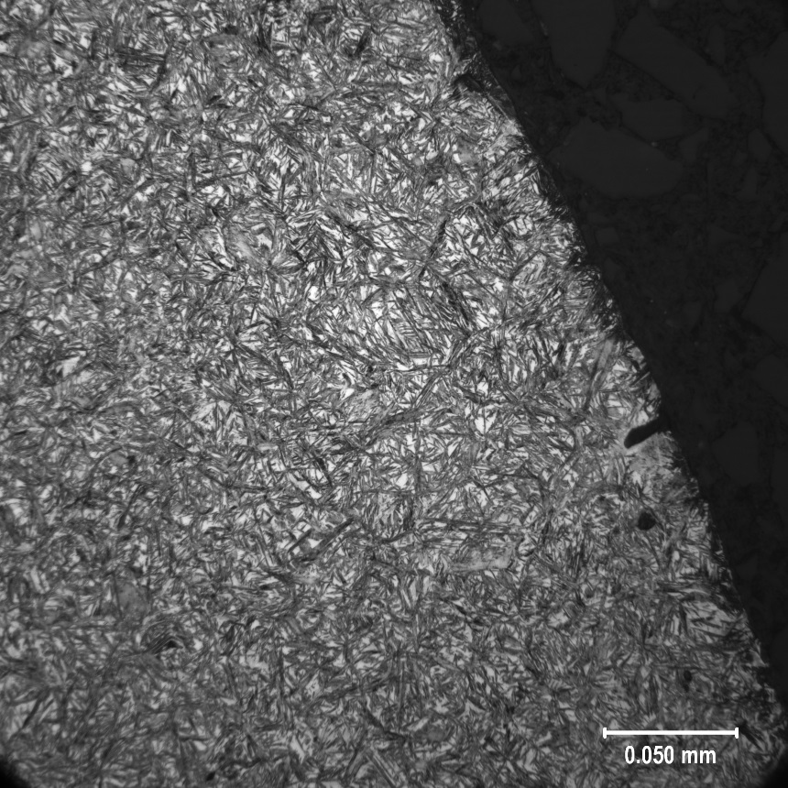
FIGURE 26: 8620 CASE MICROSTRUCTURE 100X | FIGURE 27: 8620 CASE MICROSTRUCTURE 500X
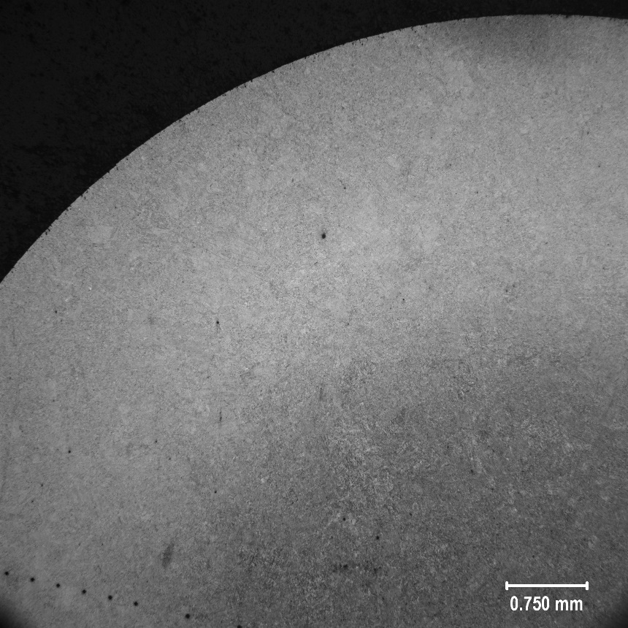 | 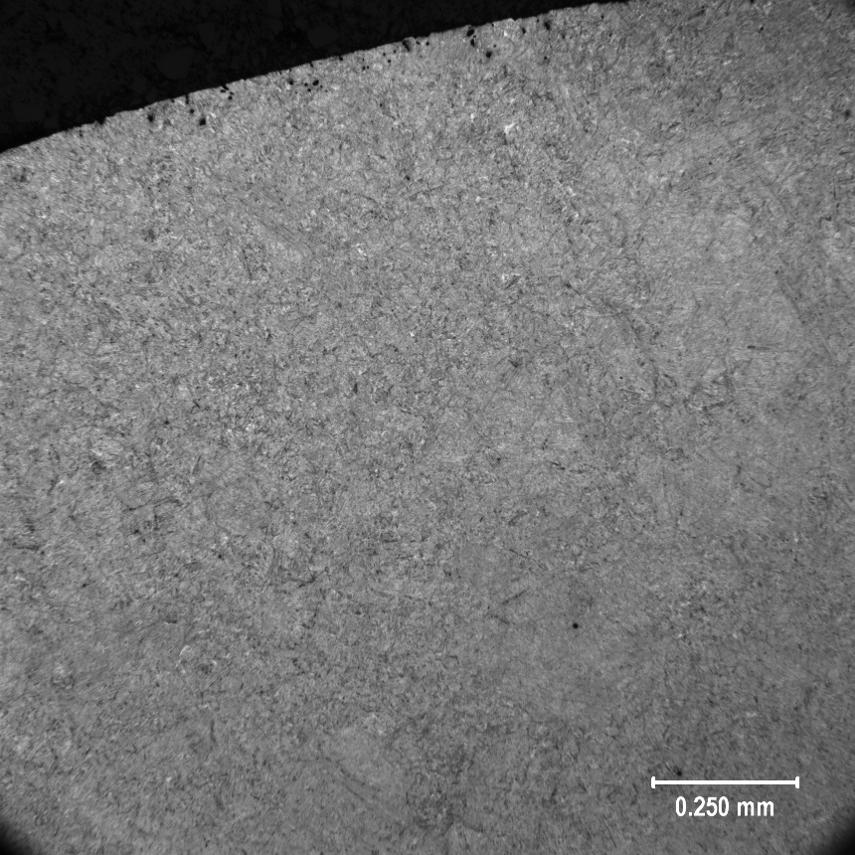
FIGURE 28: 8620 DANA GRIP CASE MICROSTRUCTURE 25X | FIGURE 29: 8620 DANA GRIP CASE MICROSTRUCTURE 100X
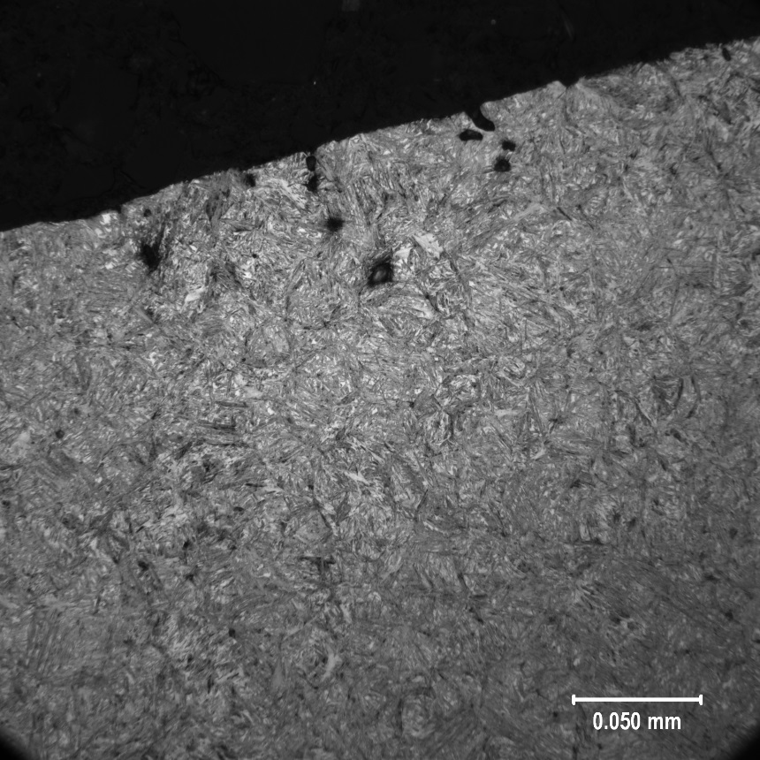 | 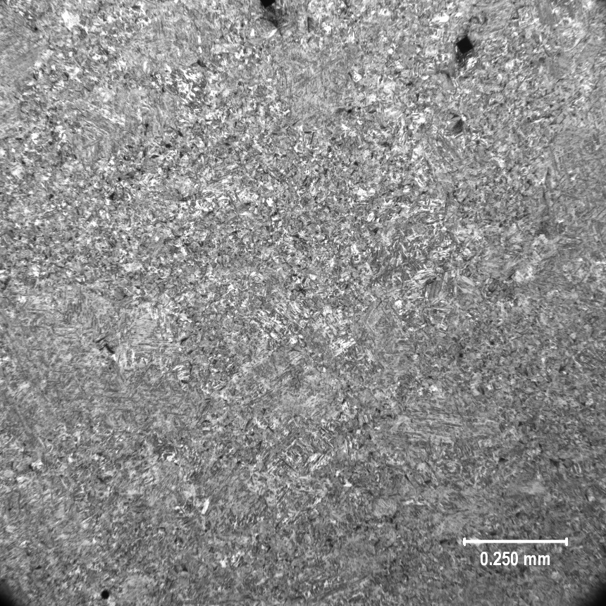
FIGURE 30: 8620 DANA GRIP CASE MICROSTRUCTURE 500X | FIGURE 31: 8620 DANA GRIP CORE MICROSTRUCTURE 100X
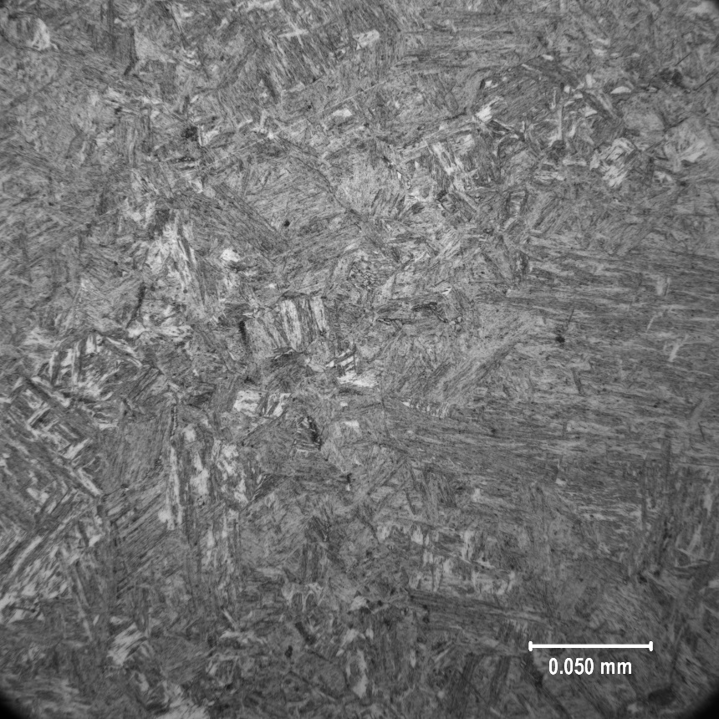 | 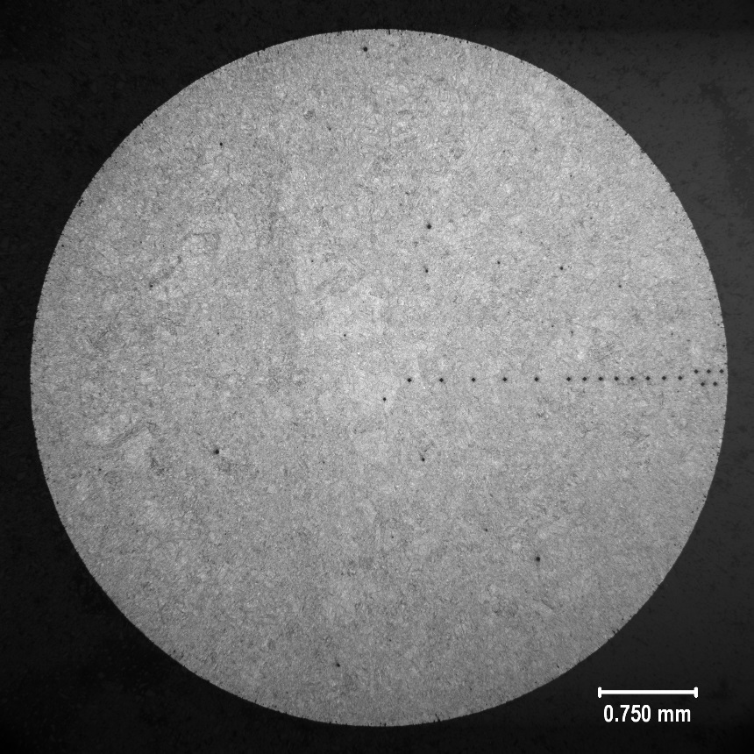
FIGURE 32: 8620 DANA GRIP CORE MICROSTRUCTURE 500X | FIGURE 33: 8620 DANA CASE MICROSTRUCTURE 25X
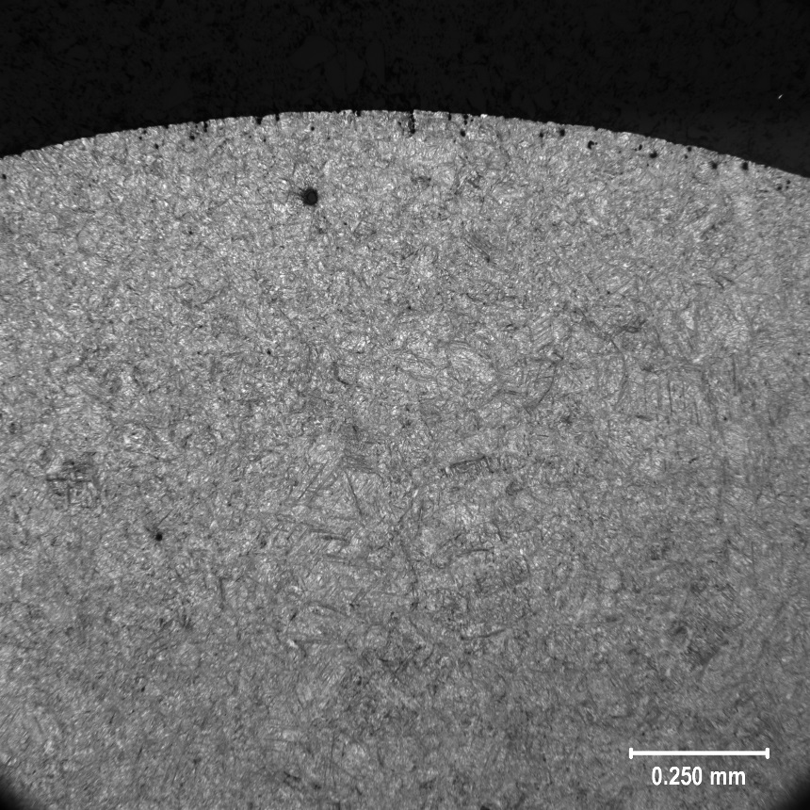 | 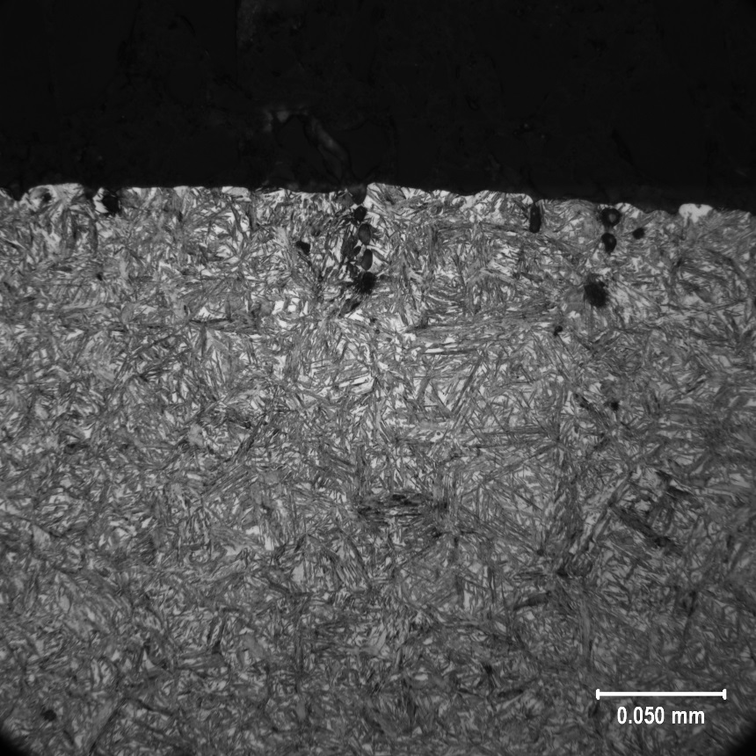
FIGURE 34: 8620 DANA CASE MICROSTRUCTURE 100X | FIGURE 35: 8620 DANA CASE MICROSTRUCTURE 500X
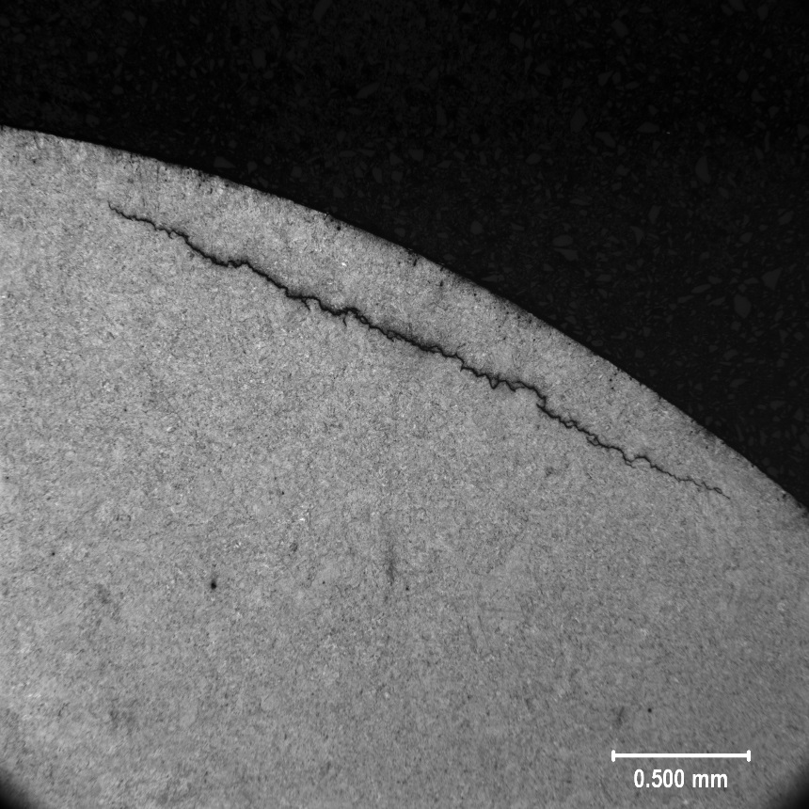
FIGURE 36: 8620 DANA SUBSURFACE CRACK 50X
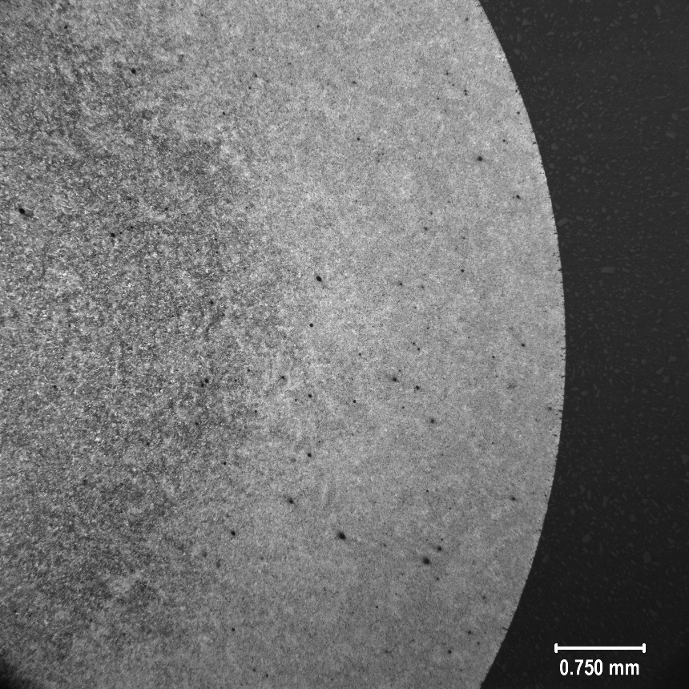 | 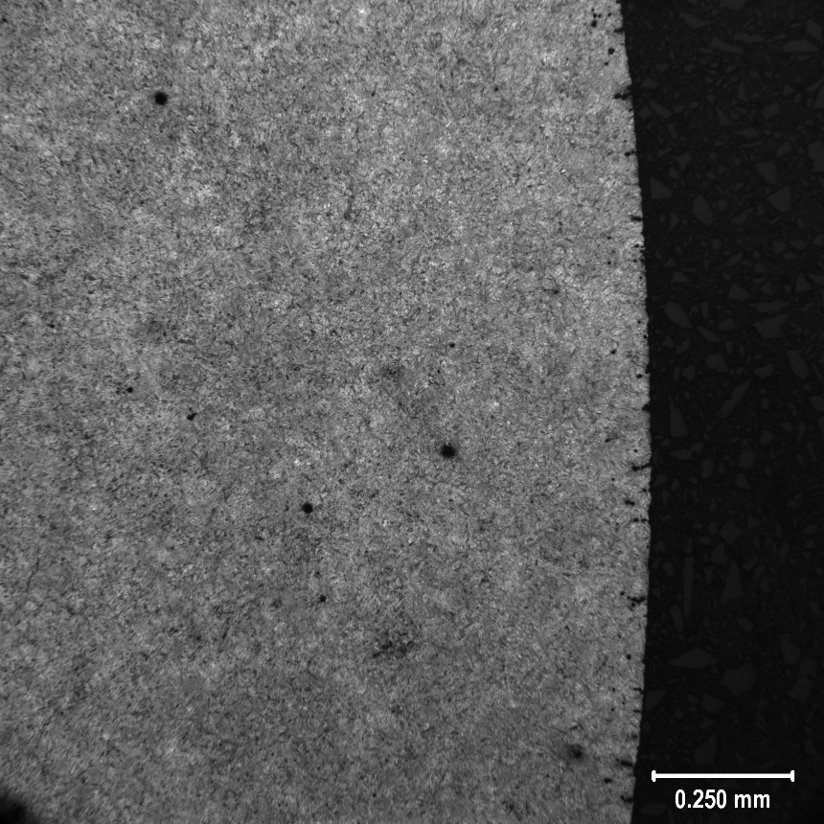
FIGURE 37: 9310 GRIP CASE MICROSTRUCTURE 25X | FIGURE 38: 9310 GRIP CASE MICROSTRUCTURE 100X
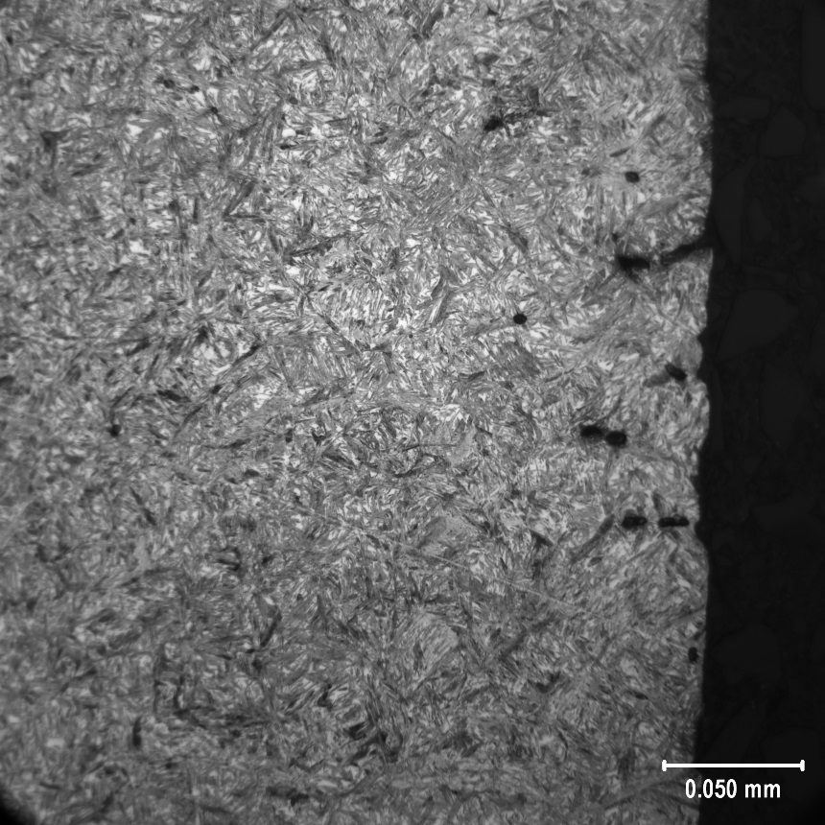 | 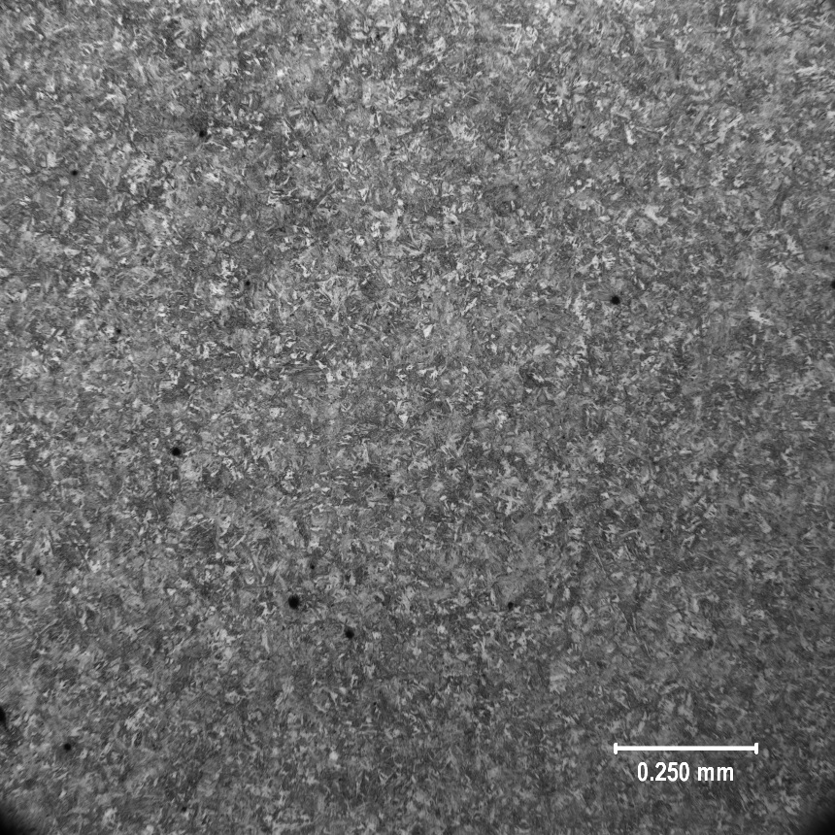
FIGURE 39: 9310 GRIP CASE MICROSTRUCTURE 500X | FIGURE 40: 9310 GRIP CORE MICROSTRUCTURE 100X
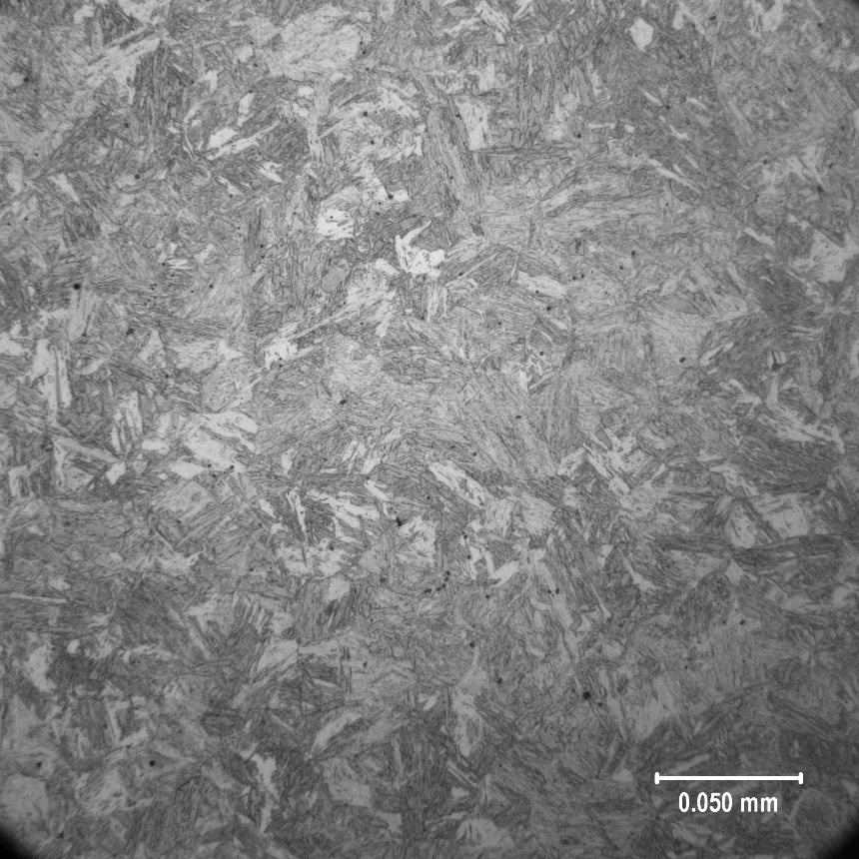 | 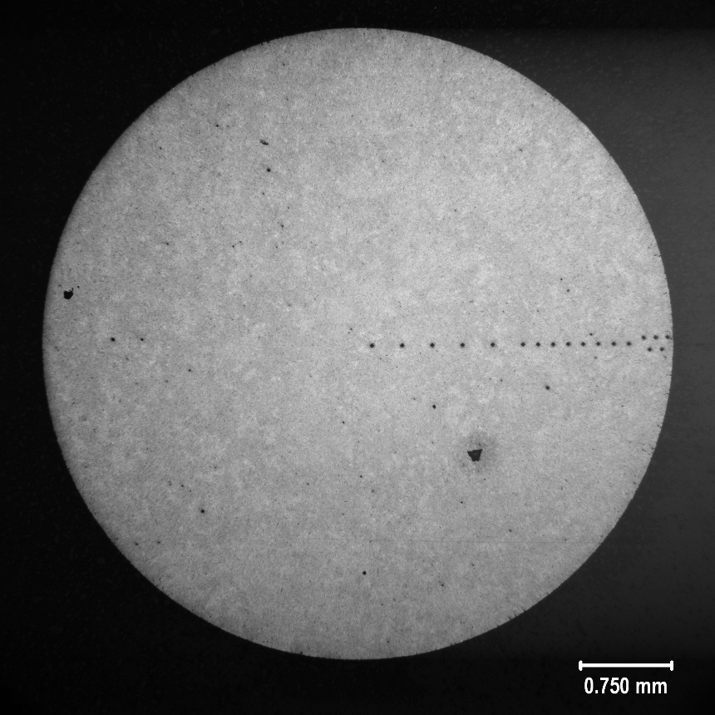
FIGURE 41: 9310 GRIP CORE MICROSTRUCTURE 500X | FIGURE 42: 9310 CASE MICROSTRUCTURE 25X
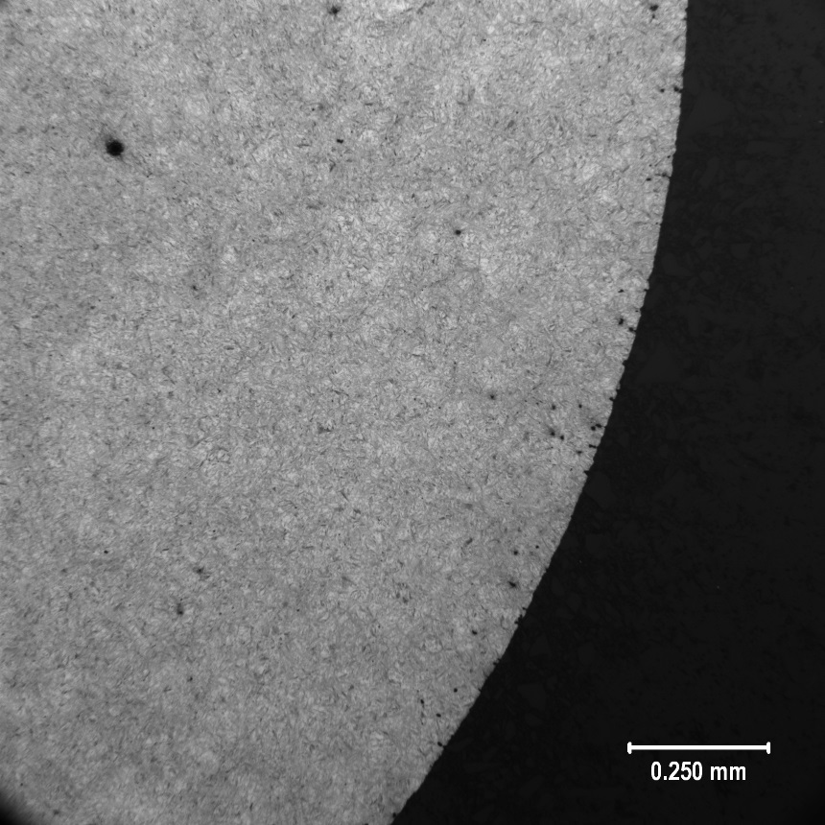 | 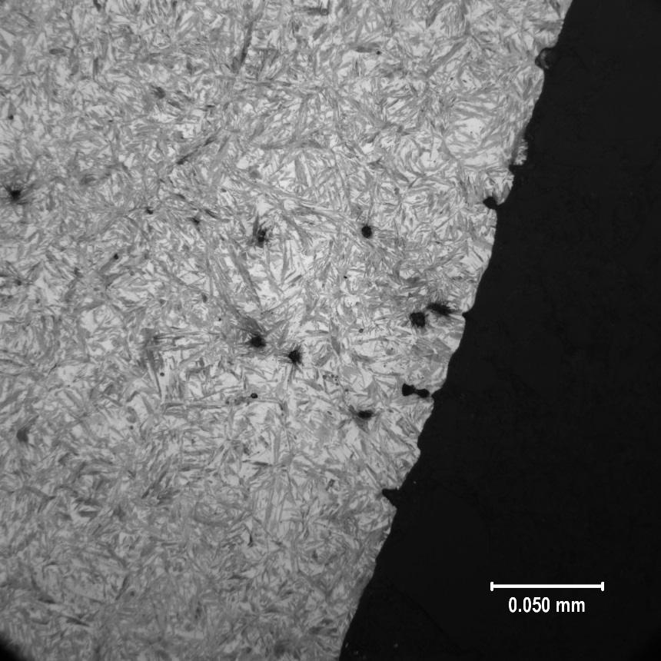
FIGURE 43: 9310 CASE MICROSTRUCTURE 100X | FIGURE 44: 9310 CASE MICROSTRUCTURE 500X

