Materials Engineering Summary Report
LTR Number: 144226

______________________________________________________________________

To: Peter Bauerle Phone: 776-7387

Location: W2003: Chrysler Technical Centre

______________________________________________________________________

From: Peter Bauerle Phone: 776-7387

Location: W2003: Chrysler Technical Centre

Date Completed: DateCompleted
______________________________________________________________________

Part Name: Fatigue Specimen - Iteration 163/164(D2)
Number of Parts: 1
Nature of Work: Process/Materials/DFSS/Decoupled Dev.

Summary/Conclusion/Recommendations

Based on this analysis, the following observations can be made:

- The surface hardness of 60 – 61 HRC meets the aim hardness of 58 – 62 HRC
- The effective case depth was measured at 0.028” (0.70 mm) as compared to the aim of 0.020 (0.51 mm)
- The microstructure of the case hardened zone is primarily comprised of tempered martensite whereas the core contains a higher percentage of ferrite
- The depth of intergranular oxidation (IGO) was measured at 14µm as compared to a specification of 20 µm maximum

History of the Part

The sample that has been submitted is a bending fatigue specimen that has been used for the development of the AISI fatigue database, namely iteration 163/164. The test speciman was prepared from an 8615 steel grade. The sample has been carburized by using the following heat treat cycle: austenitize at 1700F with a 0.9% carbon potential for 3.5 hours, step down to 1500F followed by quenching in 150F oil and then tempering at 400F.

Metallography - 144226

General Microstructure Description (Performed By: Kathryne Bacas)

A fatigue specimen from iteration 163/164(D2) was received for metallographic analysis. The sample was sectioned longitudinally through the grip section and transversely through the gage section. The two sections were mounted in Bakelite, ground, and polished in accordance to ASTM E3. The as-polished sections were examined with an Olympus PMG3 metallograph using light microscopy. Both cross-sections contained Intergranular Oxidation (IGO) at the surface to a depth of approximately 14µm (Figures Met-1 & Met-2). An inclusion rating was performed on the longitudinal grip section in accordance to ASTM E45 and the results recorded in Table Met-1. The sections were etched using a 3% Nital solution to reveal the microstructure in accordance to ASTM E407. Photographs were taken to document the microstructure mid-radius in the gage section, and at the surface and in the core in the longitudinal grip section. Microstructural details and corresponding figures were recorded in Table Met-2.

Table Met-1. Inclusion rating for the longitudinal grip section of fatigue specimen 163/164(D2).
 | A |  | B |  | C |  | D
 | Thin | Heavy | Thin | Heavy | Thin | Heavy | Thin | Heavy
Rating (1-5) | 3 | 0 | 0 | 0 | 0 | 0 | 1 | 0

Table Met-2. Microstructural descriptions and corresponding figures for the specified locations in fatigue specimen 163/164(D2).
Specimen | Location | Microstructure | Figure
163/164(D2) | Gage section  mid-radius | Acicular ferrite, tempered martensite, manganese sulfide stringers, and some carbides | Met-3
 | Grip end surface | Tempered martensite, some retained austenite, and manganese sulfide stringers | Met-4
 | Grip end core | Acicular ferrite, tempered martensite, manganese sulfide stringers, and some carbides | Met-5

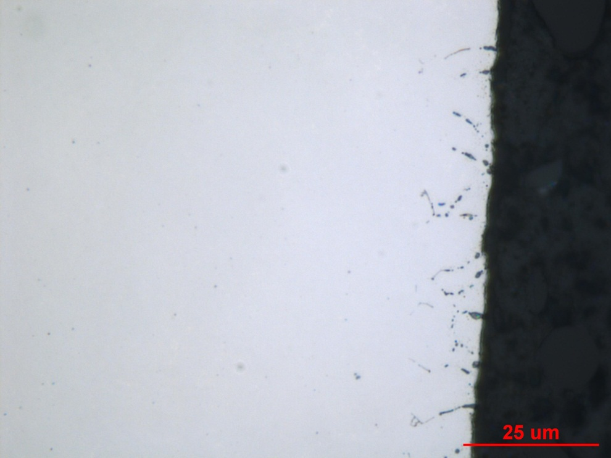
Figure Met-1. Photograph of IGO found along the surface of the transverse gage section of fatigue specimen 163/164(D2), as-polished. Original magnification 1000X.

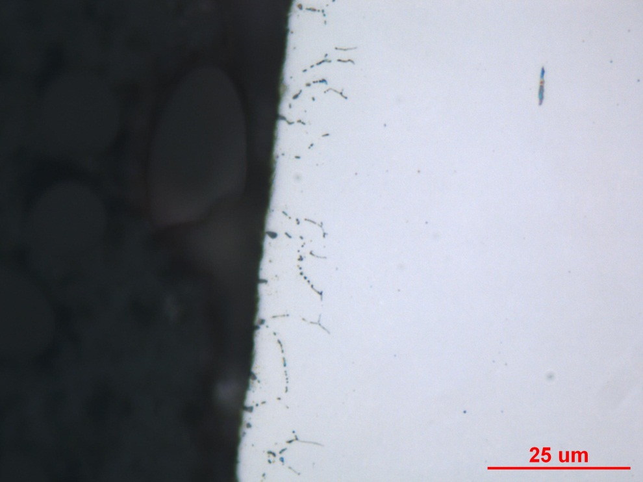
Figure Met-2. Photograph of IGO found along the surface of the longitudinal grip section of fatigue specimen 163/164(D2), as-polished. Original magnification 1000X.

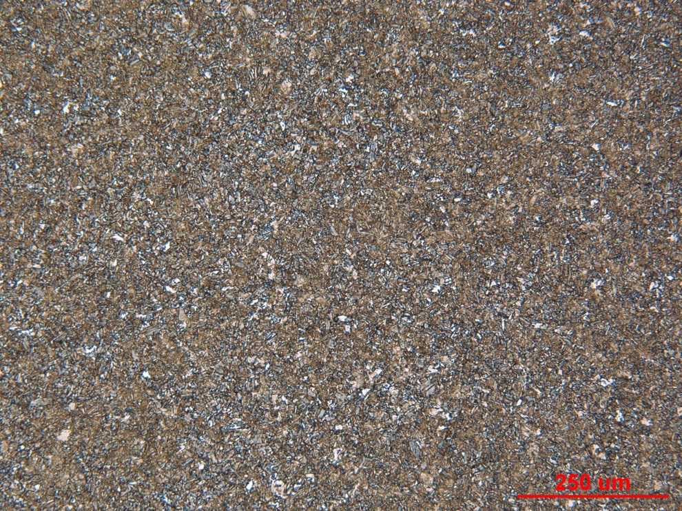

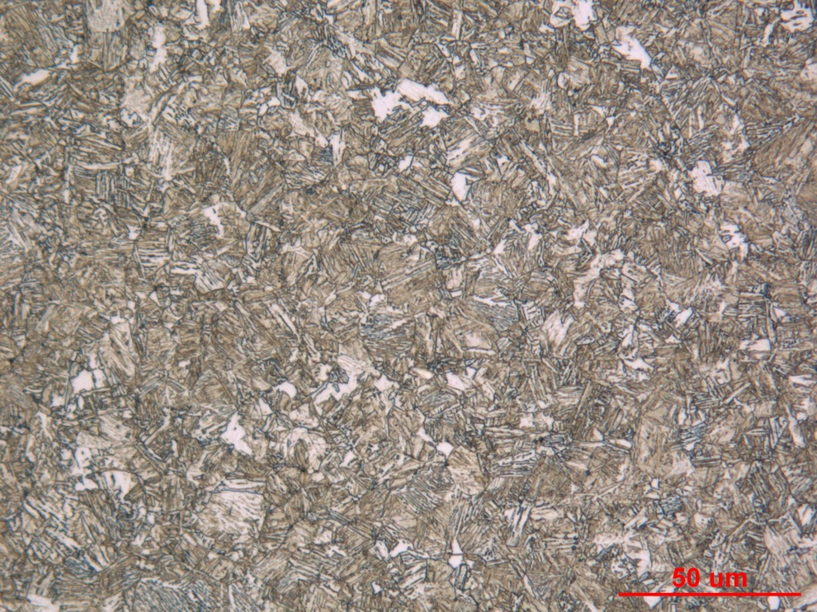
Figure Met-3. Photographs of the mid-radius microstructure in the transverse gage section of fatigue specimen 163/164(D2), Nital etch. Original magnification 100X (top) and 500X (bottom).

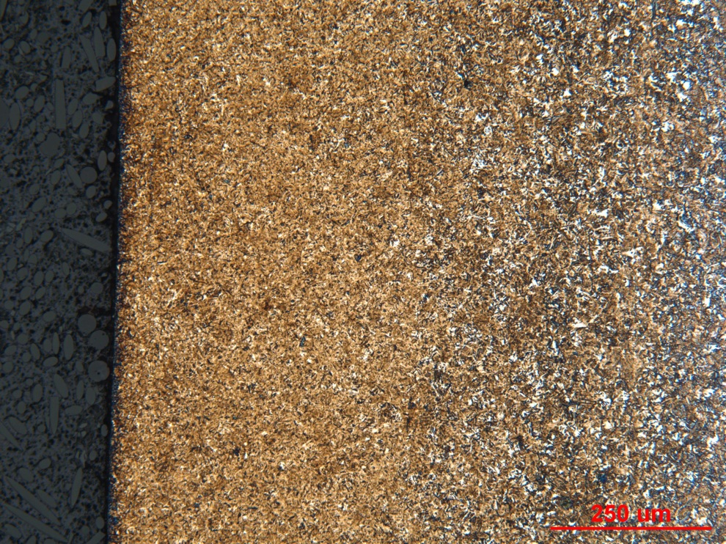

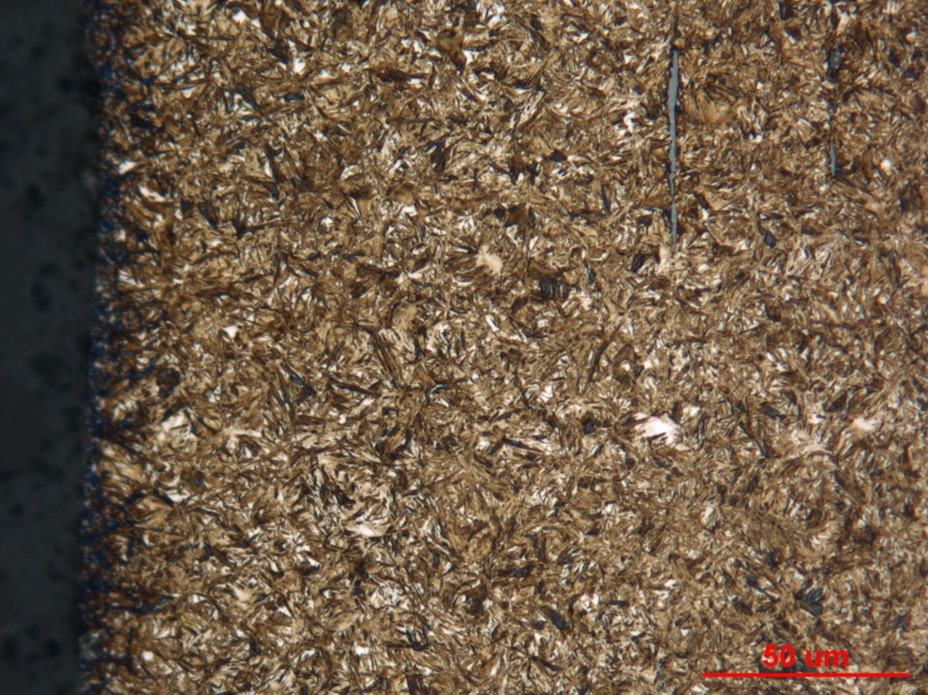
Figure Met-4. Photographs of the surface microstructure in the longitudinal grip section of fatigue specimen 163/164(D2), Nital etch. Original magnification 100X (top) and 500X (bottom).

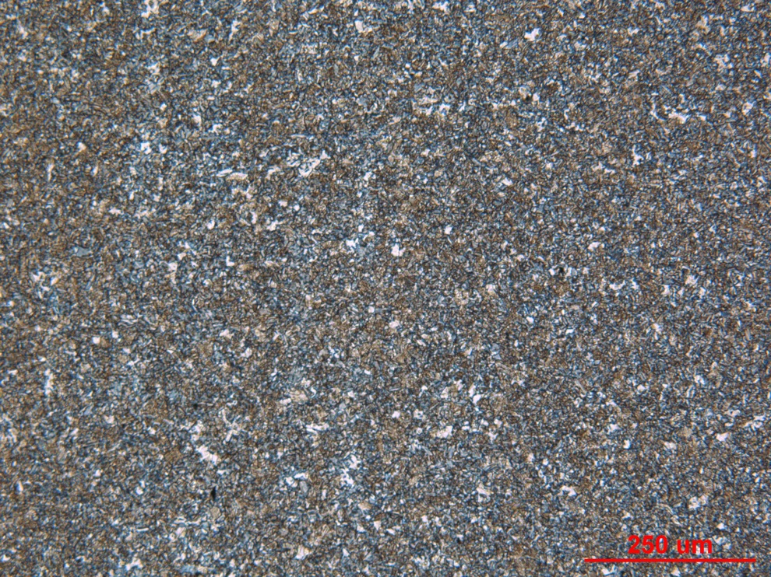

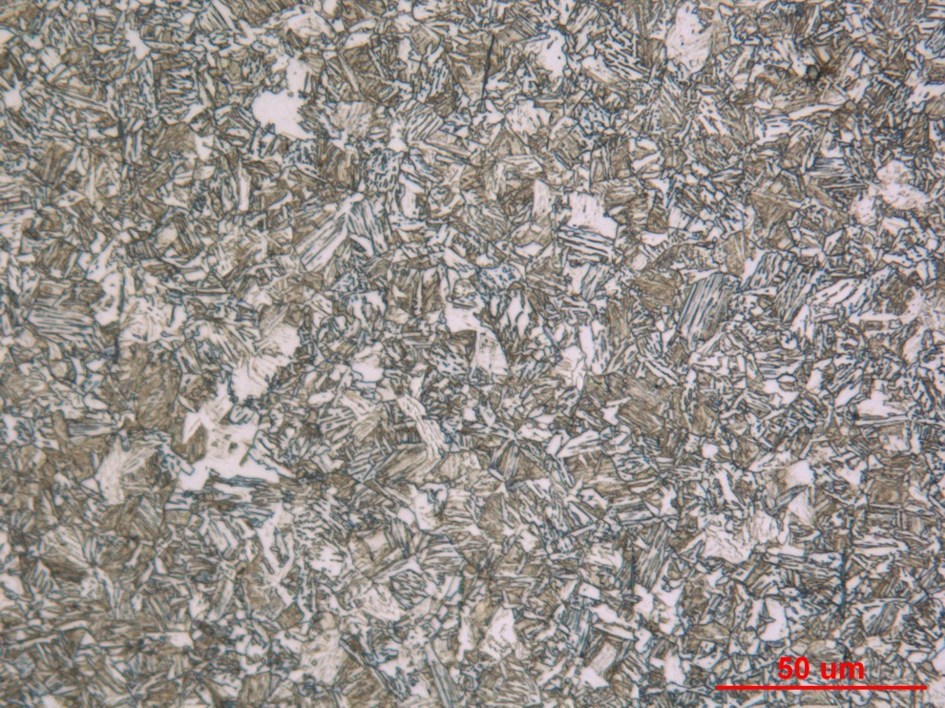
Figure Met-5. Photographs of the core microstructure in the longitudinal grip section of fatigue specimen 163/164(D2), Nital etch. Original magnification 100X (top) and 500X (bottom).
Mechanical Properties - 144226

Hardness - Rockwell (Performed By: Premji Patel)
Performed HRC test on the surface of the grip (large diameter)
Data as follows:
HRC
60.2
59.8
60.8

Hardness - Micro (Performed By: Premji Patel)
Performed Micro-hardness traverse across small section at increment of 0.01” from the edge toward core.
Data as follows: