Materials Engineering Summary Report
LTR Number: 146036

______________________________________________________________________

To: Peter Bauerle Phone: 776-7387

Location: W2003: Chrysler Technical Centre

______________________________________________________________________

From: Peter Bauerle Phone: 776-7387

Location: W2003: Chrysler Technical Centre

Date Completed: DateCompleted
______________________________________________________________________

Part Name: Fatigue Specimen - Iteration 159/160(S)-F
Number of Parts: 1
Nature of Work: Process/Materials/DFSS/Decoupled Dev.

Summary/Conclusion/Recommendations

Based on this analysis, the following observations can be made:
- The effective case depth is approximately 0.25 mm (0.0105”) as compared to the aim of 0.010”. The surface hardness was measured at 59 -60 HRC as compared to an aim hardness of 58 – 60 HRC. The core hardness ranges from 27 – 30 HRC.
- The microstructure at the surface is comprised of a high carbon martensite with a level of intergranular oxidation (IGO) of 5 – 6 microns. The core microstructure consists of tempered martensite and ferrite.
- The cleanliness of the steel had ratings that would meet those for application to gears, shafts or pinions.

History of the Part

The sample that has been submitted is a bending fatigue specimen that has been used for the development of the AISI fatigue database, namely iteration 159/160. The test speciman was prepared from an 8615 steel grade. The sample has been carburized by using the following heat treat cycle: austenitize at 1700F with a 0.9% carbon potential for 50 minutes, step down to 1500F followed by quenching in 150F oil and then tempering at 400F.

Metallography - 146036

General Microstructure Description (Performed By: James McKinney)

A fatigue specimen labeled Iteration 159/160 was submitted for metallographic analysis. The sample was sectioned longitudinally through the grip portion and transversely through the gage portion. The two sections were mounted in Bakelite, ground, and polished in accordance with ASTM E3. The as-polished samples were examined with an Olympus PMG3 metallograph using light microscopy. Both cross-sections contained Intergranular Oxidation (IGO) at the surface to a depth of approximately 5-6 µm on the transverse gauge section (Figure 1), and approximately 8-10 µm on the grip end section (Figure 2).

An inclusion rating was performed on the longitudinal grip section in accordance to ASTM E45 and the results were recorded in Table 1. The sections were etched using a 3% Nital solution to reveal the microstructure in accordance with ASTM E407. Photographs were taken of the mid-radius microstructure in the transverse gauge section and of the surface and core microstructure in the longitudinal grip section (Figures 3-5). Microstructural details and corresponding figures were recorded in Table 2.

Table 1: Inclusion rating for the longitudinal grip section of fatigue specimen 159/160.
 | A |  | B |  | C |  | D
 | Thin | Heavy | Thin | Heavy | Thin | Heavy | Thin | Heavy
Rating (1-5) | 2 | 0 | 1 | 0 | 0 | 0 | 2 | 0

Table 2: Microstructural descriptions for the specified locations in fatigue specimen 159/160.
Section | Location | Microstructure | Figure
159/160 | Gage section mid-radius | Tempered martensite with acicular ferrite and some carbides. | 3
 | Grip end surface | Tempered martensite with Manganese Sulfide stringers. | 4
 | Grip end core | Tempered martensite with some ferrite and Manganese Sulfide stringers. | 5

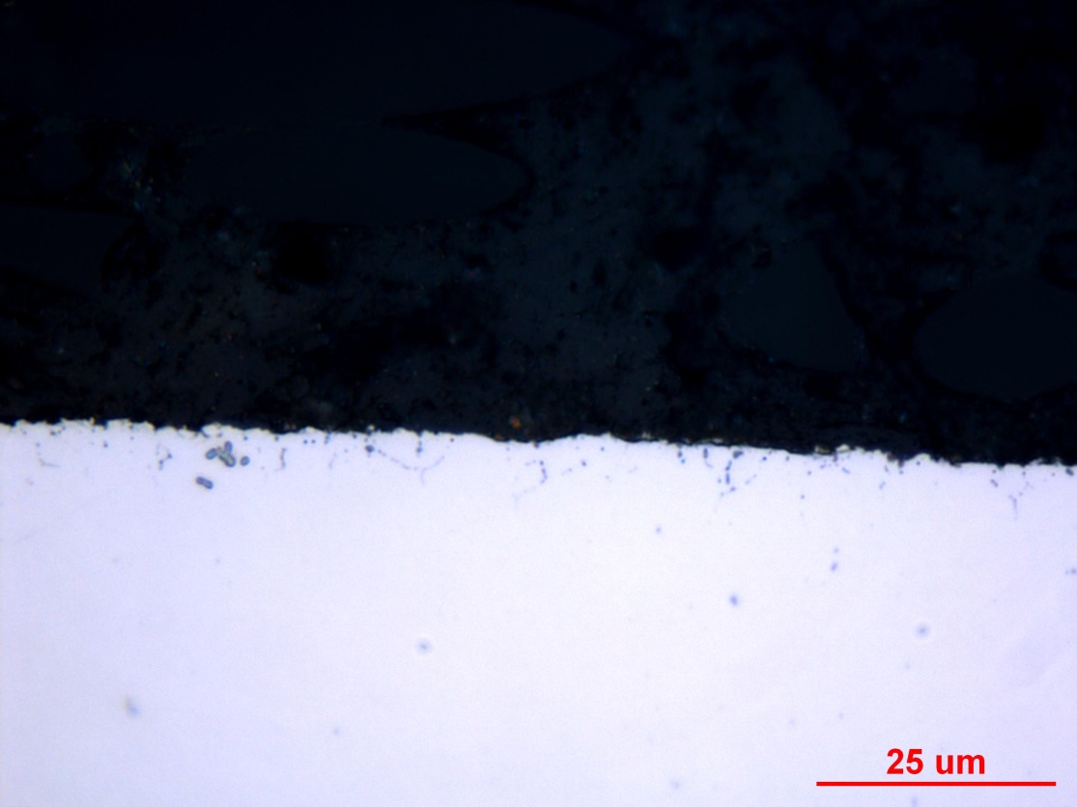
Figure 1: Photograph documenting IGO found at the surface of the transverse gauge section of fatigue specimen 159/160. Original magnification was 1000X.

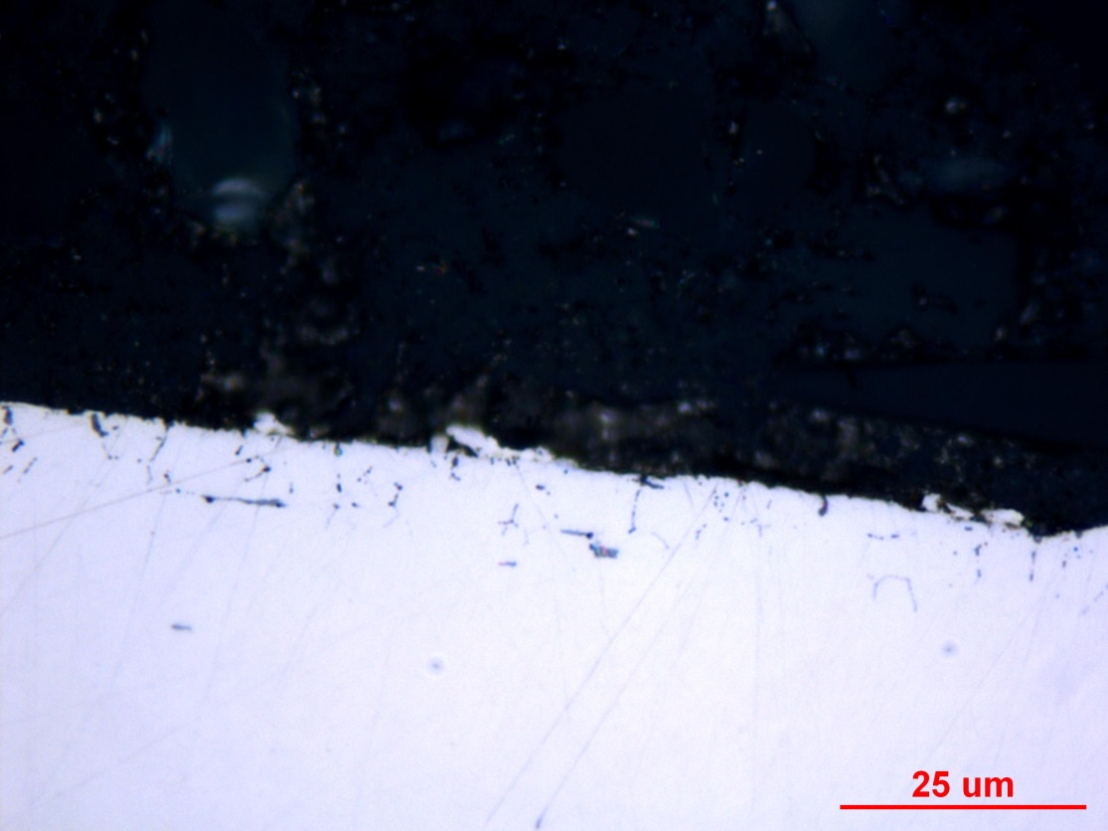
Figure 2: Photograph documenting IGO found at the surface of the longitudinal grip section of fatigue specimen 159/160. Original magnification was 1000X.
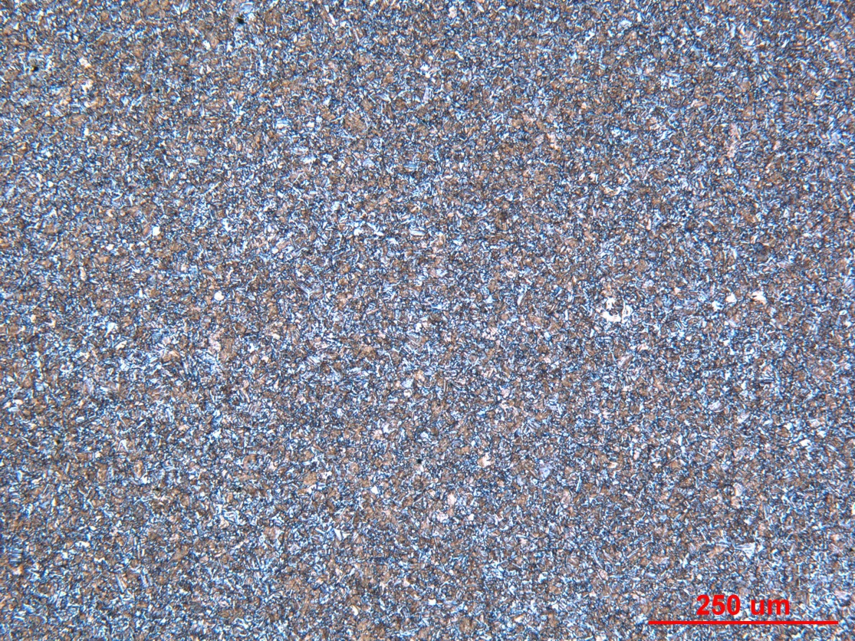

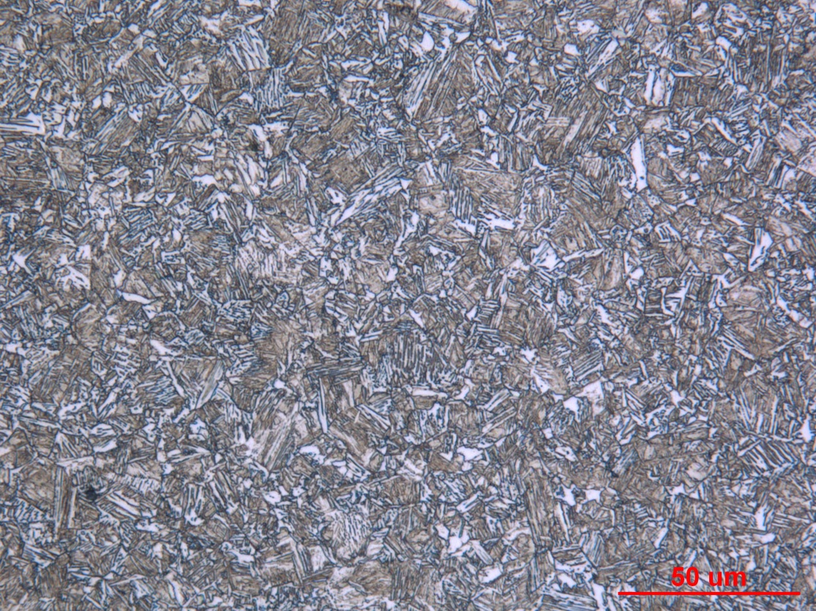

Figure 3: Photographs of the mid-radius microstructure in the transverse gauge section of fatigue specimen 159/160. Original magnifications were 100X (top) and 500X (bottom).
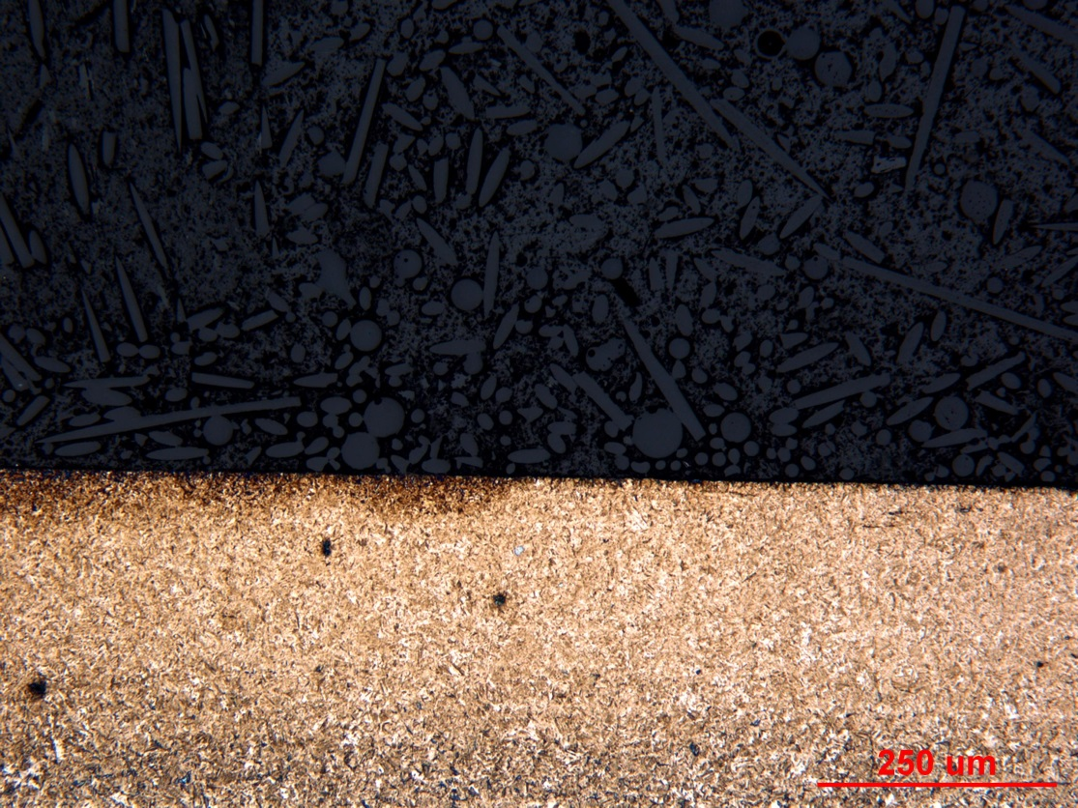

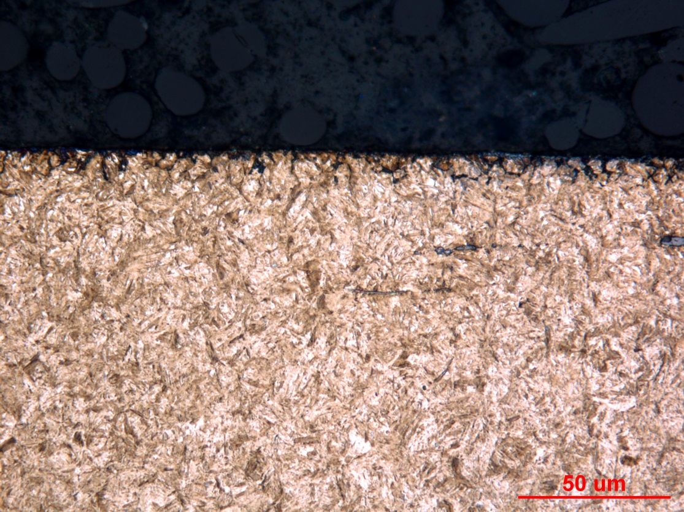

Figure 4: Photographs of the surface microstructure in the longitudinal grip section of fatigue specimen 159/160. Original magnifications were 100X (top) and 500X (bottom).
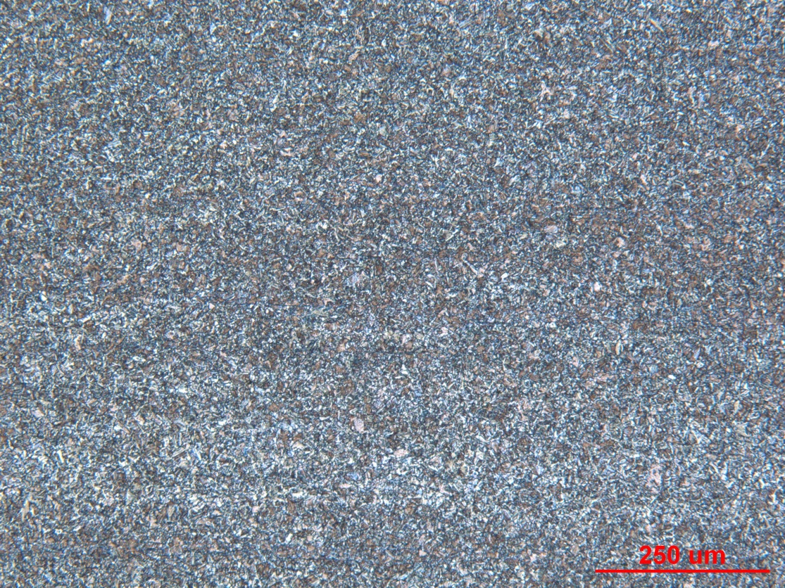

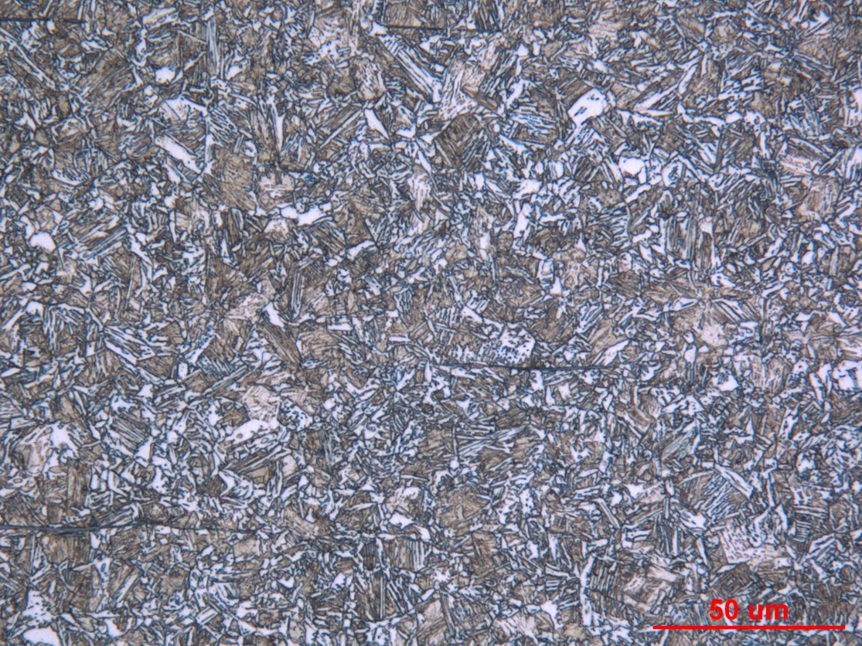

Figure 5: Photographs of the core microstructure in the longitudinal grip section of fatigue specimen 159/160. Original magnifications were 100X (top) and 500X (bottom).
Mechanical Properties - 146036

Hardness - Micro (Performed By: Donald Gross)

Micro-hardness traverse was performed on small cross section of fatigue specimen from surface to core using .005” increments. Data is shown on attached graph.

Hardness - Rockwell (Performed By: Donald Gross)

Surface hardness was performed on grip end of fatigue specimen using HR15N and converted to HRC scale due to thin case. Data is shown below.

89.9 HR15N converted 59 HRC
90.3 HR15N converted 60 HRC
90.2 HR15N converted 60 HRC
