Materials Engineering Lab Report
LTR Number: 144407

______________________________________________________________________
To: Peter Bauerle Phone: 776-7387
Location: W2003: Chrysler Technical Centre

______________________________________________________________________

Lead Engineer: Peter Bauerle Phone: 776-7387
Location: W2003: Chrysler Technical Centre Completed: 06/13/2013

______________________________________________________________________

Part Name: Fatigue Specimen - Iteration 157/158(S)-2
Number of Parts: 1
Nature of Work: Process/Materials/DFSS/Decoupled Dev.

History of Part

The sample that has been submitted is an axial fatigue specimen that has been used for the development of the AISI fatigue database, namely iterations 157 and 158. The test specimen was prepared from an 8615 steel grade with low hardenability in an attempt to produce a composite fatigue specimen with a case and core. The sample has been carburized in the gage section by using the following heat treat cycle: austenitize at 1700F with a 0.9% carbon potential for 45 minutes, step down to 1500F followed by quenching in 150F oil and then tempering at 400F.

Test Results are on the following pages

Metallography - 144407

General Microstructure Description (Performed By: Alison Hartnagel)

A fatigue specimen labeled iteration 157/158(S)-2 was submitted for metallographic analysis. The sample was sectioned longitudinally through the grip section and transversely through the gage section. The two sections were mounted in Bakelite, ground, and polished in accordance to ASTM E3. The as-polished samples were examined with an Olympus PMG3 metallograph using light microscopy. Both cross-sections contained Intergranular Oxidation (IGO) at the surface to a depth of approximately 6.5µm (Figures Met-1 & Met-2). An inclusion rating was performed on the longitudinal grip section in accordance to ASTM E45 and the results were recorded in Table Met-1. The sections were etched using a 3% Nital solution to reveal the microstructure in accordance to ASTM E407. Photographs were taken of the mid-radius microstructure in the transverse gage section and of the surface and core microstructure in the longitudinal grip section (Figures Met-3 – Met-5). The layer of transformation product visible on the surface microstructure for the grip end was approximately 7 microns in depth. Microstructural details and corresponding figures were recorded in Table Met-2.

Table Met-1. Inclusion rating for the longitudinal grip section of fatigue specimen 155-A.

 | A |  | B |  | C |  | D
 | Thin | Heavy | Thin | Heavy | Thin | Heavy | Thin | Heavy
Rating (1-5) | 1 | 1 | 0 | 0 | 0 | 0 | 1 | 1

Table Met-2. Microstructural descriptions and corresponding figures for the specified locations in fatigue specimen 155-A.
Section | Location | Microstructure | Figure
157/158(S)-2 | Gage section mid-radius | Tempered martensite with traces of ferrite along grain boundaries | Met-3
 | Grip end surface | Transformation product (7 µm), tempered martensite | Met-4
 | Grip end core | Tempered martensite and ferrite | Met-5

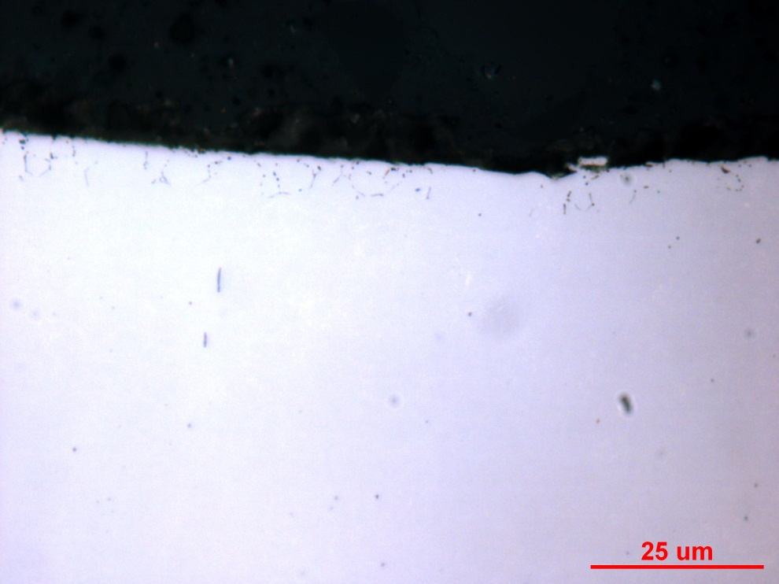
Figure Met-1. Photograph documenting IGO found at the surface of the longitudinal grip section of fatigue specimen 157/158(S)-2. Original magnification was 1000X.

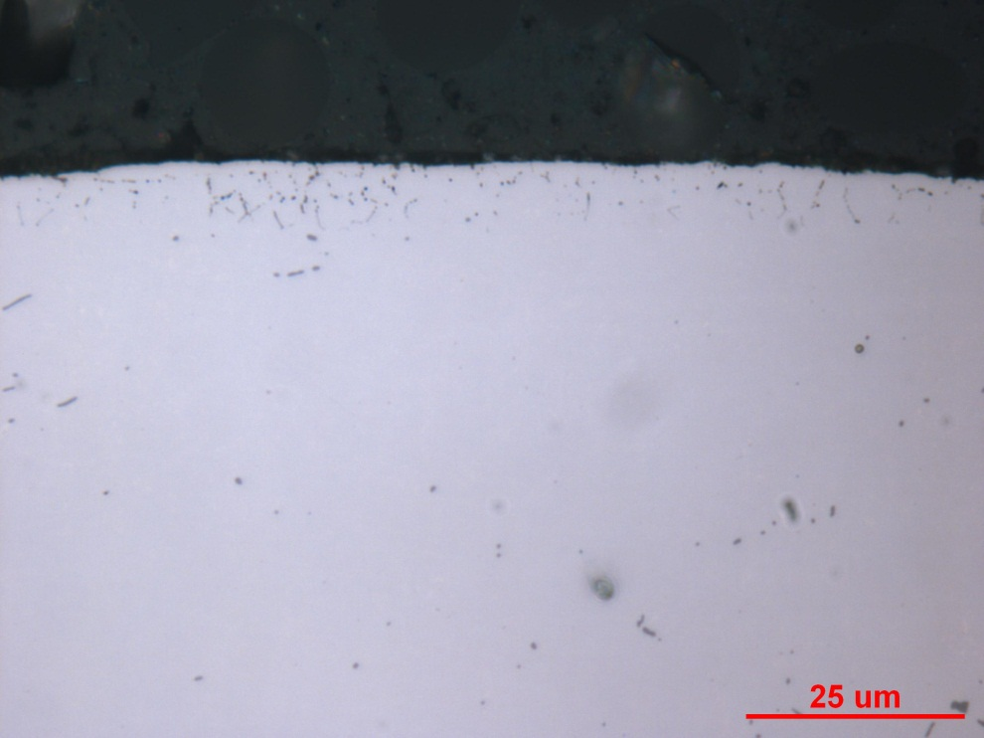
Figure Met-2. Photograph documenting IGO found at the surface of the transverse gage section of fatigue specimen 157/158(S)-2. Original magnification was 1000X.

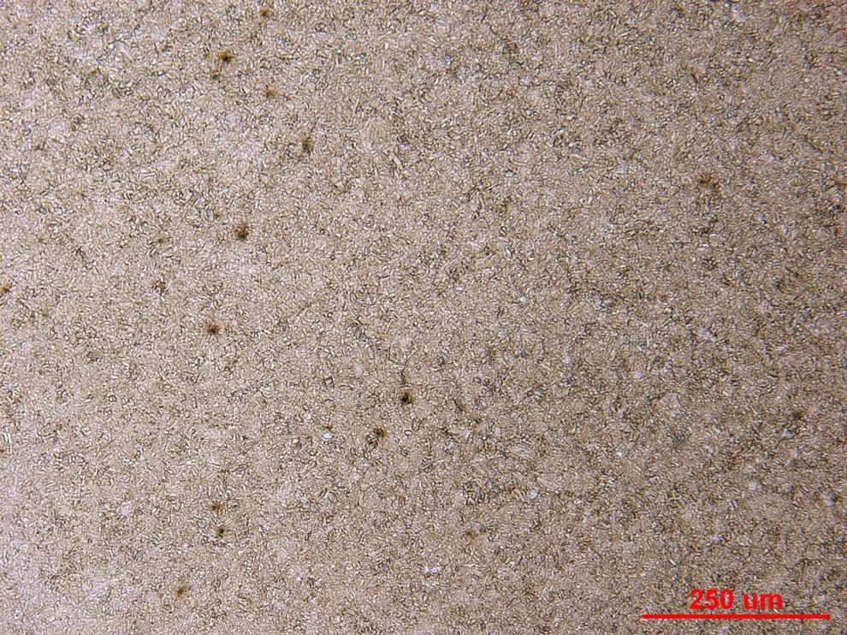

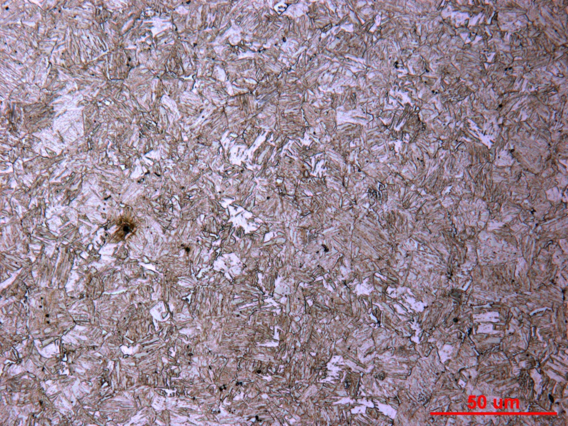
Figure Met-3. Photographs of the mid-radius microstructure in the transverse gage section of fatigue specimen 157/158(S)-2. Original magnifications were 100X (top) and 500X (bottom).

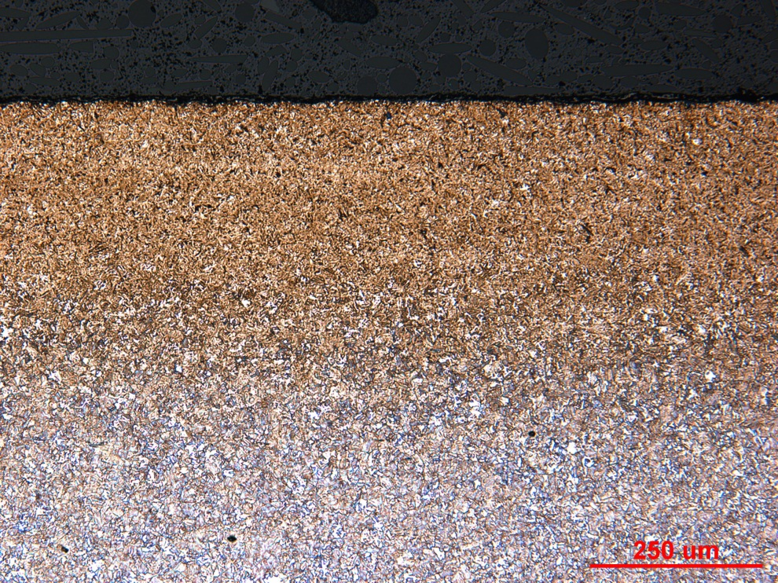

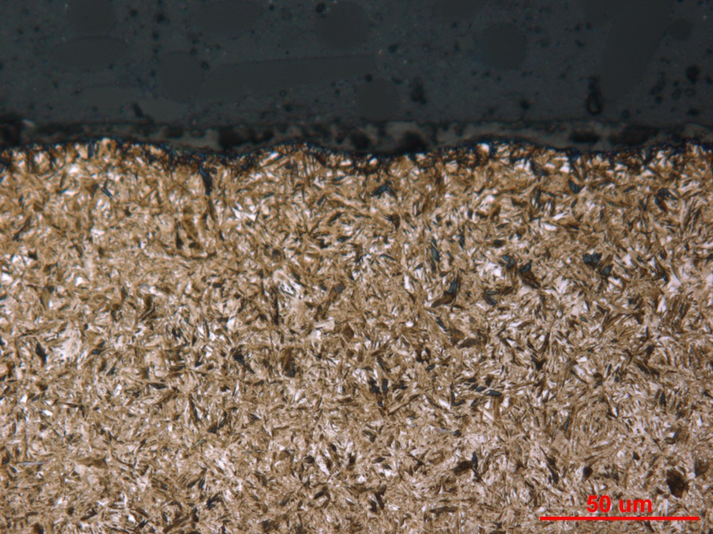
Figure Met-4. Photographs of the surface microstructure in the longitudinal grip section of fatigue specimen 157/158(S)-2. Original magnifications were 100X (top) and 500X (bottom).

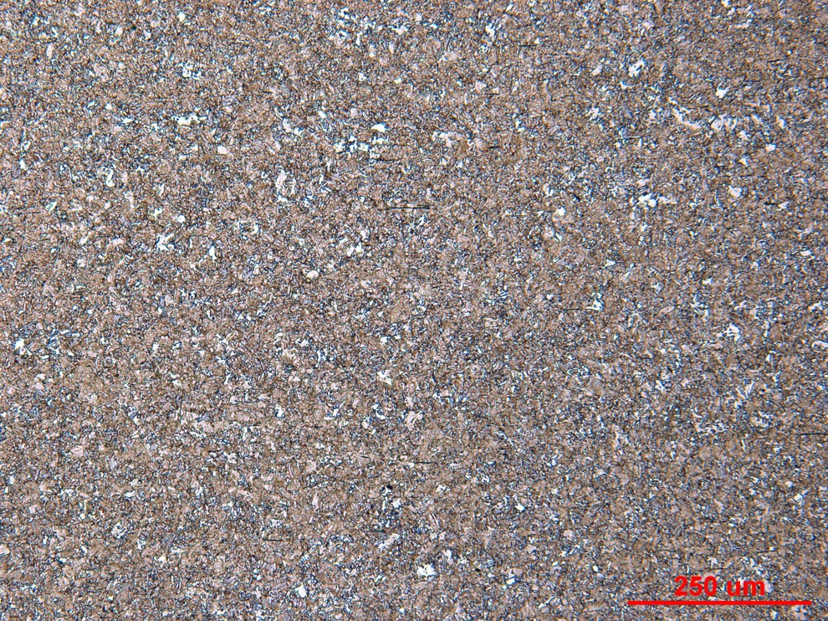

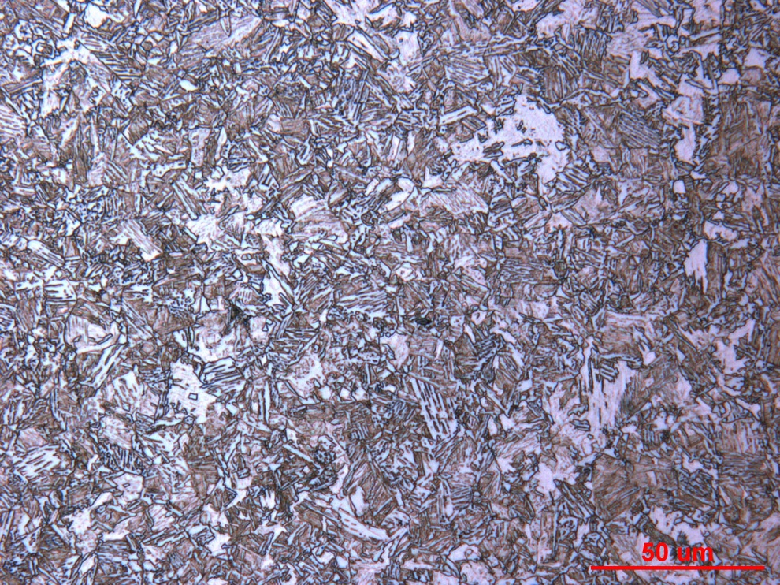
Figure Met-5. Photographs of the core microstructure in the longitudinal grip section of fatigue specimen 157/158(S)-2. Original magnifications were 100X (top) and 500X (bottom).

Mechanical Properties - 144407

Hardness - Micro (Performed By: Dean Martin)

Micro Hardness testing was conducted on one sample provided using the MT-90 Micro Hardness tester. Impressions were taken from the surface to the core of the gage section, with three additional core hits, as requested. Machine was verified with calibrated block prior to testing. Data as follows:

Core Hardness:
36.2, 38.2, 38.2 HRC

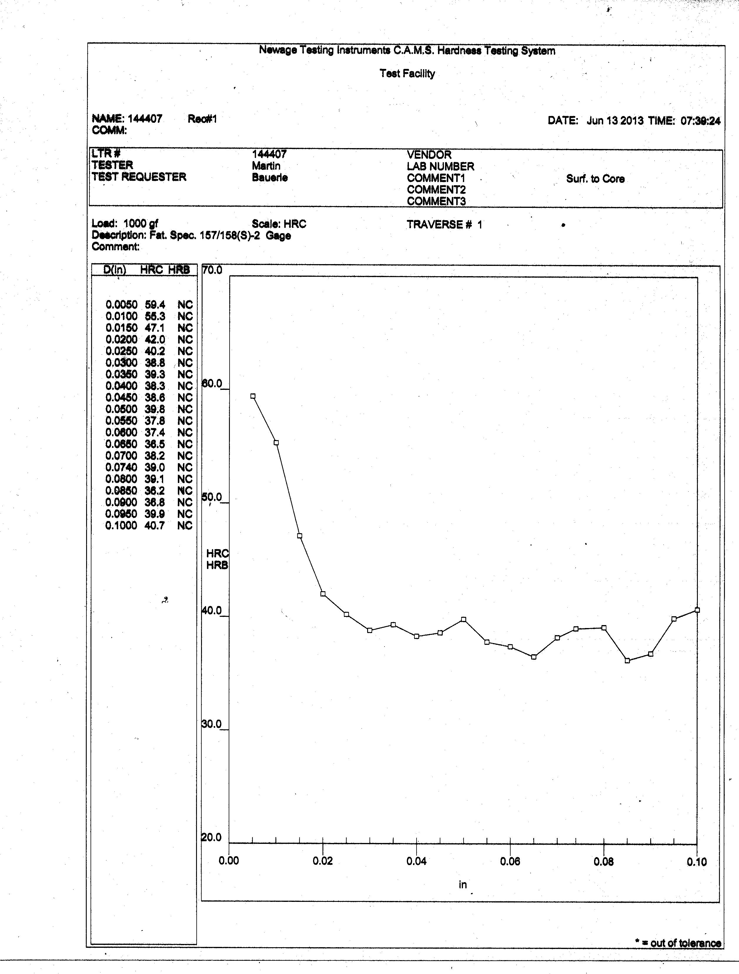
Hardness - Rockwell (Performed By: Dean Martin)

Rockwell surface hardness testing was conducted on one sample provided. Three impressions were taken in HR-15N. Data includes correction factor for roundness. Machine verified with calibrated block prior to testing. Data as follows:

Hardness – HR-15N
Impression #1: 88.1 HR-15N = 55.3 HRC
Impression #2: 88.6 HR-15N = 56.4 HRC
Impression #3: 88.4 HR-15N = 55.9 HRC

