Materials Engineering Lab Report
LTR Number: 142851

______________________________________________________________________
To: Peter Bauerle Phone: 776-7387
Location: W2003: Chrysler Technical Centre

______________________________________________________________________

Lead Engineer: Peter Bauerle Phone: 776-7387
Location: W2003: Chrysler Technical Centre Completed: 12/17/2012

______________________________________________________________________

Part Name: Fatigue Specimen - Iteration 156 (8615 Steel)
Number of Parts: 1
Nature of Work: Process/Materials Development

History of Part

The sample that has been submitted is a bending fatigue specimen that has been used for the development of the AISI fatigue database, namely iteration 156. The test speciman was prepared from an 8615 steel grade. The sample has been quench and tempered to simulate the core of a case hardened component. The heat treat cycle was as follows: austenitize at 1650F followed by quenching in 150F oil and then tempering at 350F to achieve an aim hardness of 30 - 35 HRC in the smaller cross section.

Test Results are on the following pages

Metallography - 142851

General Microstructure Description (Performed By: Myron Rudnitsky)

One fatigue specimen was submitted for microstructural examination. The fatigue specimen was sectioned transversely through the gage section and longitudinally through the grip end, mounted, ground, polished in accordance with ASTM E3, and etched in 3% Nital to reveal the microstructure in accordance with ASTM E407. Photographs were taken at low and high magnification for each sample and reported in Table 1.

Table 1: Microstructural results per sample and location.

Sample | Location | Microstructure | Figure
156 | Gauge section mid body | Tempered martensite and acicular ferrite | 1
 | Grip end case | Tempered martensite, acicular ferrite and MnS stringers in a lightly banded structure | 2
 | Grip end core | Tempered martensite, acicular ferrite and MnS stringers in a lightly banded structure | 3

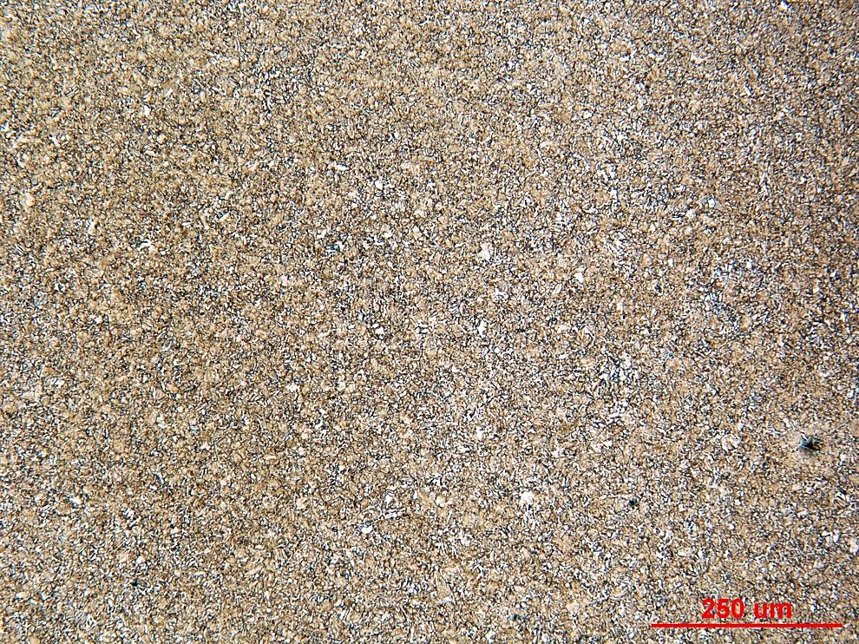

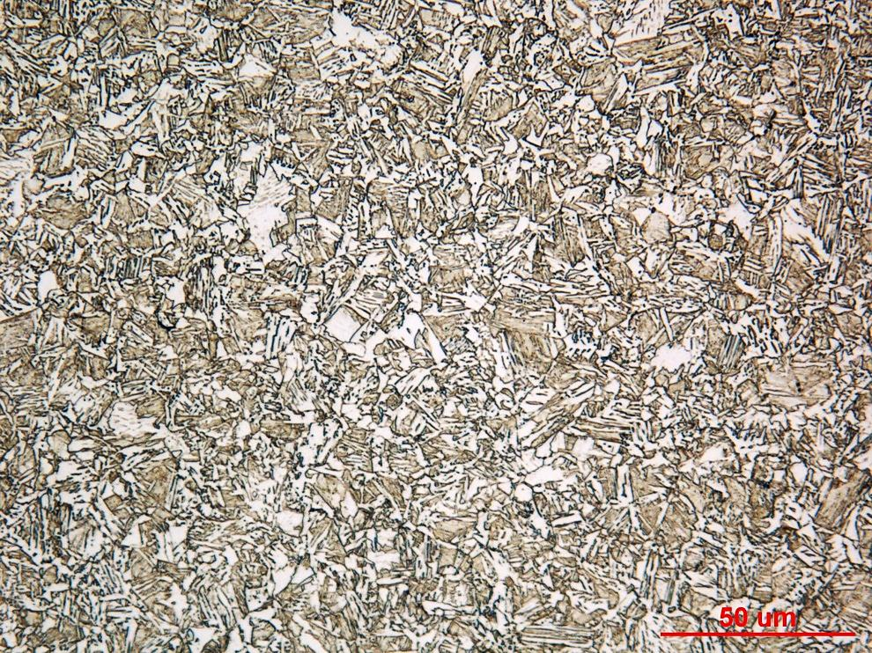

Figure 1. Photograph of sample 156 cross section mid body at low and high magnification.

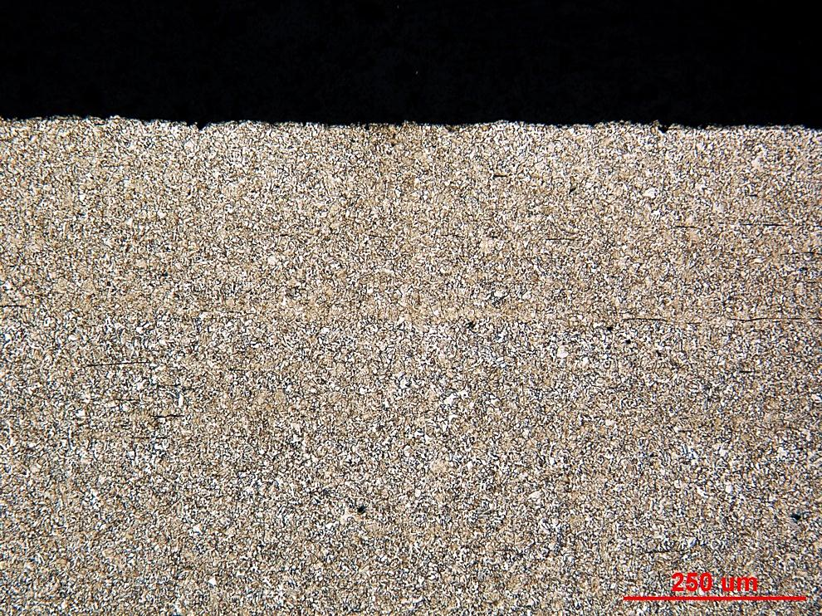

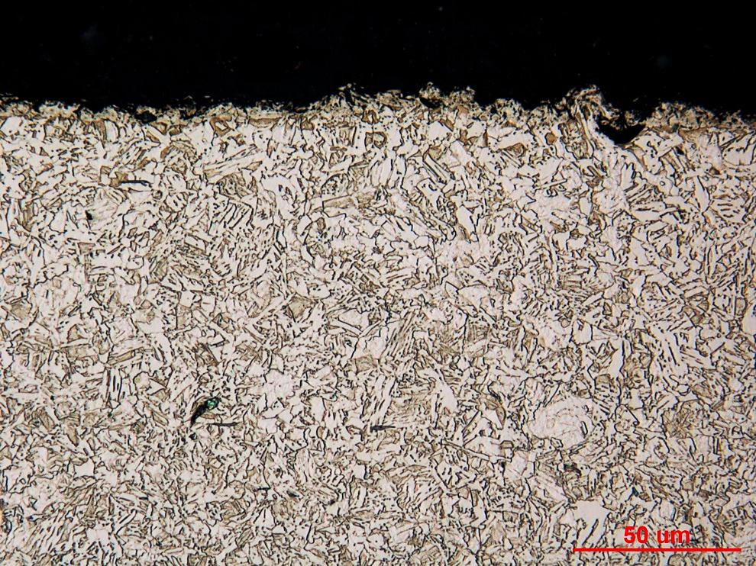

Figure 2. Photograph of sample 156 grip end surface microstructure at low and high magnification.

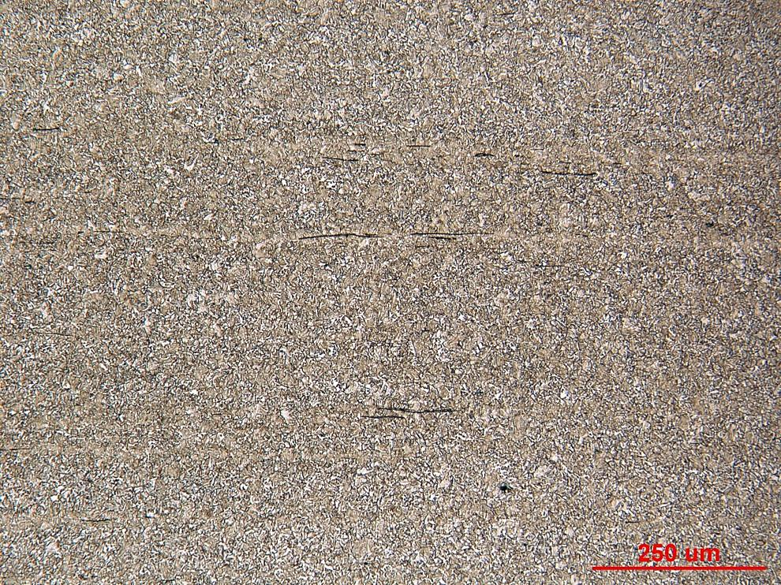

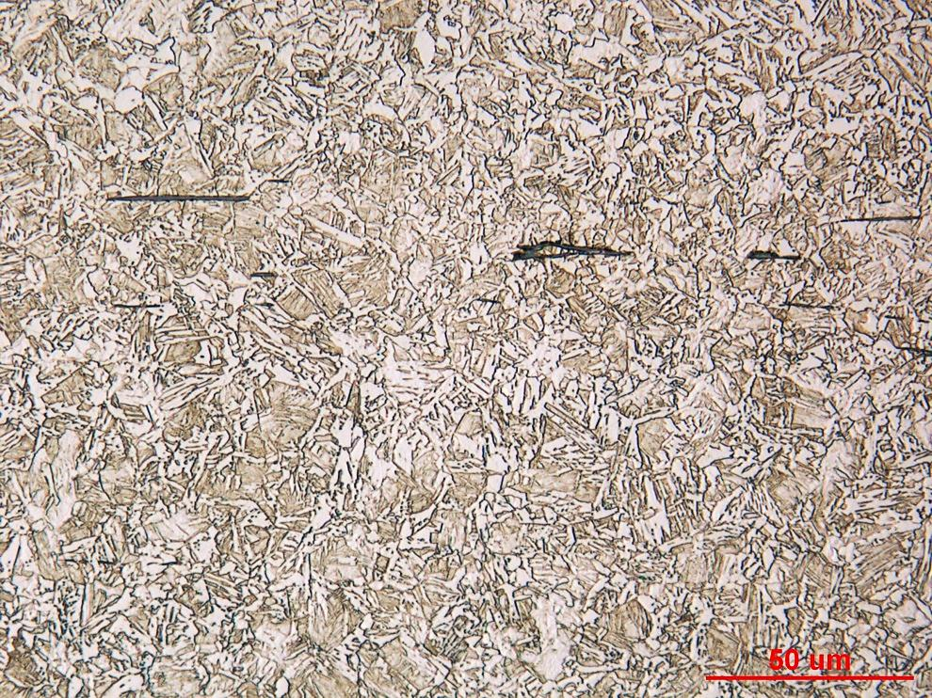

Figure 3. Photograph of sample 156 grip end core microstructure at low and high magnification.

Mechanical Properties - 142851

Hardness - Rockwell (Performed By: Dean Martin)

Rockwell surface hardness testing was conducted on one sample provided. Impressions were taken in HRC. Machine was verified with calibrated block prior to testing. Data as follows:

Surface Hardness – HRC
23.0, 25.0, 23.8 HRC

Hardness - Micro (Performed By: Dean Martin)

Micro hardness testing was conducted on one sample provided using the MT-90 Micro Hardness Tester. Impressions were taken from the thin-edge surface to the core as requested. Data as follows:

