Materials Engineering Summary Report
LTR Number: 143903

______________________________________________________________________

To: Peter Bauerle Phone: 776-7387

Location: W2003: Chrysler Technical Centre

______________________________________________________________________

From: Peter Bauerle Phone: 776-7387

Location: W2003: Chrysler Technical Centre

Date Completed: DateCompleted
______________________________________________________________________

Part Name: Fatigue Specimen-Iteration 137/138R
Number of Parts: 1
Nature of Work: Pilot, Mule, Program Development Issue

Summary/Conclusion/Recommendations

Based on this analysis, the following observations can be made:

- The microstructure is comprised of a tempered martensite with approximately 10% retained austenite (visual estimate) at the surface. The core microstructure is also tempered martensite but contains some acicular ferrite.
- The intergranular oxidation (IGO) ranges from 20 – 25 microns
- The surface hardness of 60 -61 HRC is close to the targeted value of 58 – 60 HRC and the range between the surface and core is 57 – 60 HRC.

History of the Part

The sample represents a fatigue specimens that will be tested by AISI. The specimens have been prepared from a 20MoCr4 steel. The sample has been through carburized in the gage section by austenitizing at 1700F with a 0.9% carbon potential for 24 hours prior to quenching in 150F oil and then tempering at 350F to an aim hardness of 58-60 HRC.

Metallography - 143903

General Microstructure Description (Performed By: Kathryne Bacas)

A fatigue specimen from iteration 137/138R was received for metallographic analysis. The sample was sectioned longitudinally through the grip section and transversely through the gage section. The two sections were mounted in Bakelite, ground, and polished in accordance to ASTM E3. The as-polished samples were examined with an Olympus PMG3 metallograph using light microscopy. Both cross-sections contained Intergranular Oxidation (IGO) at the surface to a depth of approximately 25µm (Figures Met-1 & Met-2). An inclusion rating was performed on the longitudinal grip section in accordance to ASTM E45 and the results recorded in Table Met-1. The sections were etched using a 3% Nital solution to reveal the microstructure in accordance to ASTM E407. Photographs were taken of the mid-radius microstructure in the transverse gage section and of the surface and core microstructure in the longitudinal grip section. Microstructural details and corresponding figures were recorded in Table Met-2.

Table Met-1. Inclusion rating for the longitudinal grip section of fatigue specimen 137/138R.
 | A |  | B |  | C |  | D
 | Thin | Heavy | Thin | Heavy | Thin | Heavy | Thin | Heavy
Rating (1-5) | 3 | 0 | 0 | 0 | 0 | 0 | 1 | 0

Table Met-2. Microstructural descriptions and corresponding figures for the specified locations in fatigue specimen 137/138R.
Section | Location | Microstructure | Figure
137/138R | Gage section mid radius | Tempered martensite, some retained austenite, manganese sulfide inclusions, and some carbides | Met-3
 | Grip end case | Tempered martensite, retained austenite, and manganese sulfide stringers in a lightly banded structure | Met-4
 | Grip end core | Tempered martensite, acicular ferrite, manganese sulfide stringers, and some carbides | Met-5

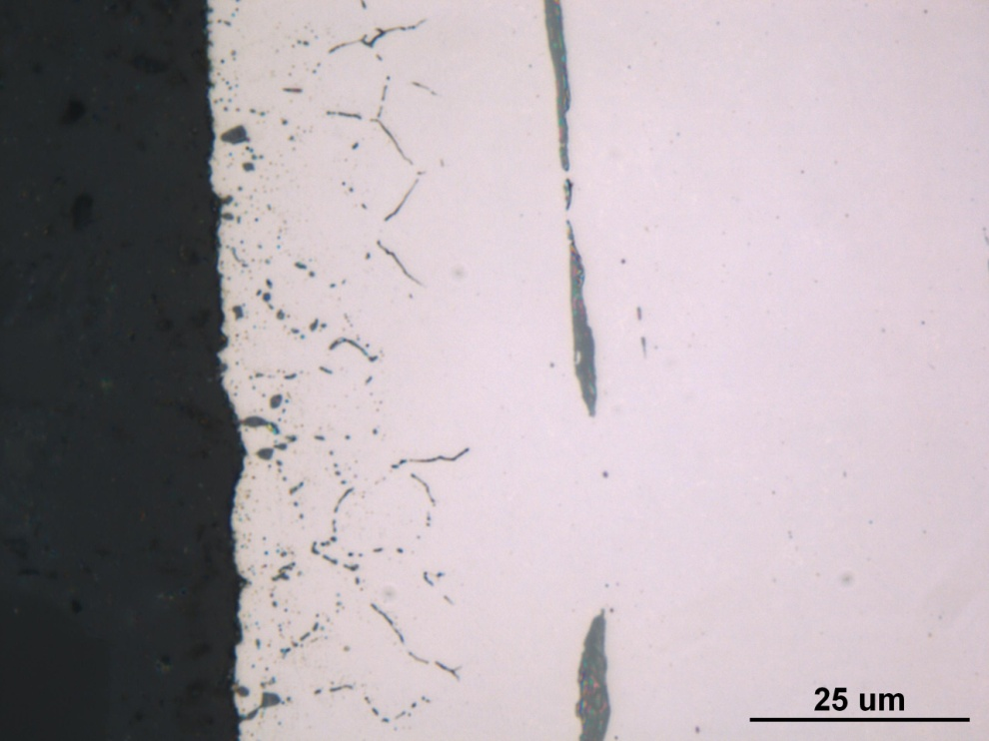
Figure Met-1. Photograph documenting IGO found at the surface of the longitudinal grip section of fatigue specimen 137/138R. Original magnification 1000x.

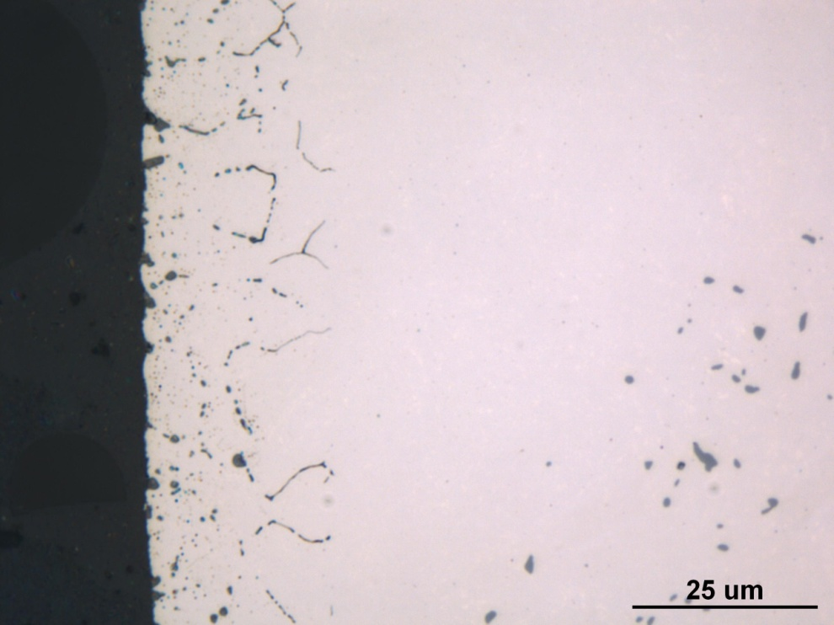
Figure Met-2. Photograph documenting IGO found at the surface of the transverse gage section of fatigue specimen 137/138R. Original magnification 1000x.

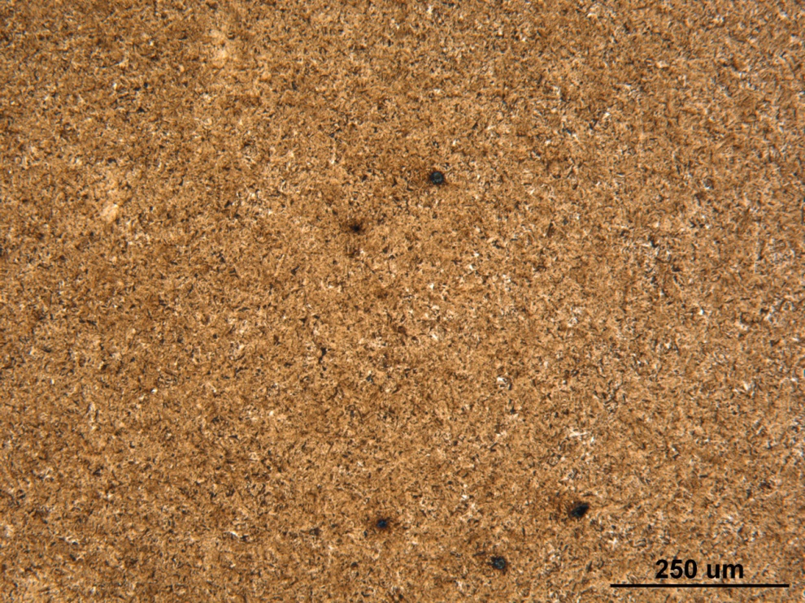

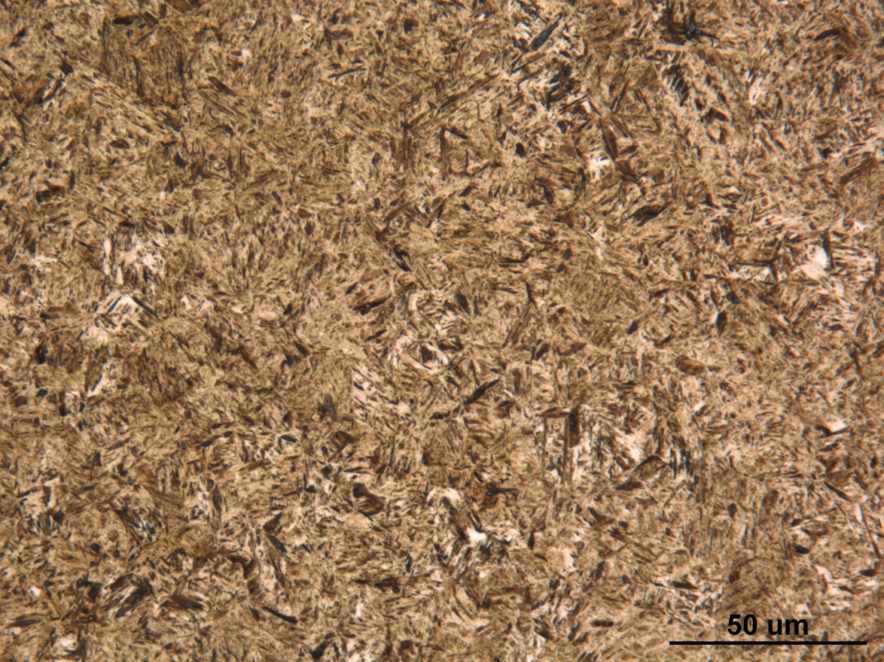
Figure Met-3. Photographs of the mid-radius microstructure of the transverse gage section of fatigue specimen 137/138R. Original magnifications 100x (top) and 500x (bottom).

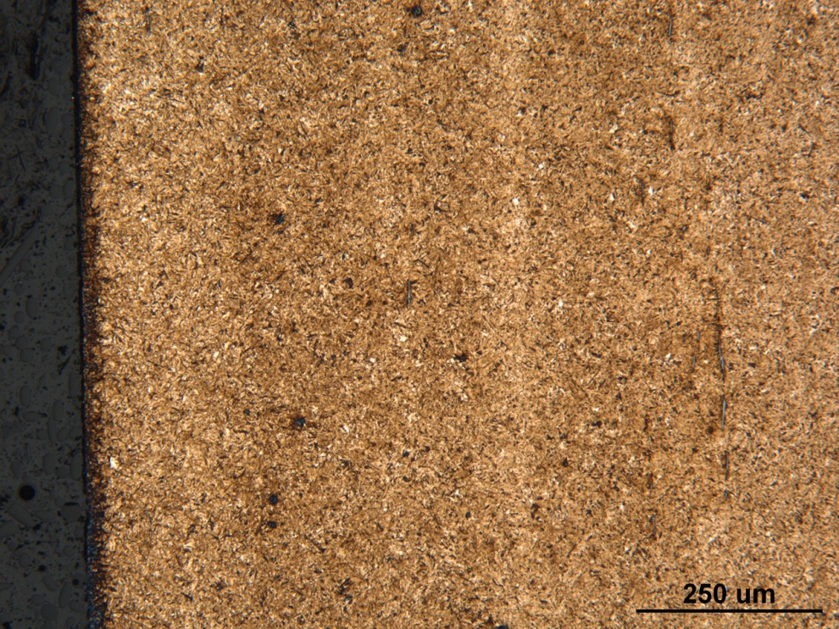

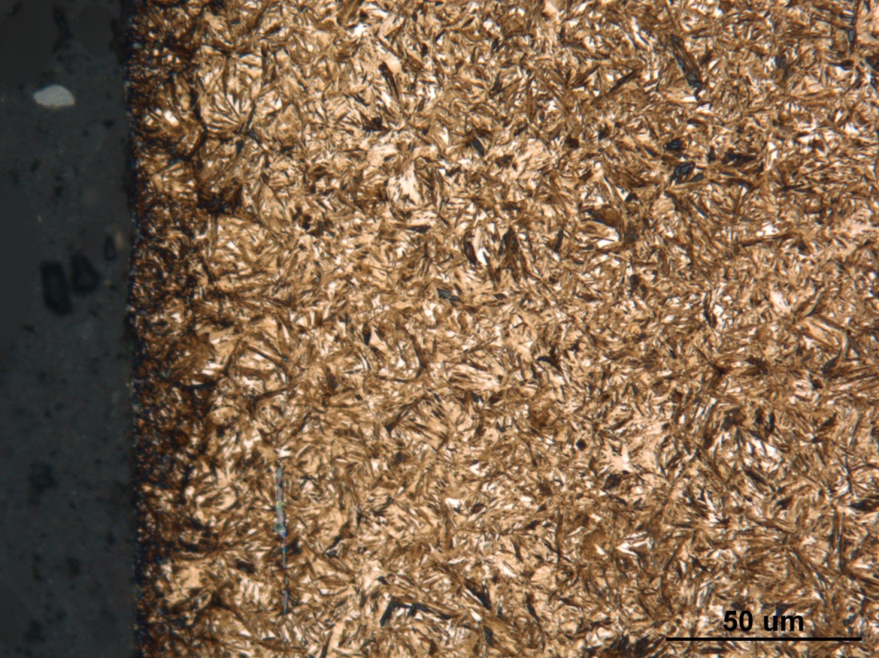
Figure Met-4. Photographs of the surface microstructure in the longitudinal grip section of fatigue specimen 137/138R. Original magnifications 100x (top) and 500x (bottom).

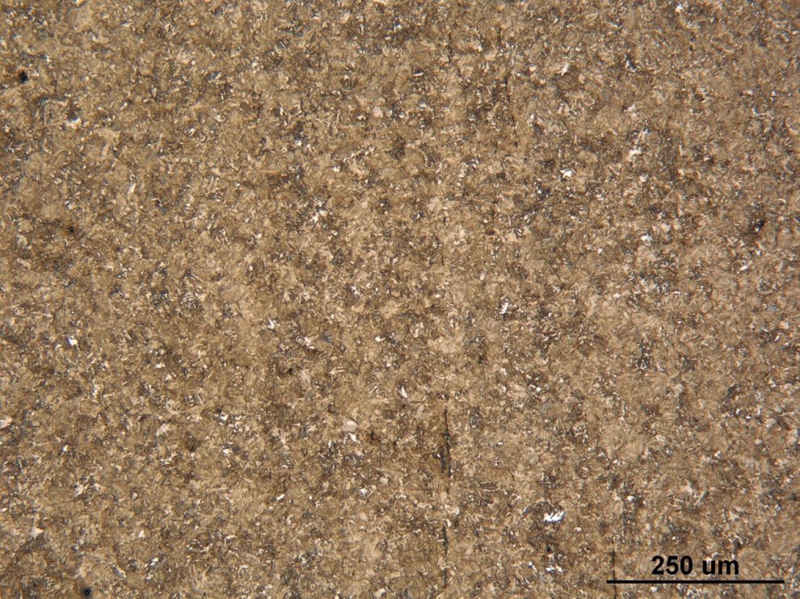

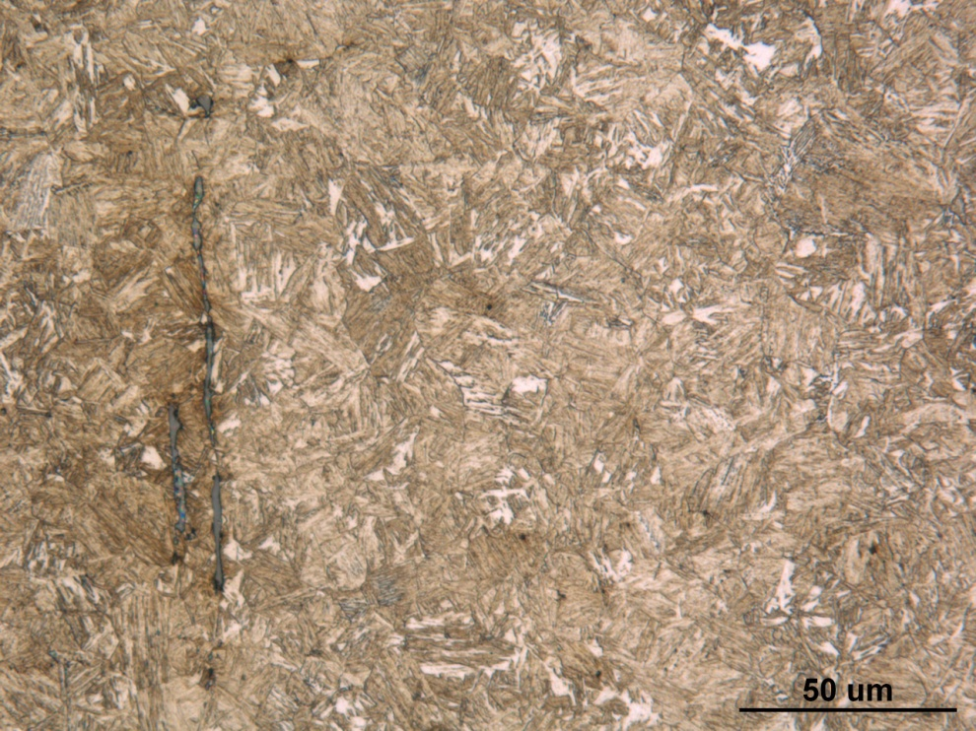
Figure Met-5. Photographs of the core microstructure in the longitudinal grip section of fatigue specimen 137/138R. Original magnifications 100x (top) and 500x (bottom).
Mechanical Properties - 143903

Hardness - Rockwell (Performed By: Dean Martin)

Rockwell Surface Hardness Testing was conducted on one sample provided. Impressions were taken in HRC on the large grip end. A correction factor for roundness, diameter 0.5”, is included in the data below.

Hardness – HRC:
60.3, 61.2, 60.7 HRC

Hardness - Micro (Performed By: Dean Martin)

Micro Hardness Testing was conducted on one sample provided, as requested, using the Wilson Micro Hardness Testing. Machine was verified with calibrated block prior to testing. Data as follows:

Depth from Surface (inches) | Hardness - HRC
.005” | 60
.010” | 61
.015” | 60.5
.020” | 60.5
.025” | 60
.030” | 60
.040” | 59
.050” | 58
.060” | 57.5
.070” | 56
.080” | 57
.090” | 56.5
.100” | 56.5

