Materials Engineering Summary Report
LTR Number: 140160

______________________________________________________________________

To: Peter Bauerle Phone: 776-7387

Location: W2003: Chrysler Technical Centre

______________________________________________________________________

From: Peter Bauerle Phone: 776-7387

Location: W2003: Chrysler Technical Centre

Date Completed: 02/24/2012
______________________________________________________________________

Part Name: Fatigue Specimen - Iteration 128,129,130
Number of Parts: 3
Nature of Work: Process/Materials Development

Summary/Conclusion/Recommendations

The machined diameter of the heat treated bars was adjusted to provide the different core hardness levels. The hardness traverses for each of the iterations appear to be close or have met the aim hardness range.

History of the Part

The samples that have been submitted are fatigue specimens that have been used for the development of the AISI fatigue database, namely iterations 128, 129 and 130. The test specimens were prepared from a 20MnCr5 steel grade. The samples have been vacuum carburized to meet core hardness of 28-35 HRC, 35-40 HRC and 40-45 HRC, respectively. Please reference LTR #139684 for comparison of how the photomicrographs and hardness data should be presented.

Metallography - 140160

General Microstructure Description (Performed By: Christopher Rasmussen)

Three mounted fatigue specimens were submitted for microstructural examination. The mounts were ground and polished per ASTM E3 and etched in 3% Nital per ASTM E407. Photomicrographs were taken at low and high magnification for each sample and reported in Table 1 below.

Table 1 Microstructural results per sample and location.
Sample | Location | Microstructure | Figure
128 | cross section mid radius | bands of tempered martensite, ferrite and bainite | 1
 | grip end case | bands of tempered martensite, ferrite and bainite | 2
 | grip end core | bands of tempered martensite, ferrite and bainite | 3
129 | cross section mid radius | tempered martensite | 4
 | grip end case | tempered martensite | 5
 | grip end core | bands of tempered martensite, ferrite and bainite | 6
130 | cross section mid radius | tempered martensite, some ferrite and bainite | 7
 | grip end case | tempered martensite | 8
 | grip end core | tempered martensite | 9

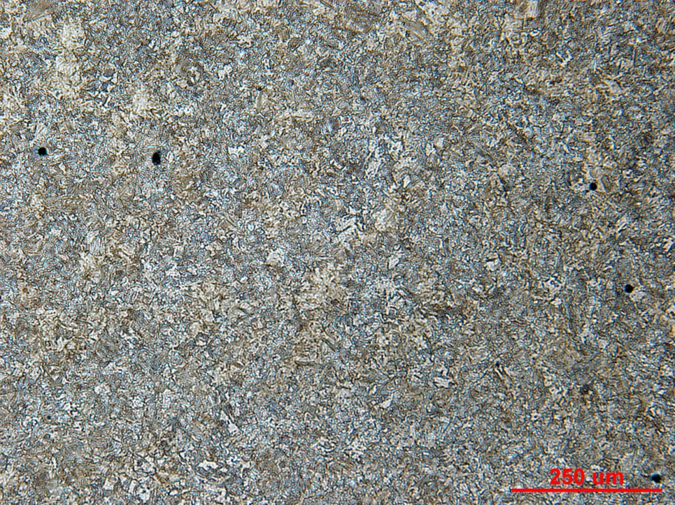

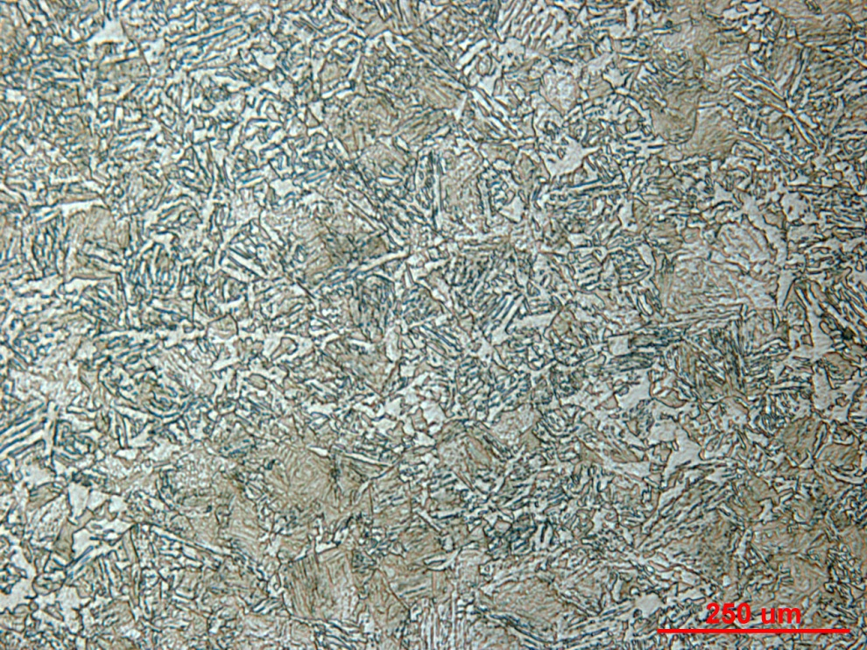
Figure 1 Photomicrograph of Sample 128 cross section mid radius at low and high magnification.

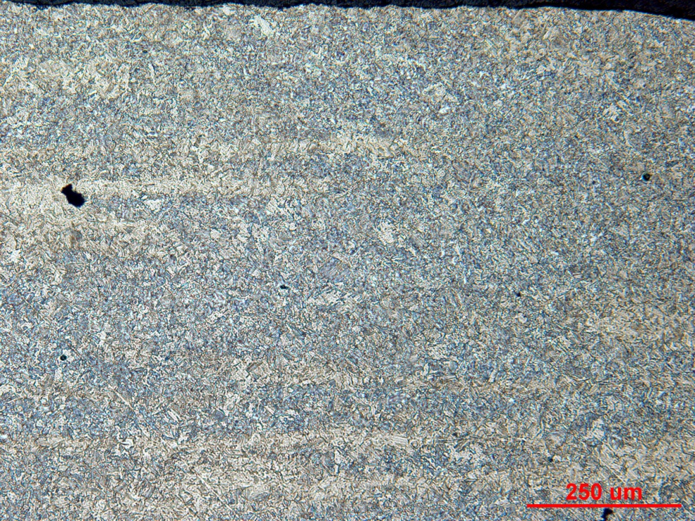

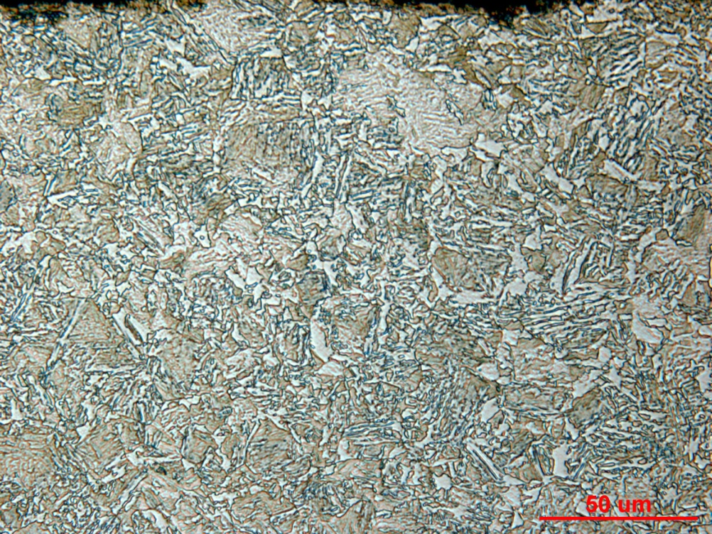
Figure 2 Photomicrograph of Sample 128 grip end case at low and high magnification.

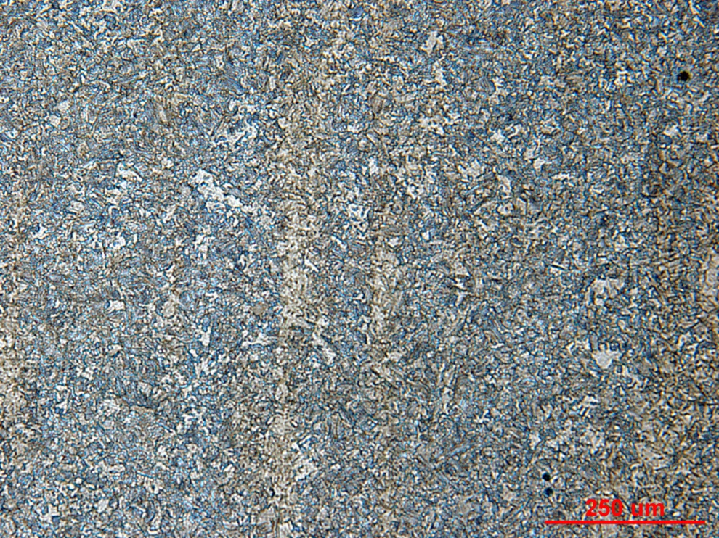

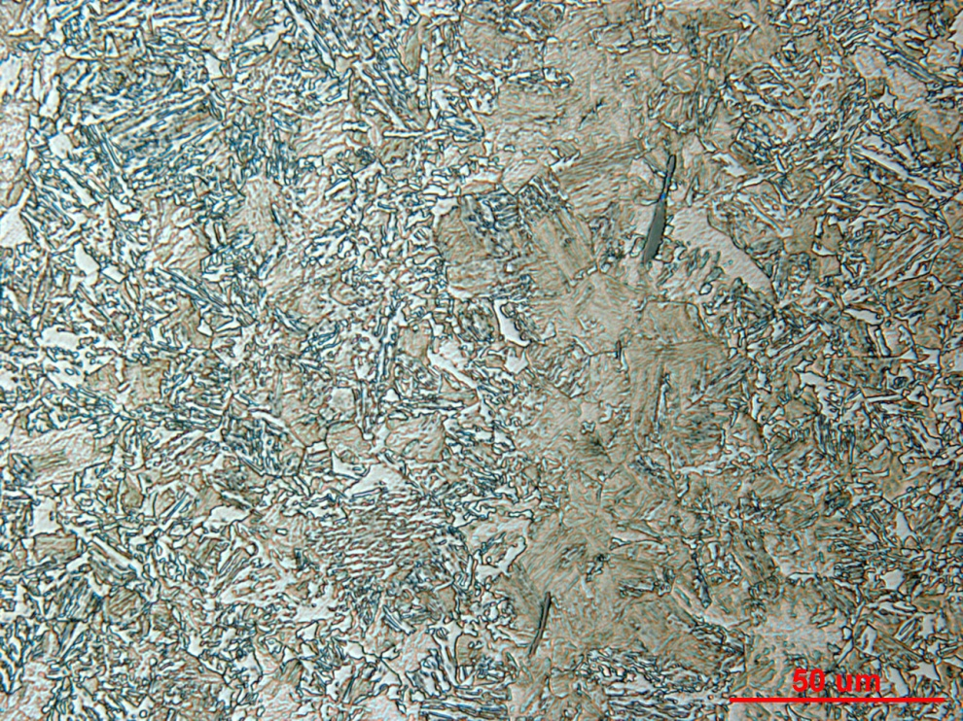
Figure 3 Photomicrograph of Sample 128 grip end core at low and high magnification.

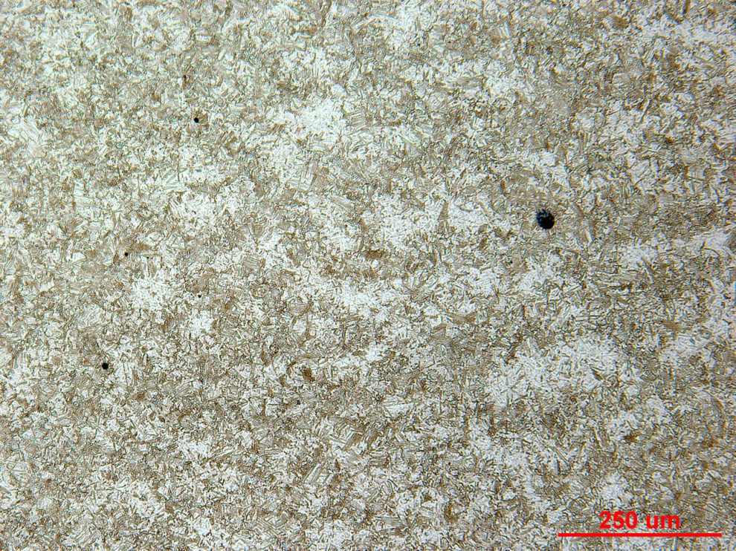

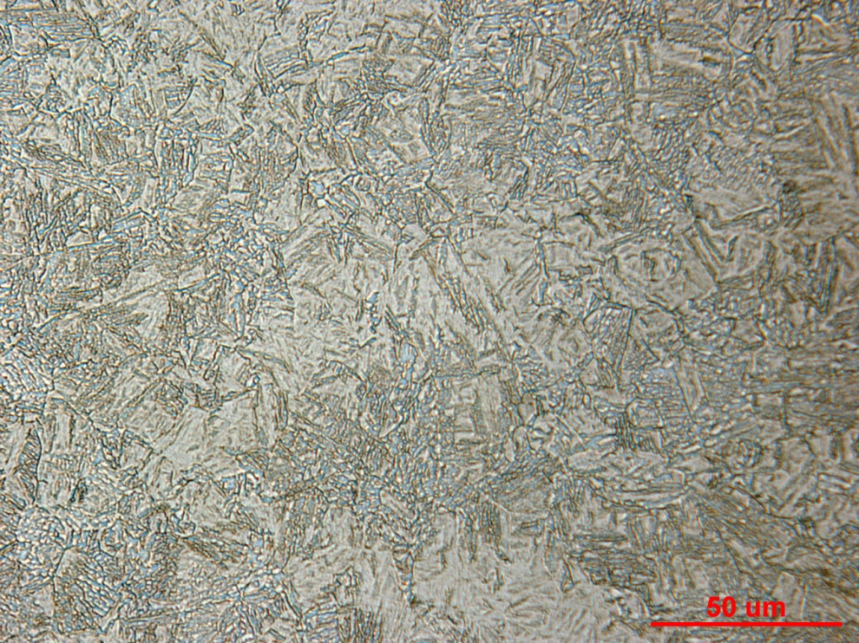
Figure 4 Photomicrograph of Sample 129 cross section mid radius at low and high magnification.

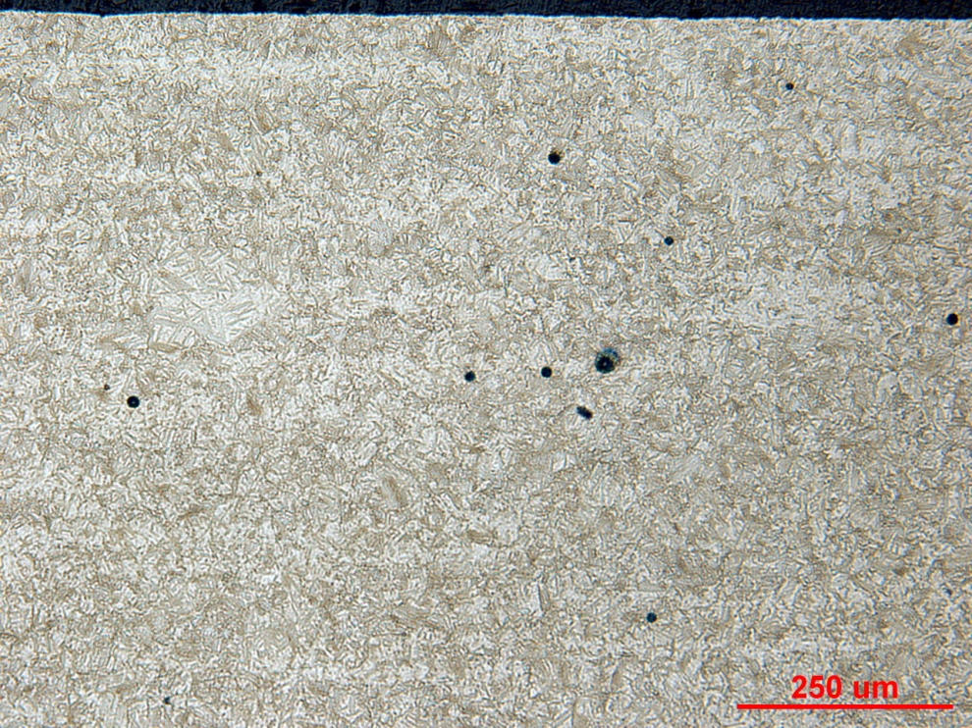

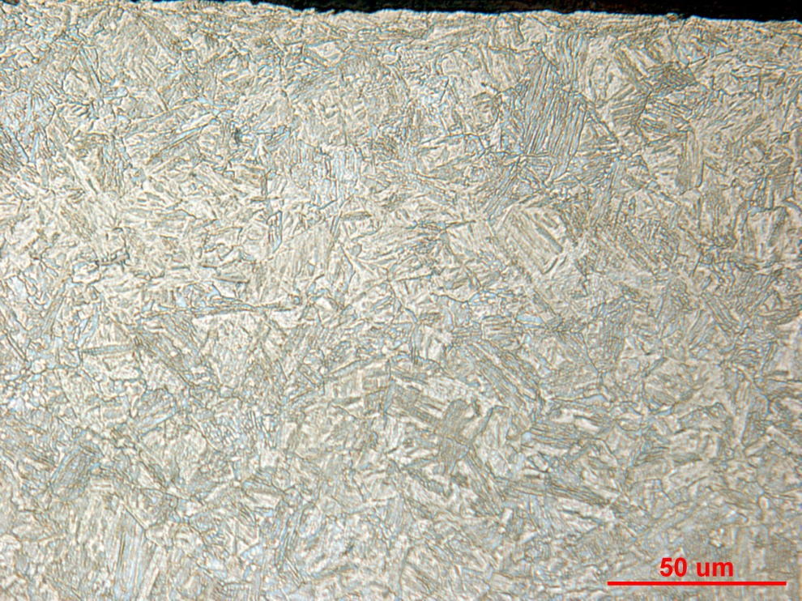
Figure 5 Photomicrograph of Sample 129 grip end case at low and high magnification.

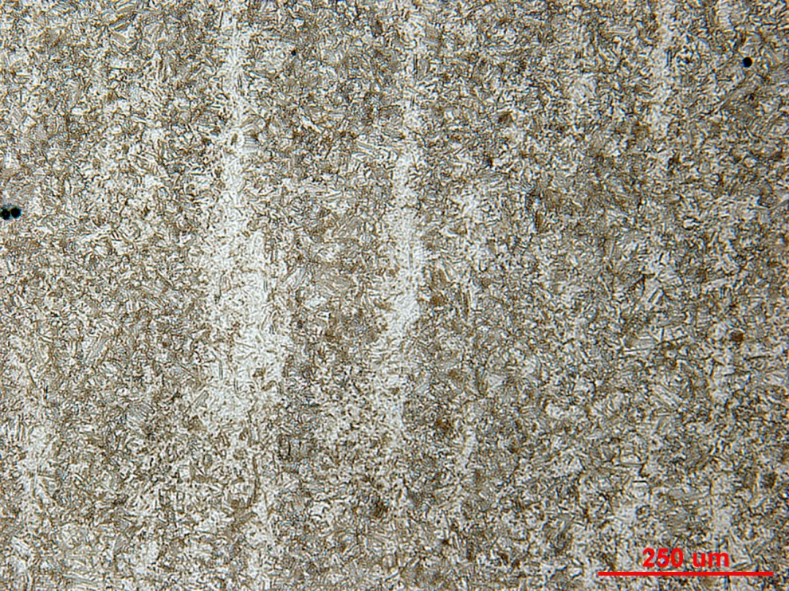

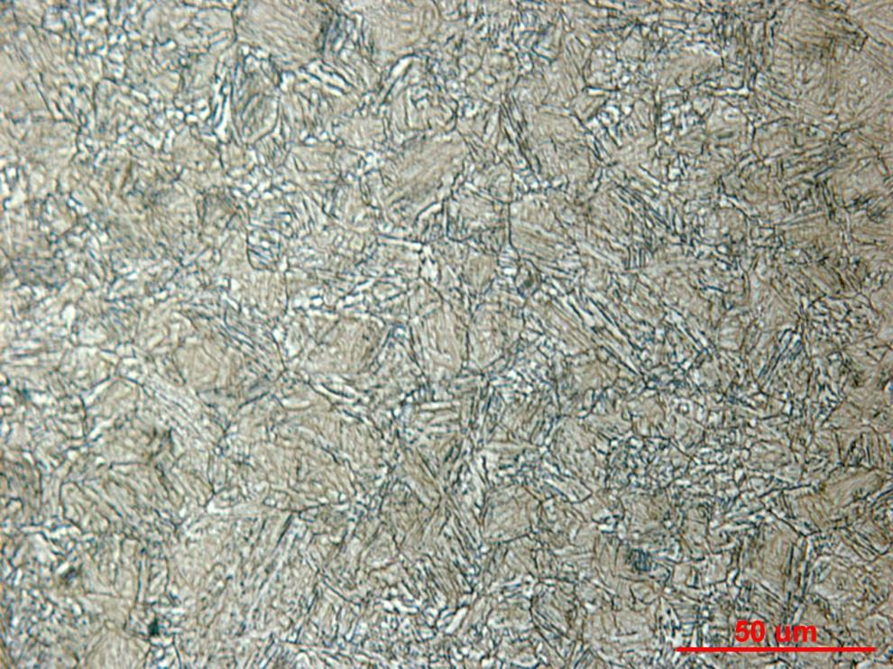
Figure 6 Photomicrograph of Sample 129 grip end core at low and high magnification.

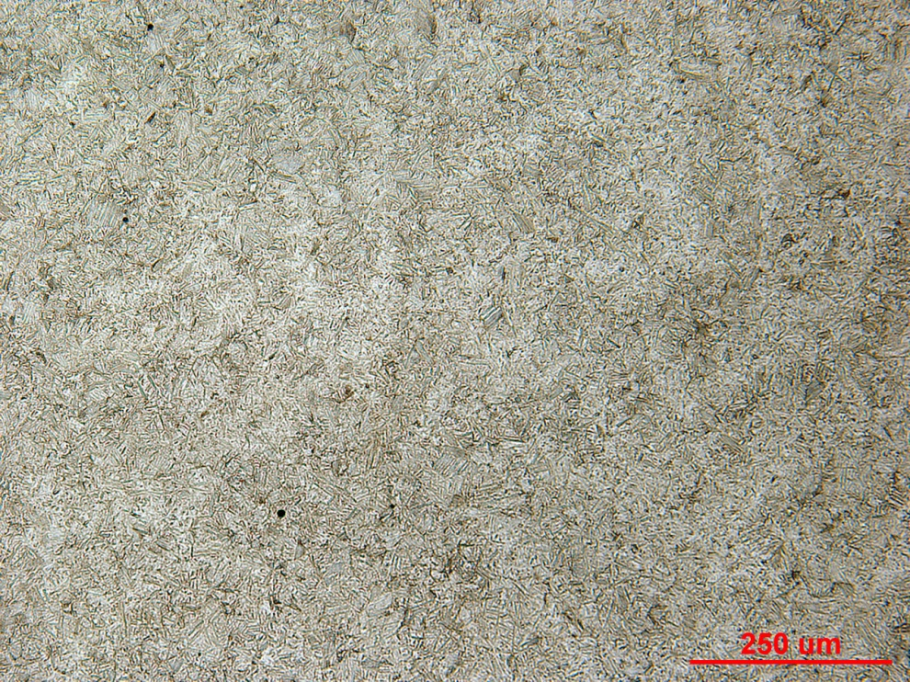

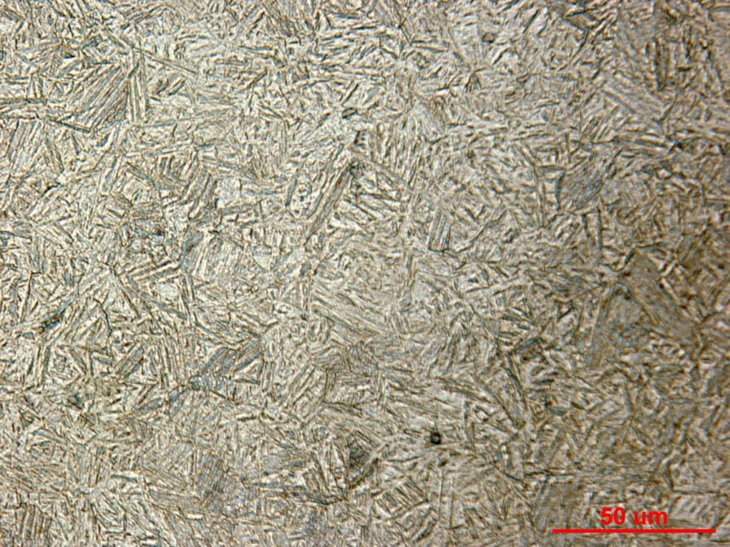
Figure 7 Photomicrograph of Sample 130 cross section mid radius at low and high magnification.

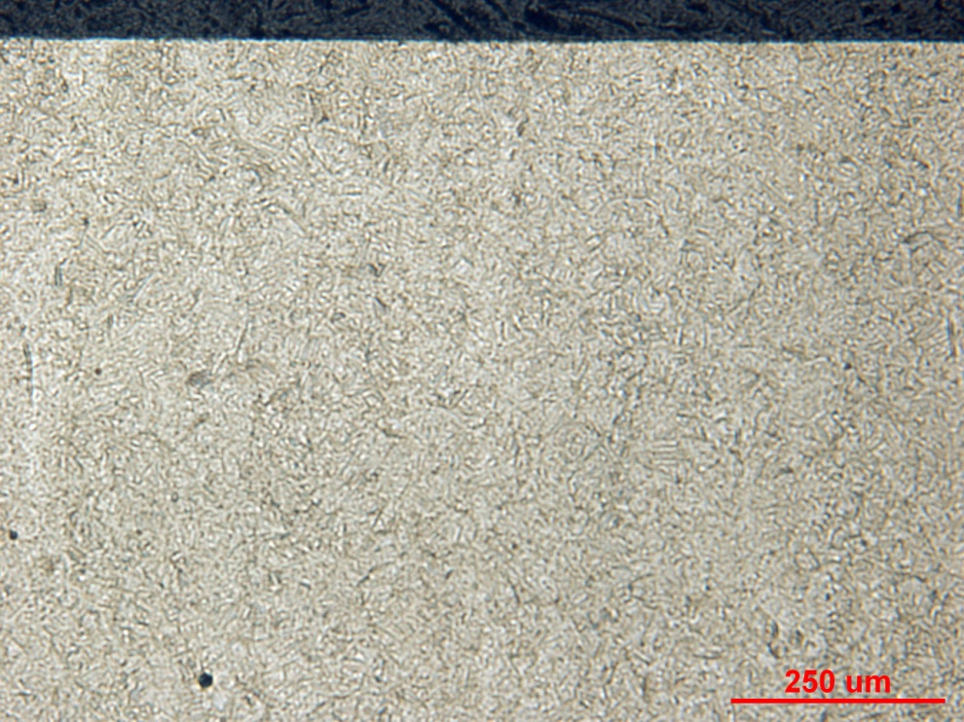

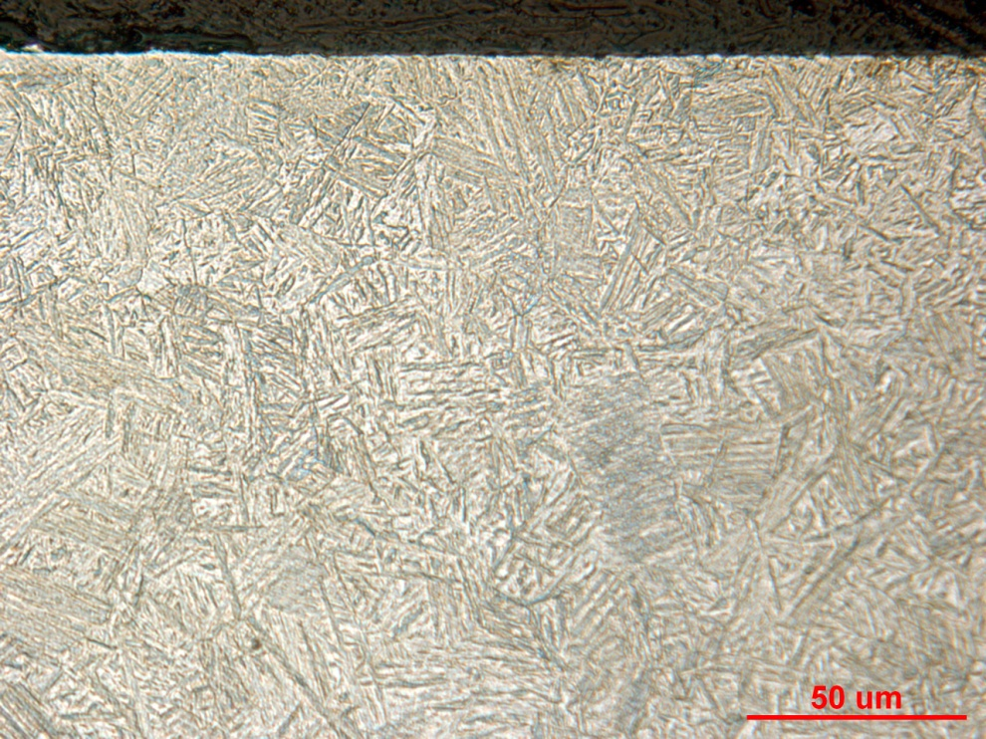
Figure 8 Photomicrograph of Sample 130 grip end case at low and high magnification.

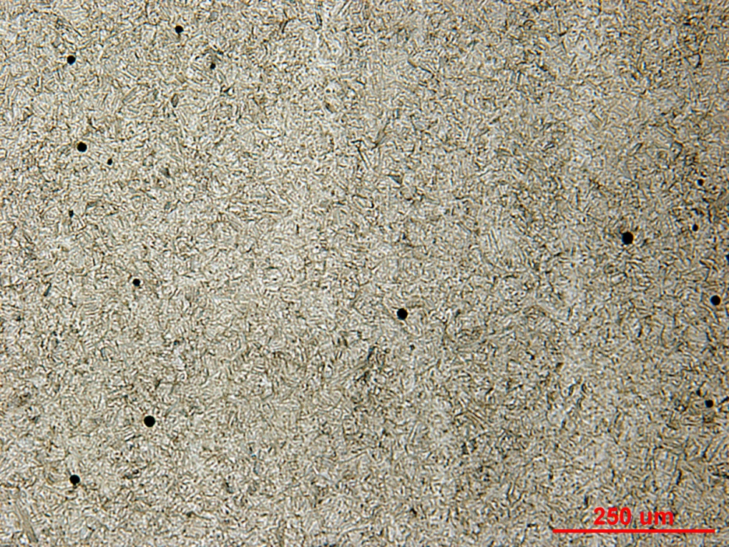

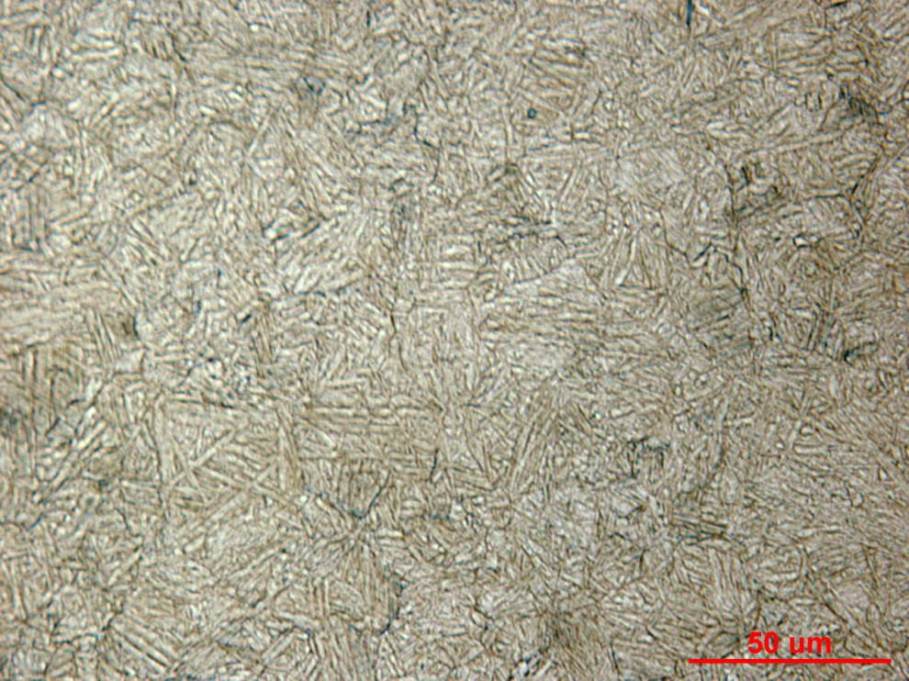
Figure 9 Photomicrograph of Sample 130 grip end core at low and high magnification.

Mechanical Properties - 140160

Hardness - Rockwell (Performed By: Premji Patel)
Performed HRC on the surface of the grip end (large diameter)
Data as follows:
Iteration 128 | 129 | 130
30.7 | 34.5 | 42.2
30.5 | 35.1 | 43.6
30.2 | 35.8 | 43.4

Hardness - Micro (Performed By: Premji Patel)
Performed micro-hardness traverse across the gage cross section (small diameter) at 0.010” increment.
Data as follows: 