Materials Engineering Lab Report
LTR Number: 139684

______________________________________________________________________
To: Peter Bauerle Phone: 776-7387
Location: W2003: Chrysler Technical Centre

______________________________________________________________________

Lead Engineer: Peter Bauerle Phone: 776-7387
Location: W2003: Chrysler Technical Centre Completed: 12/23/2011

______________________________________________________________________

Part Name: Fatigue Specimen - Iteration 125,126,127
Number of Parts: 3
Nature of Work: Process/Materials Development

History of Part

The samples that have been submitted are fatigue specimens that have been used for the development of the AISI fatigue database, namely iterations 125, 126 and 127. The test specimans were prepared from a 9310 steel grade. The samples have been vacuum carburized to meet core hardnese of 28-35 HRC, 35-40 HRC and 40-45 HRC, respectively.These samples were originally supplied under LTR # 138978.

Test Results are on the following pages

Metallography - 139684

General Microstructure Description (Performed By: Christopher Rasmussen)

Three mounted fatigue specimens were submitted for microstructural examination. The mounts were ground and polished per ASTM E3 and etched in 3% Nital per ASTM E407. Photomicrographs were taken at low and high magnification for each sample and reported in Table 1 below.

Table 1 Microstructural results per sample and location.
Sample | Location | Microstructure | Figure
125 | cross section mid radius | mix of tempered martensite, ferrite and bainite | 1
 | grip end case | bands of tempered martensite, ferrite and bainite | 2
 | grip end core | bands of tempered martensite, ferrite and bainite | 3
126 | cross section mid radius | tempered martensite, some ferrite and bainite | 4
 | grip end case | tempered martensite | 5
 | grip end core | tempered martensite, some ferrite and bainite | 6
127 | cross section mid radius | tempered martensite, some ferrite and bainite | 7
 | grip end case | tempered martensite | 8
 | grip end core | tempered martensite | 9

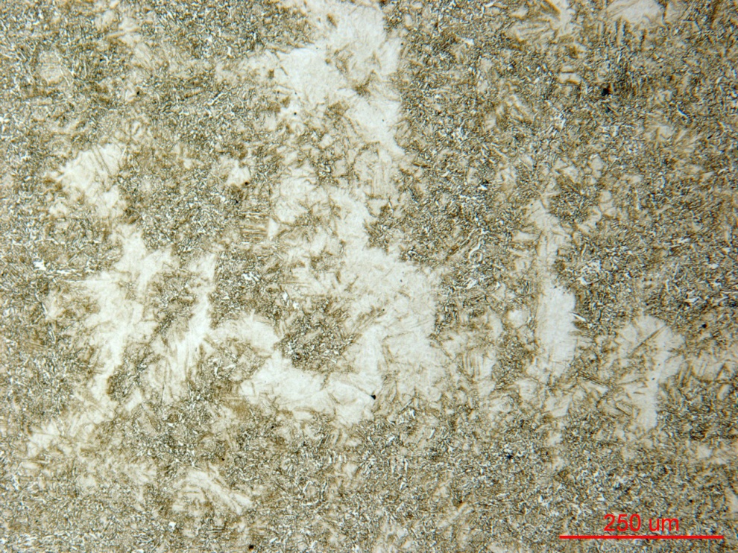

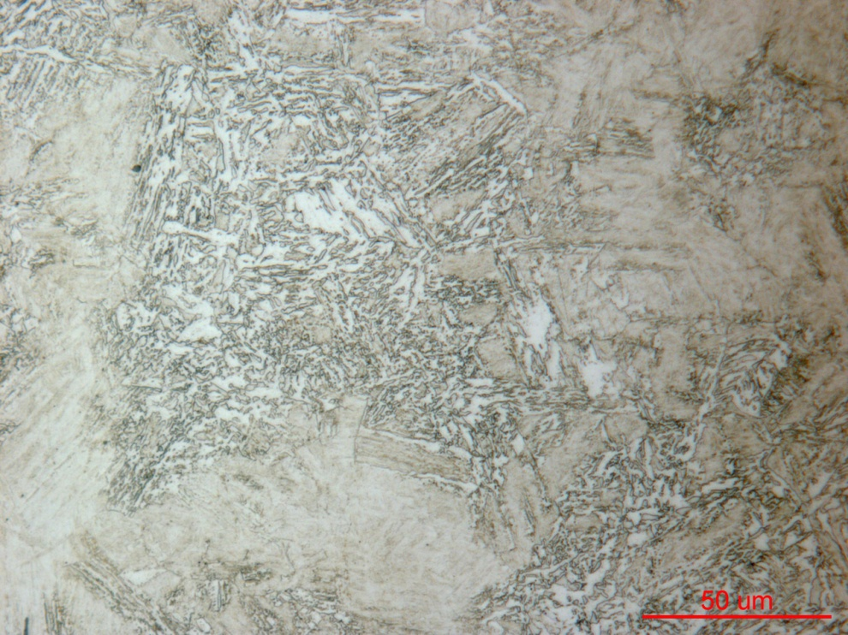
Figure 1 Photomicrograph of Sample 125 cross section mid radius at low and high magnification.

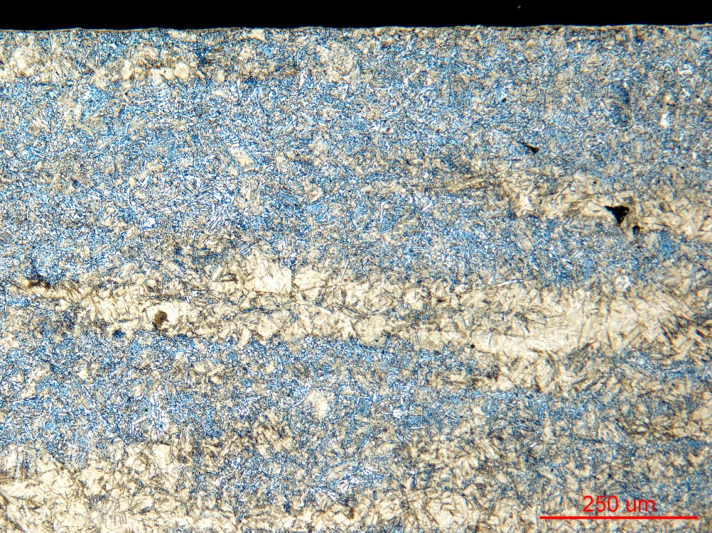

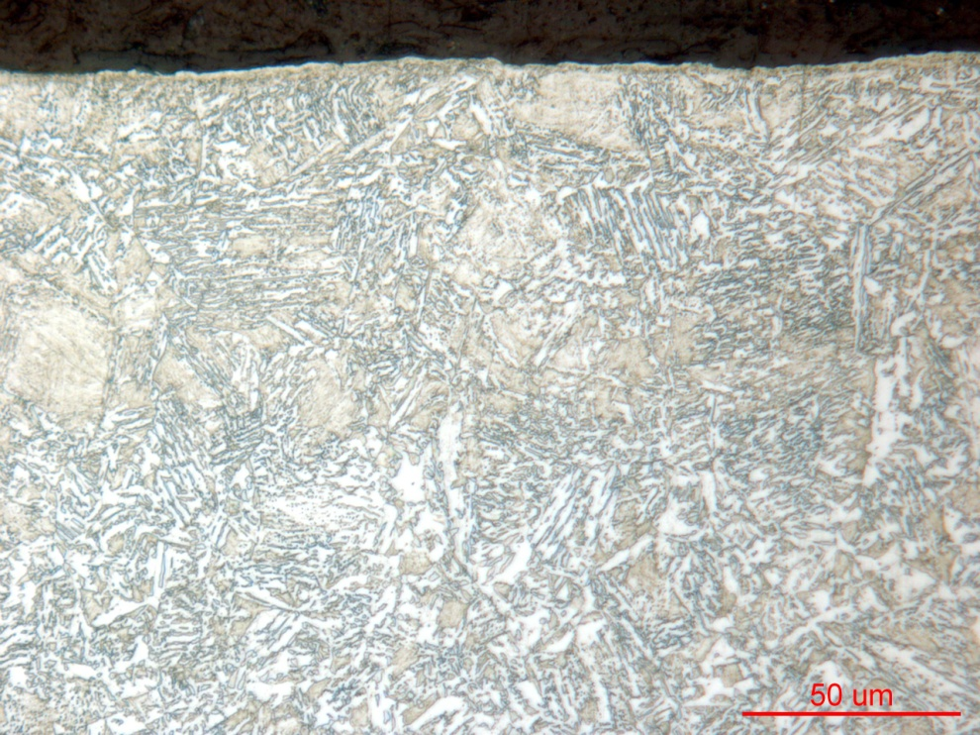
Figure 2 Photomicrograph of Sample 125 grip end case at low and high magnification.

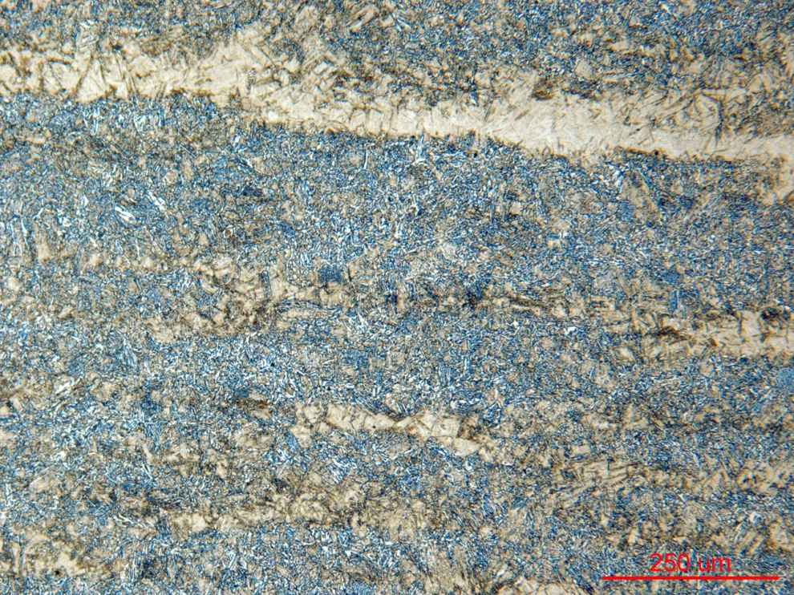

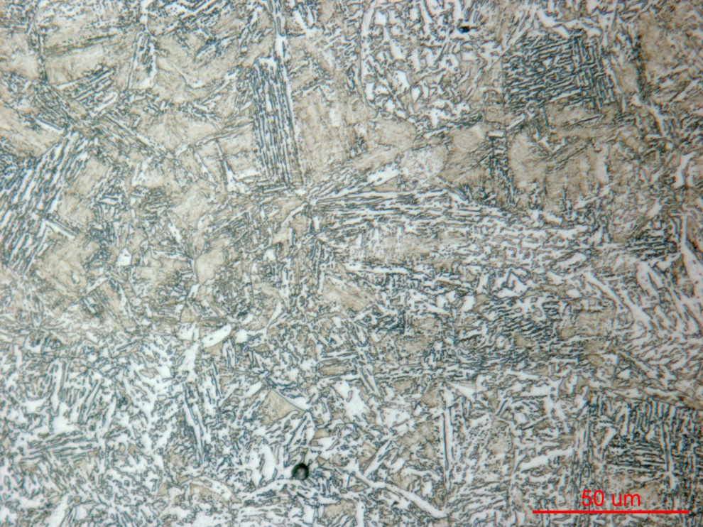
Figure 3 Photomicrograph of Sample 125 grip end core at low and high magnification.

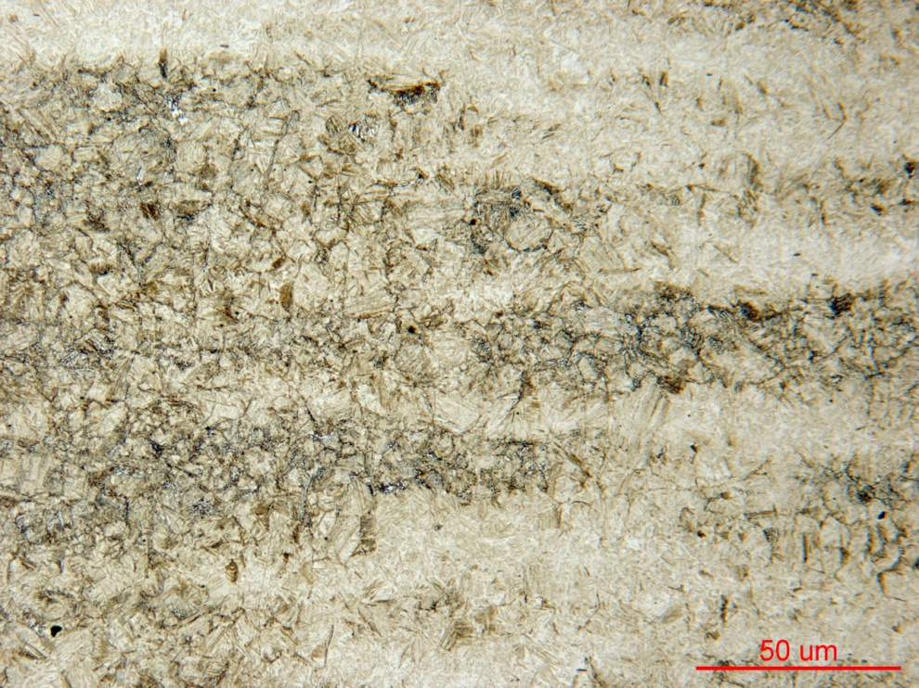

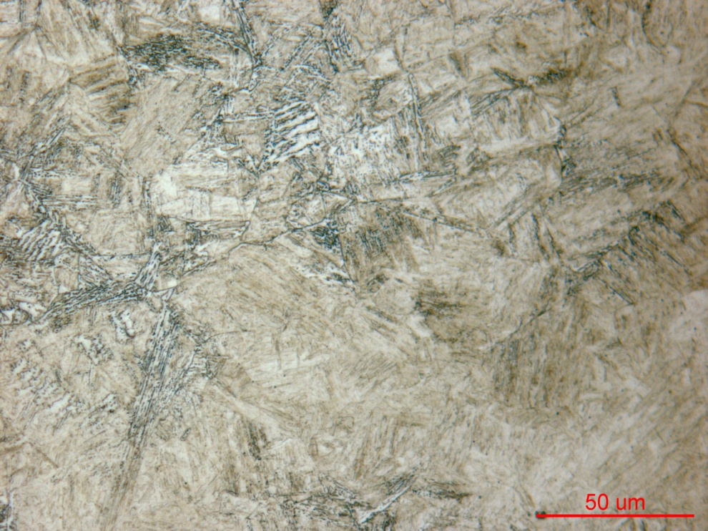
Figure 4 Photomicrograph of Sample 126 cross section mid radius at low and high magnification.

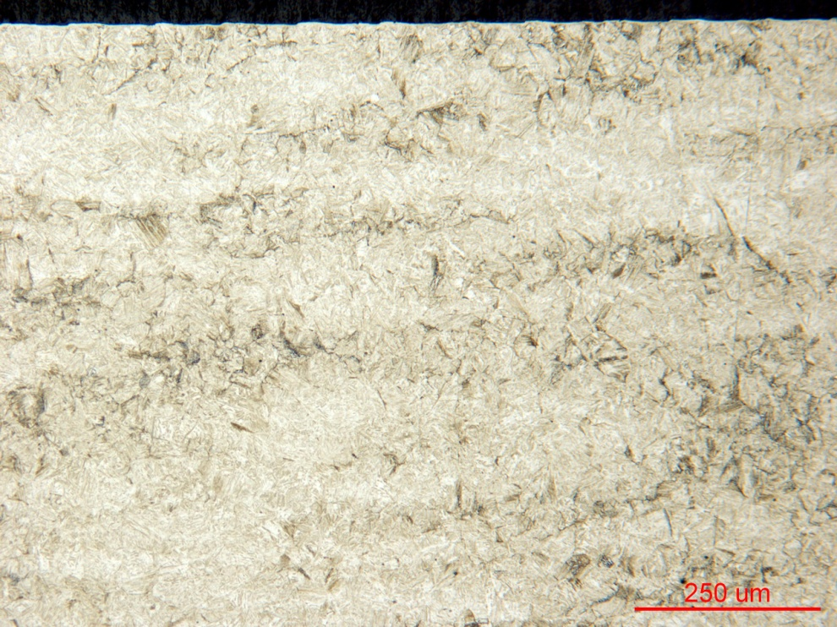

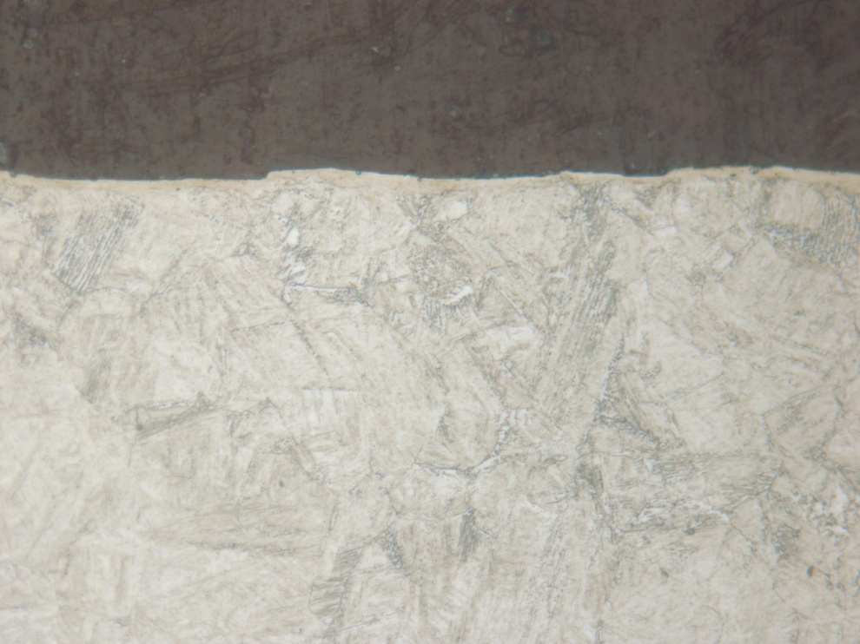
Figure 5 Photomicrograph of Sample 126 grip end case at low and high magnification.

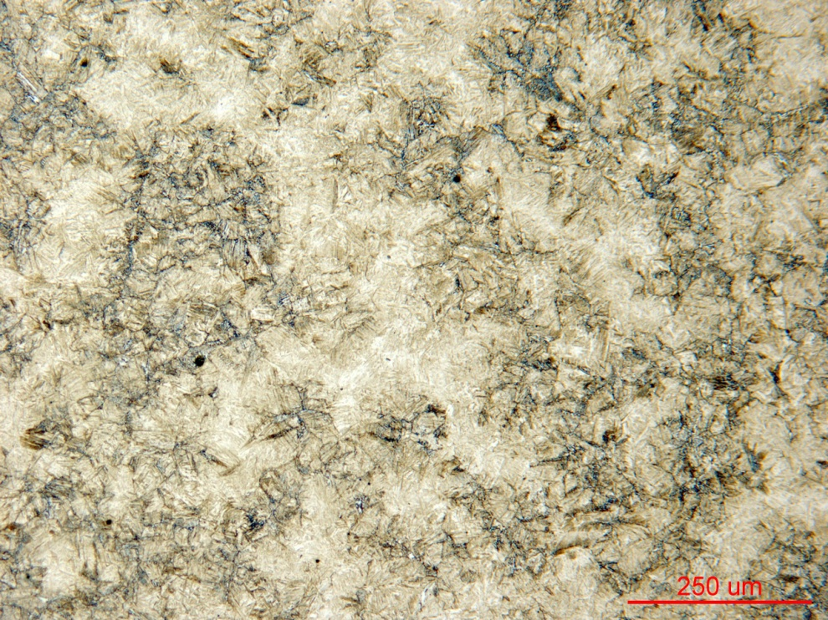

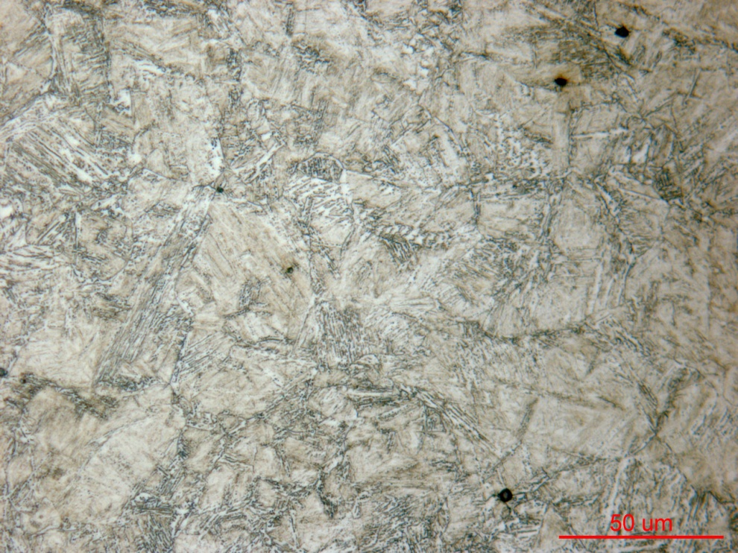
Figure 6 Photomicrograph of Sample 126 grip end core at low and high magnification.

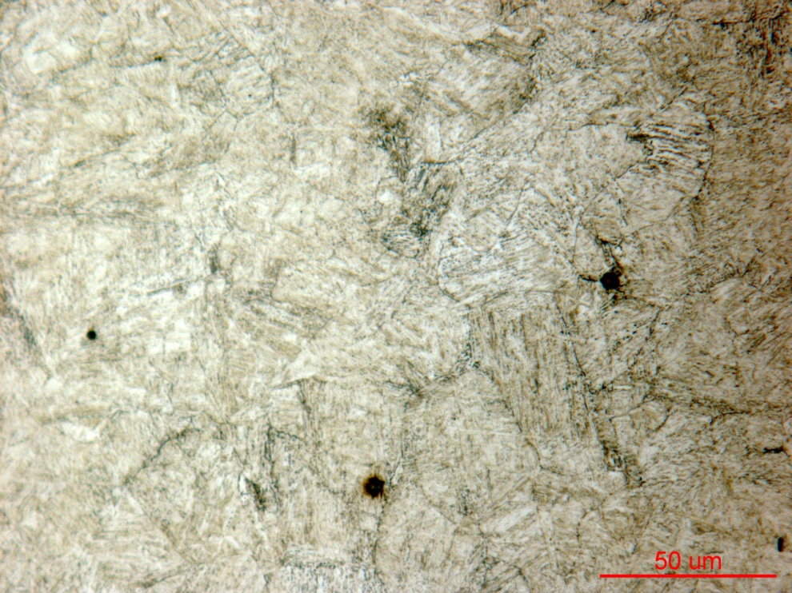

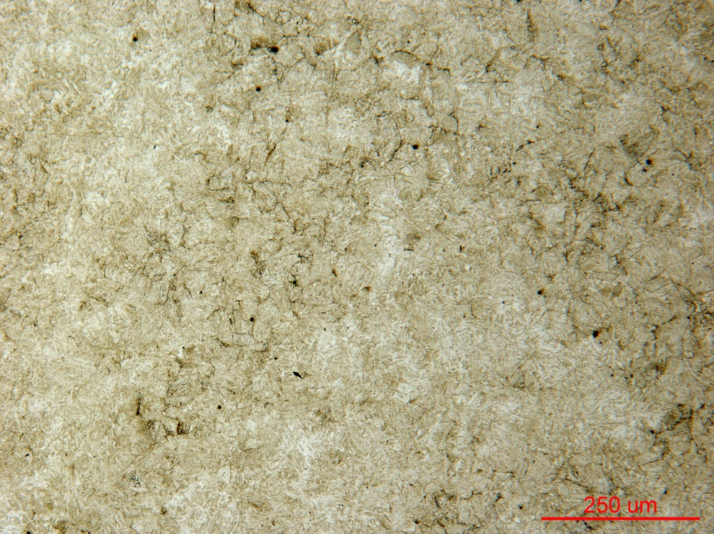
Figure 7 Photomicrograph of Sample 127 cross section mid radius at low and high magnification.

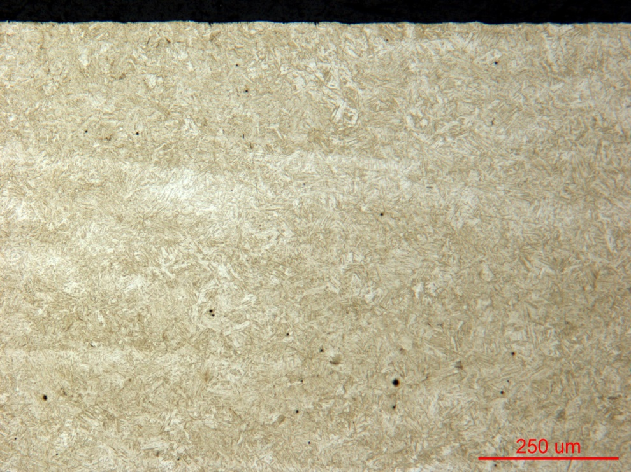

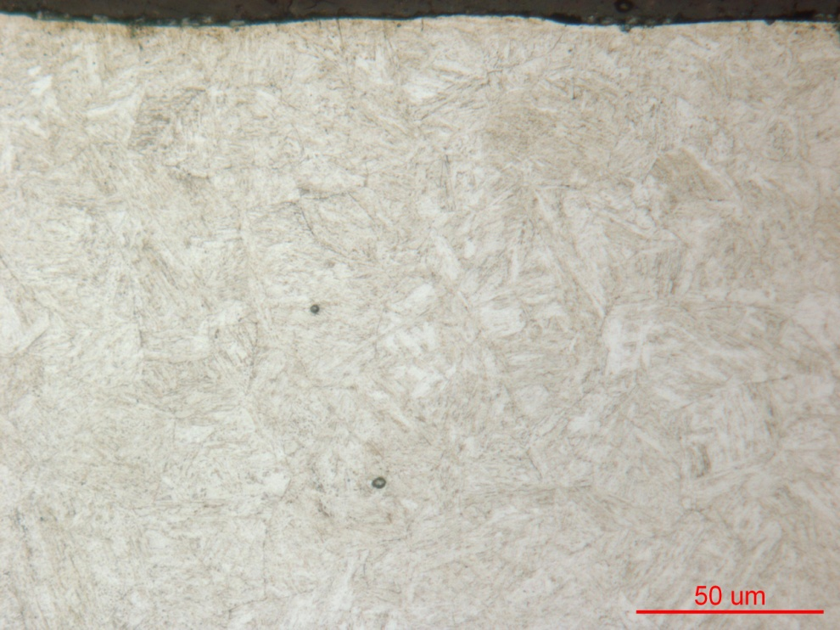
Figure 8 Photomicrograph of Sample 127 grip end case at low and high magnification.

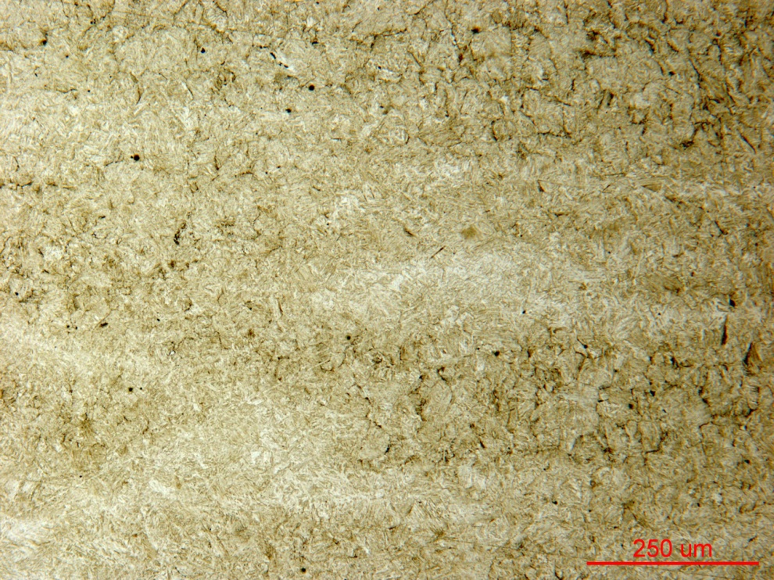

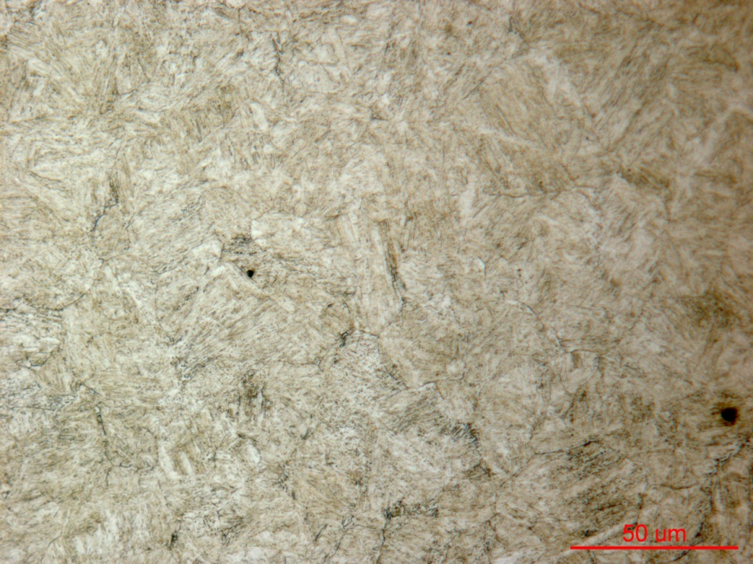
Figure 9 Photomicrograph of Sample 127 grip end core at low and high magnification.

Mechanical Properties - 139684

Hardness - Rockwell (Performed By: Premji Patel)
Performed HRC on the surface of the grip end (large diameter).
Data as follows:
Iteration no | 125 | 126 | 127
HRC | 28.2 | 36.0 | 38.8
HRC | 27.8 | 35.2 | 37.8
HRC | 28.0 | 34.9 | 39.0

Hardness - Micro (Performed By: Premji Patel)
Performed micro-hardness traverse across the gage section (small diameter) at 0.01”increment, from the edge to the core.
Data as follows:
