

Materials Engineering Summary Report
LTR Number: 136537

From: Peter Bauerle Phone: 776-7387

Location: CTC

Lab(s): Metallography Completed: 9/2/2010

Mechanical Properties

Subject/Part Name: Fatigue Specimen - Iteration 116-117-118

Approver: Peter Bauerle

Originator: Peter Bauerle

Originator Phone: 248-576-7387

Number of Parts: 1
Nature of Work: Process/Materials Development
Vendor:
Plant:
P/N:
MS:
PS:

History of Part

The sample that has been submitted is a fatigue specimen that has been used for the development of the AISI fatigue database. The test specimen was prepared from a 4140 steel grade with low sulfur content but will actually represent iterations 116, 117 and 118 all of which are 4140 to be quenched and tempered to an aim HRC40. The sample has been quench and tempered by austenitizing at 1550F in salt bath prior to quenching in 150F oil and then tempering at 800F to achieve the approximate hardness.

Purpose

The purpose of this LTR is to evaluate the microstructure and hardness of the sample.
Metallography - 136537

General Microstructure Description (Performed By: Xichen Sun)

Samples were prepared by requester.
Microstructure is tempered martensite

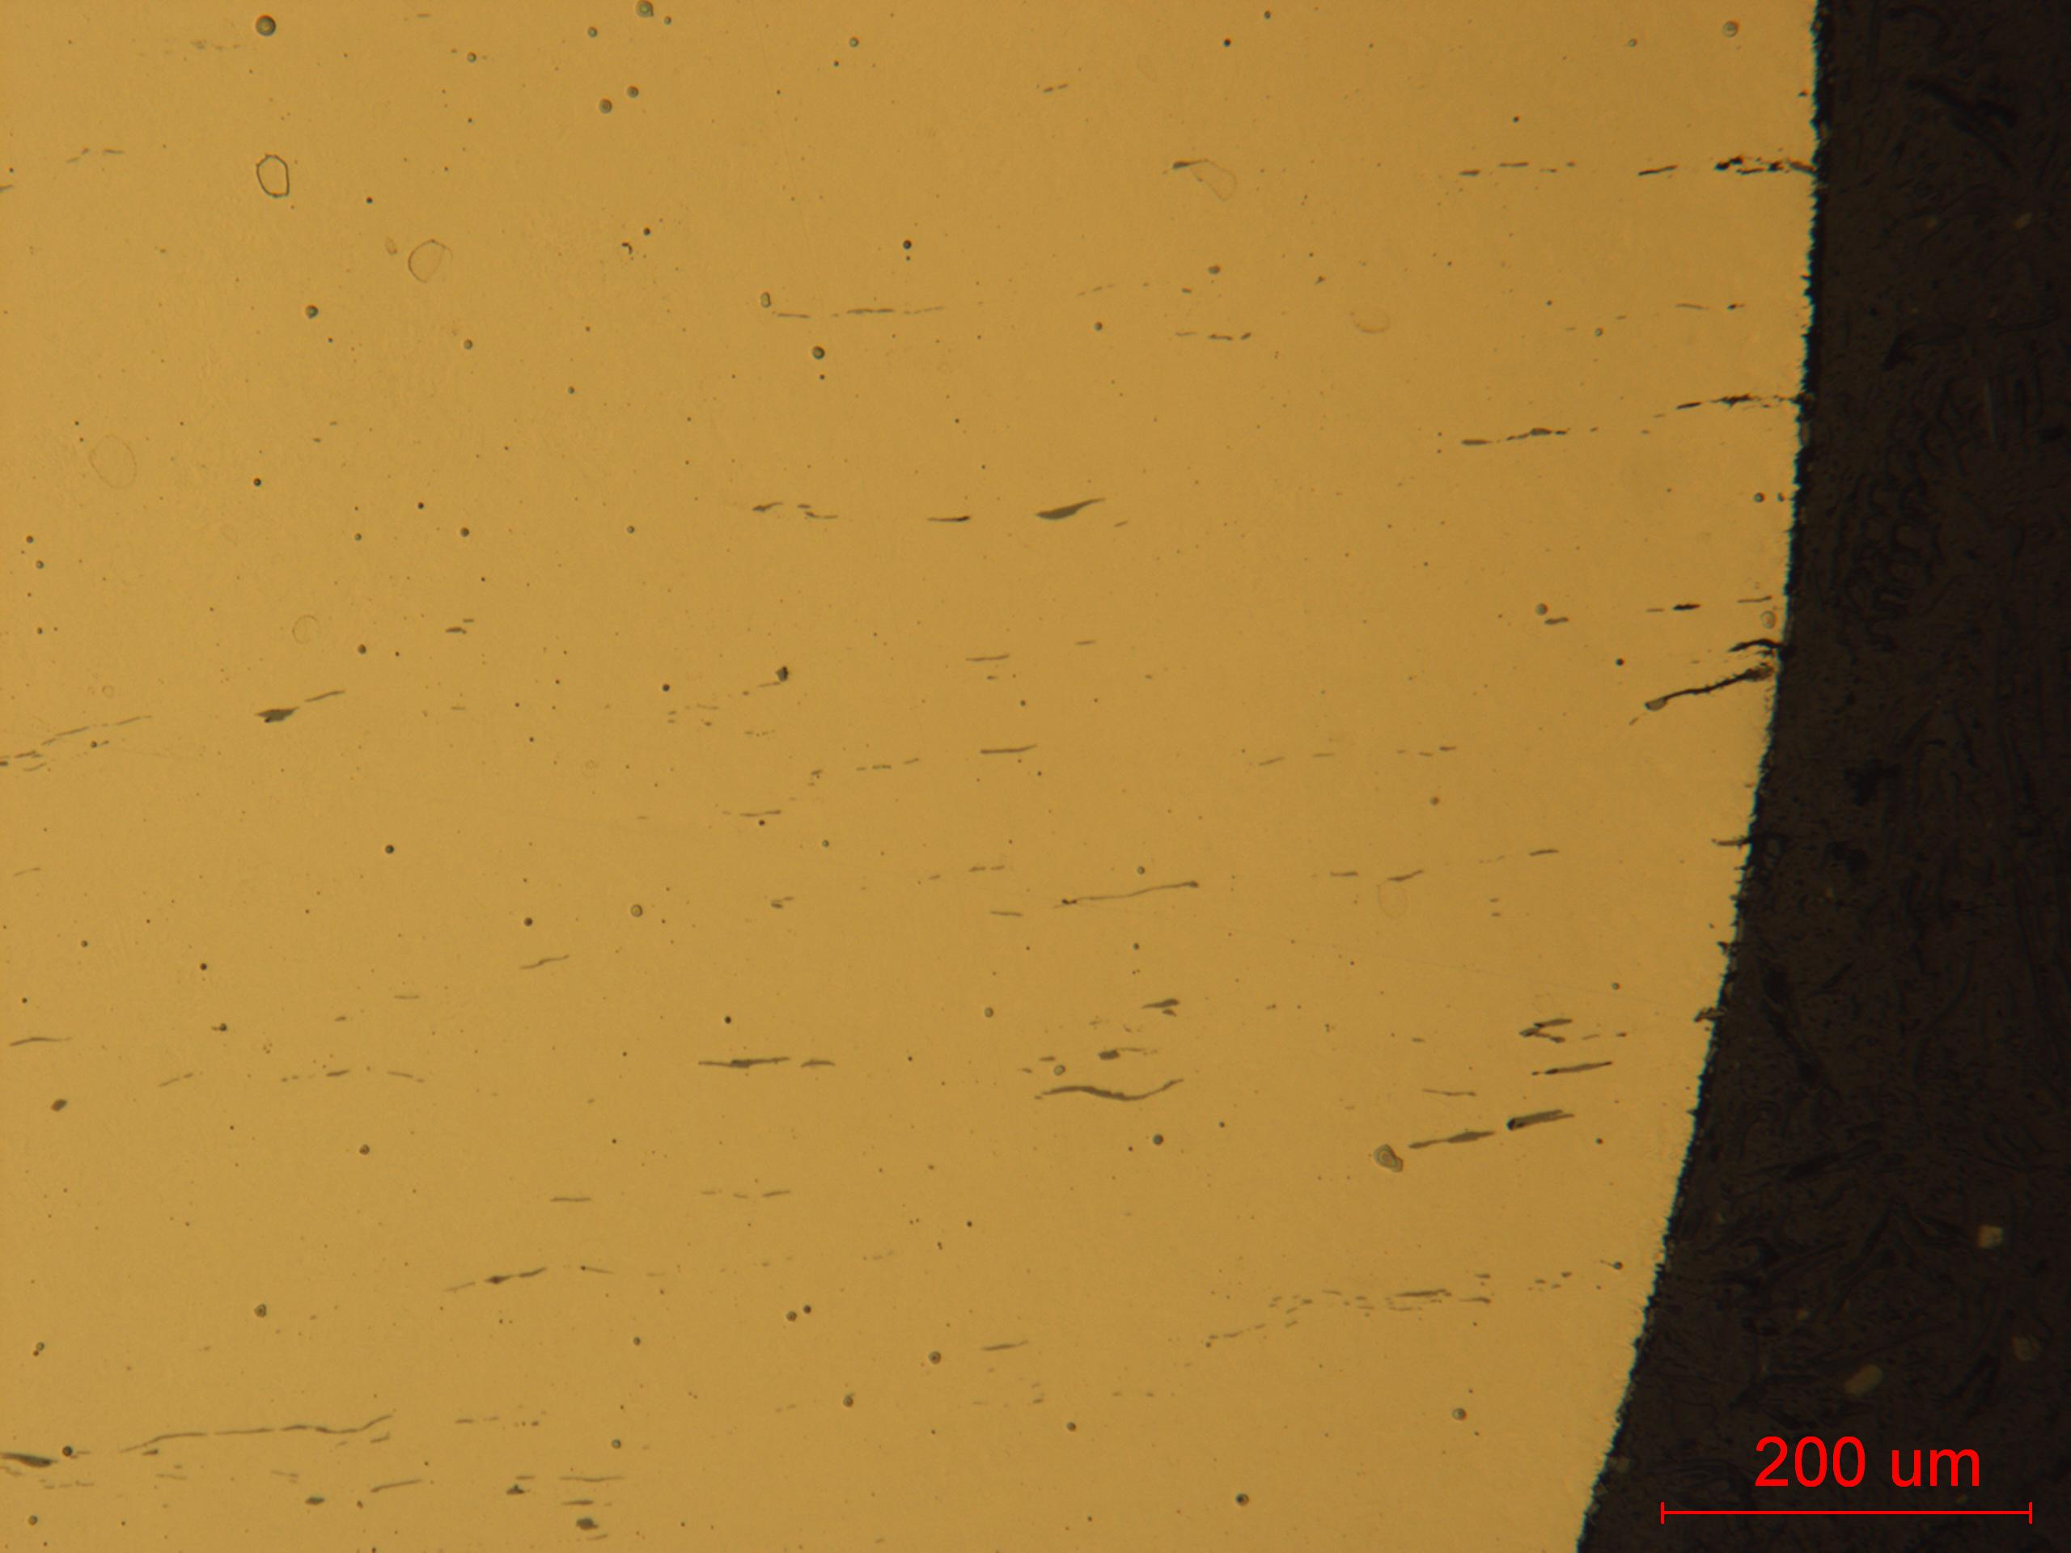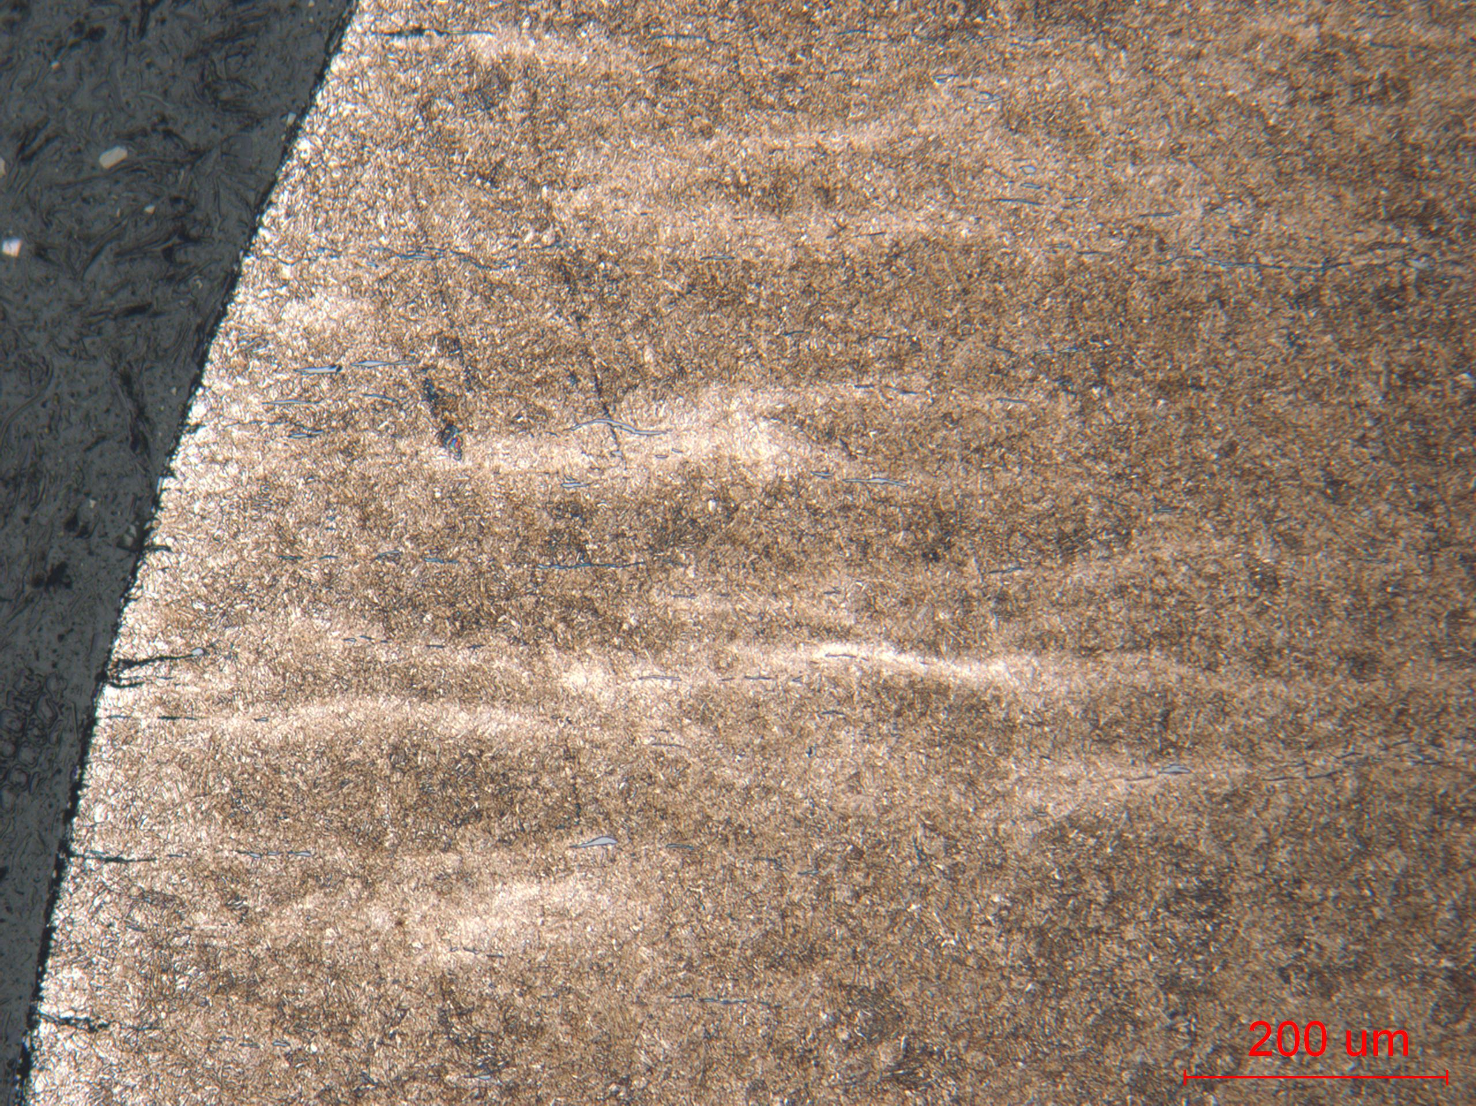
- Unetched structure (b) Etched structure
Low mag. showing high MnS inclusion (a) and tempered martensite (b).

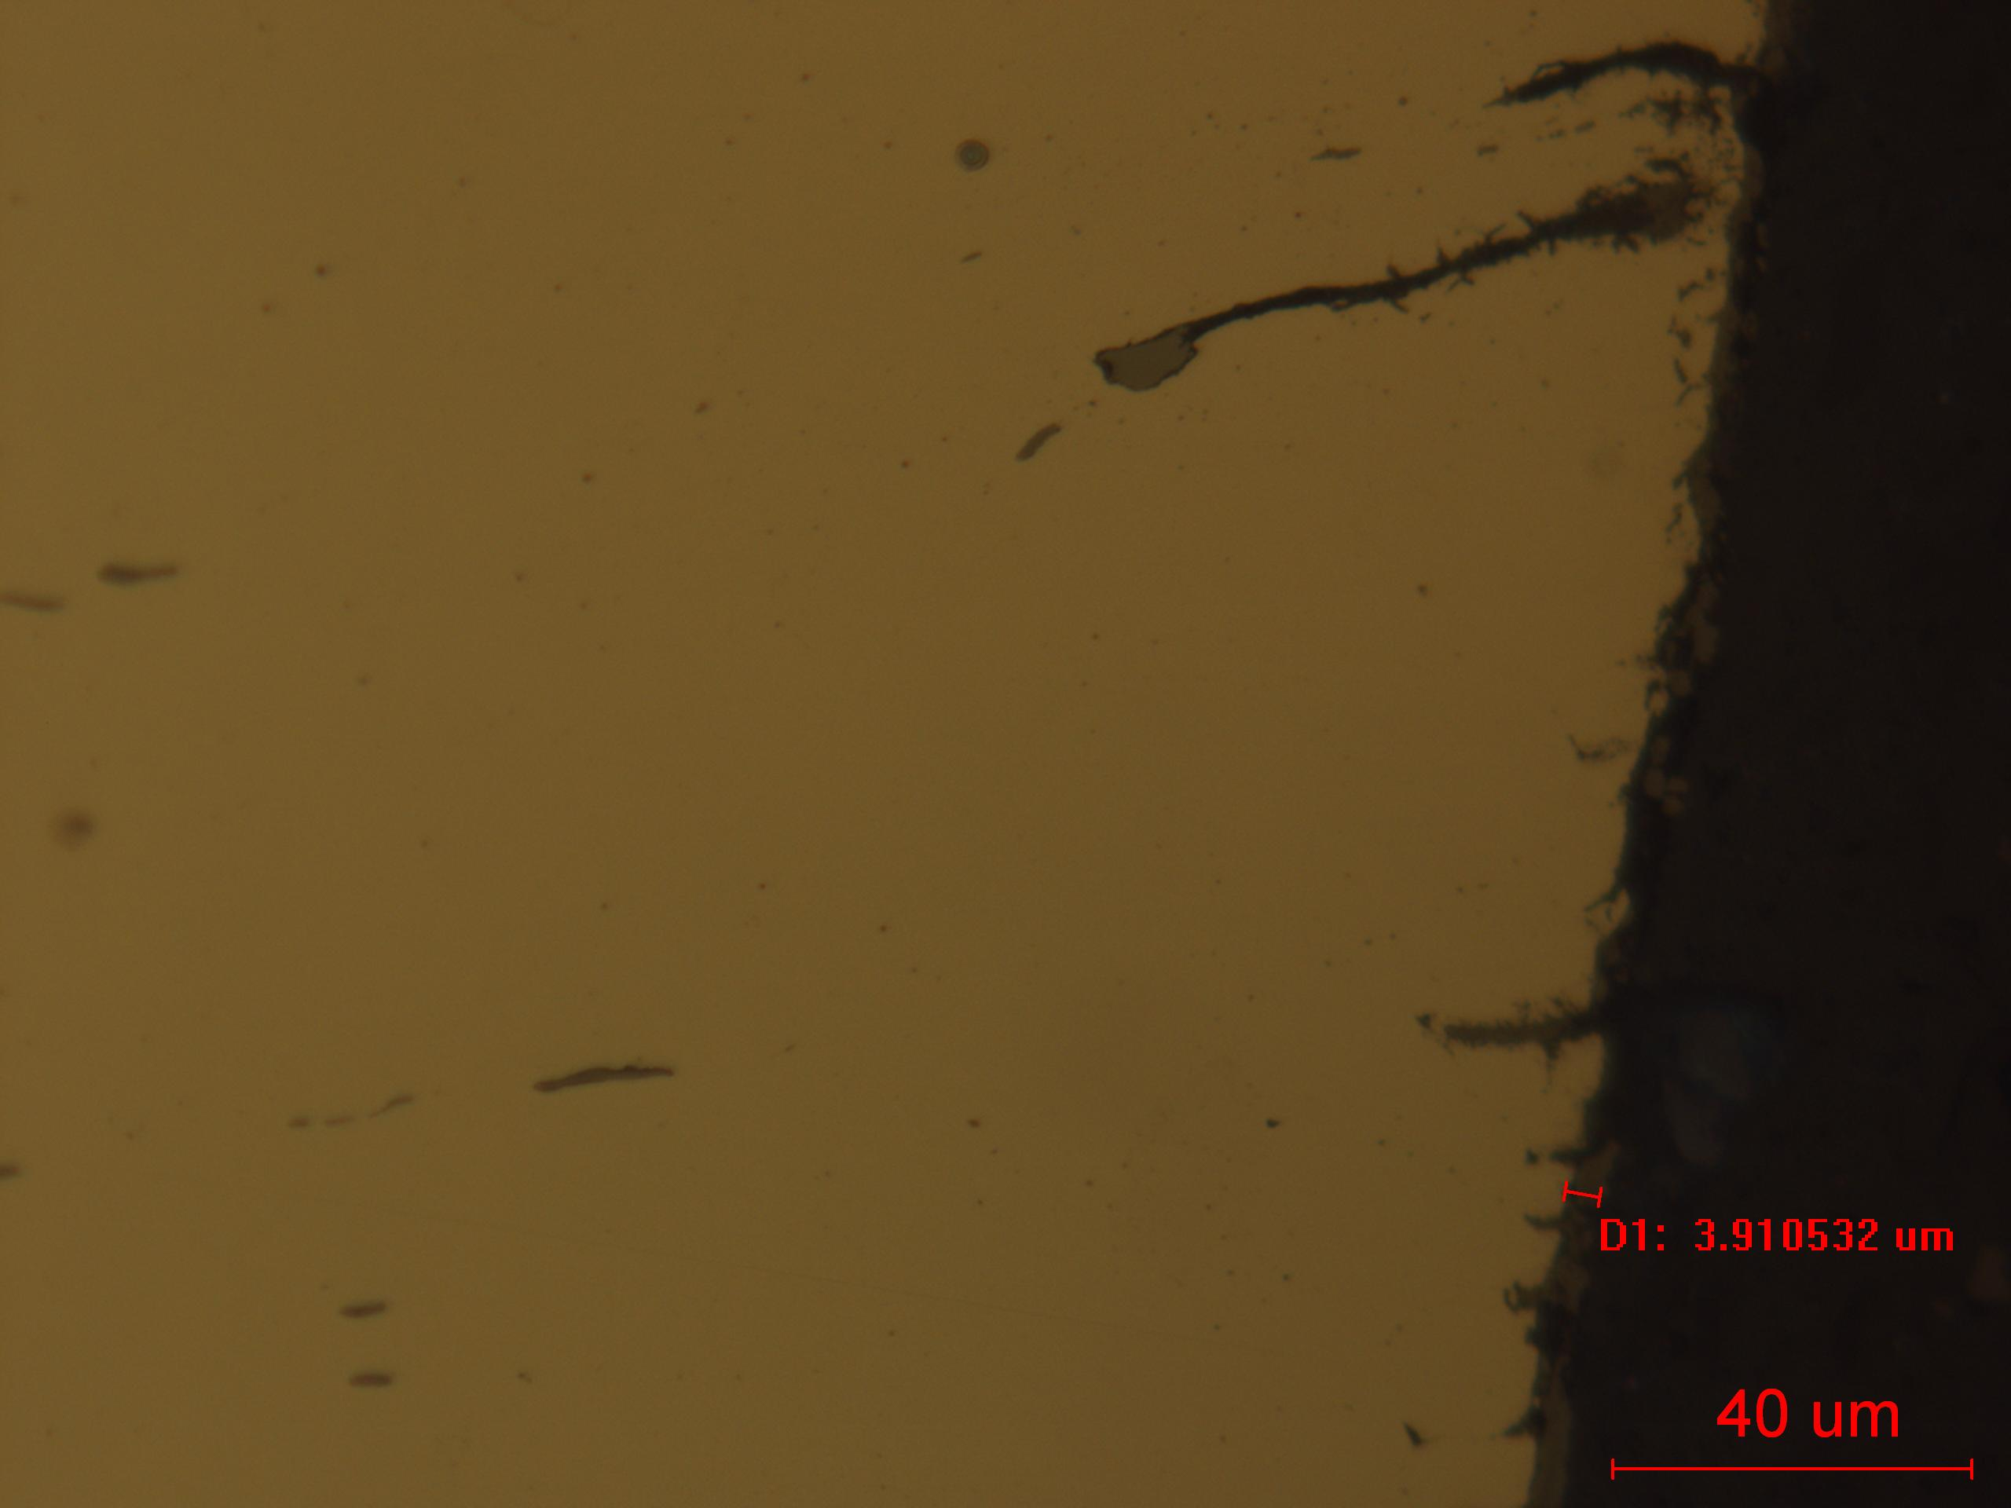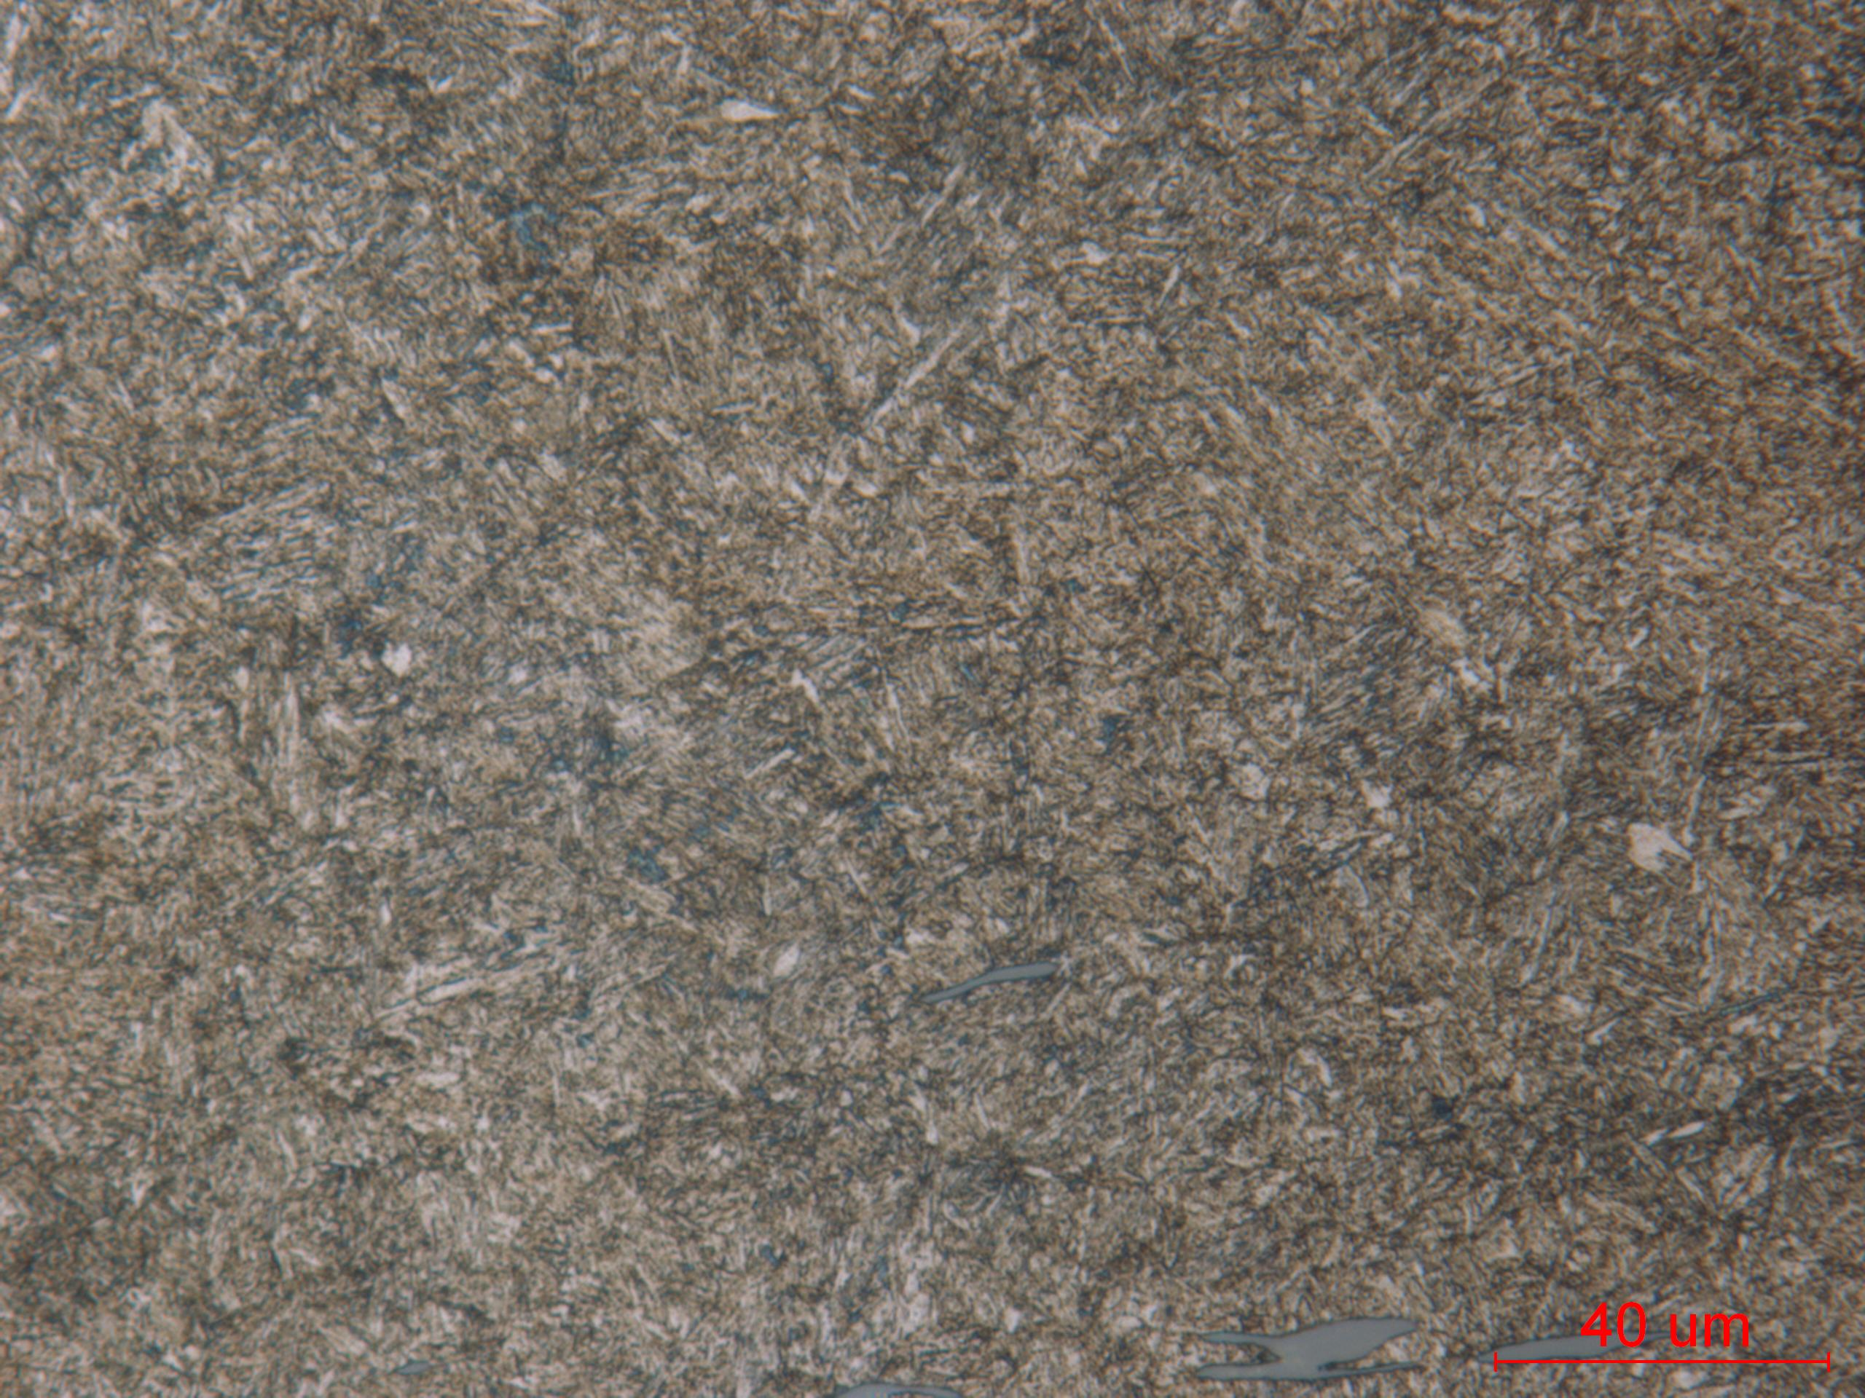
(c) Unetched structure (d) Etched structure
High mag. showing high level of MnS inclusion (c) and tempered martensite (d).

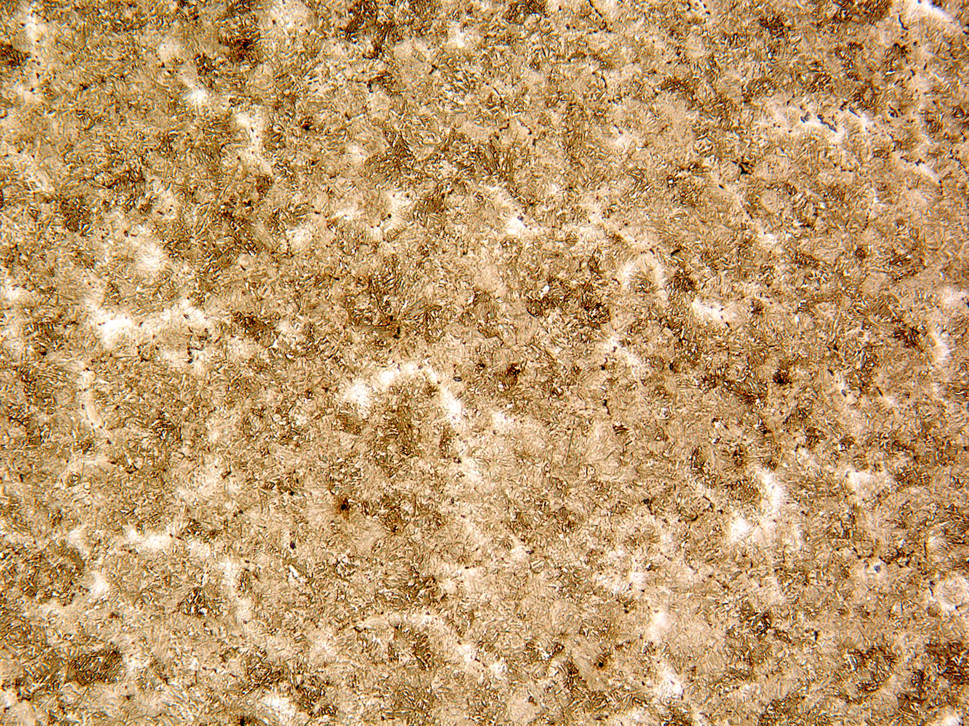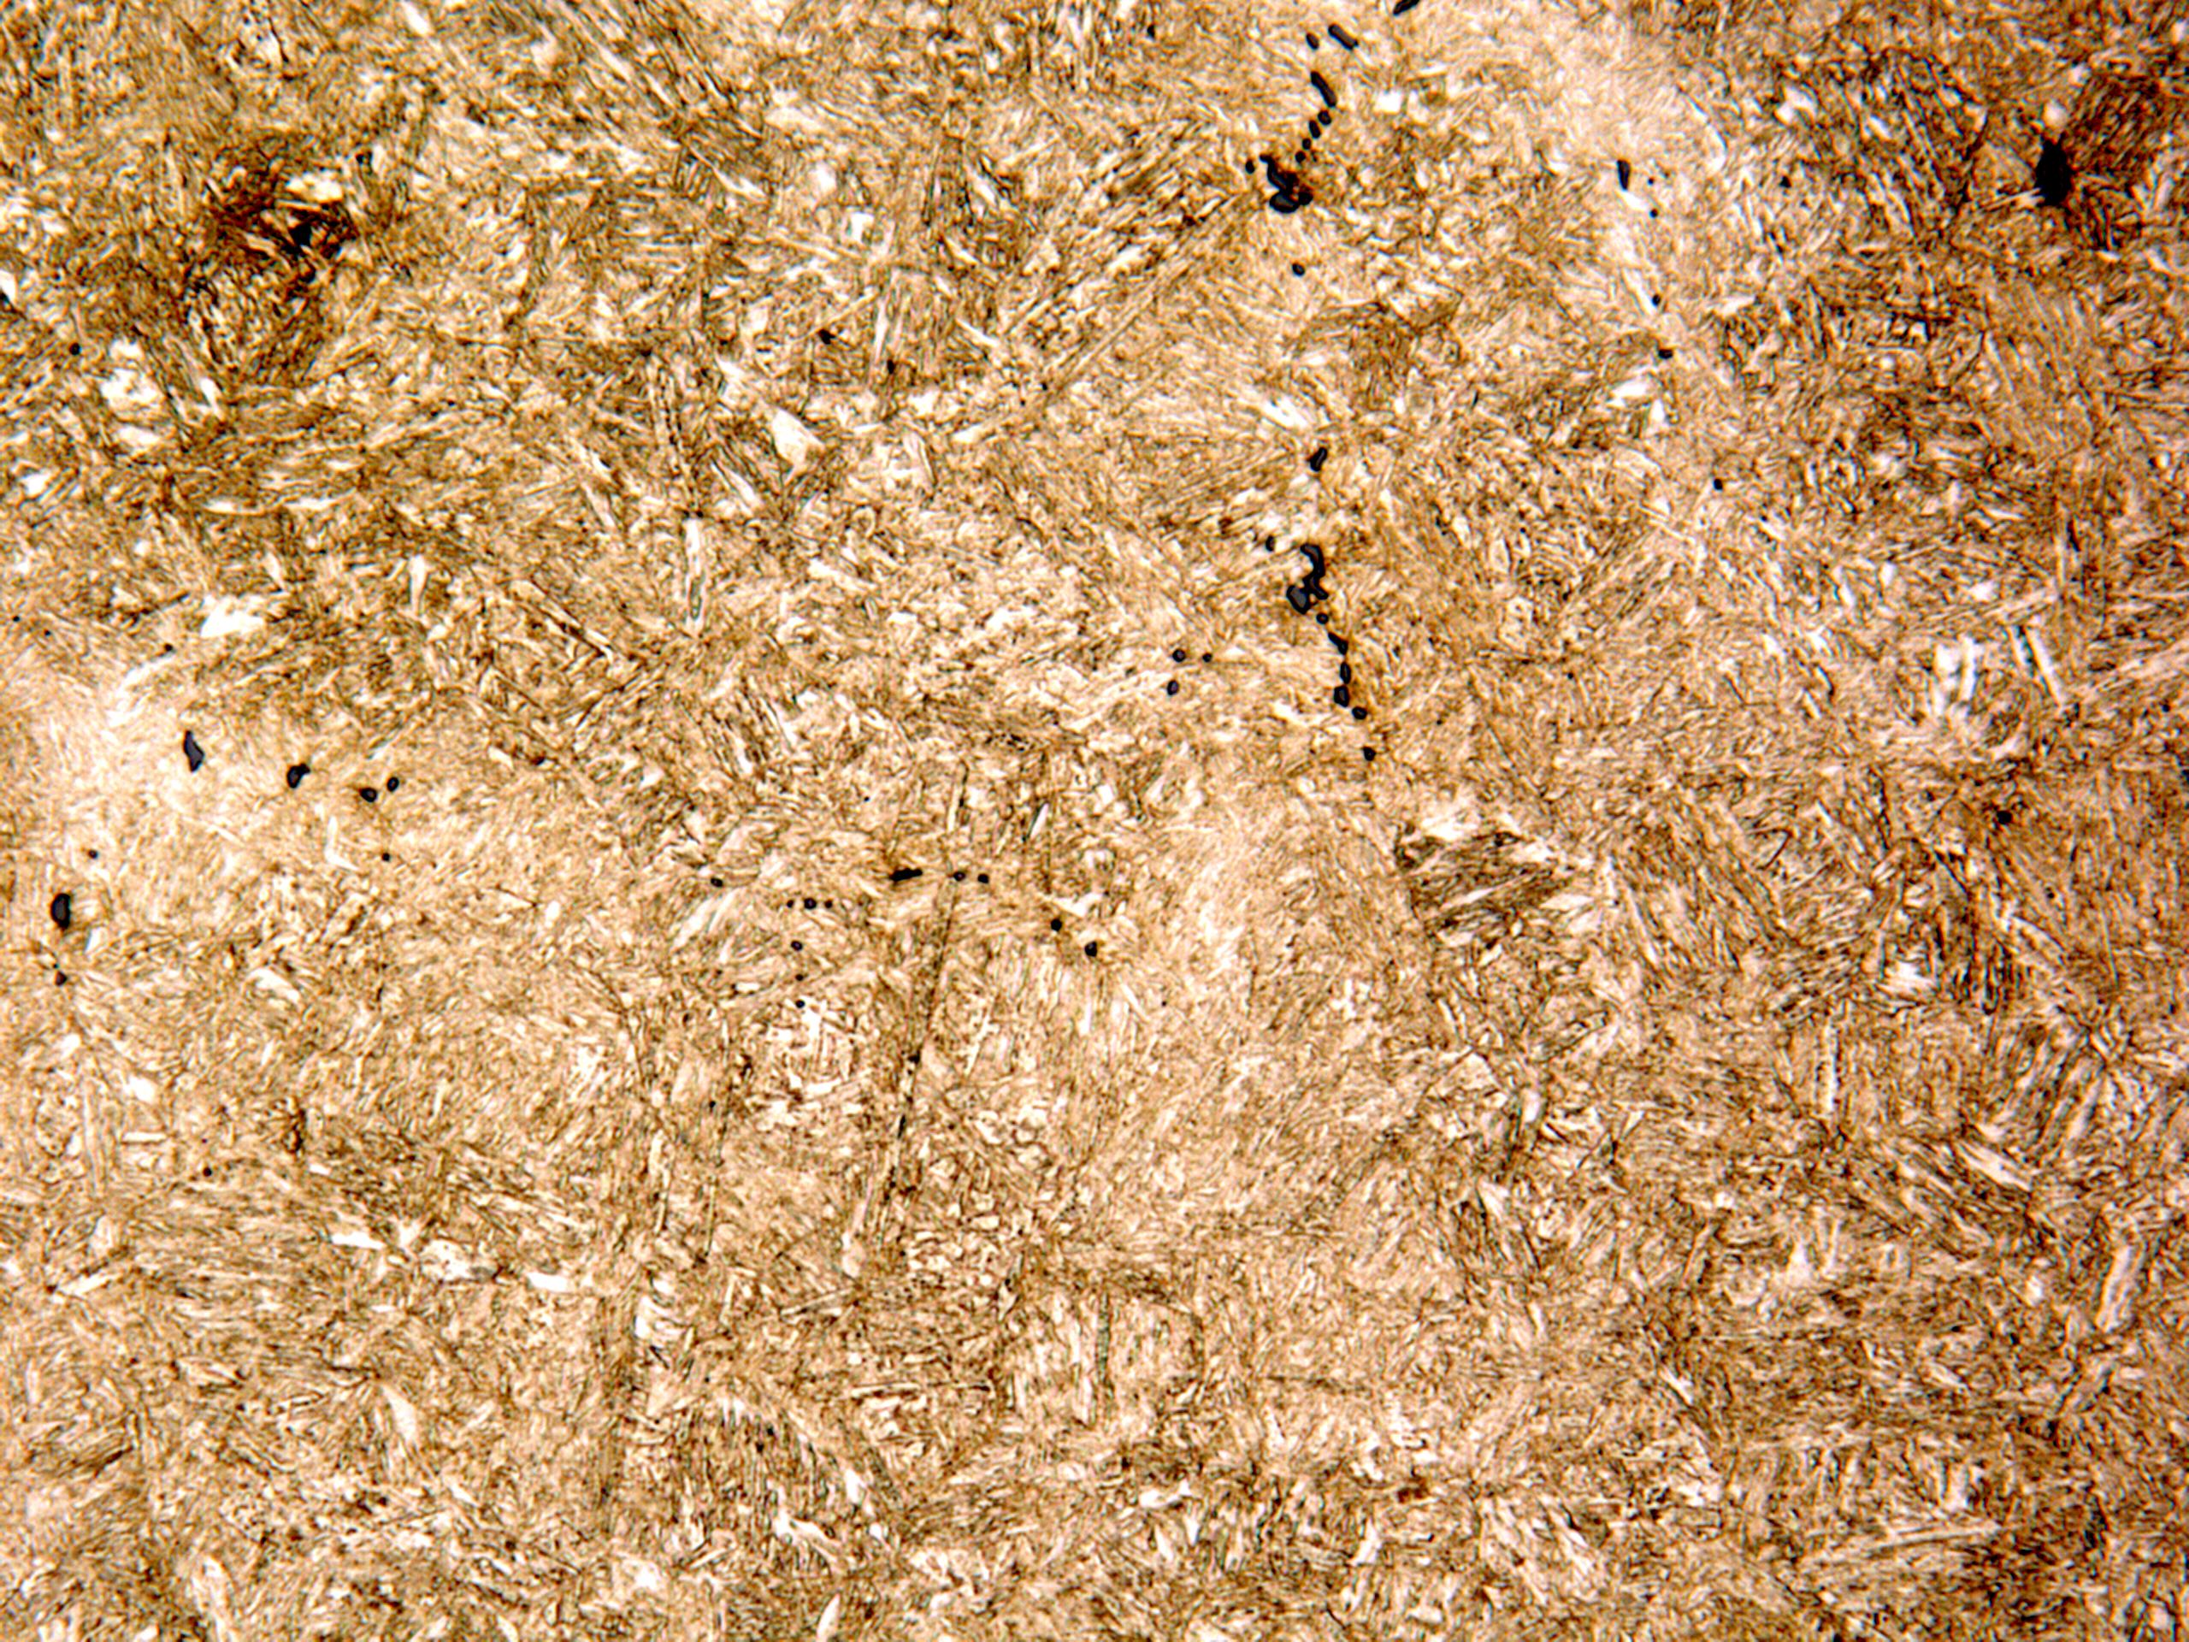
Grip section (longitudinal) X100 Grip section (longitudinal) X500

Mechanical Properties - 136537

Hardness - Rockwell (Performed By: Greg Cornelissen)

Grip end (surface hardness) - 39.3 HRC 40.2 HRC 40.8 HRC

Hardness - Micro (Performed By: Greg Cornelissen)

Newage Microhardness Tester – 1000gf

Microhardness traverse staggered in increments of .005” to a depth of .030” followed by increments of .010”.

.005” 40.4 HRC
.010” 41.4 HRC
.015” 42.4 HRC
.020” 42.8 HRC
.025” 42.3 HRC
.030” 43.2 HRC
.040” 41.7 HRC
.050” 43.3 HRC
.060” 42.0 HRC
.070” 43.5 HRC
.080” 43.0 HRC
.090” 43.1 HRC
.100” 42.7 HRC

