

Materials Engineering Summary Report
LTR Number: 131332

From: Peter Bauerle Phone: 776-7387

Location: CTC

Lab(s): Mechanical Properties Completed: 1/25/2008

Metallography

Subject/Part Name: Fatigue Specimen-Iteration 102/106

Approver: Peter Bauerle

Originator: Peter Bauerle

Originator Phone: 248-576-7387

Number of Parts: 1
Nature of Work: Process/Materials Development
Vendor:
Plant:
P/N:
MS:
PS:

History of Part

The sample that has been submitted is a fatigue specimen that will be used for the development of the AISI fatigue database, iterations 102 & 106. The test speciman was prepared from an 8822 steel grade with low side chemistry. The sample has been quench and tempered by austenitizing at 1700F prior to gas quenching in nitrogen at 18 bar and then tempering at 350F to an aim hardness of 30-35 HRC.

Purpose

The purpose of this LTR is to evaluate the microstructure and hardness of the sample.
Mechanical Properties - 131332

Hardness - Rockwell (Performed By: Greg Cornelissen)

Surface hardness (grip end) - 26.4 HRC 27.9 HRC 27.8 HRC

Hardness - Micro (Performed By: Greg Cornelissen)

Newage Microhardness Tester - 1000gf

Microhardness traverse starting from the edge of the part staggered in increments of .005” up to .030” deep followed by increments of .010”.

.005” 31.7 HRC
.010” 34.7 HRC
.015” 32.3 HRC
.020” 30.9 HRC
.025” 35.5 HRC
.030” 31.6 HRC
.040” 31.8 HRC
.050” 30.8 HRC
.060” 32.4 HRC
.070” 33.6 HRC
.080” 34.4 HRC
.090” 31.2 HRC
.100” 34.5 HRC

Metallography - 131332

General Microstructure Description (Performed By: Jon Stache)

The fatigue specimen was sectioned transversely thru the gage section and longitudinally thru the grip section. The samples were prepared with standard lab procedures for sectioning, mounting, grinding, polishing and etched with 3% Nital. Photomicrographs were taken using a Nikon Epiphot 200 microscope and Image-Pro Plus was used to estimate case depth.

The microstructure consisted of tempered martensite from surface to core (photos 1 thru 8). There was some centerline segregation and banding in the sample.

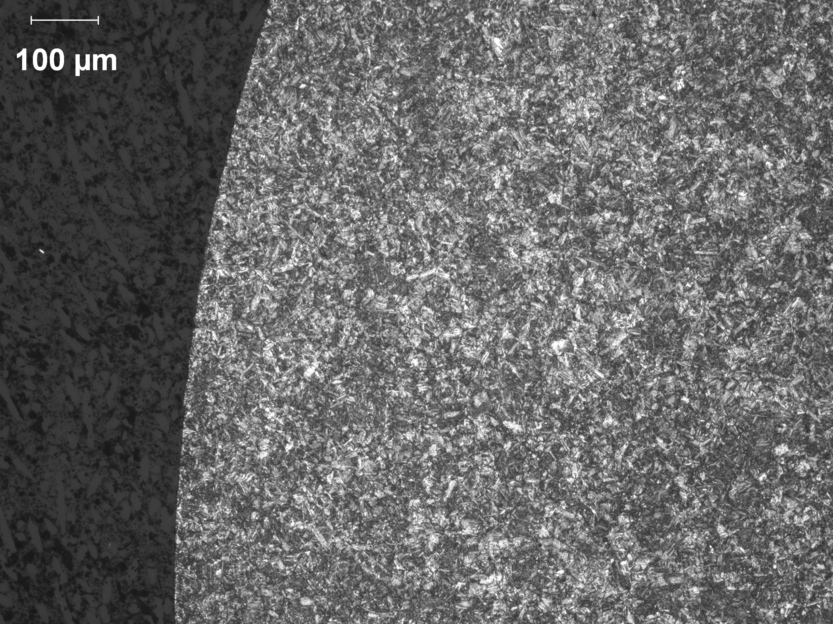
Photo 1: Etched low magnification (100X) of the surface, transverse section.

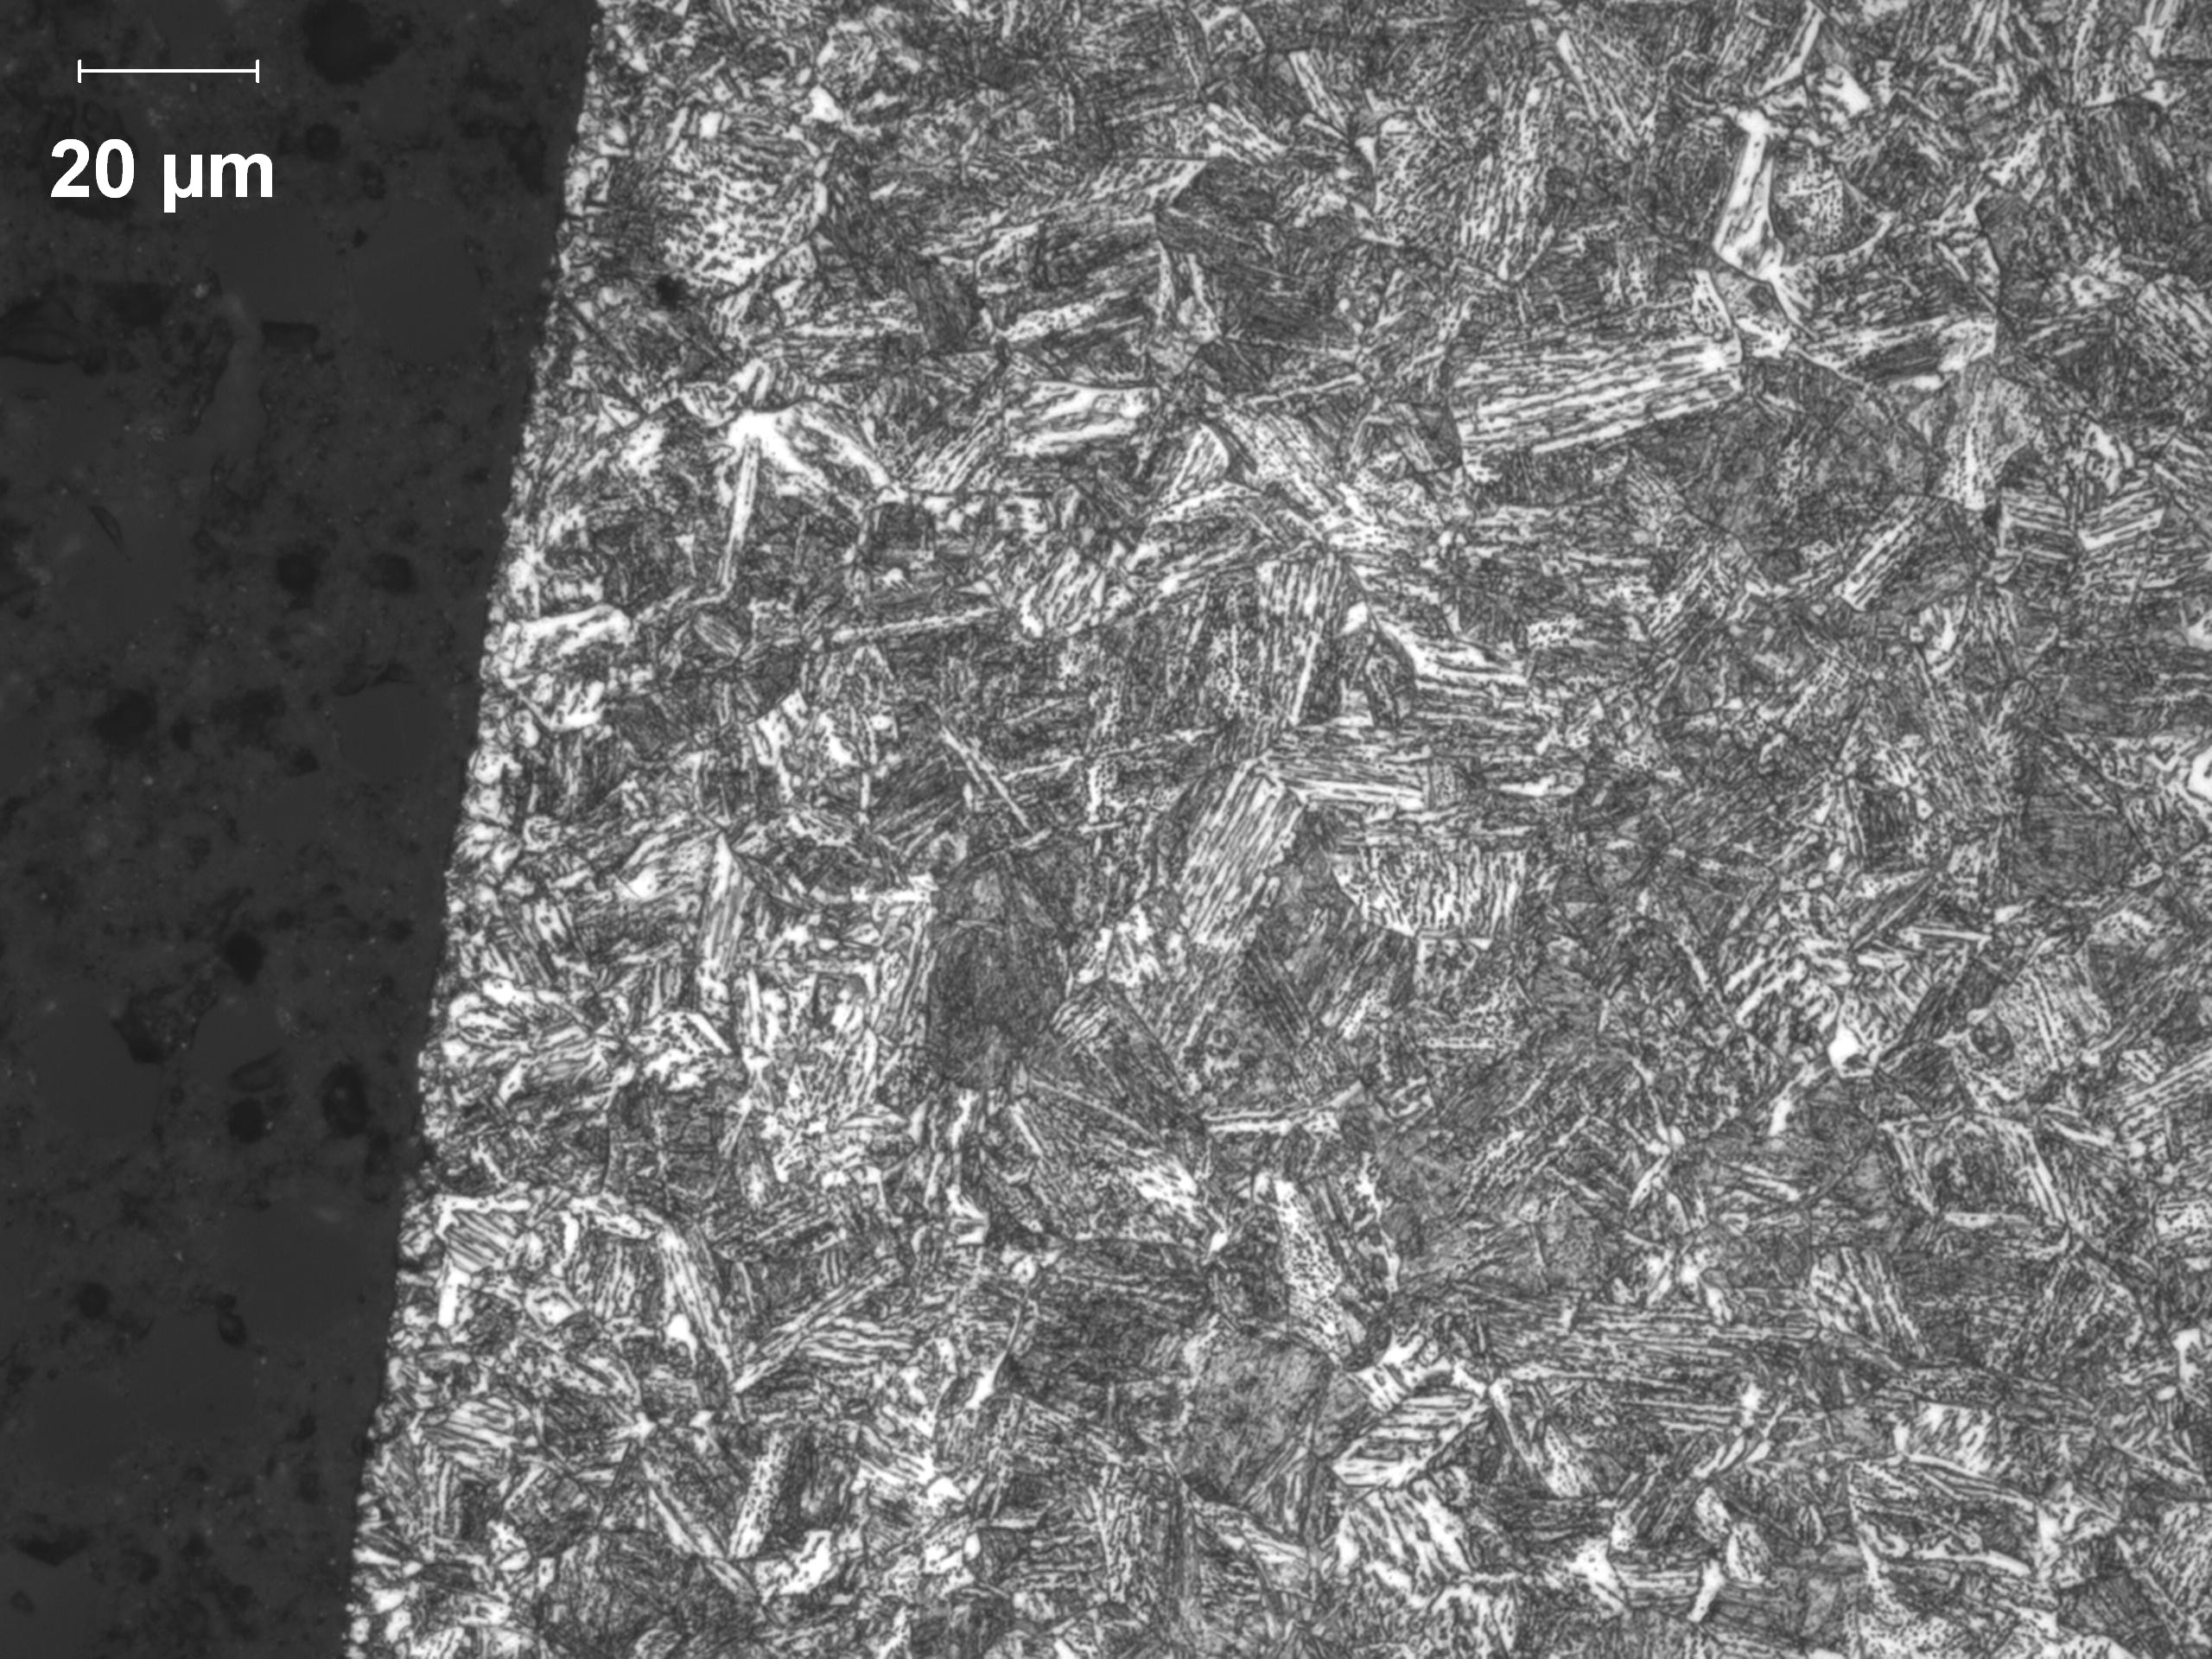
Photo 2: Etched high magnification (500X) of the surface, transverse section.

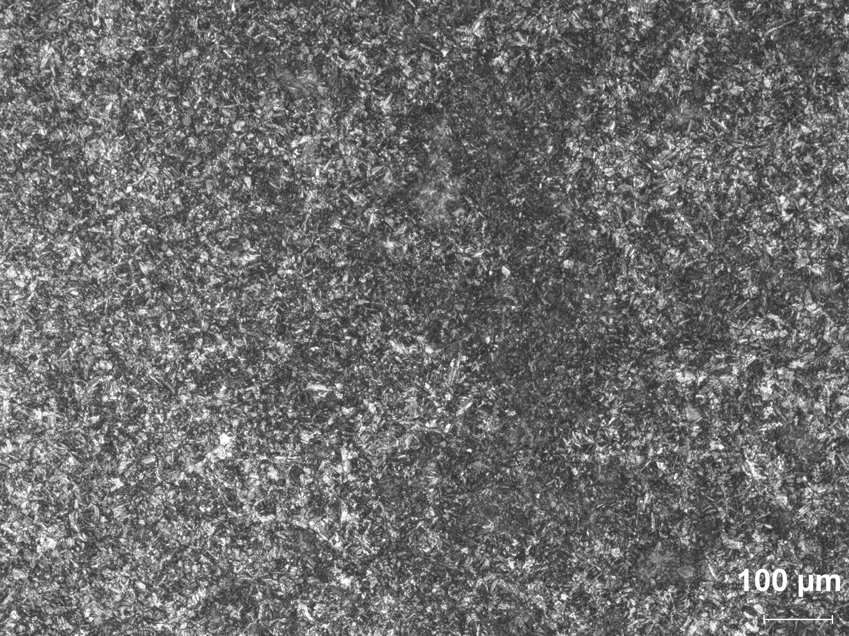
Photo 3: Etched low magnification (100X) of the core, transverse section.

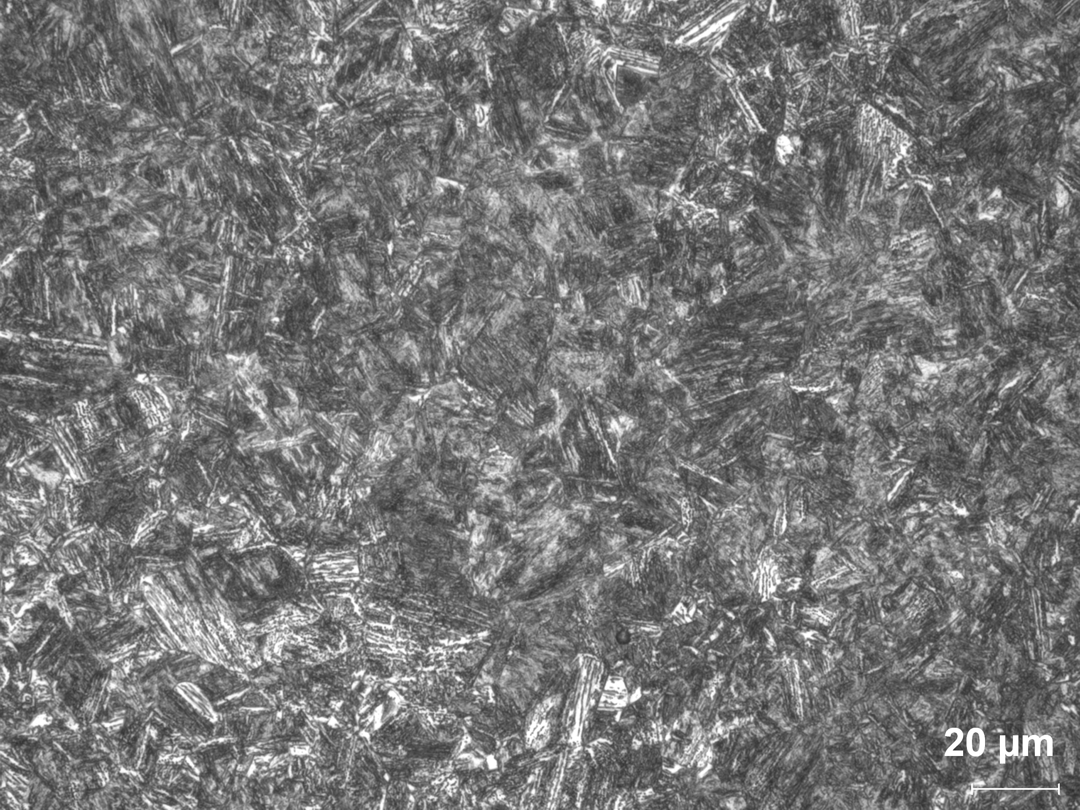
Photo 4: Etched high magnification (500X) of the core, transverse section.

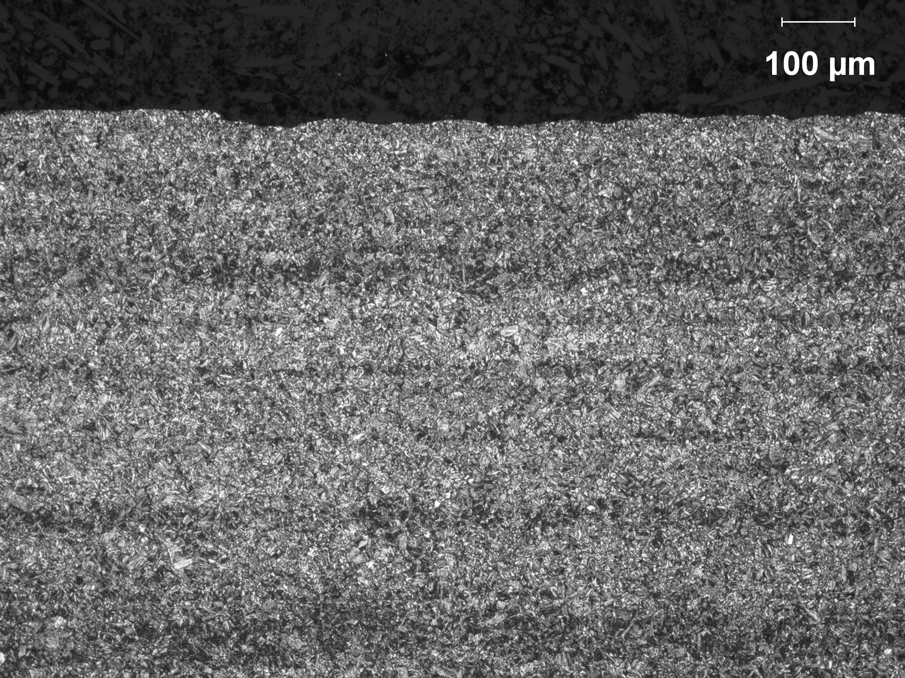
Photo 5: Etched low magnification (100X) of the surface, longitudinal section.

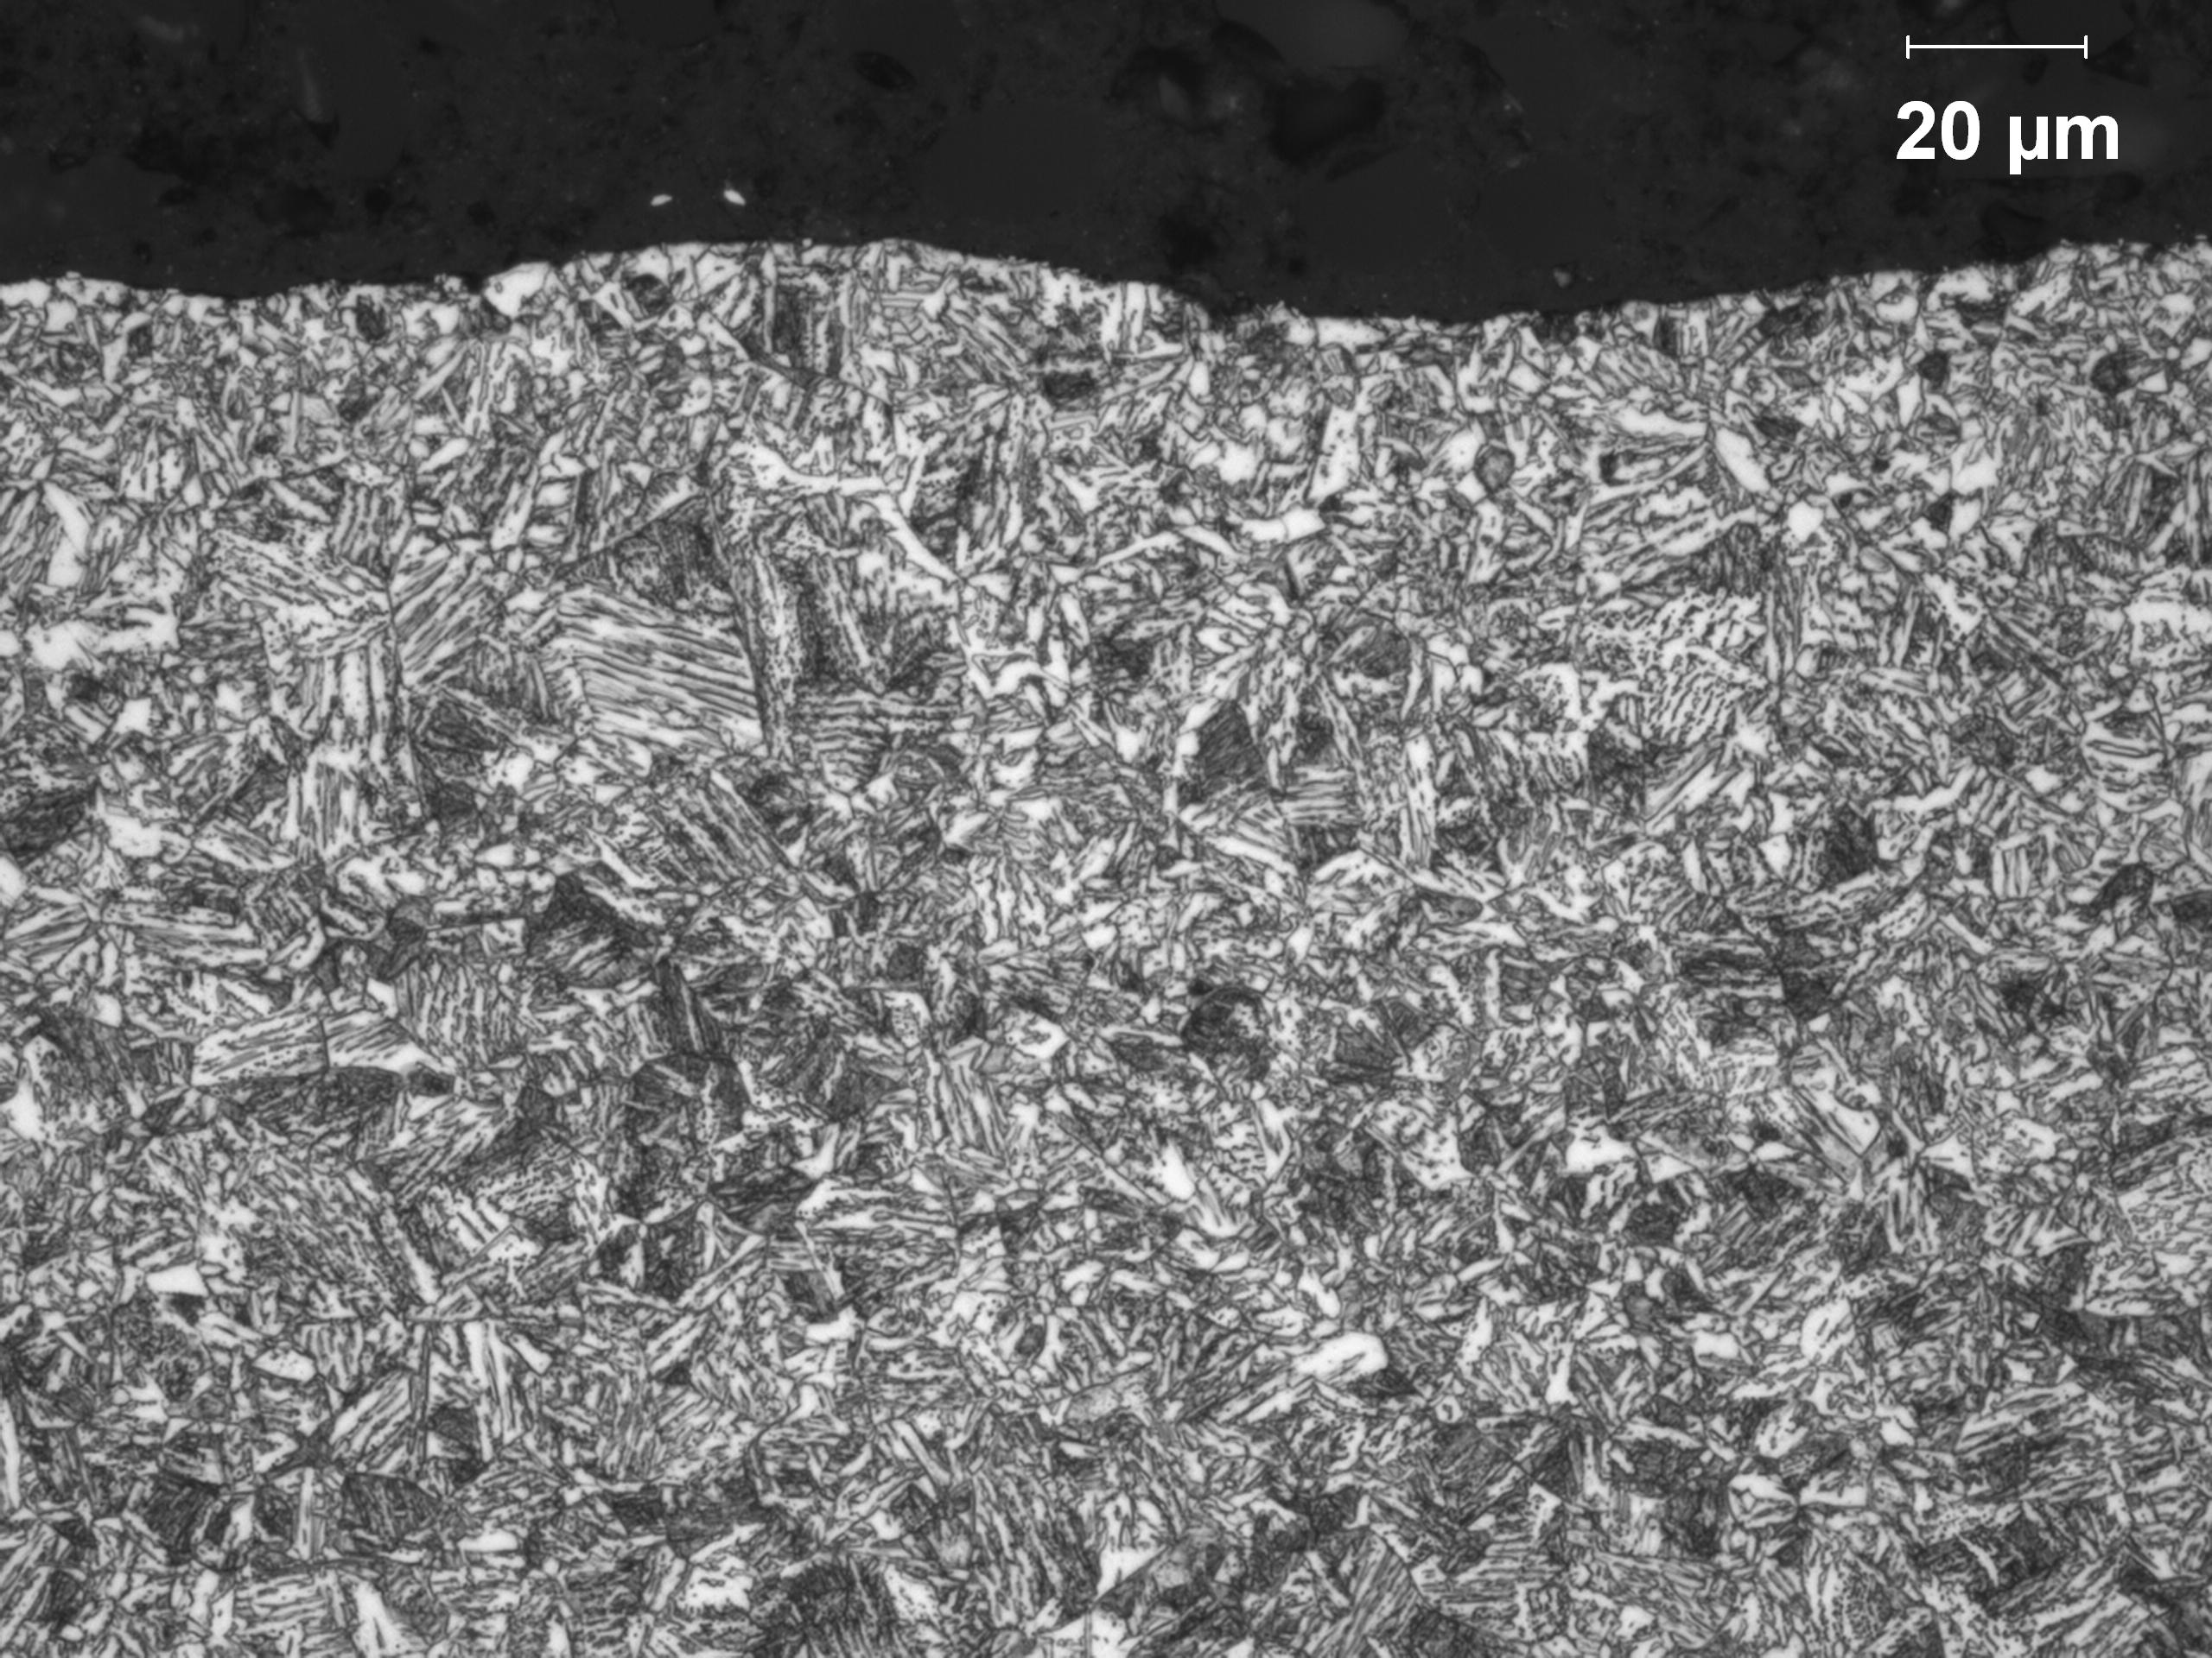
Photo 6: Etched high magnification (500X) of the surface, longitudinal section.

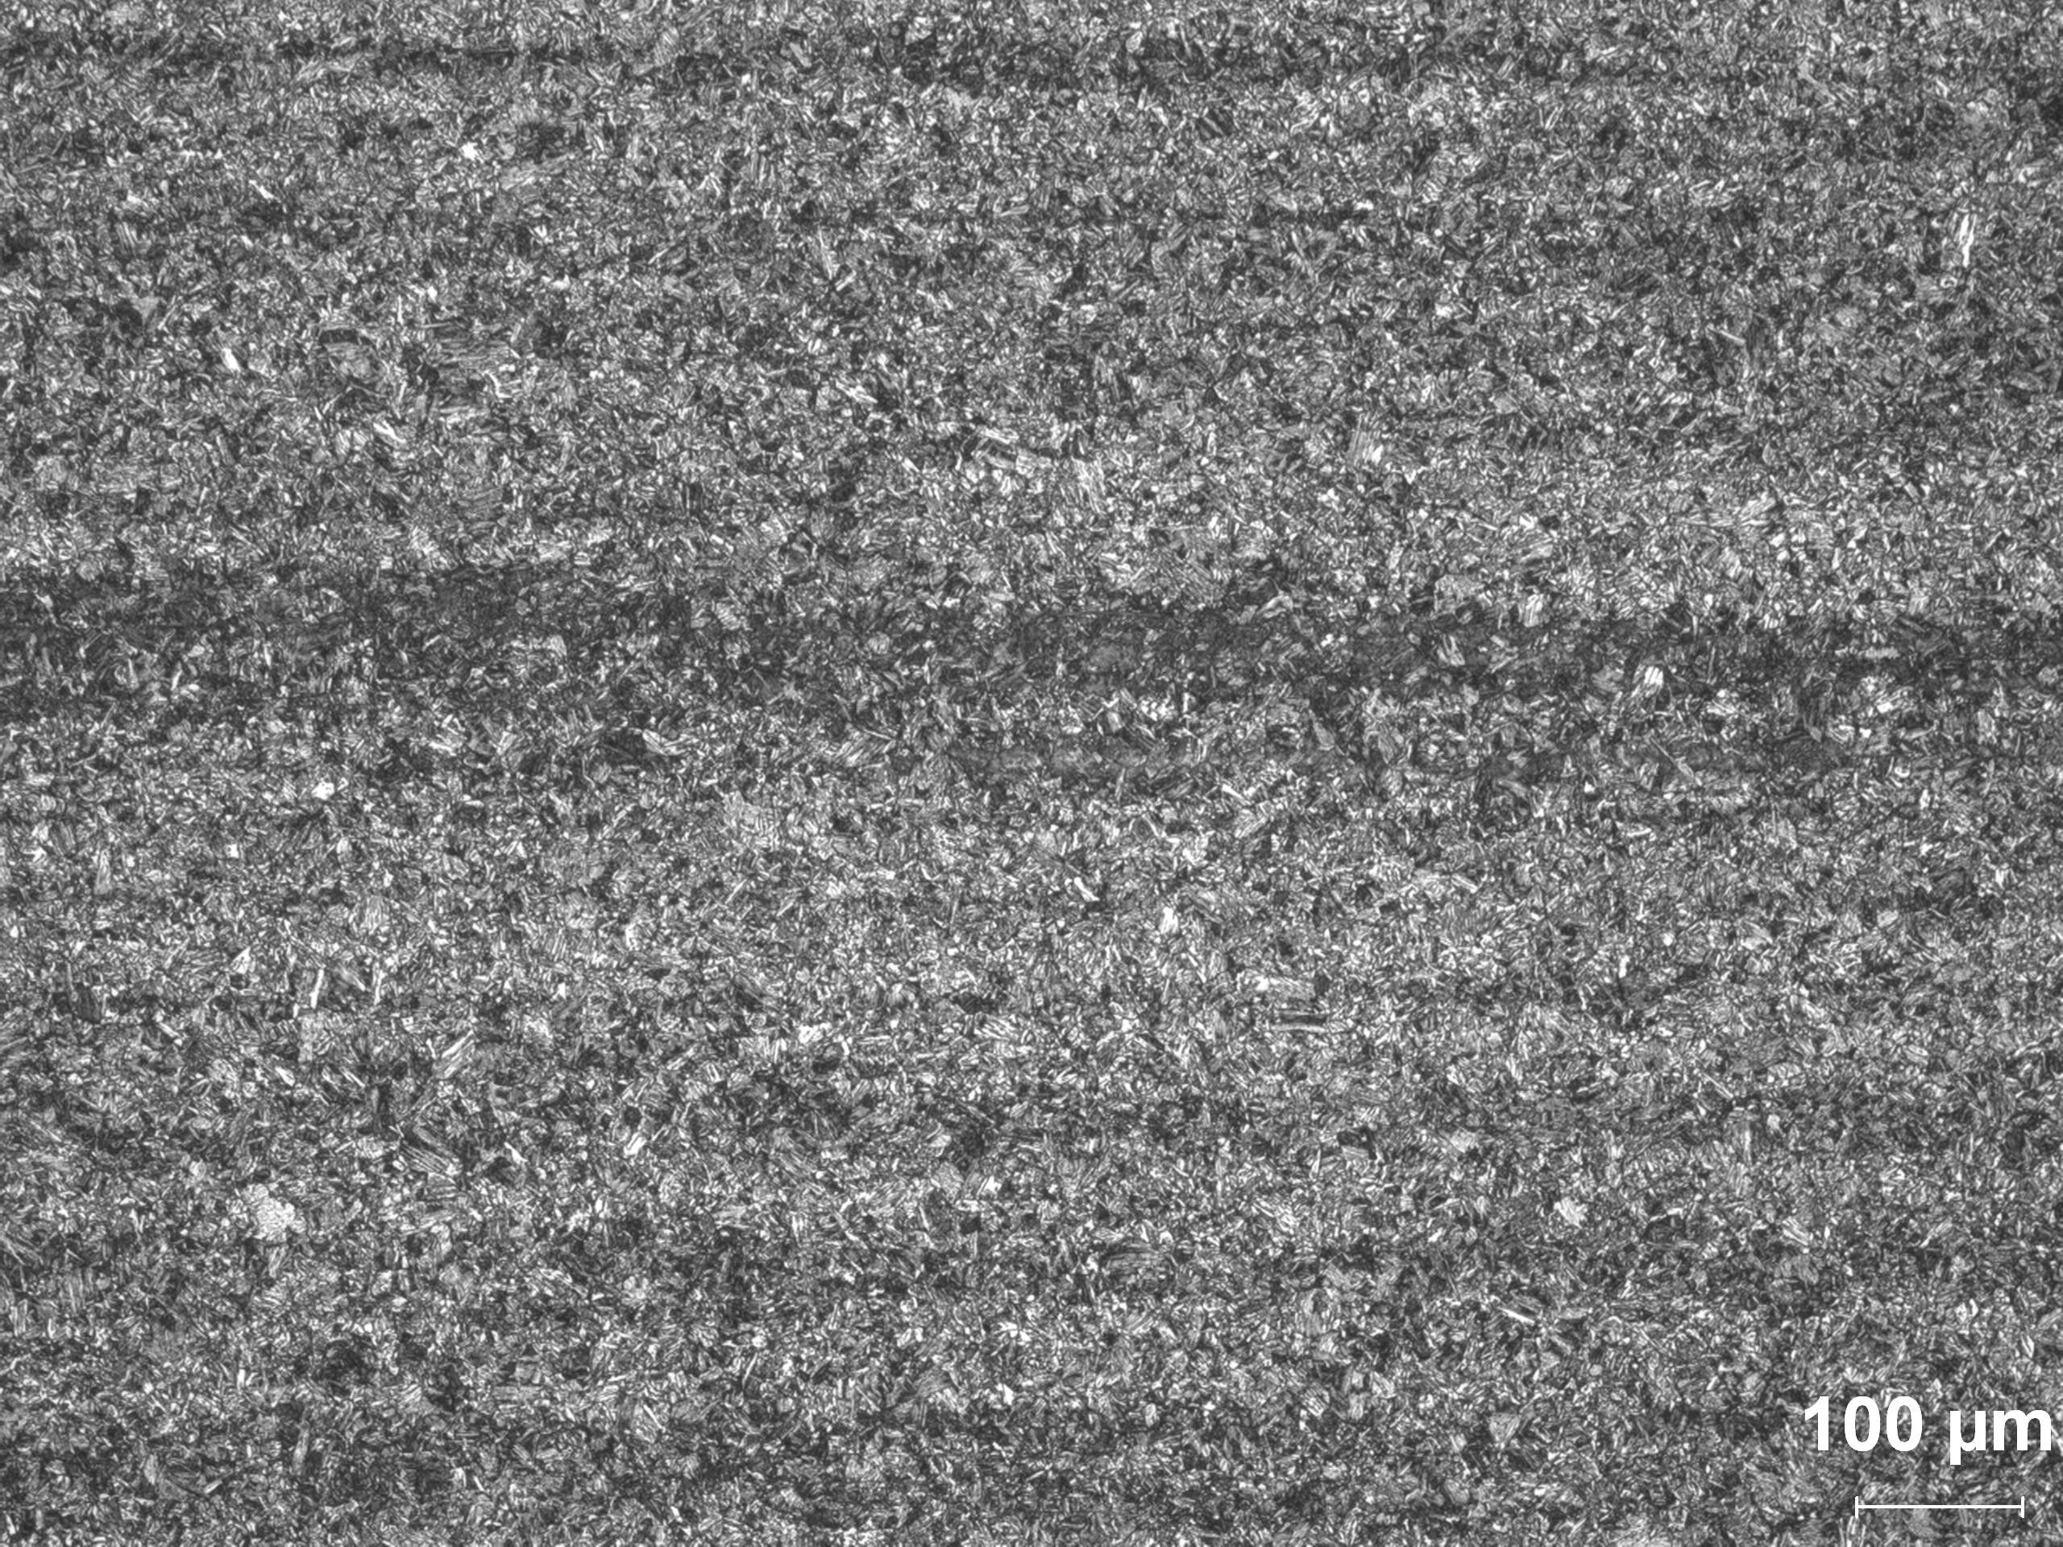
Photo 7: Etched low magnification (100X) of the core, longitudinal section.

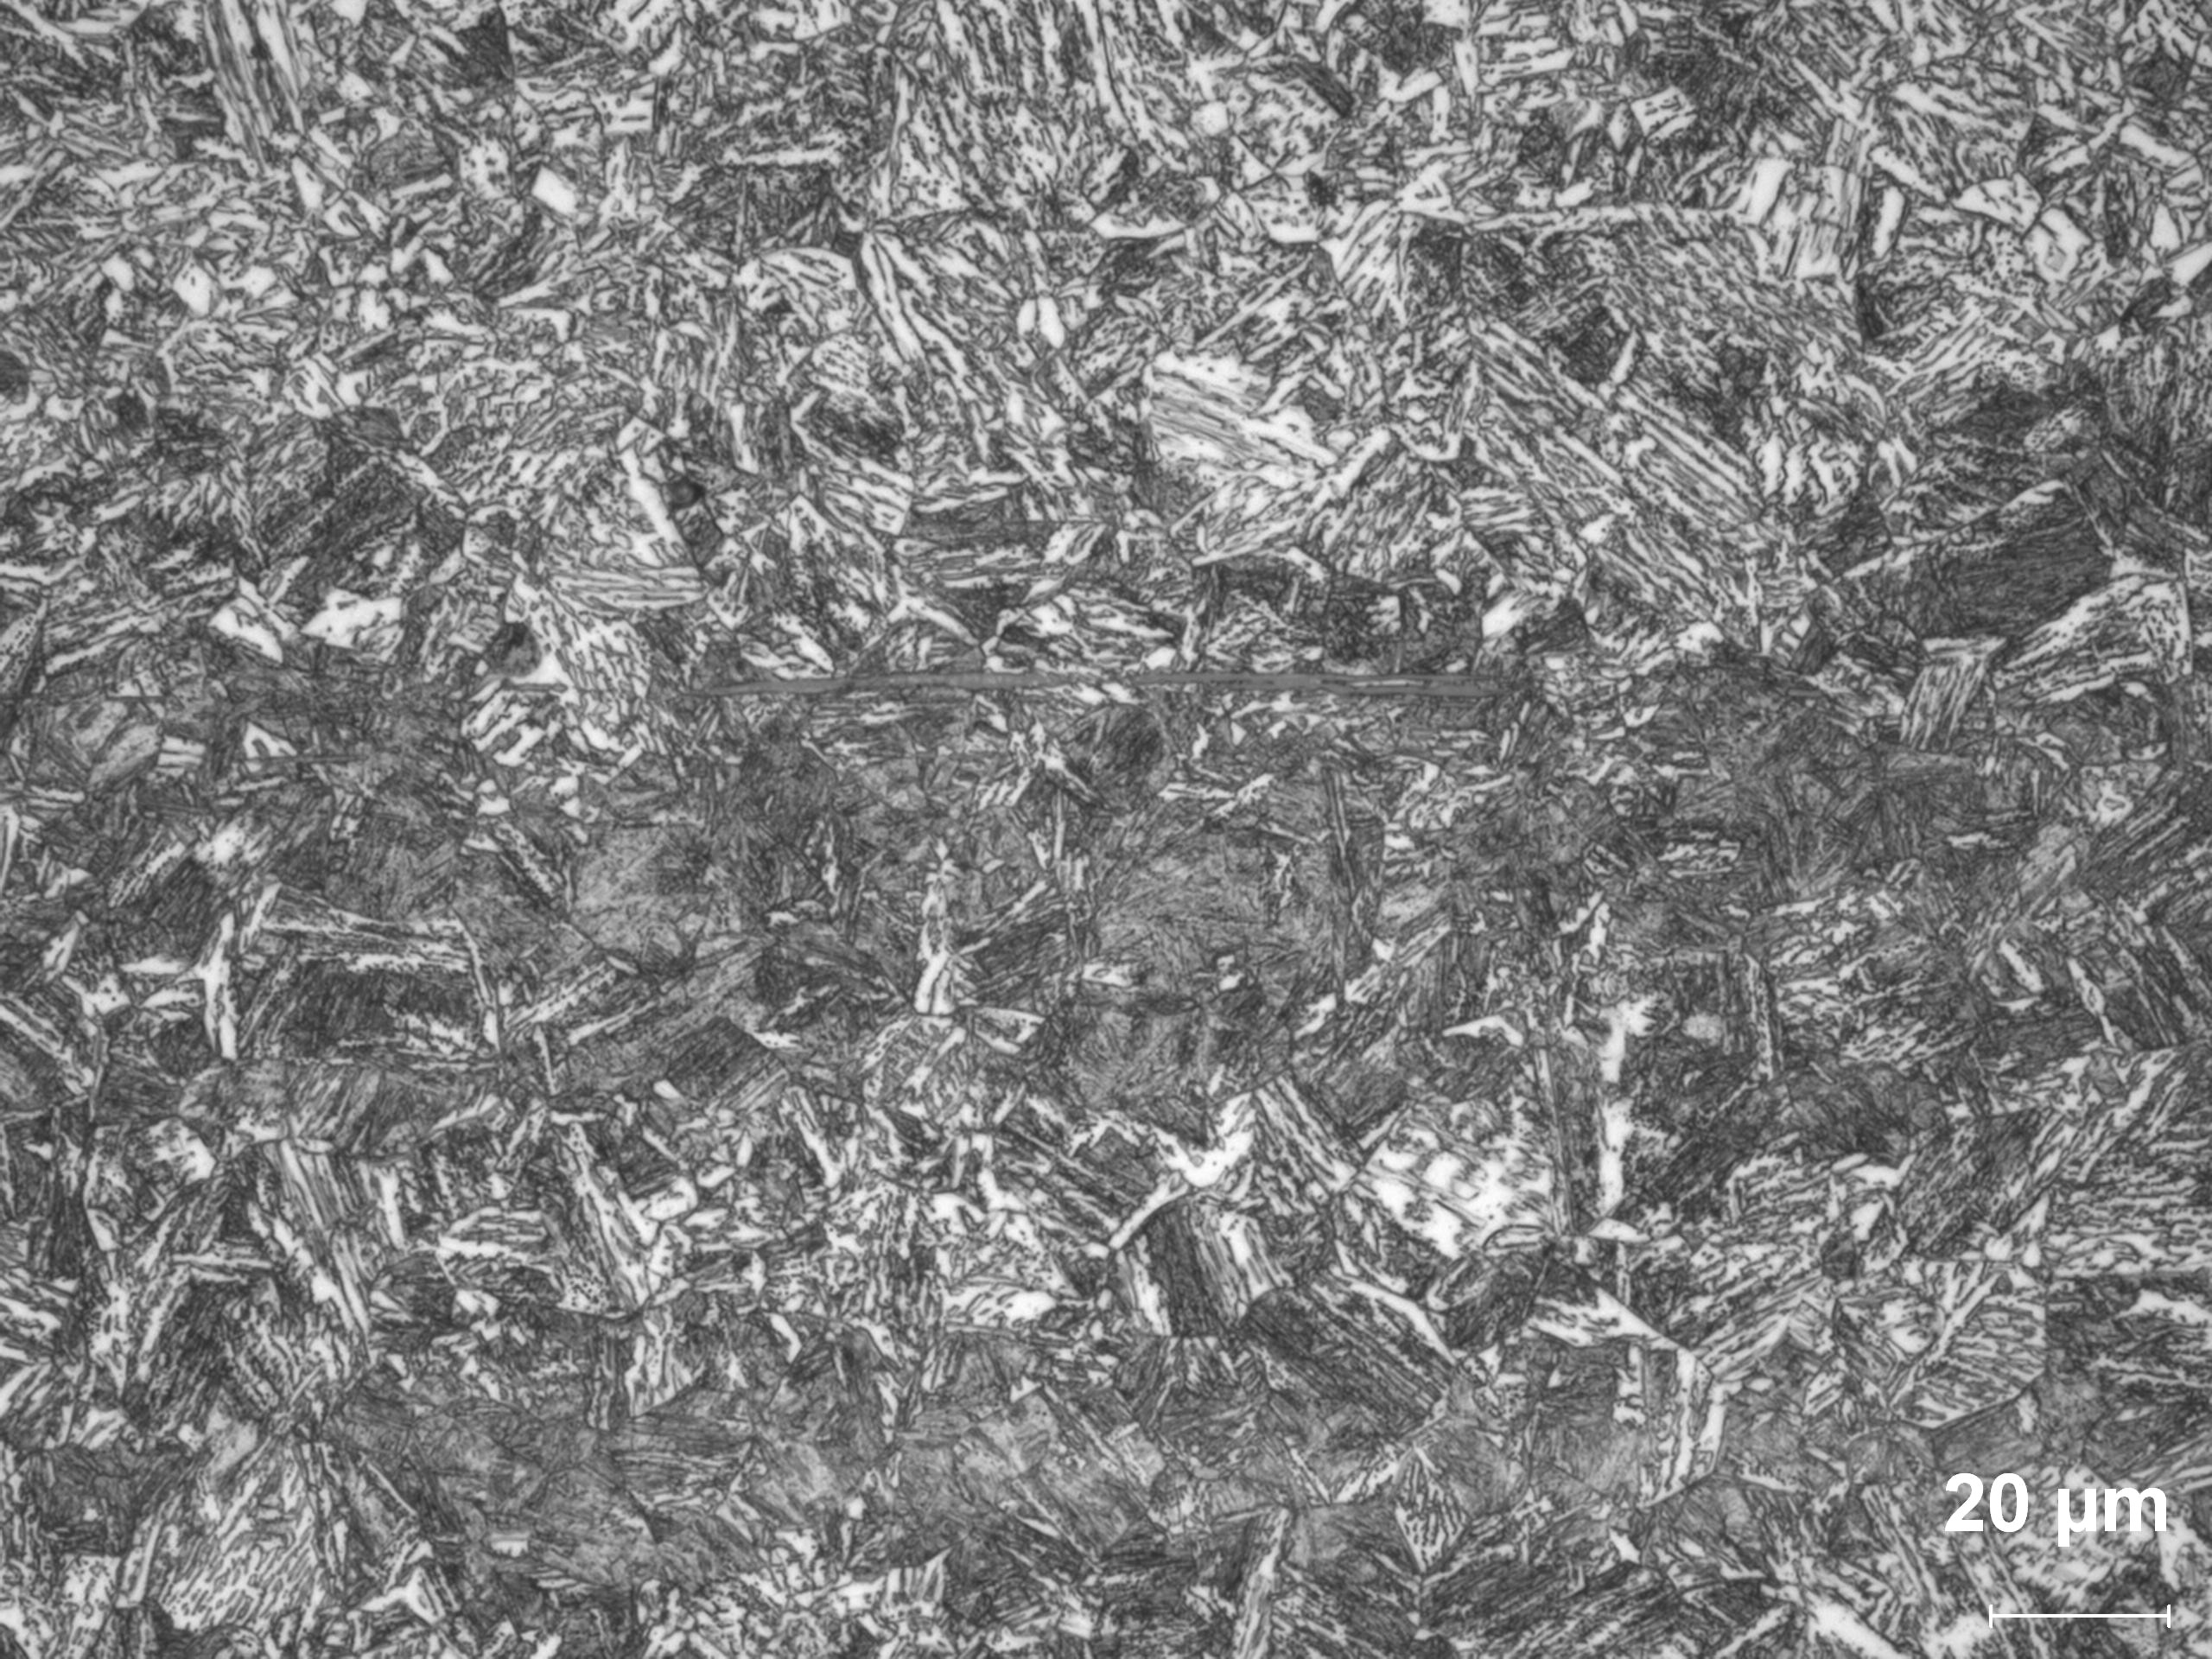
Photo 8: Etched high magnification (500X) of the core, longitudinal section.

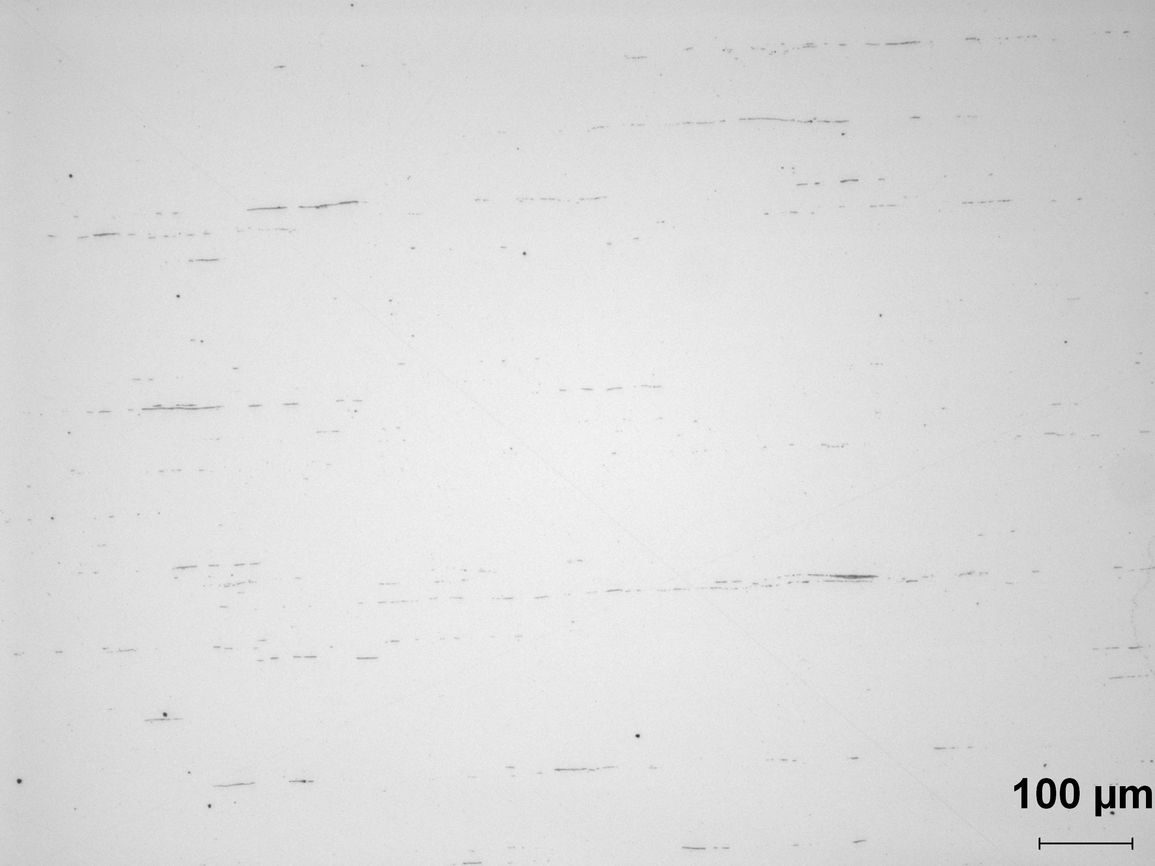
Photo 9: Unetched high magnification (100X) of the core, longitudinal section.

Summary/Conclusion/Recommendations

Based on this analysis, the following observations can be made:

- The hardness appears to border the low side of the desired range of 30/35 HRC
- The microstructure is a uniform tempered martensite although some banding is evident in the core structure
- These samples are to be released for test by AISI

