


Materials Engineering Lab Report
LTR Number: 123985

To: Peter Bauerle Phone: 776-7387

Location: CTC

From: Mechanical Properties Completed: 9/23/2005

Metallography

Subject/Part Name: Fatigue Test Specimen

Report Status: Complete

Originator: Peter Bauerle

Originator Phone: 248-576-7387

Number of Parts: 1
Nature of Work: Pilot, Mule, Program Development Issue
Vendor:
Plant:
P/N:
MS:
PS:

History of Part

The sample that has been submitted is a fatigue specimen that will be used for the development of the AISI fatigue database, iteration 93. The sample is a 4140 steel grade that has been induction hardened by heating to approximately 1700F followed by a polymer quench (8%) to a hardness of 58 HRC. However, the tempering temperature has been modified from 700F to 800F to achieve a hardness of 40-41 HRC.

Test Results

Mechanical Properties - 123985

Hardness - Rockwell (Performed By: Mike Terrell)

See below

Hardness - Micro (Performed By: Mike Terrell)

123985
Micro hardness threw the "small diameter" @ HRC
Distance | HRC
0.005 | 43
0.01 | 44
0.015 | 45
0.02 | 46
0.025 | 44
0.03 | 46
0.035 | 45
0.04 | 46
0.045 | 46
0.05 | 44
0.055 | 45
0.06 | 45
0.065 | 45
0.07 | 46
0.075 | 45
0.08 | 45
0.085 | 46
0.09 | 45
0.095 | 44
0.1 | 43
Core | 45
 | 43
 | 45
 | 44
Direct Surface Hardness on the grip end
HRC
36.8
38.2
37.2
37.7

Metallography - 123985

General Microstructure Description (Performed By: James Shi)

The submitted fatigue specimen was sectioned longitudinally at the grip end and transversely at the gage, and prepared according to the normal procedures for microstructural evaluation. Using optical microscope Olympus PMG3, the microstructures were examined and microphotographs were taken. The results of the evaluation revealed that the microstructure of the part consisted of banded structure of tempered martensite with unresolved pearlite from surface to core at the grip end and tempered martensite from surface to core at the gage section. The details of the microstructures are shown in Figs.1-6.

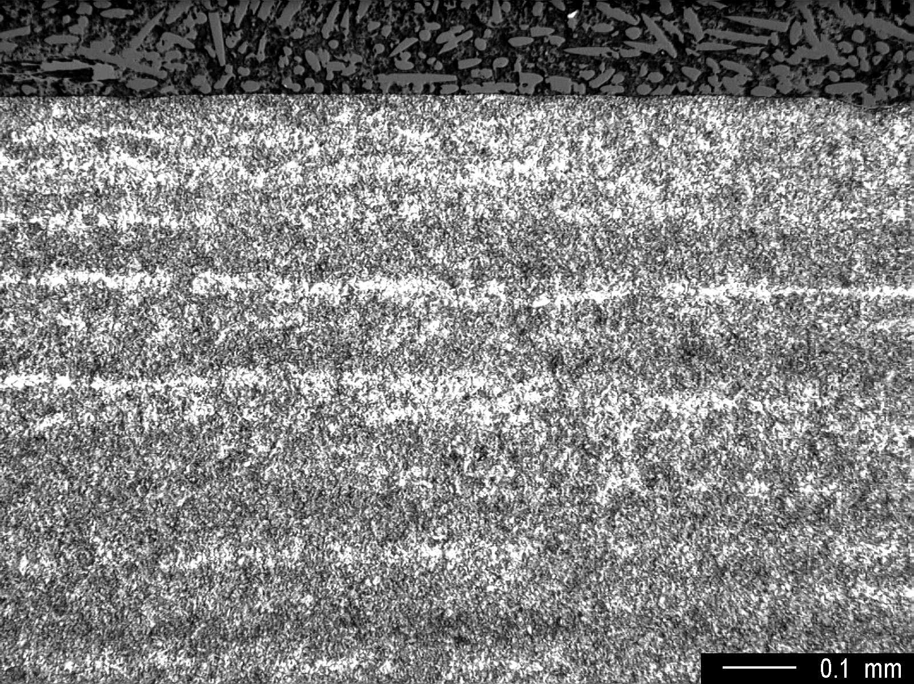

Fig.1 Microstructure at the surface showing banded structure, medium magnification.

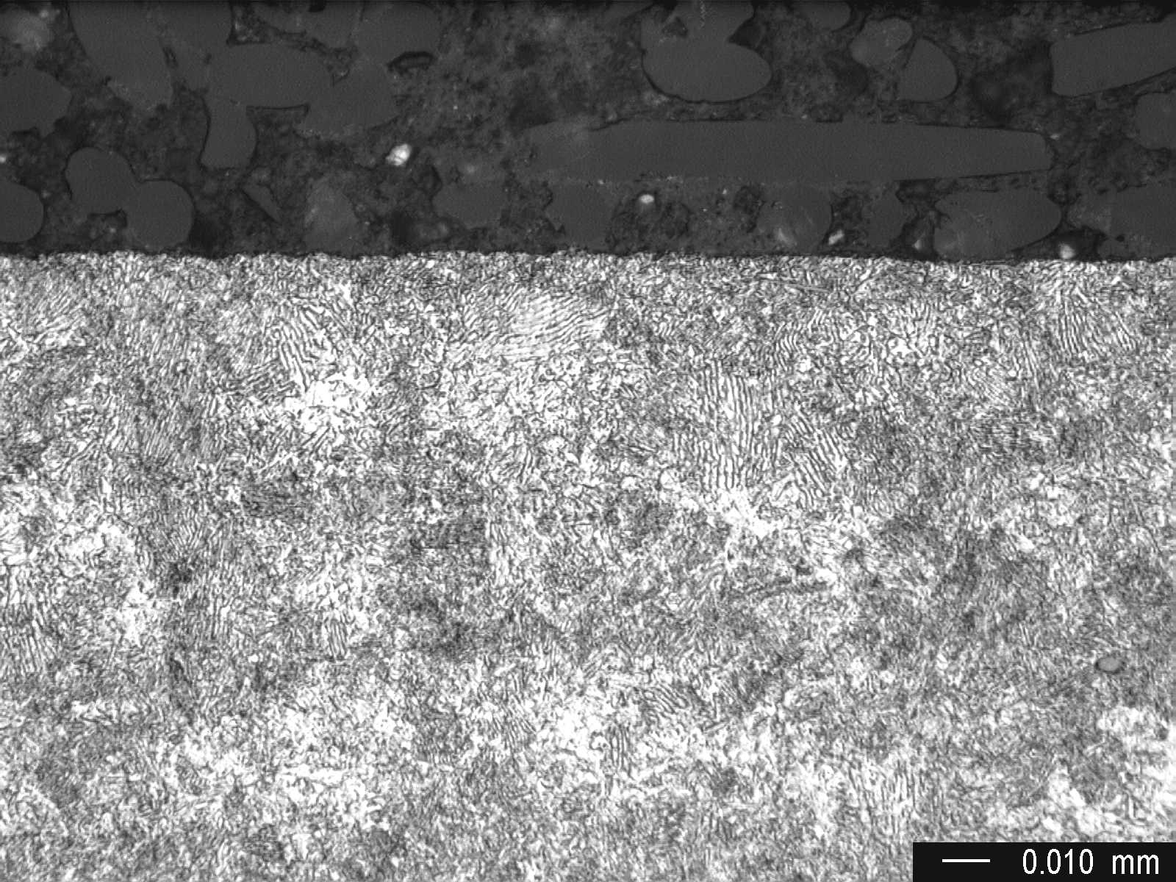

Fig.2 Microstructure at the surface showing unresolved pearlite, high magnification.

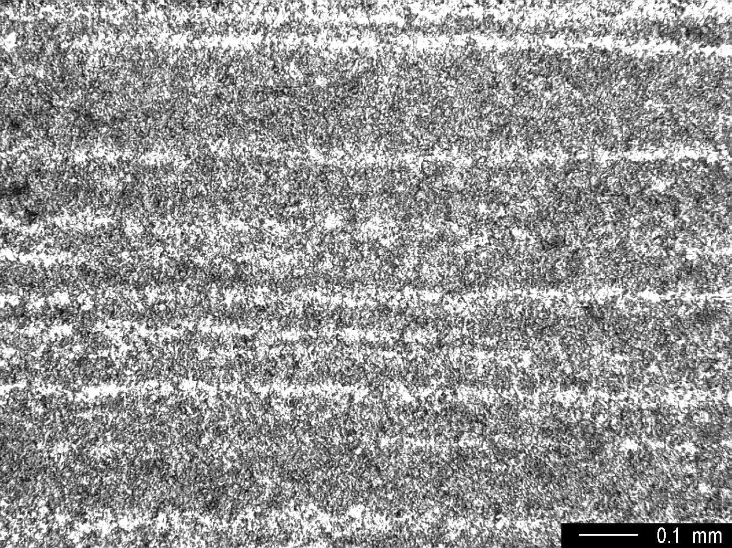

Fig.3 Core microstructure showing banded structure, medium magnification.

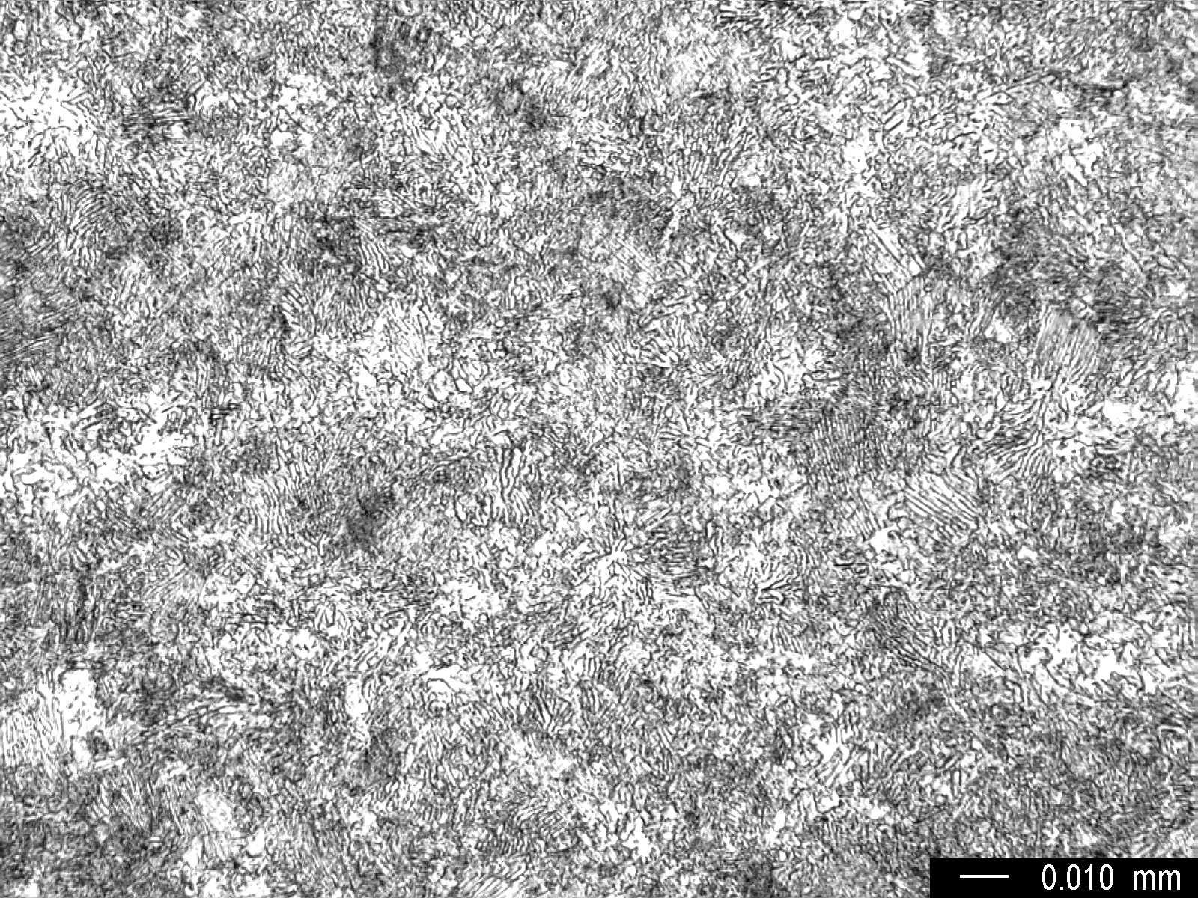

Fig.4 Core microstructure, high magnification.

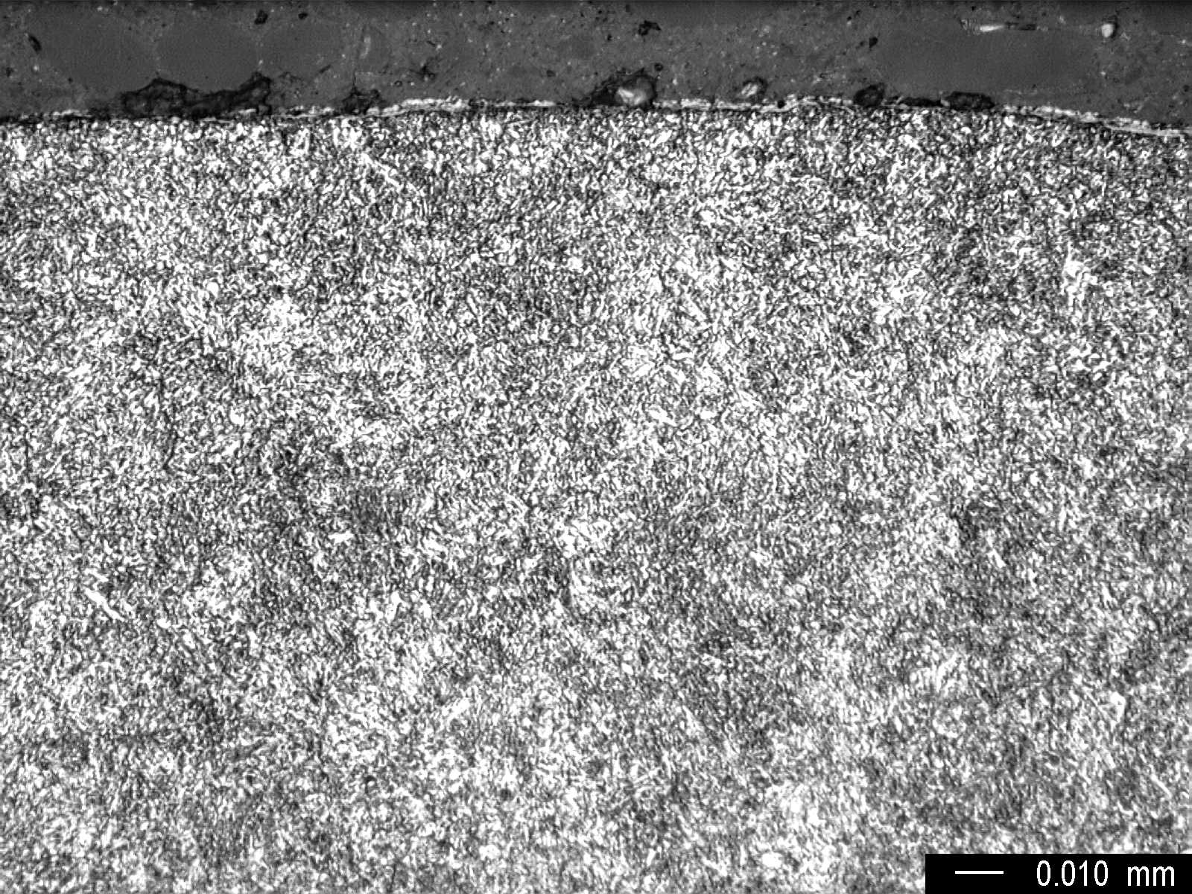

Fig.5 Microstructure at the gage length surface showing tempered martensite,
high magnification.

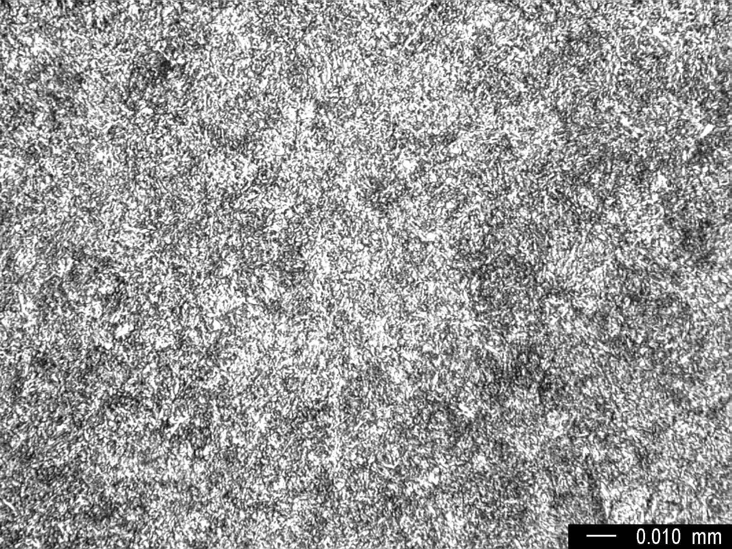

Fig.6 Core microstructure at the gage length showing tempered martensite,
high magnification.

