


Materials Engineering Lab Report
LTR Number: 125624

To: Peter Bauerle Phone: 776-7387

Location: CTC

From: Mechanical Properties Completed: 3/27/2006

Metallography

Subject/Part Name: Fatigue Specimen - Iteration 83

Report Status: Complete

Originator: Peter Bauerle

Originator Phone: 248-576-7387

Number of Parts: 1
Nature of Work: Process/Materials Development
Vendor:
Plant:
P/N:
MS:
PS:

History of Part

The sample that has been submitted is a fatigue specimen that will be used for the development of the AISI database. The sample has been identified as iteration 83 and is a grade 86B20. The specimen has been carburized at 1800F with a carbon potential of 0.8% minimum until the gage section has been through carburized prior to quenching in nitrogen at an 18 Bar pressure. The sample was then tempered at 370F to achieve a hardness of 58-60 HRC.

Test Results

Mechanical Properties - 125624

Hardness - Rockwell (Performed By: Dean Martin)

Testing was conducted on one component sample (Fatigue Specimen – Iteration 83 ) with three (3) different impressions taken on the grip end of the sample. Rockwell measurements were taken. Data as follows:

Surface Hardness – Rockwell, taken in Rockwell C

Fatigue Specimen
Hardness - HRC
1) 59.5 HRC
2) 59.2 HRC
3) 60.0 HRC

Hardness - Micro (Performed By: Dean Martin)

Testing was conducted on the core section ( Fatigue Specimen – Iteration 83, gage area ) using increments as specified by the requester. Data as follows:

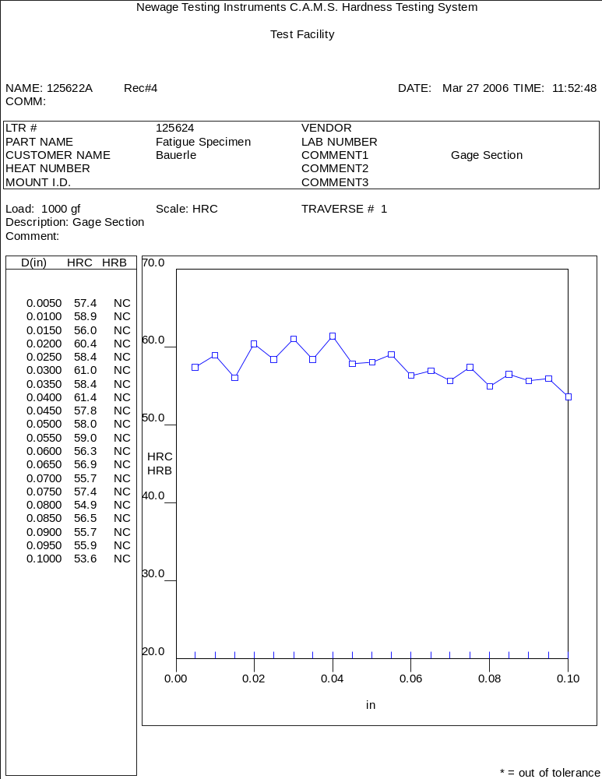

Metallography - 125624

General Microstructure Description (Performed By: Jin Dong)

The fatigue specimen-Iteration 83 was sectioned longitudinally from the grip end of the test coupon to conduct a general microstructure description.

The sample was prepared with standard test procedures for sectioning, mounting, polishing and etched with 3% nital. The sample was reviewed and microphotographs were taken using an Olympus PMG3 Microscope.

The microphotographs revealed a significant level of retained austenite at the surface (approximately 20-30%) with a transition to predominantly tempered martensite in the core area. The microhardness traverse indicated a variation in hardness such that the surface hardness was within a 57-61 HRC range with a gradual reduction to approximately 54-55 HRC in the core. The plant that performed the vacuum carburizing heat treatment was instructed not to section any additional samples following the development phase since the number of specimens remaining for the test program was at the minimum number required.

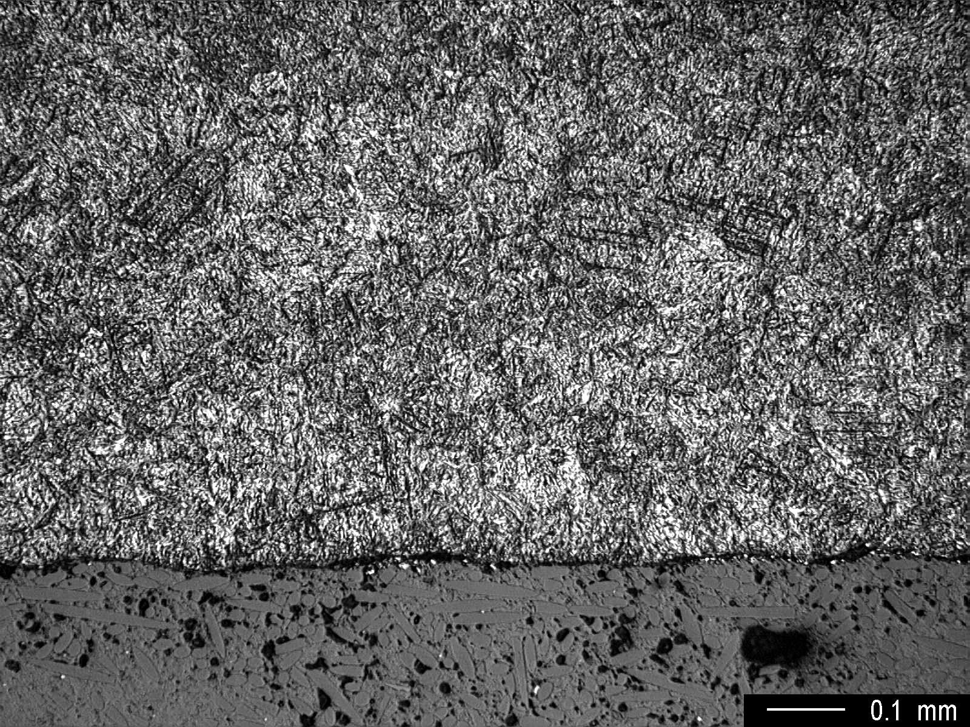
Fig. 1 Low magnification showing microstructure in the surface area.
Note the level of retained austenite.

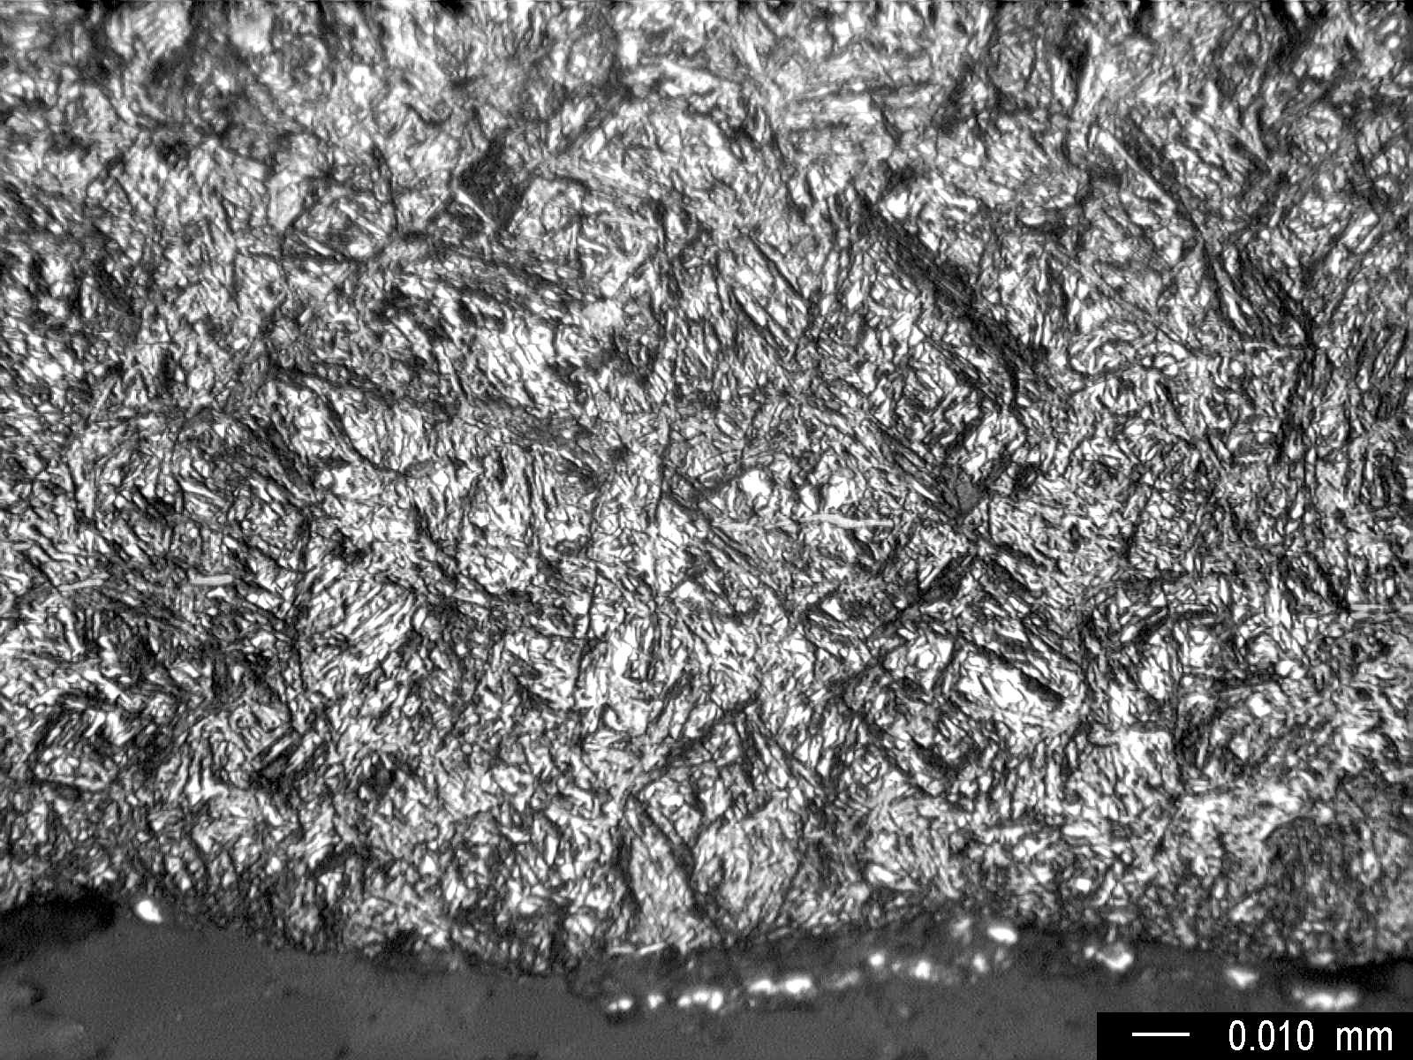
Fig. 2 High magnification showing details of the microstructure
(retained austenite) in the surface area.

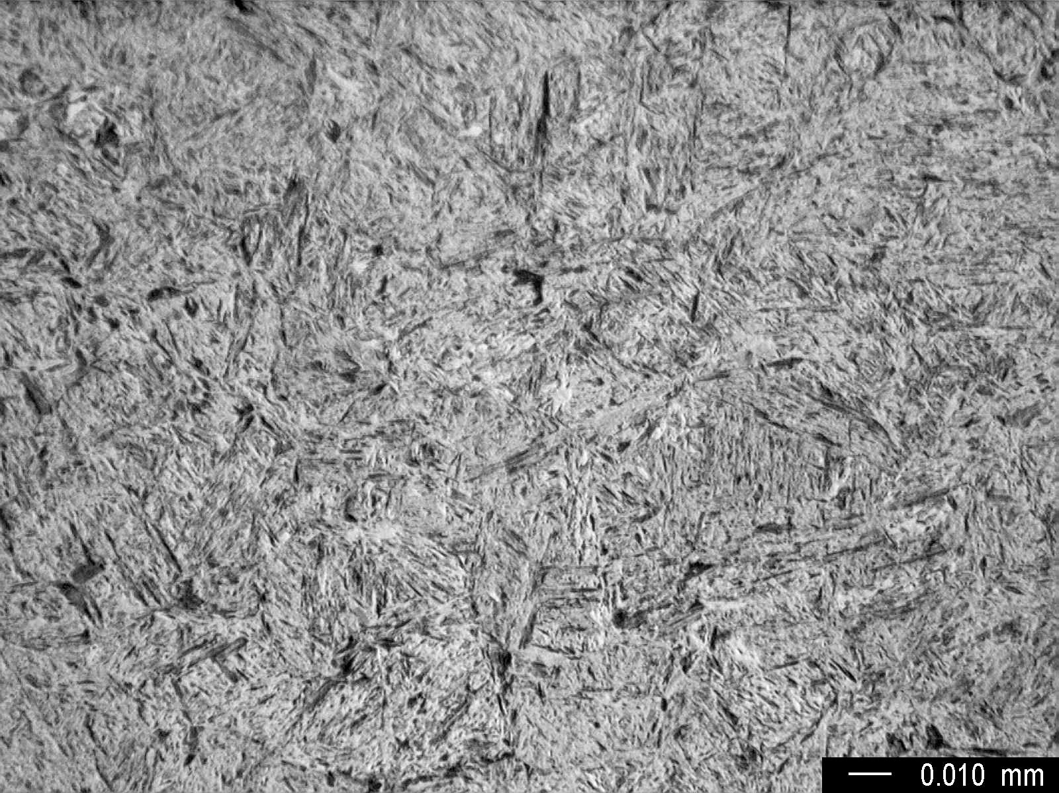
Fig. 3 High magnification showing microstructure (tempered martensite) in the case area

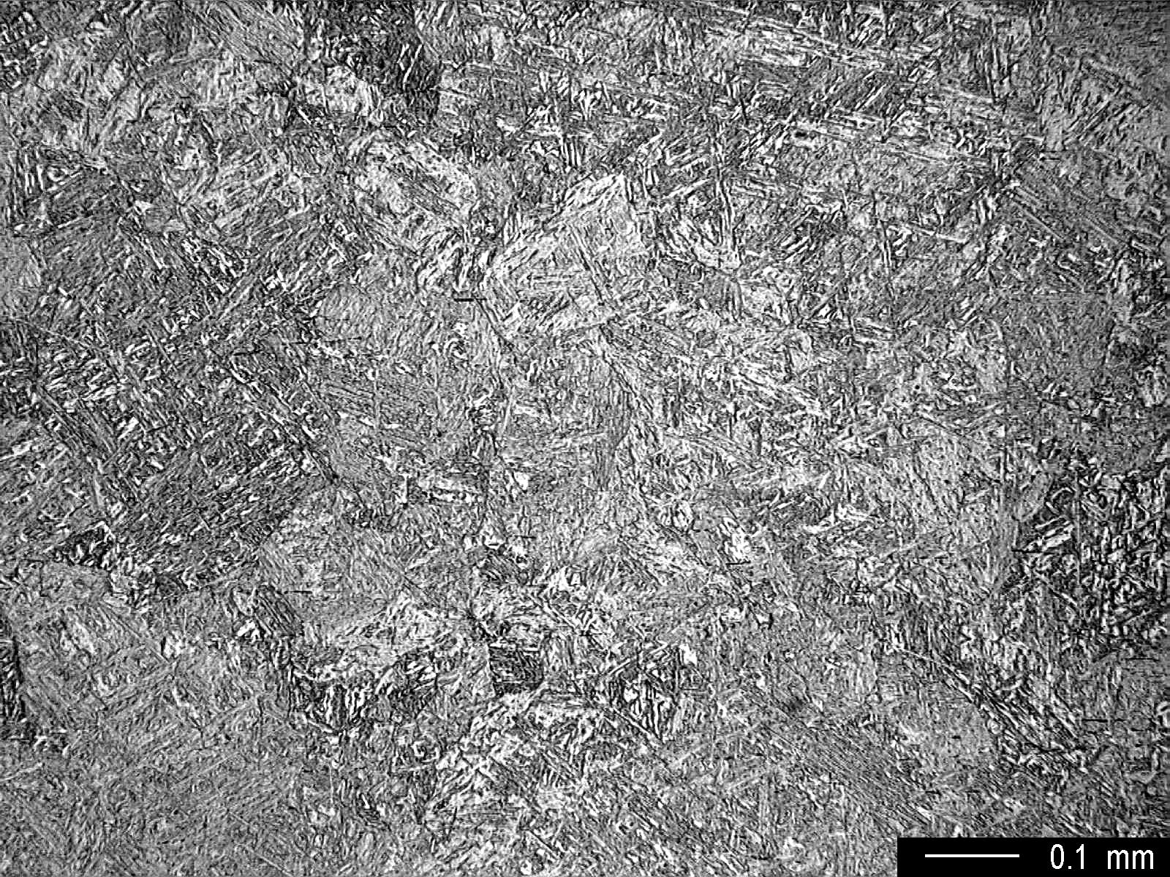
Fig. 4 Low magnification showing microstructure in the core area.

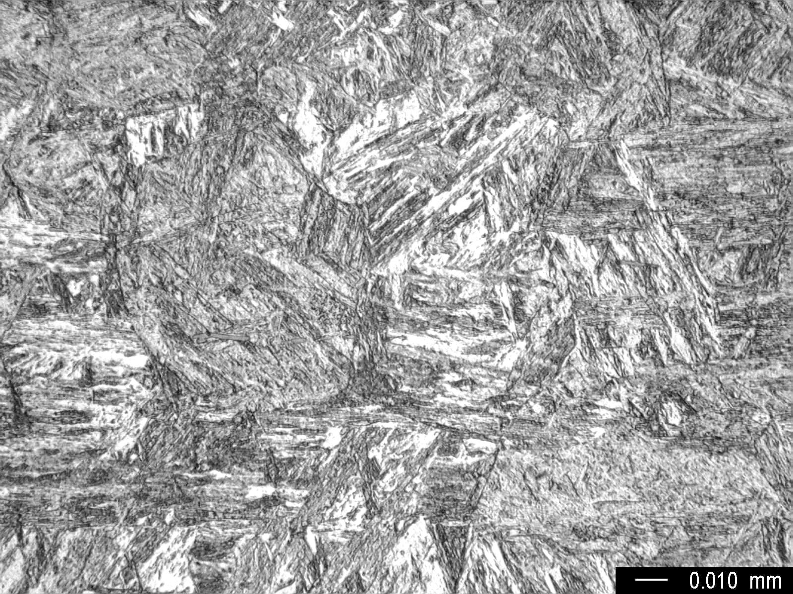
Fig. 5 High magnification showing microstructure in the core area.

