


Materials Engineering Lab Report
LTR Number: 124249

To: Peter Bauerle Phone: 776-7387

Location: CTC

From: Mechanical Properties Completed: 10/25/2005

Metallography

Subject/Part Name: Fatigue Test Specimen

Report Status: Complete

Originator: Peter Bauerle

Originator Phone: 248-576-7387

Number of Parts: 1
Nature of Work: Pilot, Mule, Program Development Issue
Vendor:
Plant:
P/N:
MS:
PS:

History of Part

The sample that has been submitted is a fatigue specimen that will be used for the development of the AISI database. The sample has been identified as iteration 72 and is a grade 41B17. The sample has been quenched and tempered to produce a core hardness of 20-25 HRC. The specimens were austenitized at 1650F for one hour followed by oil quenching and then tempered at 1100F to achieve a surface hardness of 24 HRC.

Test Results

Mechanical Properties - 124249

Hardness - Rockwell (Performed By: Jim Bolton)

Direct hardness was taken on O.D. of sample the values are 25.6*/24.3*/24.6*
NOTE* a value of 3 was added to these hardness values for roundness correction.

Core readings were taken on a mounted sample and are seen below
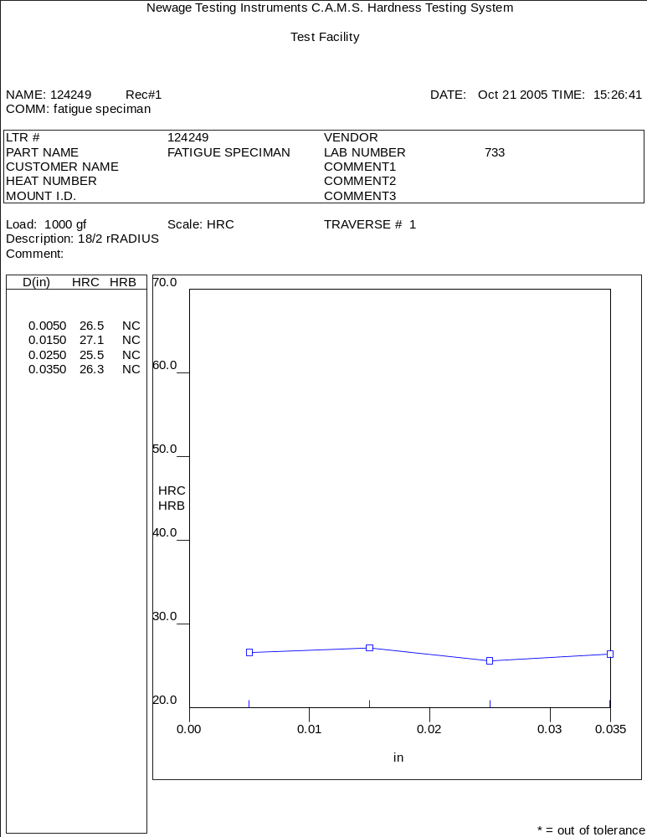
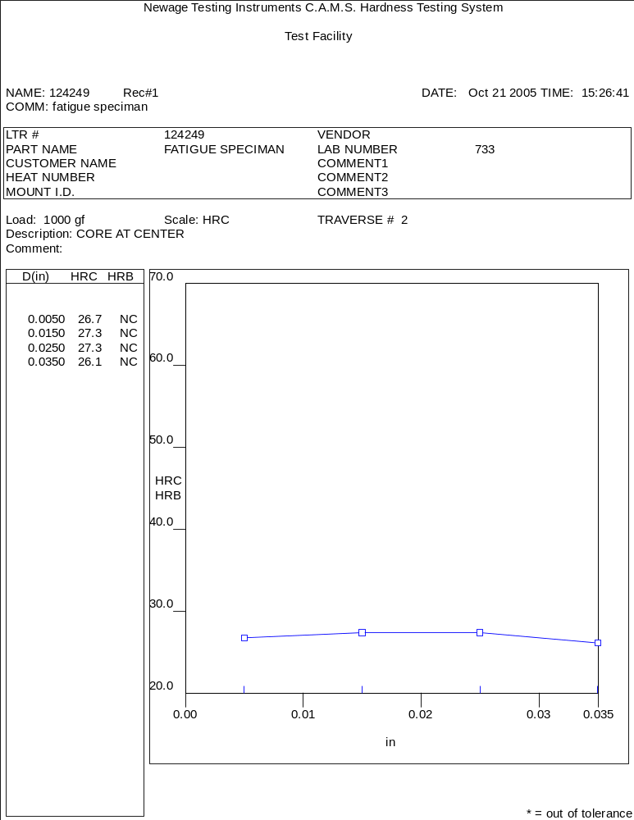

Metallography - 124249

General Microstructure Description (Performed By: James Shi)

The submitted fatigue specimen was sectioned longitudinally through the centerline at the grip end and prepared according to the normal procedures for microstructural evaluation. Using optical microscope Olympus PMG3, the microstructures were examined and microphotographs were taken. The results of the evaluation revealed that the part was through hardened. The microstructure of the part consisted of tempered martensite from surface to core. No apparent banded structure, no decarburization and no surface related abnormalities were observed. The details of the microstructures are shown in Figs.1-5.

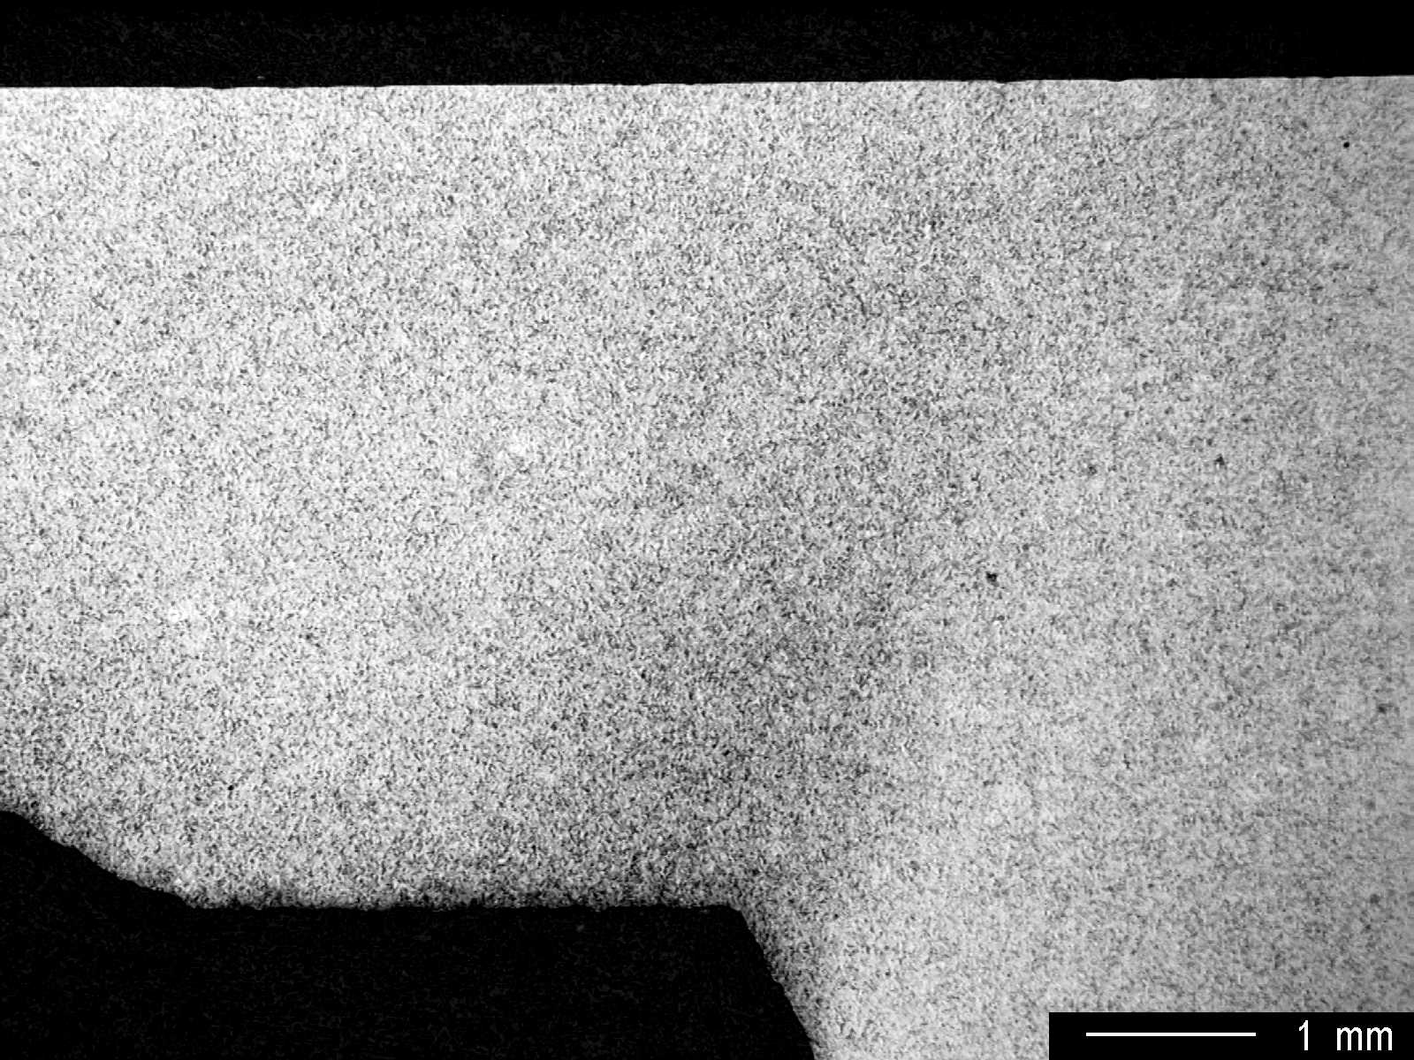

Fig.1 Microstructure in the section of the grip end, low magnification.

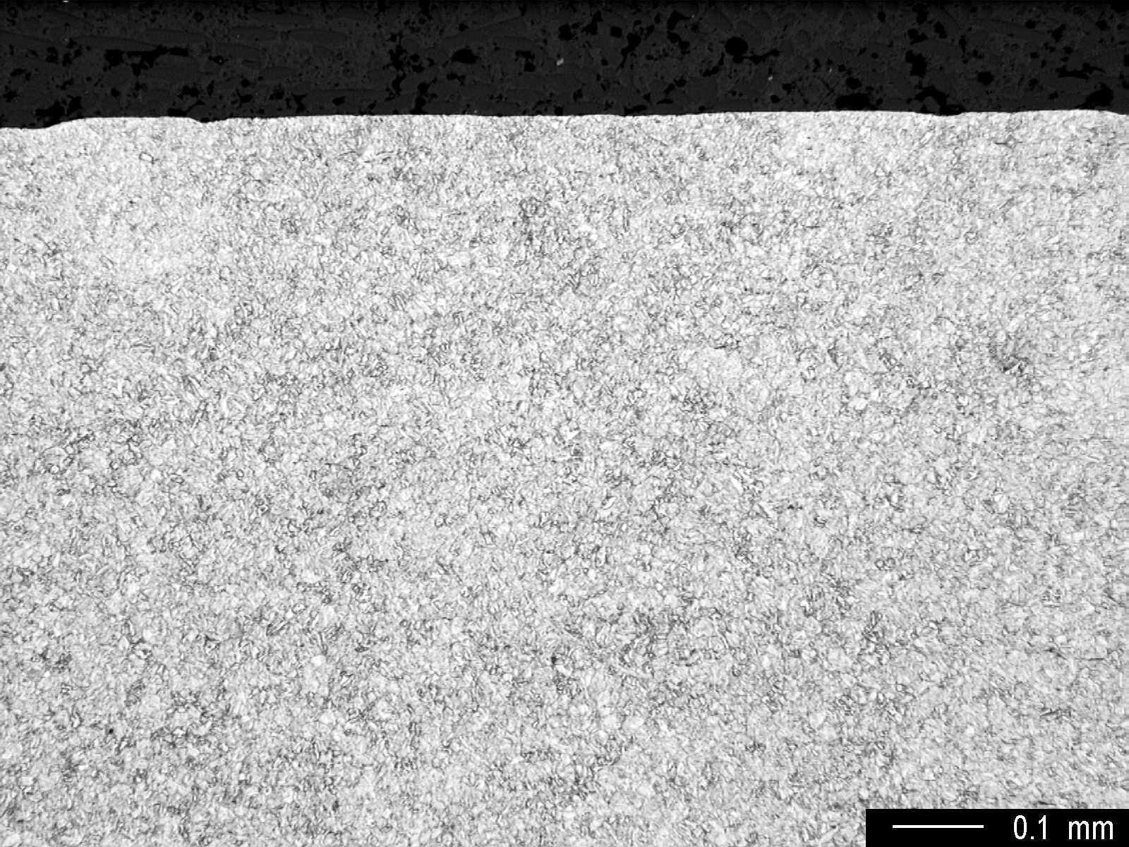

Fig.2 Microstructure at the surface, medium magnification.

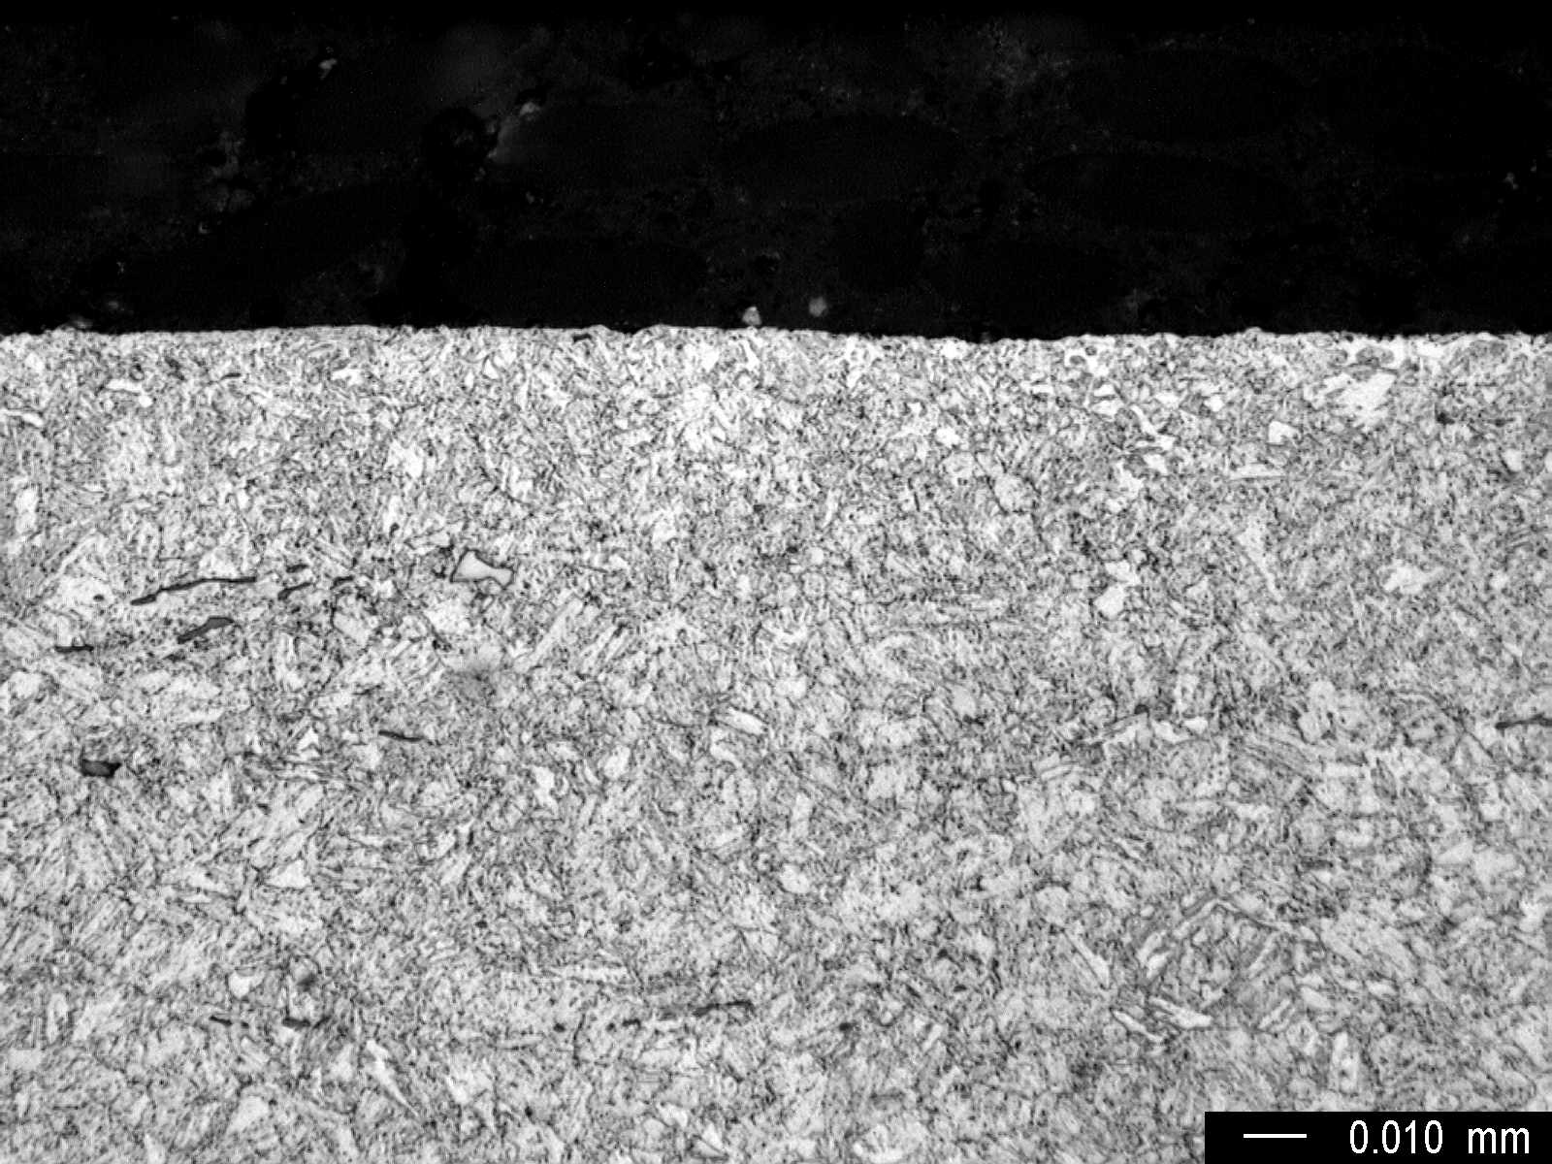

Fig.3 Microstructure at the surface, high magnification.

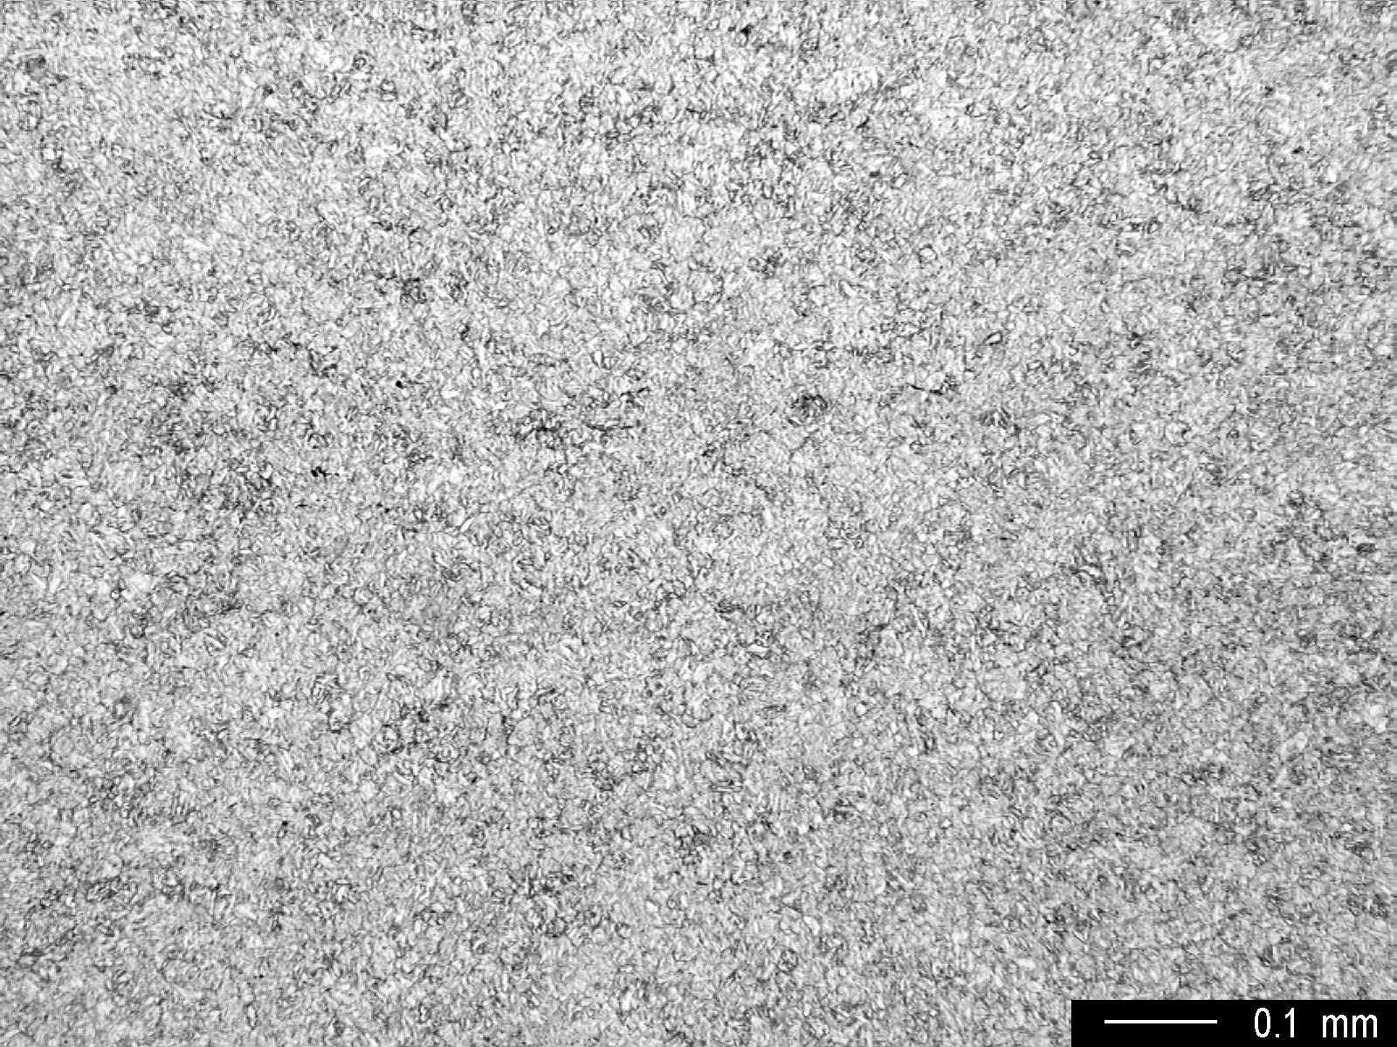

Fig.4 Core microstructure, medium magnification.

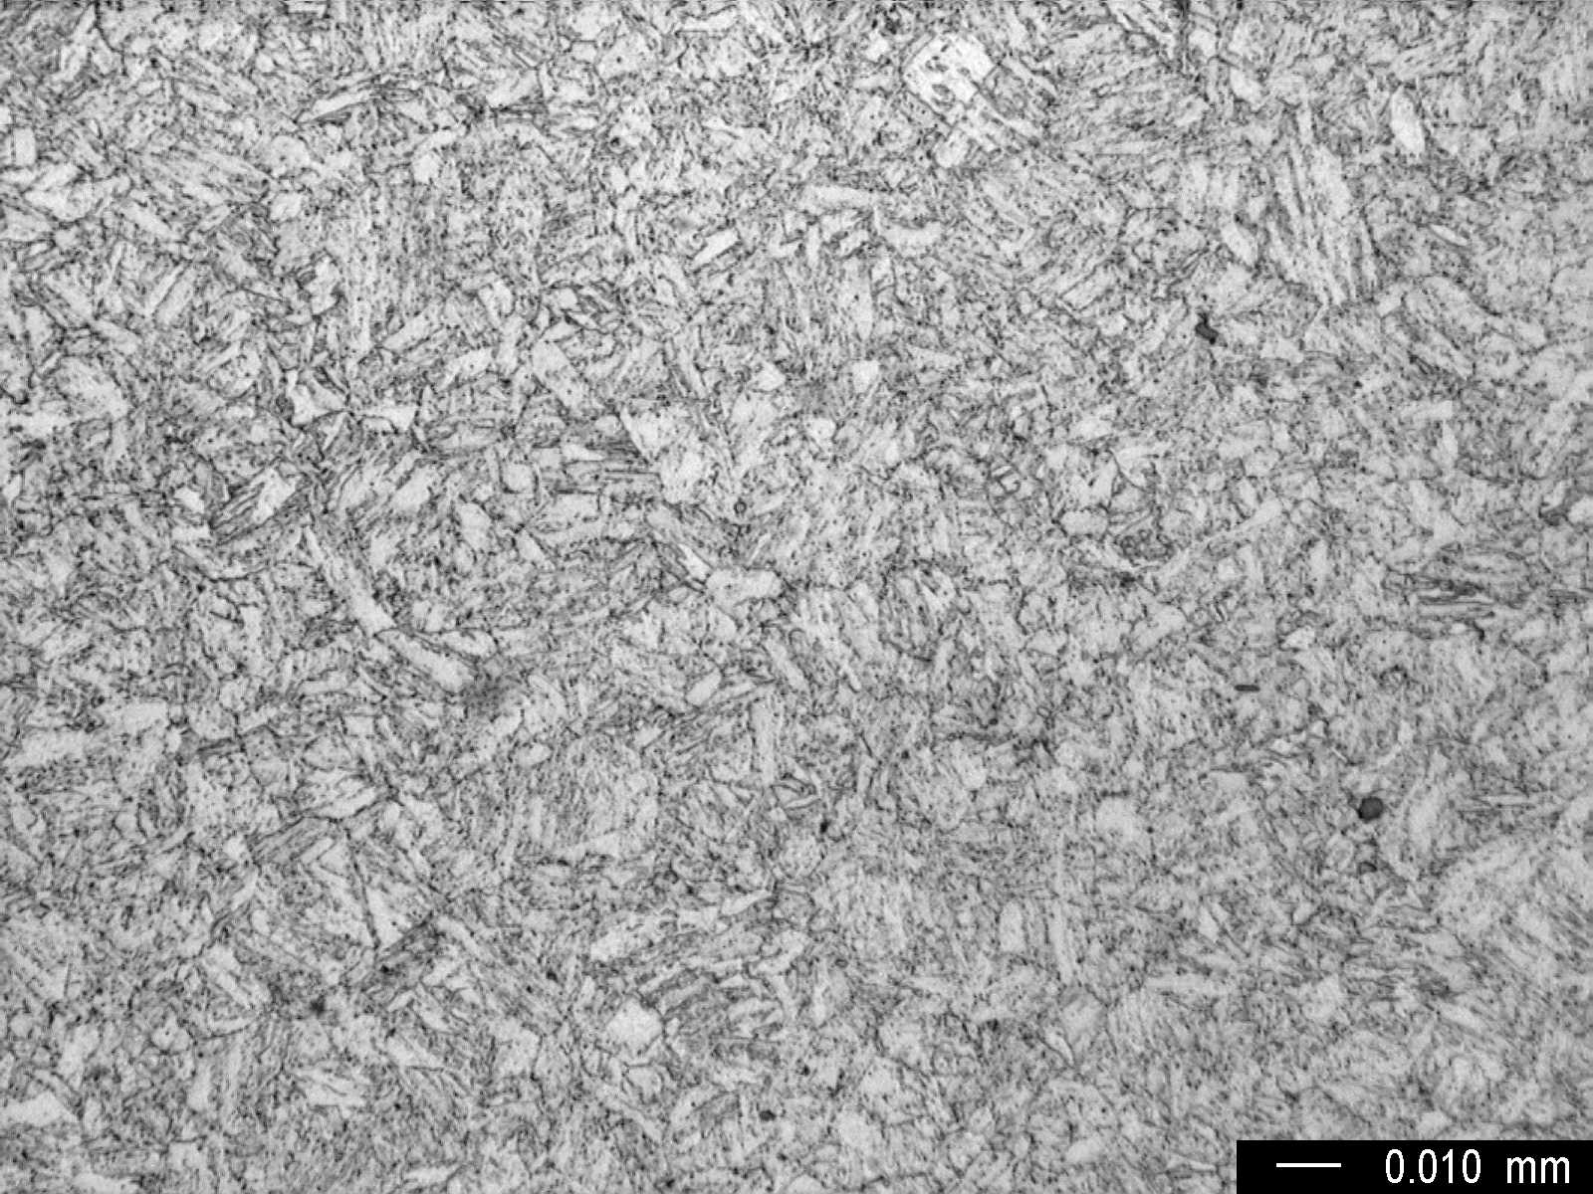

Fig.5 Core microstructure, high magnification.

