UW RGB Colour**Fatigue Behavior and Monotonic Properties**

**For**

**AISI 20MnCr5 Steel**

**Iteration 170**

T.H. Topper and D. Gaia

Department of Civil and Environmental Engineering

University of Waterloo

Waterloo, Ontario, Canada N2L 3G1

Prepared for:

The AISI Bar Steel Applications Group

July 2015

Summary 3

Introduction 4

Experimental Procedure 4

Specimen Preparation 4

Test Equipment and Procedure 4

Results 5

Chemical Composition 5

Monotonic Tension Test 5

Cyclic Stress-Strain Curves 5

Constant Amplitude Fatigue Data 6

References 7

# Summary

The required mechanical fatigue properties, cyclic stress-strain data, strain-controlled fatigue data and overload fatigue data for AISI 20MnCr5 Steel have been obtained. The material was provided by the American Iron and Steel Institute (AISI) in the form of metal bars. These bars were machined into smooth axial fatigue specimens. The Rockwell C hardness (RC) was determined by micro-hardness measurements performed at Dana Holding Corporation. Constant-amplitude tests as well as overload fatigue tests were conducted in laboratory air at room temperature to establish the cyclic stress-strain curve and strain-life curve.

# Introduction

This report presents the results of tensile and fatigue tests performed on a group of 20MnCr5 Steel specimens (Iteration 170). The material was provided by the American Iron and Steel Institute. The objective of this investigation is to obtain the mechanical fatigue properties, cyclic stress-strain data and strain-life fatigue data of this material.

# Experimental Procedure

## Specimen Preparation

## 

The material for this study was received in the form of round bars. Smooth cylindrical fatigue specimens, shown in Figure 1, were machined from the cylindrical metal bars. Before being heat treated, the specimens had a final polish in the loading direction in the gauge sections using 240, 400, 500, and 600 emery papers. A thin band of M-coat D acrylic coating was applied along the central gauge section before testing. The purpose of the M-coat D application was to prevent scratching of the smooth surface by the knife-edges of the strain extensometer, thus reducing the incidence of knife-edge failures.

## Test Equipment and Procedure

Two monotonic tension tests were performed to determine the yield strength, the tensile strength, the percent elongation and the percent reduction of area. All fatigue tests were carried out in a laboratory environment at approximately 25oC using an MTS servo-controlled closed loop electro hydraulic testing machine.

A process control computer, controlled by FLEX software [1] was used to output constant strain amplitudes for constant strain amplitude tests and stress amplitudes for the overload tests.

Axial, constant strain amplitude, fully reversed (R=-1), strain-controlled fatigue tests were performed on smooth specimens. The stress-strain limits for each specimen were recorded at logarithmic intervals throughout the test via peak reading voltmeters. Failure of a specimen was defined as a 50 percent drop in the tensile peak load from the peak load observed at one half the expected specimen life. The loading frequency varied from 0.05 Hz to 3 Hz. For fatigue lives greater than 100,000 reversals (once the stress-strain loops had stabilized) in constant amplitude tests and in all periodic overload tests, the specimens were tested in load control. For the load-controlled tests, failure was defined as the separation of the smooth specimen into two pieces. The test frequencies used in this case were between 30 and 120 Hz.

# Results

## Chemical Composition

The chemical composition as provided by Gerdau corporation is shown in Table 1.

## Monotonic Tension Test

The engineering monotonic tensile stress-strain curve is given in Figure 2. The monotonic properties are given in Table 2. The Hardness of the 20MnCr5 Steel was taken from DANA Lab Report 2015-0134 on 20MnCr5 specimens [2] and is given in Table 2

## Cyclic Stress-Strain Curves

Stabilized stress data obtained from strain-life fatigue tests were used to construct the companion specimen cyclic stress-strain curve shown in Figure 3. The true monotonic and true cyclic stress-strain curves are plotted together in Figure 4. The cyclic stress-strain curve is described by the following equation:

 (Eq. 1)

Where  is the true total strain amplitude,  is the cyclically stable true stress amplitude, Ec is the cyclic modulus of elasticity obtained from a best fit of the above equation to the test data and is given in Table 2, K’ is the cyclic strength coefficient, and n’ is the strain hardening exponent.

The same equation with stress and strain rather than stress and strain amplitudes was used to fit the monotonic engineering stress versus engineering strain results.

## Constant Amplitude Fatigue Data

Constant amplitude fatigue test data obtained in this investigation are given in Table 3. The stress amplitude corresponding to the peak strain amplitude was calculated from the peak load amplitude at one half of the specimen’s life. A constant amplitude fatigue life curve for the steel is given in Figure 5 and is described by the following equations:

 (Eq. 2)

 (Eq. 3)

Since  (Eq. 4)

 (Eq. 5)

Where;

** is the total strain amplitude,

is the elastic strain amplitude,

is the plastic strain amplitude,

2*Nf* is the number of reversals to failure,

*σ′f* is the fatigue strength coefficient,

*b* is the fatigue strength exponent,

*'f* is the fatigue ductility coefficient,

*c* is the fatigue ductility exponent.

The values of the strain-life parameters were determined from a best fit of Equations 2 and 3 and are given in Table 2.

**Microstructure:**

Microstructure was analyzed by Chrysler lab, and is shown in Figures 7 and 8.

# References

[1] M. Pompetzki, R. Saper, T. Topper, Software for rig frequency control of variable amplitude fatigue tests, Canadian Metallurgical Quarterly 25 (2) (1987) 181-194

[2] DANA Lab Report 2015-0134 on 20MnCr5 specimens

**Note:**

Some specimen IDs, a digital number with a letter “B”, such as 19B, it means this specimen (19) was tested at low strain amplitude without failure, then it was tested at high strain amplitude (19B).



Figure 1: Uni-axial smooth cylindrical fatigue specimen

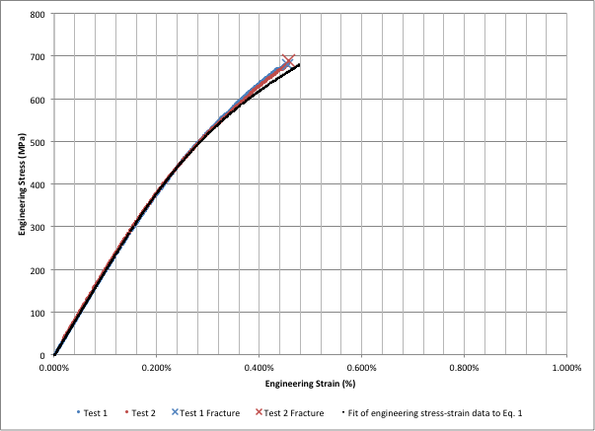

Figure 2: Monotonic engineering stress-strain curves for AISI 20MnCr5 (IT 170)

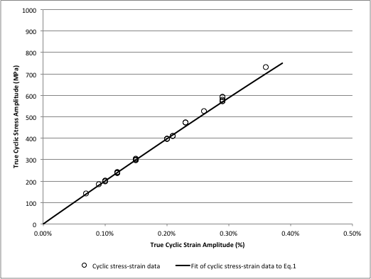

Figure 3: Cyclic stress-strain curve for AISI 20MnCr5 Steel (IT 170)

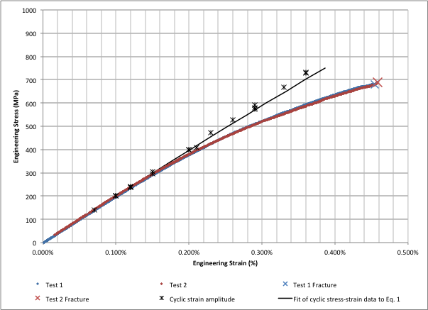

Figure 4: Monotonic & cyclic true stress-strain curves for AISI 20MnCr5 Steel (IT 170)

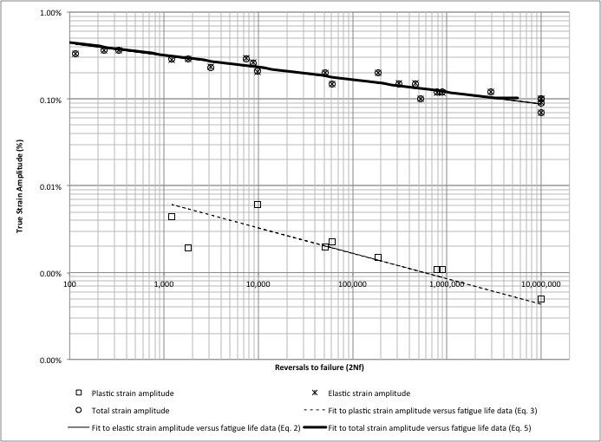

Figure 5: Strain-life fatigue curves for AISI 20MnCr5 (IT 170)

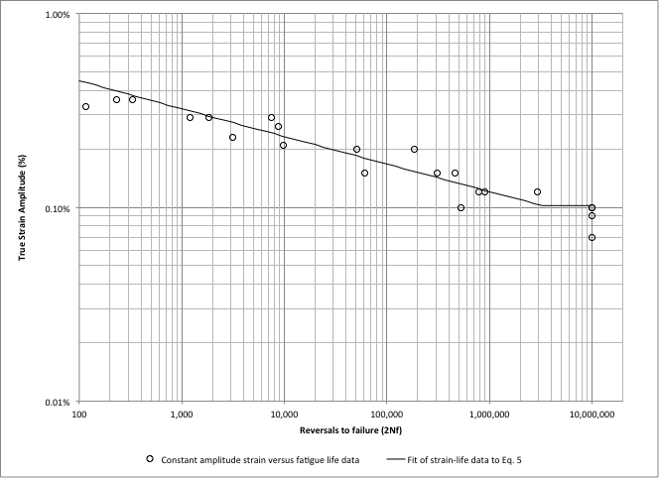

2

Figure 6: Constant amplitude fatigue curve for AISI 20MnCr5 (IT 170)

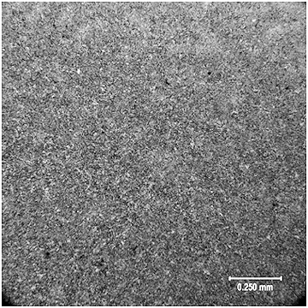

Figure 7: Microstructure of Iteration 170, low magnification.

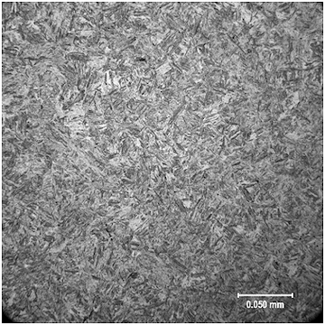

Figure 8: Microstructure of Iteration 170, high magnification.

**Table 1: Chemical Analysis (Bar Average) for AISI 20MnCr5 Steel**

**(Iteration 170)**

|  |  |
| --- | --- |
| **C** | **0.18** |
| **Mn** | **1.20** |
| **P** | **0.010** |
| **S** | **0.030** |
| **Si** | **0.21** |
| **Ni** | **0.16** |
| **Cr** | **1.11** |
| **Mo** | **0.04** |
| **Cu** | **0.21** |
| **Sn** | **0.008** |
| **Al** | **0.034** |
| **V** | **0.002** |
| **B** | **0.0007** |
| **Ca** | **0.0011** |
| **Ti** | **0.004** |
| **Nb** | **0.002** |
| **N** | **0.0097** |
| **H** | **2.3000** |
| **O** | **0.0008** |
| **Pb** | **0.0006** |
| **Zr** | **0.0020** |
| **Sb** | **0.003** |
| **As** | **0.003** |
| **Zn** | **0.004** |

|  |  |
| --- | --- |
| **Table 2: Monotonic and Cyclic Properties for AISI 20MnCr5 Steel**  **(IT 170)** | |
| Monotonic Properties | |
| Average elastic modulus, E (GPa) | 200 |
| Yield strength (MPa) | - |
| Ultimate tensile strength (MPa) | 684 |
| % Elongation (%) | 0.46% |
| % Reduction of area (%) | 0.16% |
| True fracture strain,  (%) | 0.46% |
| True fracture stress, (MPa) | 684 |
| Monotonic tensile strength coefficient, K (MPa) | 2881 |
| Monotonic tensile strain hardening exponent, n | 0.219 |
| Hardness, Rockwell C (HRC) | 60-63 |
| Cyclic Properties | |
| Cyclic Yield Strength, (0.2% offset) (MPa) | 2100 |
| Cyclic strength coefficient, K' (MPa) | 22599 |
| Cyclic strain hardening exponent, n' | 0.382 |
| Cyclic elastic modulus, Ec (GPa) | 201 |
| Fatigue strength coefficient,'f (MPa) | 1674 |
| Fatigue strength exponent, b | -0.140 |
| Fatigue ductility coefficient,'f | 0.0005 |
| Fatigue ductility exponent, c | -0.293 |

|  |  |  |  |  |  |  |  |  |  |  |  |  |  |  |  |  |  |  |  |  |  |  |  |  |  |  |  |  |  |  |  |  |  |  |  |  |  |  |  |  |  |  |  |  |  |  |  |  |  |  |  |  |  |  |  |  |  |  |  |  |  |  |  |  |  |  |  |  |  |  |  |  |  |  |  |  |  |  |  |  |  |  |  |  |  |  |  |  |  |  |  |  |  |  |  |  |  |  |  |  |  |  |  |  |  |  |  |  |  |  |  |  |  |  |  |  |  |  |  |  |  |  |  |  |  |  |  |  |  |  |  |  |  |  |  |  |  |  |  |  |  |  |  |  |  |  |  |  |  |  |  |  |  |  |  |  |  |  |  |  |  |  |  |  |  |  |  |  |  |  |  |  |  |  |  |  |  |  |  |  |  |  |  |  |  |  |  |  |  |
| --- | --- | --- | --- | --- | --- | --- | --- | --- | --- | --- | --- | --- | --- | --- | --- | --- | --- | --- | --- | --- | --- | --- | --- | --- | --- | --- | --- | --- | --- | --- | --- | --- | --- | --- | --- | --- | --- | --- | --- | --- | --- | --- | --- | --- | --- | --- | --- | --- | --- | --- | --- | --- | --- | --- | --- | --- | --- | --- | --- | --- | --- | --- | --- | --- | --- | --- | --- | --- | --- | --- | --- | --- | --- | --- | --- | --- | --- | --- | --- | --- | --- | --- | --- | --- | --- | --- | --- | --- | --- | --- | --- | --- | --- | --- | --- | --- | --- | --- | --- | --- | --- | --- | --- | --- | --- | --- | --- | --- | --- | --- | --- | --- | --- | --- | --- | --- | --- | --- | --- | --- | --- | --- | --- | --- | --- | --- | --- | --- | --- | --- | --- | --- | --- | --- | --- | --- | --- | --- | --- | --- | --- | --- | --- | --- | --- | --- | --- | --- | --- | --- | --- | --- | --- | --- | --- | --- | --- | --- | --- | --- | --- | --- | --- | --- | --- | --- | --- | --- | --- | --- | --- | --- | --- | --- | --- | --- | --- | --- | --- | --- | --- | --- | --- | --- | --- | --- | --- | --- | --- |
| **Table 3: Constant Strain Amplitude Data for AISI 20MnCr5 Steel (IT 165)**   |  |  |  |  |  |  |  | | --- | --- | --- | --- | --- | --- | --- | | **Sp. Id** | **True** | **True** | **True Plastic** | **True Elastic** | **Reversals** | **Hardness** | |  | **Strain (%)** | **Stress (MPa)** | **Strain (%)** | **Strain (%)** | **to Failure** |  | | **114B** | **0.365** | **733** | **-** | **0.365** | **332** |  | | **115B** | **0.363** | **729** | **-** | **0.363** | **230** |  | | **122** | **0.332** | **667** | **-** | **0.332** | **116** |  | | **109** | **0.295** | **592** | **-** | **0.295** | **7,542** |  | | **121** | **0.288** | **579** | **0.001940299** | **0.288** | **1818** |  | | **116B** | **0.286** | **574** | **0.004427861** | **0.286** | **1206** |  | | **123** | **0.263** | **528** | **-** | **0.263** | **8,796** | **Average** | | **110** | **0.235** | **473** | **-** | **0.235** | **3,130** | **HRC 60-63** | | **111** | **0.204** | **410** | **0.0060199** | **0.204** | **9,838** |  | | **120** | **0.199** | **399** | **0.001492537** | **0.199** | **186,946** |  | | **124** | **0.198** | **398** | **0.00199005** | **0.198** | **51,134** |  | | **118** | **0.152** | **306** | **-** | **0.152** | **463,282** |  | | **117** | **0.150** | **302** | **-** | **0.150** | **310,726** |  | | **112** | **0.148** | **297** | **0.002238806** | **0.148** | **60,444** |  | | **126** | **0.120** | **242** | **-** | **0.120** | **2,924,664** |  | | **127** | **0.119** | **239** | **0.001094527** | **0.119** | **892,076** |  | | **128** | **0.119** | **239** | **0.001094527** | **0.119** | **783,816** |  | | **113** | **0.100** | **202** | **-** | **0.100** | **522,292** |  | | **125** | **0.100** | **202** | **-** | **0.100** | **10,000,000** |  | | **116** | **0.100** | **200** | **0.000497512** | **0.100** | **10,000,000** |  | | **115** | **0.092** | **185** | **-** | **0.092** | **10,000,000** |  | | **114** | **0.070** | **141** | **-** | **0.070** | **10,000,000** |  | | **114B** | **0.365** | **733** | **-** | **0.365** | **332** |  | | **115B** | **0.363** | **729** | **-** | **0.363** | **230** |  | | **122** | **0.332** | **667** | **-** | **0.332** | **116** |  | |